When Violins Fell Silent. Archaeological Traces of Mass Executions of Romani People in Slovenia
Uroš Košir

Supplementary Material: Figures
All illustrations are by the author unless stated otherwise.

Supplementary Figure S1. The seven graves discovered in Iška were in close proximity to the wooden cross (red dot) erected in the period after 1991.

Supplementary Figure S2. Upper layer of human remains in grave no. 3, Iška.
Supplementary Figure S3. Lower layer of human remains in grave no. 3, Iška.
Supplementary Figure S4. Foetus from grave no. 3 at Iška.

Supplementary Figure S5. Upper layer of human and animal remains in grave no. 4, Iška.

Supplementary Figure S6. Lower layer of human remains in grave no. 4, Iška.

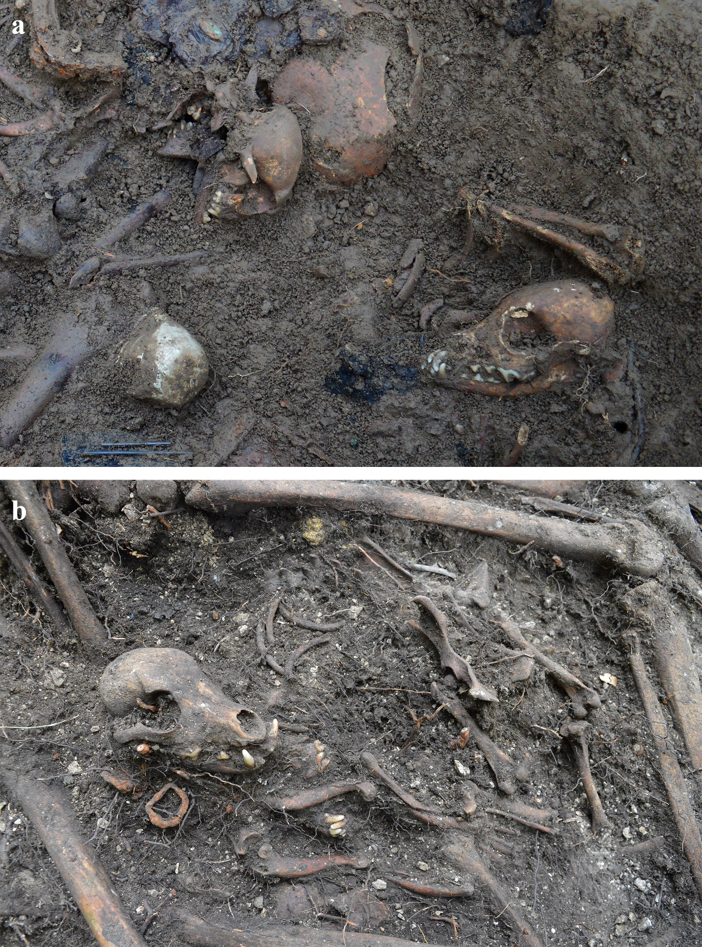
Supplementary Figure S7. A) Remains of two dogs in grave no. 4, Iška and B) two dogs in grave no. 1, Boncar.

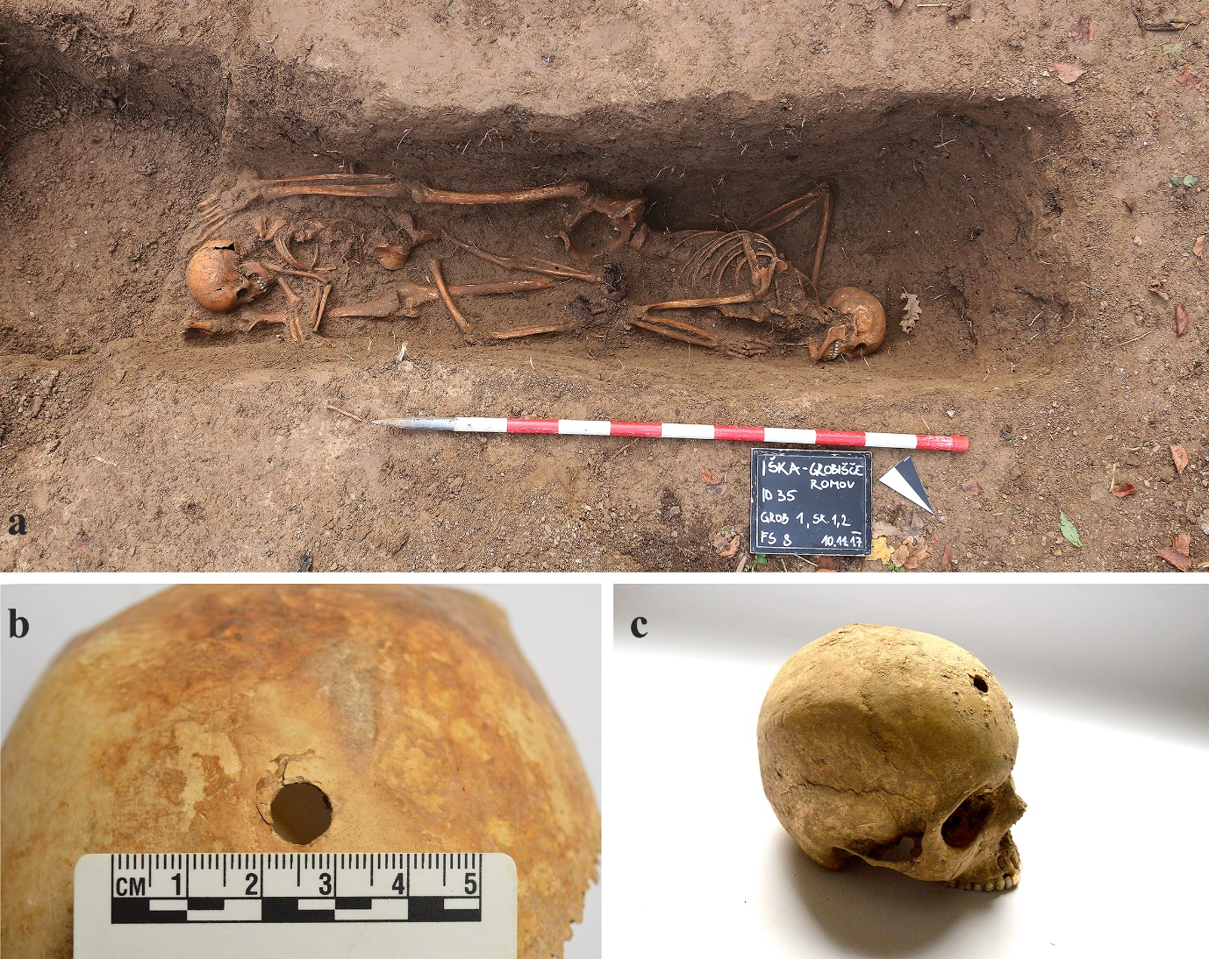
Supplementary Figure S8. A) Mira Lampret and her daughter were most probably buried in grave no. 1 at Iška (photograph: M. Pečovnik, 2018). B) Individual no. 2 - os frontale with a bullet entry wound. C) Individual no. 1 - os frontale with a bullet entry wound.

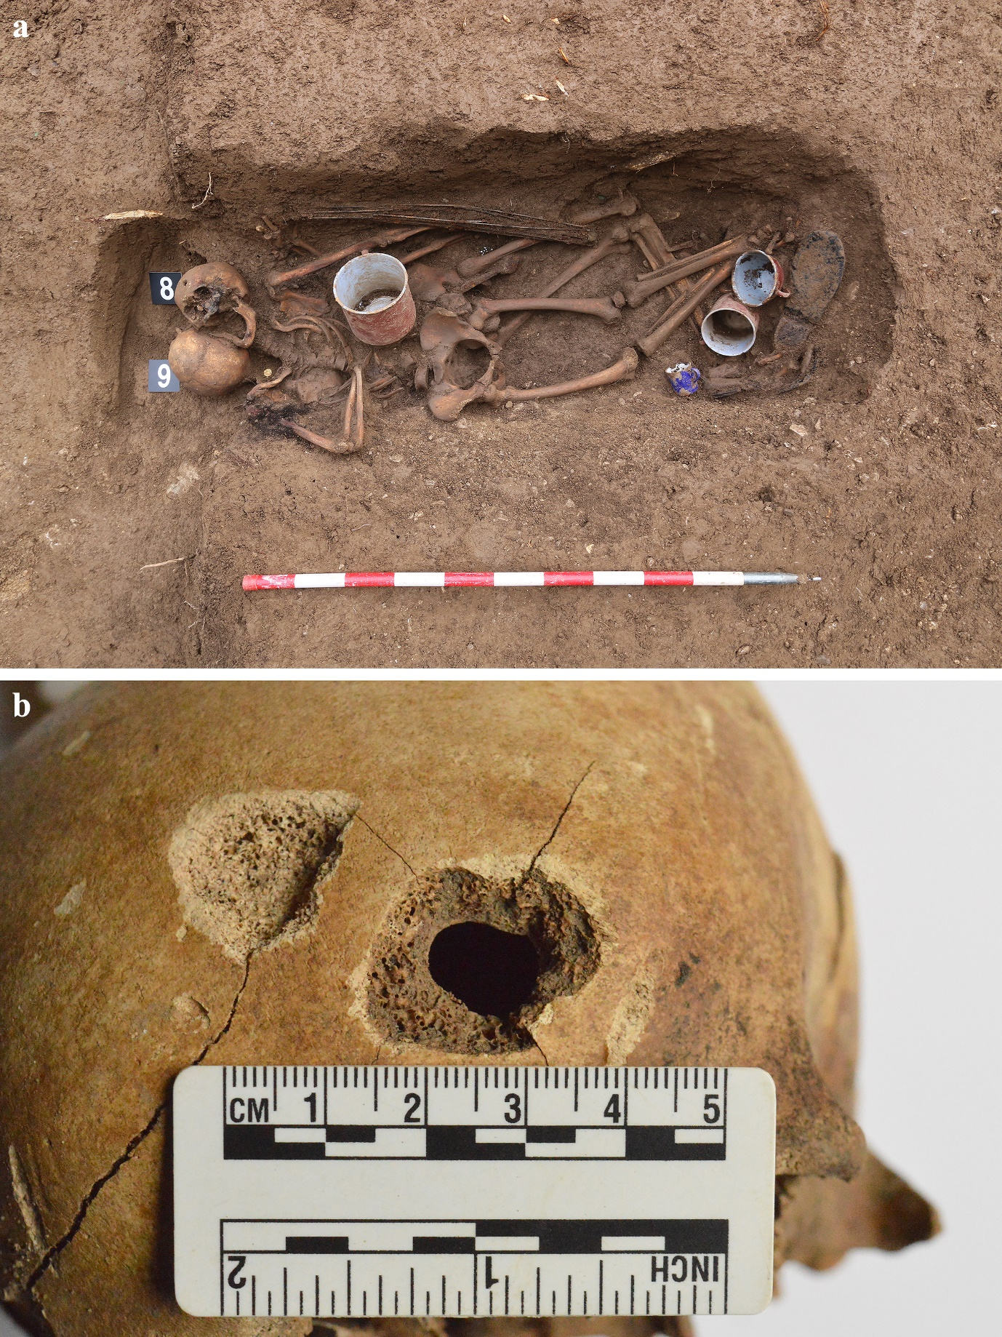Supplementary Figure S9. Grave no. 6 at Iška. A) individuals nos. 8 and 9. B) Individual no. 8: exit bullet wound on os frontale.

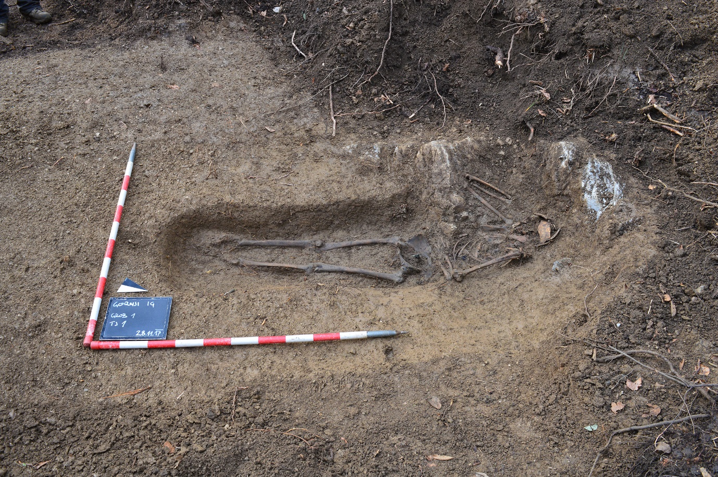
Supplementary Figure S10. Grave at Gornji Ig.

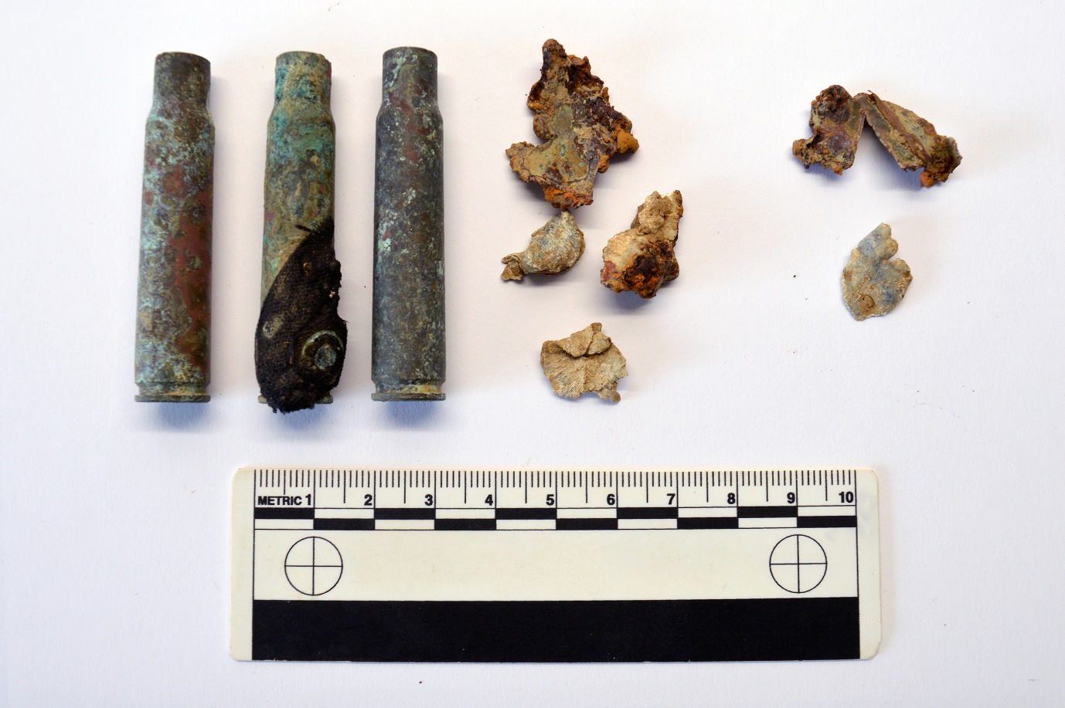
Supplementary Figure S11. Cartridge cases and fragmented bullets from the grave at Gornji Ig.

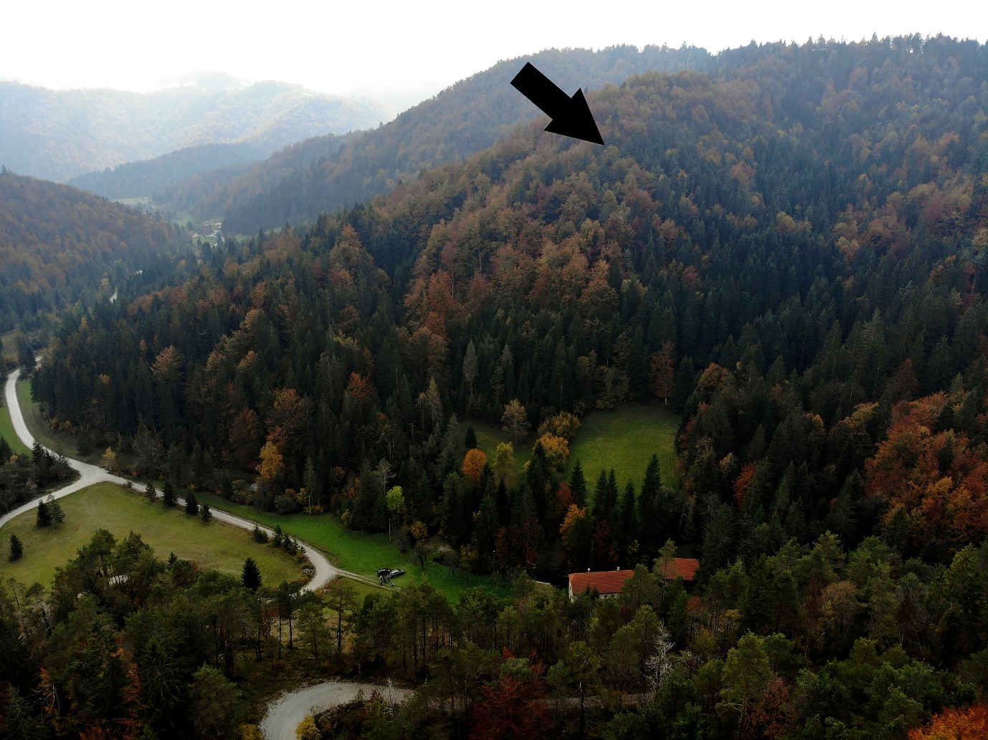
Supplementary Figure S12. Approximate location of the burial site on Boncar Hill near Podklanec (photograph: M. Pečovnik, 2018).

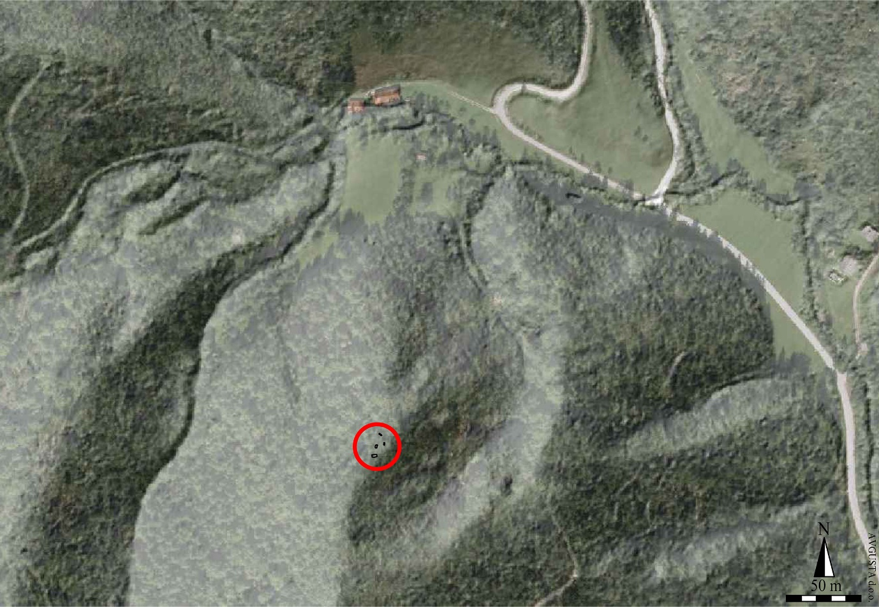
Supplementary Figure S13. Location of the burial site on Boncar Hill near Podklanec.

Supplementary Figure S14. Graves, executions sites and distribution of cartridge cases at Boncar.

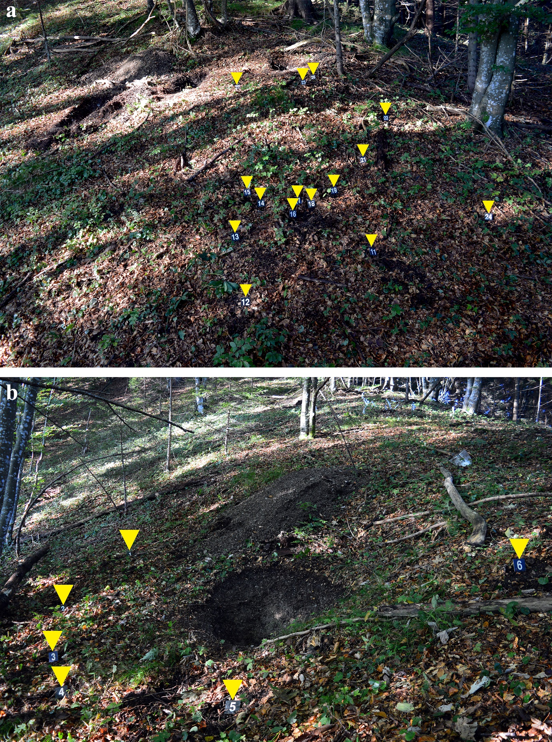
Supplementary Figure S15. A) Distribution of cartridge cases at the execution site above the mass graves and B) around grave no. 1. The test pit was dug prior to the excavation.

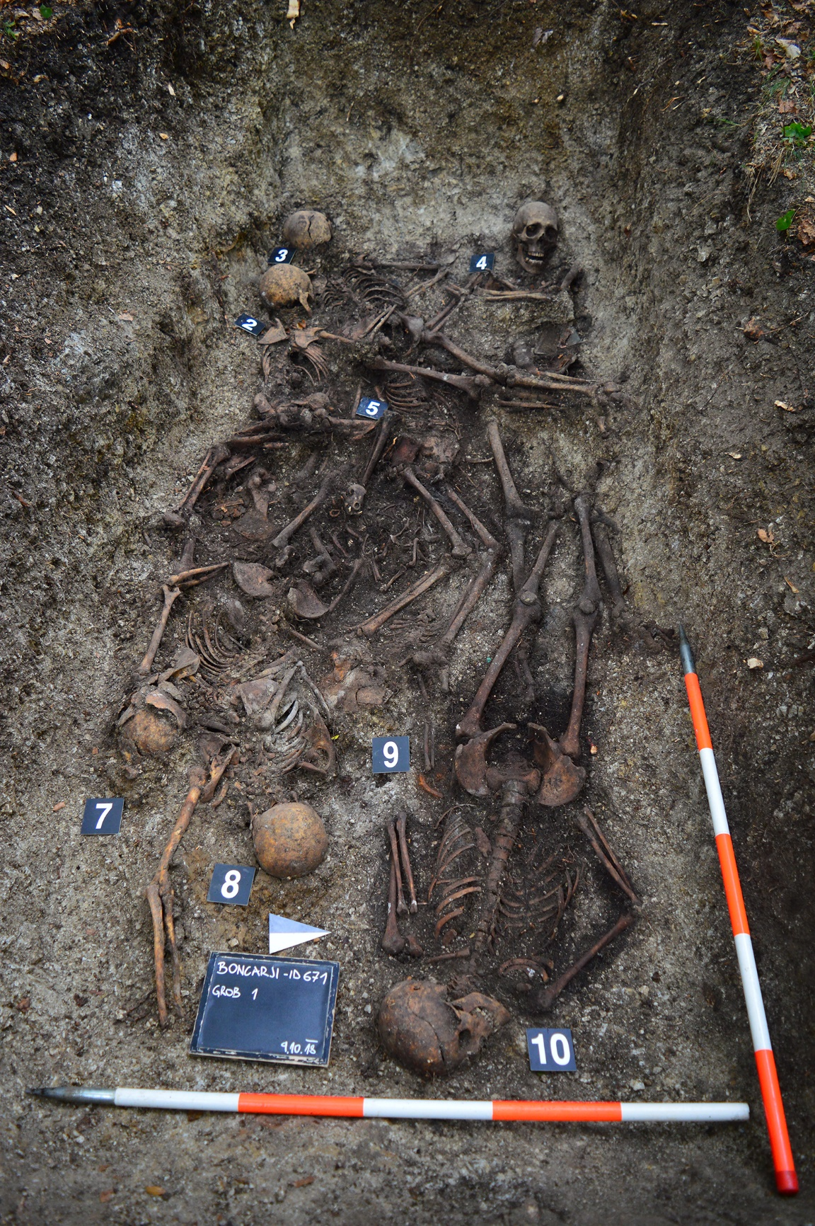
Supplementary Figure S16. Grave no. 1, Boncar.

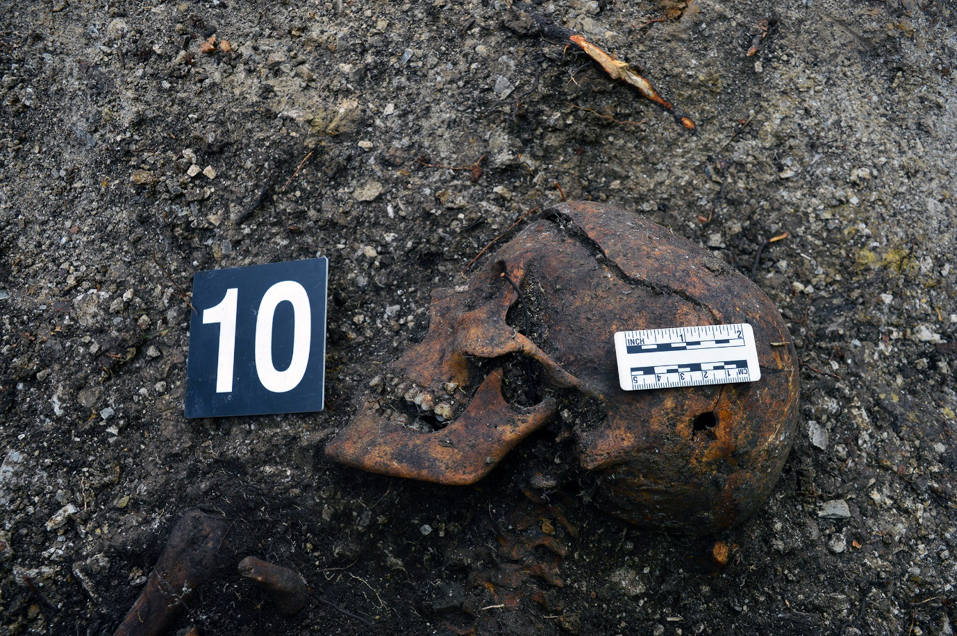
Supplementary Figure S17. Grave no. 1, Boncar: entry bullet wound on os parietale of individual no. 10.

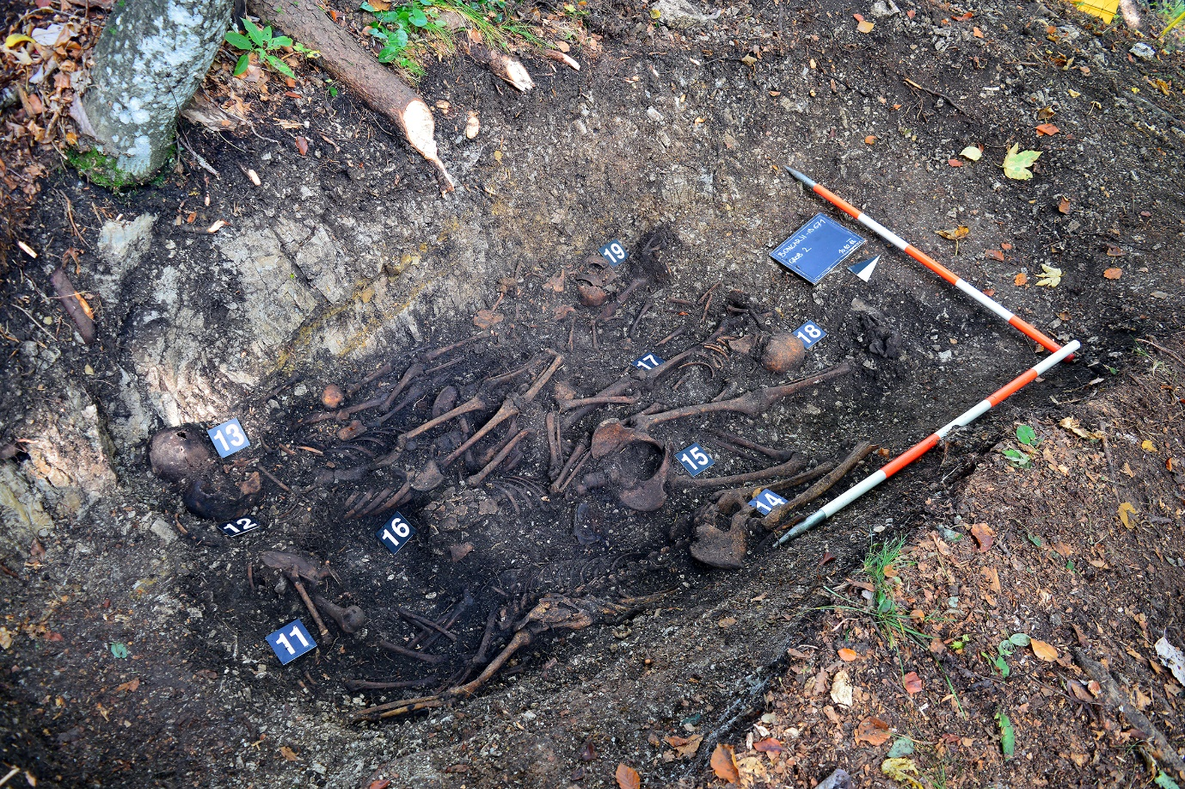Supplementary Figure S18. Grave no. 2, Boncar. Post-war destruction of the remains can be observed between plates numbered 11, 12 and 16.

