Supplementary electronic material:
Table S1: Percentage of different phenotypic classes for ten morphological traits in four regions of Kenya.
 |  |  | % of different phenotypic classes
Trait | Code | Coast |  | Eastern | Turkana | Western
Panicle compactness and shape | 1 | 58.76 |  | 14.30 | 35.30 | 33.33
Panicle compactness and shape | 2 | 5.33 |  | 28.57 | 64.70 | 33.33
Panicle compactness and shape | 3 | 3.84 |  | 0.00 | 0.00 | 0.00
Panicle compactness and shape | 4 | 10.70 |  | 0.00 | 0.00 | 25.01
Panicle compactness and shape | 5 | 21.36 |  | 7.13 | 0.00 | 0.00
Panicle compactness and shape | 6 | 0.00 |  | 50.00 | 0.00 | 8.32
Inflorescence exsertion | 1 | 10.54 |  | 0.00 | 62.50 | 0.00
Inflorescence exsertion | 2 | 15.79 |  | 21.43 | 37.50 | 8.32
Inflorescence exsertion | 3 | 73.67 |  | 78.57 | 0.00 | 91.68
Grain covering | 3 | 0.00 |  | 9.08 | 18.75 | 12.48
Grain covering | 5 | 33.33 |  | 18.21 | 43.74 | 12.48
Grain covering | 7 | 33.33 |  | 36.36 | 37.50 | 50.00
Grain covering | 9 | 33.33 |  | 36.36 | 0.00 | 25.04
Glume hairiness | 1 | 52.63 |  | 42.87 | 52.95 | 91.68
Glume hairiness | 2 | 47.37 |  | 57.13 | 47.05 | 8.32
Glume hair colour | 1 | 15.79 |  | 33.33 | 11.10 | 0.00
Glume hair colour | 3 | 21.04 |  | 0.00 | 0.00 | 0.00
Glume hair colour | 5 | 5.25 |  | 16.69 | 0.00 | 0.00
Glume hair colour | 7 | 0.00 |  | 0.00 | 0.00 | 18.20
Glume hair colour | 9 | 47.37 |  | 33.33 | 77.81 | 63.61
Glume hair colour | 11 | 10.54 |  | 8.32 | 11.10 | 18.20
Glume hair colour | 13 | 0.00 |  | 8.32 | 0.00 | 0.00
Glume colour | 1 | 0.00 |  | 14.30 | 11.78 | 0.00
Glume colour | 2 | 15.80 |  | 7.13 | 17.65 | 8.32
Glume colour | 3 | 36.85 |  | 14.30 | 29.39 | 25.01
Glume colour | 4 | 26.31 |  | 14.30 | 11.78 | 0.00
Glume colour | 5 | 5.25 |  | 0.00 | 0.00 | 8.32
Glume colour | 6 | 15.80 |  | 49.98 | 29.39 | 58.35

Table S1: Cont.
 |  | % of different phenotypic classes
Trait | Code | Coast | Eastern | Turkana | Western
Grain colour | 1 | 0.00 | 0.00 | 11.78 | 0.00
 | 2 | 26.31 | 14.30 | 5.87 | 16.68
 | 3 | 5.25 | 7.13 | 0.00 | 0.00
 | 4 | 68.44 | 78.57 | 82.35 | 66.63
 | 6 | 0.00 | 0.00 | 0.00 | 16.68
Grain plumpness | 1 | 0.00 | 0.00 | 0.00 | 8.32
 | 2 | 100.00 | 100.00 | 100.00 | 91.68
Awn | 1 | 47.37 | 64.30 | 76.48 | 66.67
 | 2 | 52.63 | 35.70 | 23.52 | 33.33
Shattering | 3 | 5.25 | 14.30 | 88.22 | 16.68
 | 5 | 68.44 | 57.10 | 11.78 | 16.68
 | 7 | 26.31 | 14.30 | 0.00 | 33.32
 | 9 | 0.00 | 14.30 | 0.00 | 33.32

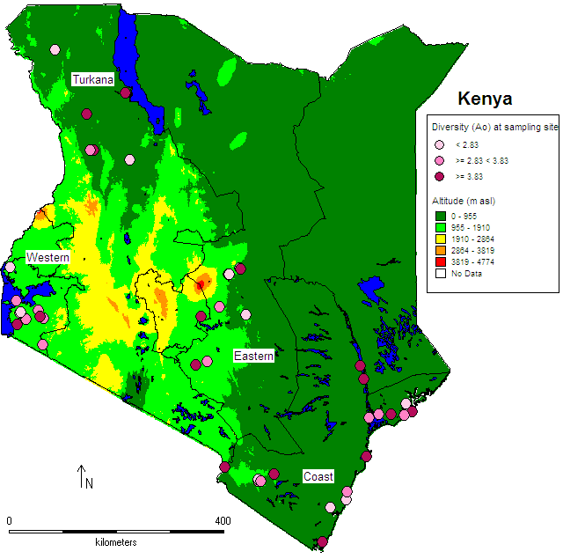
Figure S2: Major growing areas (encircled) of sorghum in Kenya; Allelic diversity of wild sorghum populations at respective sampling sites is given as coloured dots (see legend). Allelic diversity was obtained by genotyping 24 individuals per population using 18 microsatellite markers. Map adopted from Muraya et al. submitted

a
b
c
e
d
f

Figure S3: Distribution of wild sorghum (a) plant height, (b) number of tillers, (c )panicle length, (d) flag leaf length, (e) panicle width and (f) flag leaf width among regions: lines extending from boxes indicate minimum and maximum observations above and below lower and upper bounds, respectively; the boxes indicate 50% of the data values (25th to 75th percentiles) with the plus sign and the horizontal line indicating the mean and median, respectively; and the squares outside the value ranges indicate outliers.

