Supplementary online material

Table S1

Table S2
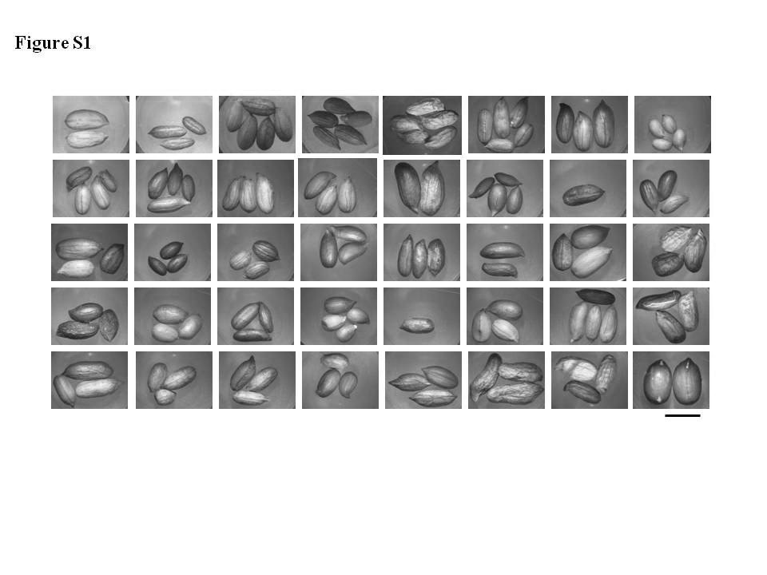
Figure legends

Figure S1 Seed size, shape and testa color from different peanut wild relatives. From left to right, first row from A. appressipila (PI 468153), A. archeri (PI 604843), A. batizocoi (PI 468328), A. benensis (PI 475877), A. burchellii (PI 604854), A. correntina (PI 210554), A. cruziana (PI 476003), and A. dardanoi (Grif 7635); second row from A. decora (Grif 7721), A. diogoi (PI 276235), A. duranensis (PI 468201), A. giacomettii (PI 331189), A. glandulifera (PI 4688343), A. helodes (PI 468144), A. hermannii (PI 604847), and A. hoehnei (Grif 7683); third row from A. ipaensis (PI 468322), A. kretschmeri (Grif 7567), A. kuhlmannii (Grif 7691), A. magna (PI 468337), A. major (PI 468172), A. matiensis (PI 476105), A. monticola (PI 219824), and A. palustris (Grif 7448); fourth row from A. paraguariensis (PI 468176), A. pintoi (PI 604812), A. porphyrocalyx (PI 497577), A. pusilla (PI 497572), A. rigonii (PI 262142), A. seridoensis (Grif 7747), A. simpsonii (Grif 15004), and A. stenophylla (PI 468170); fifth row from A. stenosperma (Grif 7731), A. sylvestris (Grif 7737), A. trinitensis (Grif 14278), A. valida (Grif 7689), A. villosa (Grif 7725), A. villosulicarpa (PI 336895), A. williamsii (Grif 14229), and A. hypogaea (cultivated peanut, PI 370331), respectively. The bar for seed size represents 1 cm.

