Table S1: Characteristics of the fields and farmers per study area in Fig. 1.
Characteristics | Area 1  (10 fields) | Area 2  (9 fields) | Area 3  (9 fields)
Average number of varieties per farmer (field) | 3.9 | 3.1 | 2.4
Average field size (in ha) | 0.3 | 0.4 | 0.8
Average number of sub-plots per field | 4.8 | 4.8 | 4.0
Average age | 48.2 | 47.6 | 48.2
Average number of years spent in the village | 44.1 | 28.8 | 33.2
Average number of people per compound | 8.6 | 11.3 | 19.1
Women with active husband (in %) | 50 | 50 | 100

Table S2: Overview of average pollination rates of rice found by various studies.
Author | pollination rate  (in %) | range  (in %) | # varieties
Lord (1932) | 0.47 | 0.34 - 0.67 | 3
Beachell et al. (1938)¹ | 0.60 | 0.00 - 3.39 | 4
Larter (1950) | 0.48 | 0.35 - 0.92 | 4
Brown (1957) | 0.41 | 0.00 - 1.19 | 4
Roberts et al. (1961) | 0.56 | 0.04 - 1.07 | 1
Reaño and Pham (1998) | 0.25 | 0.00 - 0.50 | 5
Messeguer et al. (2001) | 0.08 | - | 1
Zhang et al. (2003) | 0.55 | 0.33 - 0.76 | 2
Messeguer et al. (2004) | 0.06 | 0.04 - 0.09 | 2
Rong et al. (2004) ¹ | 0.23 | 0.19 - 0.28 | 2
¹ From this study only the percentages are shown for field designs in which the varieties were planted in an equal ratio.
Figure legends

Fig. S1: Location of study villages: A = Tujereng, B = Kitti, C = Faraba, D = Janack, E = Batabut Kantore, F = Sangajor, G = Kartong, H = Jiroff, I = Massembe, J = Damfakunda and K = Sanending; Major cities: 1 = Banjul (Capital), 2 = Bakau, 3 = Serrekunda and 4 = Brikama.

Fig. S2: Photos of the varieties grown in the three areas in Fig. 1.

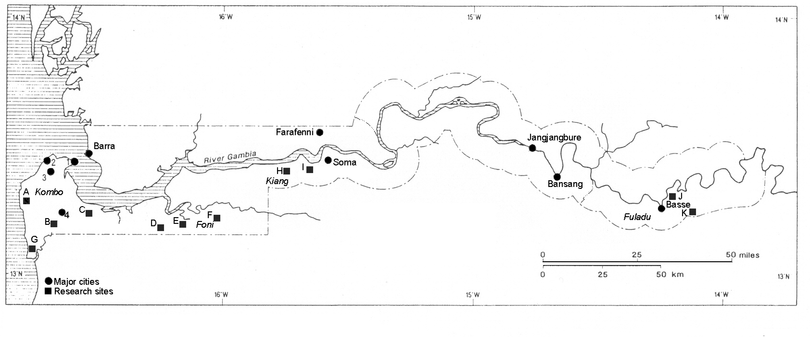
Figure S1
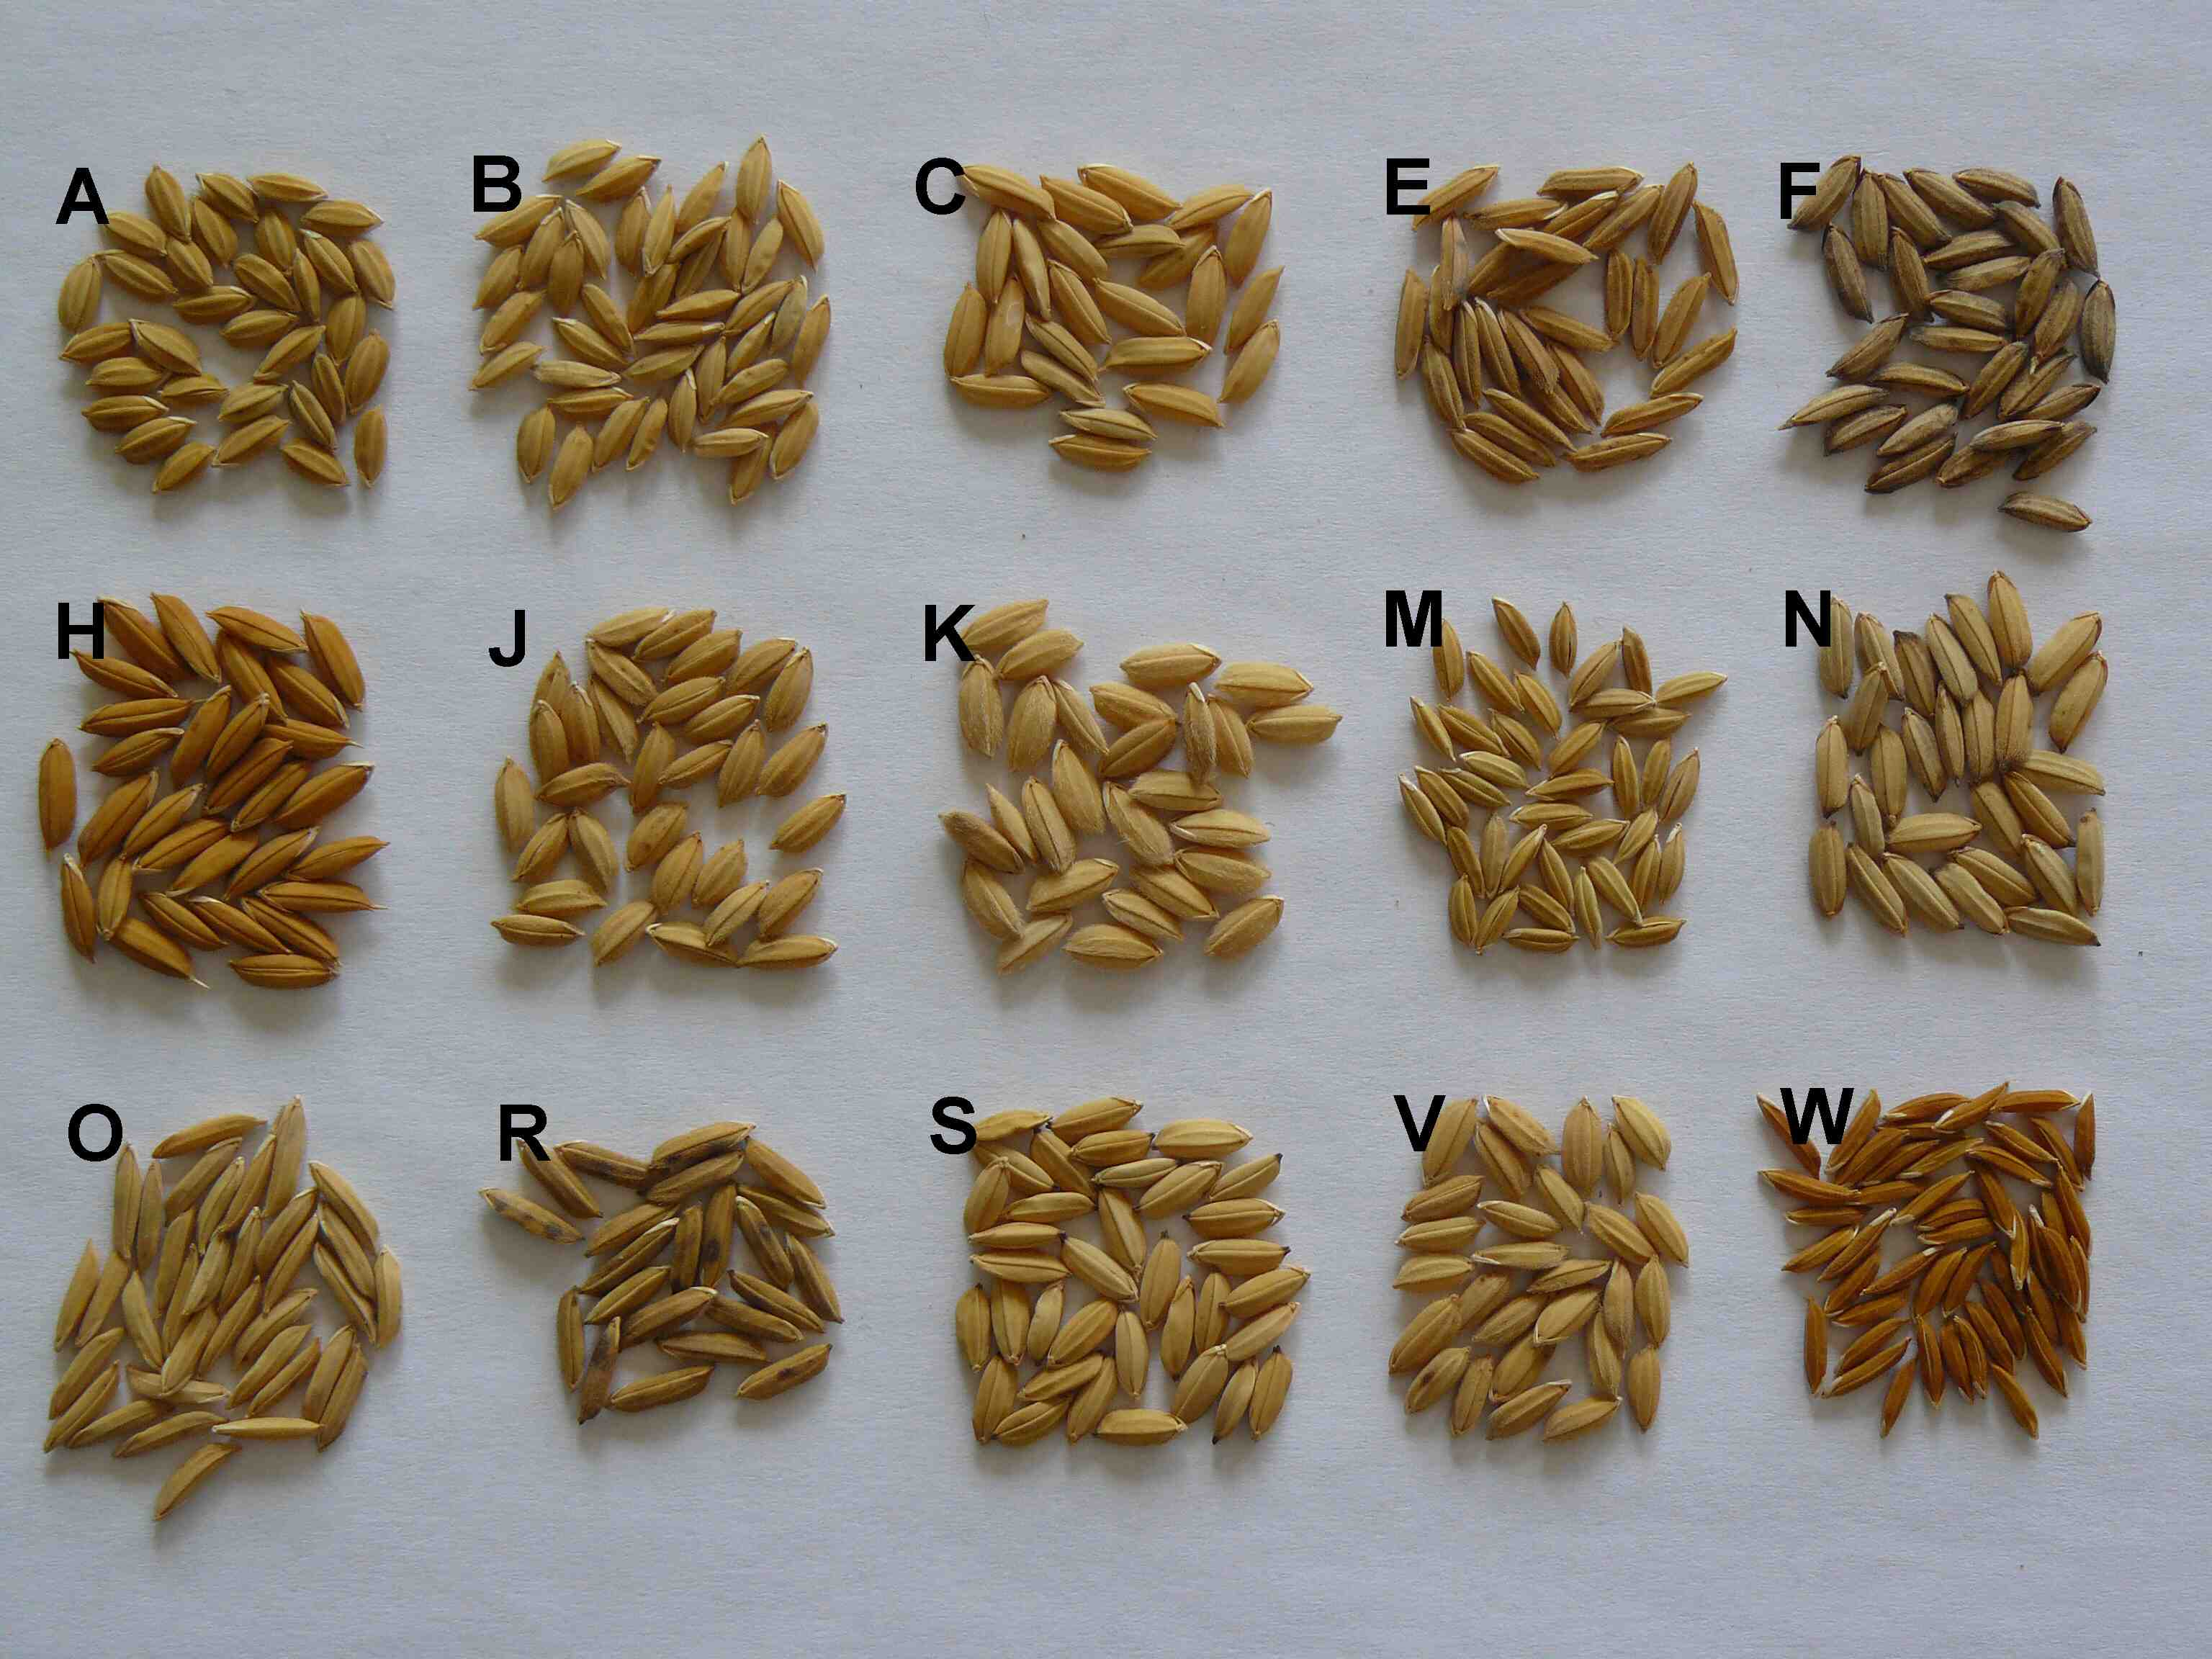

Figure S2

