List of captions for supplementay table and figures

Supplementary table

Table S1. Average values for plant height, heading time, thousand kernel weight (TKW), and grain yield determined for three lines obtained from hybridization of Triticum aestivum cv Chinese Spring (CS) and MxV-nb₁ hexaploid amphiploids. The values are mean of plots raised at two locations (S. Angelo Lodigiano, SAL, and Viterbo, VT) in Italy for two years (2008 and 2009)

Supplementary figures

Figure S1 - Tritìcum turgidum var durum. cv “Modoc” x Dv hybridization that gave rise to the brittle-rachis MxV-b₁ hexaploid amphiploid (2n=6x=42; AABBVV), and later, by spontaneous mutation, to the non-brittle rachis MxV-nb₁ homoploid derivative.

Figure S2 - Wheat introgression breeding lines from the [T. aestivum cv “Chinese Spring”, CS x Dv) x CS] hybridization and backcrossing scheme.

Figure S3 - Synthesis of “new” farro, durums, and bread wheats using the MxV-nb₁ amphiploid as bridge strategy

Figure S4 - Mendelian scheme developed by crossing a powdery mildew susceptible 6V-disomic addition line (CS+6V#1) to a resistant 6V#4-disomic addition line (CSxV63) to study the inheritance of the resistance to Blumeria graminis f.sp. tritici, Puccinia triticina, and P. graminis f.sp. tritici

Figure S5 - Gliadin (a) and glutenin (b) electrophoretic patterns, bread-test (c), and chromosomal configurations for homoeologous groups 1 and 6 (d) of the CS_1BL-1VS wheat introgression breeding line.

Figure S6 - Metaphase plate in the root meristem of a selfed plant from the F₂ of the hybridization Triticum aestivum cv Chinese Spring (CS) and MxV-nb₁ hexaploid amphiploid. DAPI staining (a), GISH using labeled DNA from genome V and blocking DNA from T.aestivum (b), labeled DNA from genome A (T. urartu) and blocking DNA from the B, D, and V genomes (c), and labeled DNA from genome D (Ae. squarrosa) and blocking DNA from T. durum and Dv (d).

Table S1. Average values for plant height, heading time, thousand kernel weight (TKW), and grain yield determined for three inbred breeding lines obtained from hybridization of Triticum aestivum cv Chinese Spring (CS) and MxV-nb₁ hexaploid amphiploids. The values are mean of plots raised at two locations (S. Angelo Lodigiano, SAL, and Viterbo, VT) in Italy for two years (2008 and 2009)

Entry | Plant height (cm) |  | Heading time (Days from April 1st) |  | TKW |  | Grain yield (t ha⁻¹)
Entry | 2008 | 2009 | 2008 | 2009 | 2008 | 2009 | 2008 | 2009
Inbred breeding lines
VT 8-1 | 90 | 72 | 31 | 35 | 43.2 | 43.7 | 6.7 | 5.3
VT 41-3 | 89 | 72 | 32 | 34 | 44.3 | 44.3 | 6.8 | 5.0
VT Mut 3-04 | 87 | 72 | 31 | 35 | 44.2 | 44.5 | 6.7 | 4.9
Control
Bologna | 83 | 71 | 38 | 40 | 32.0 | 29.7 | 6.8 | 5.3
PR22R58 | 79 | 68 | 38 | 41 | 39.4 | 33.1 | 7.9 | 5.7
Summary statistics
MEAN | 84 | 71 | 34 | 38 | 38.5 | 36.5 | 6.4 | 5.5
LSD | 4.4 | ns | 0.4 | 4.5 | 2.10 | 8.86 | 0.13 | ns
StEr | 9.2 | 9.8 | 0.9 | 1.4 | 4.38 | 2.72 | 0.26 | 1.29
CV | 5.0 | 19.5 | 2.2 | 5.1 | 6.47 | 10.50 | 5.76 | 33.60

Figure S1

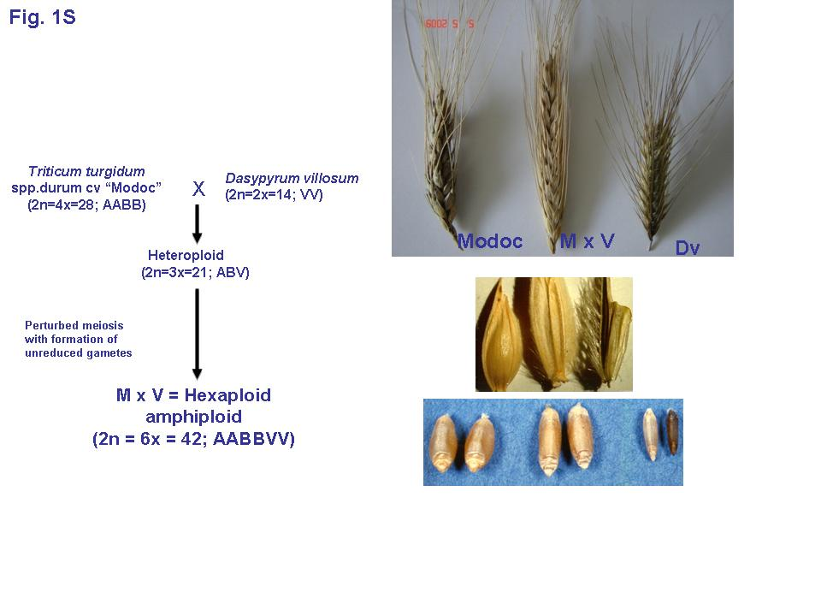

Figure S2

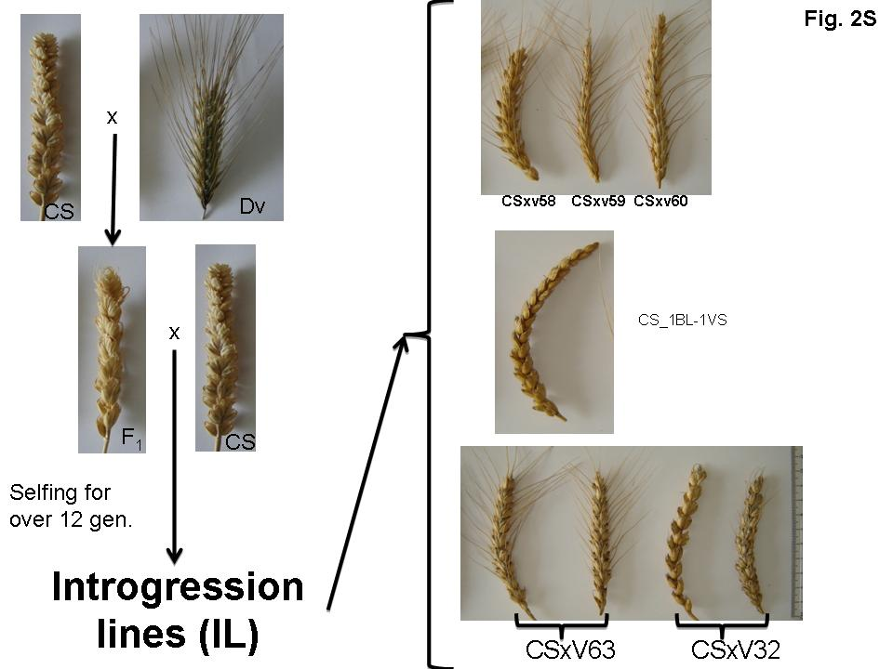

Figure S3

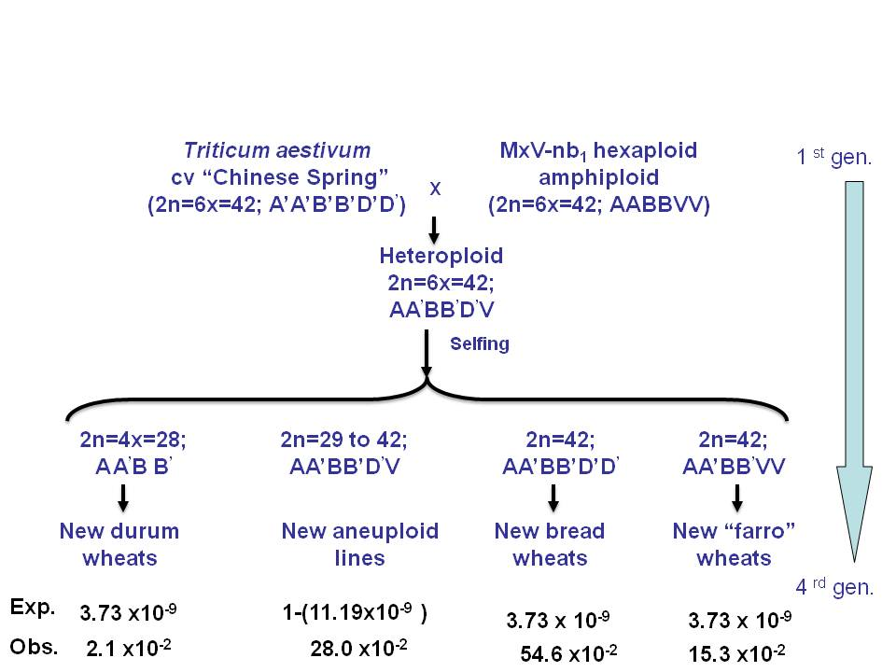

Figure S4

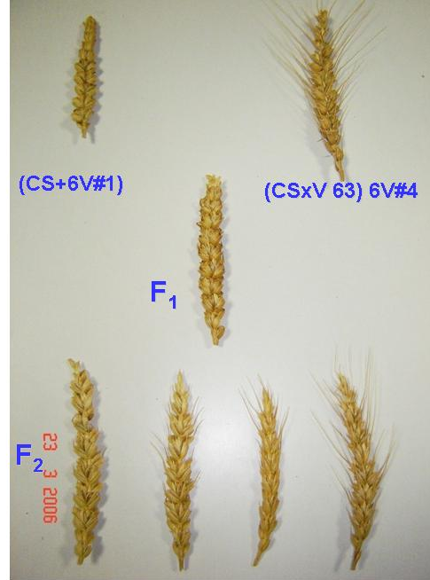

Figure S5

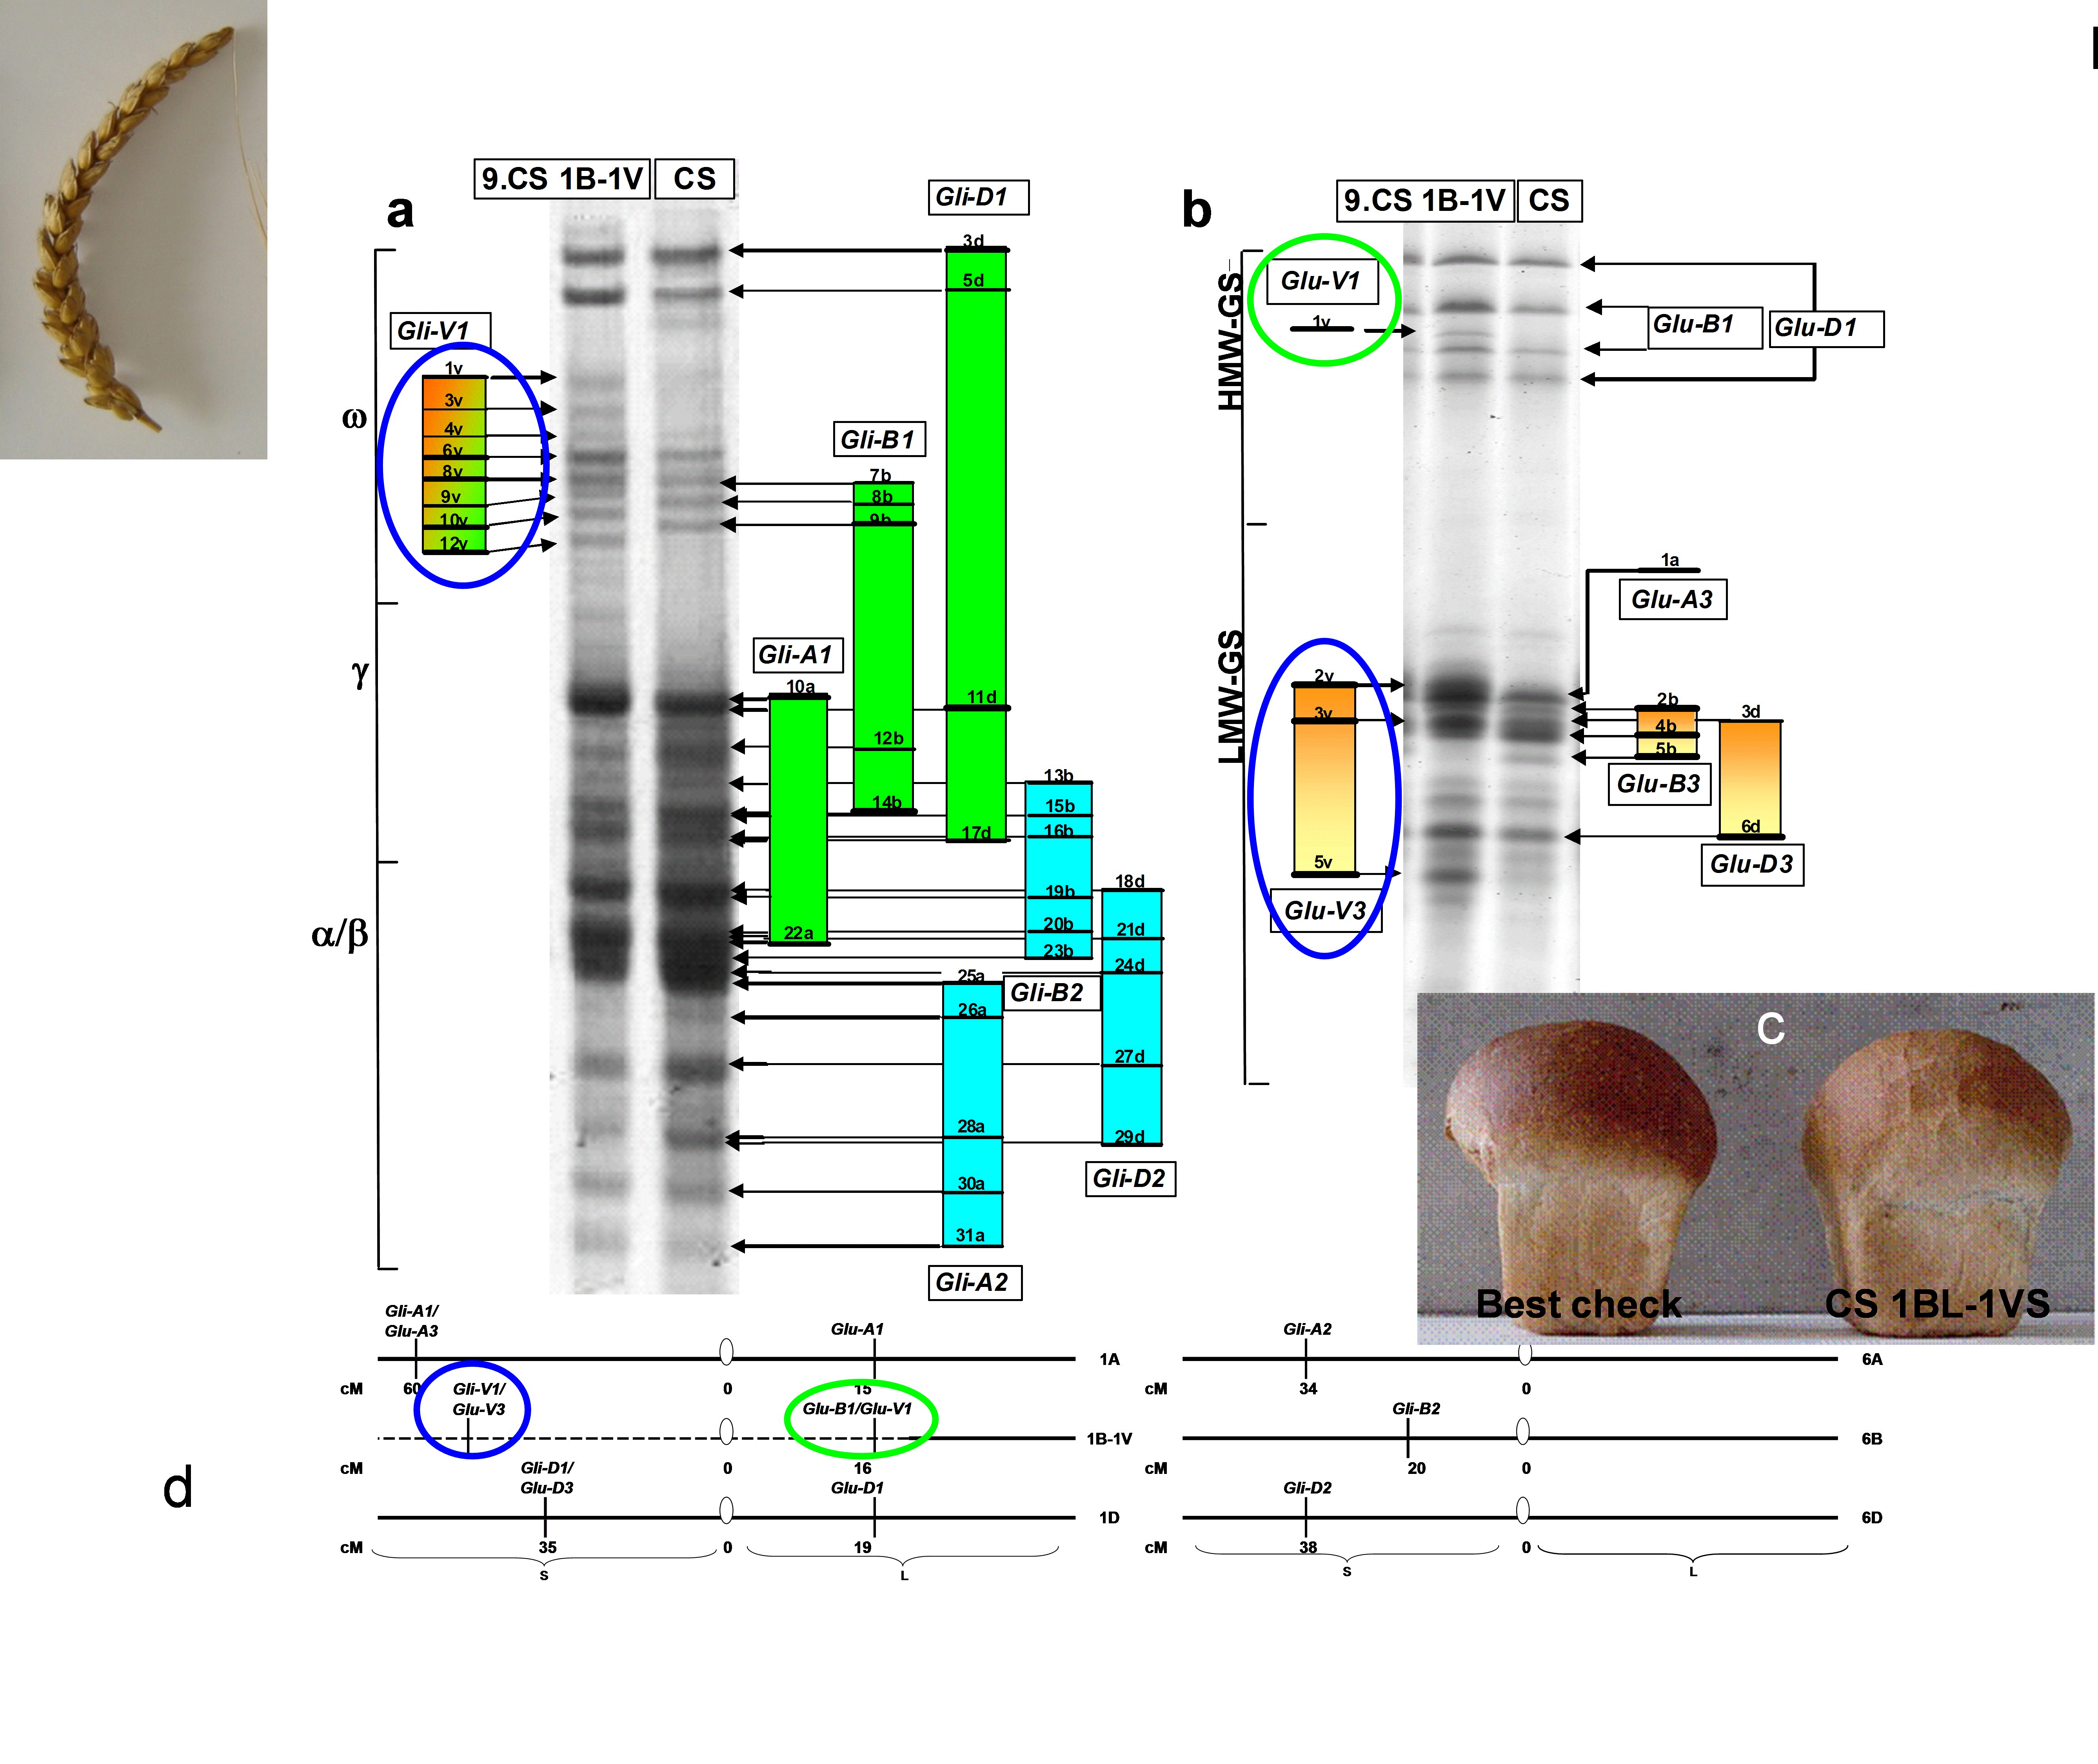

Figure S6

