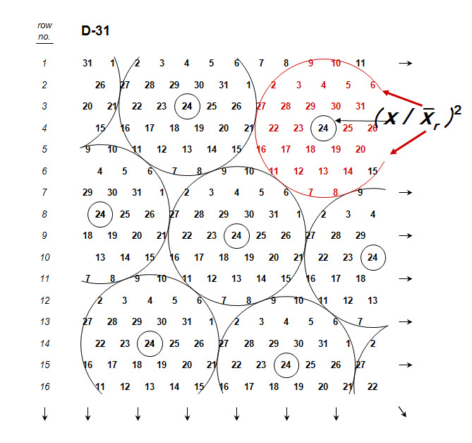

Figure S1. When a number of entries (in this case, 31) are laid in the field into moving complete blocks (MCB), each plant occupies the center of a circular complete block including all the remaining entries (Fasoula, 2008). The number of MCBs equals the number of plants in the trial and the yield of each plant is expressed as a ratio to the average yield of the surrounding plants included within a ring forming a complete moving replicate.

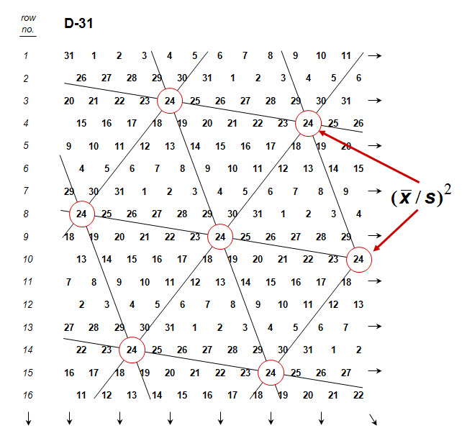

Figure S2. In the MCB designs, the equidistant plants of each entry are allocated in the corners of a triangular grid pattern across the whole field, insuring comparable growing conditions for both the entries and the plants within entries (Fasoula, 2008). Because the entries are allocated evenly over the whole field, this pattern samples soil heterogeneity more effectively compared to the random allocation.

