Table S1. Computational tools used for phylogenetic and molecular evolutionary analyses, sequences analyses, identification of repeats and palindromes, as well as secondary structure prediction/ modelling.

Phylogenetic analyses | MEGA version 4 | Tamura et al., 2007
Phylogenetic analyses | DNAsp | Rozas et al., 2003
Phylogenetic analyses | Arlequin version 3.1 | Excoffier et al., 2005
Phylogenetic analyses | SplitsTree | Huson and Bryant, 2006
Sequence analyses | EINVERTED | EMBOSS web site
Sequence analyses | Palindrome | EMBOSS web site
Sequence analyses | REPuter | http://bibiserv.techfak.uni-bielefeld.de/reputer/submission.html  Kurtz et al., 2001
Sequence analyses | Tandem Repeat Finder | http://tandem.bu.edu/trf/trf.html  Benson, 1999
Sequence analyses | CENSOR | http://www.girinst.org/censor/index.php  Kohany et al., 2006
Sequence analyses | TREP (Triticeae Repeat Sequence Database) | http://wheat.pw.usda.gov/ITMI/Repeats/blastrepeats3.html
Sequence analyses | CpG | EMBOSS web site
Modelling | MFOLD | http://frontend.bioinfo.rpi.edu/applications/mfold/cgi-bin/rna-form1.cgi
Modelling | Geno3D | http://pbil.ibcp.fr/htm/index.php
Modelling | SSM server | http://www.ebi.ac.uk/msd-srv/ssm/cgi-bin/ssmserver

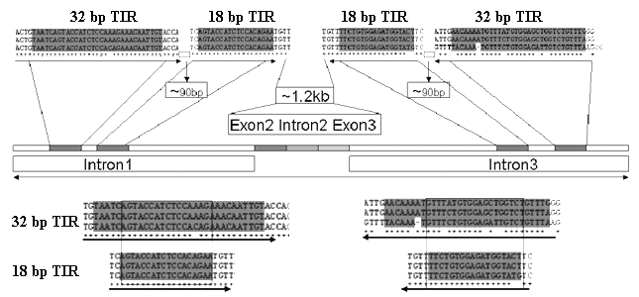
Figure S1. Schematic diagram showing organization of TIRs in the three AsDRF1 genes.
The alignments between TIR-18 bp and TIR-32 bp are shown below.

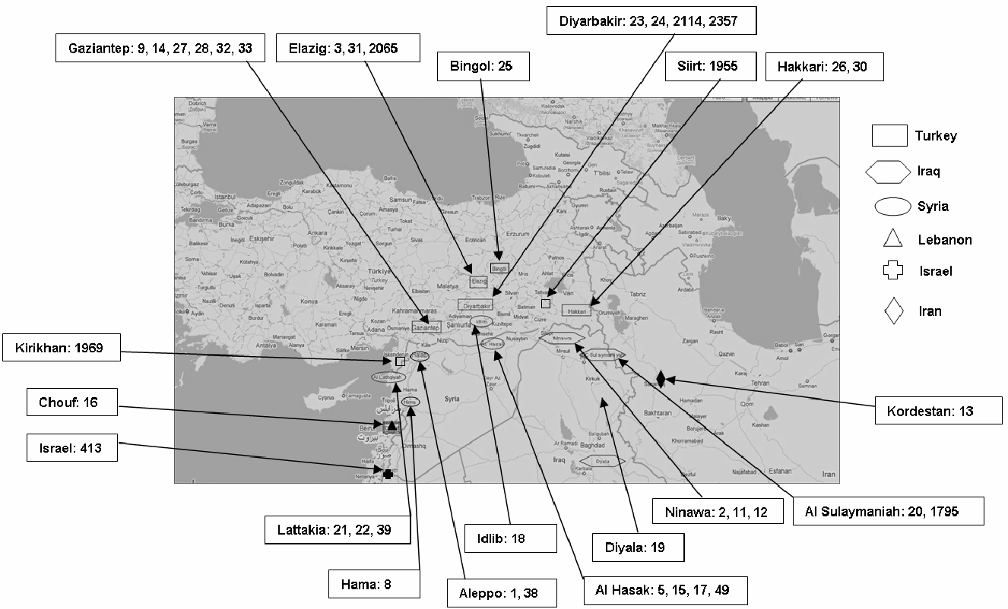
Figure S2. Map of Aegilops speltoides sampling locations. The respective countries are indicated.

