Fig. S1 Male spadices of Pandanus species from Southern India: A, P. kaida; B, P. furcatus; C, P. odorifer; D, P. palakkadensis; E, P. canaranus and F, P. thwaitesii
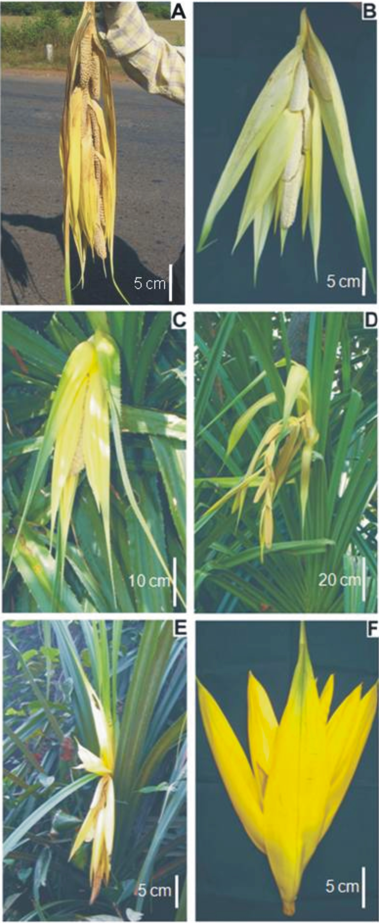

Table S1. Geographical information for the Pandanus species collected in Southern India
Species | State | Locality | Longitude (⁰E) | Latitude (⁰N) | Elevation above mean sea level (m)
P. furcatus | Maharashtra | Kudal | 73⁰ 42’ 39 | 16⁰ 05’ 92 | 17
P. kaida | Karnataka | Bhatkal | 74⁰ 30’ 28 | 14⁰ 04’ 09 | 1
P. canaranus | Karnataka | Udupi | 74⁰ 52’ 88 | 13º 21’ 90 | 1
P. thwaitesii | Karnataka | Udupi | 74⁰ 54’ 58 | 12⁰ 23’ 44 | 39
P. foetidus | Karnataka | Shimoga | 75⁰ 05’ 26 | 13⁰ 30’ 07 | 663
P. odorifer | Kerala | Trivandrum | 76⁰ 53’ 39 | 08⁰ 30’ 38 | 0
P. palakkadensis | Kerala | Palakkad | 76⁰ 36’ 94 | 10⁰ 47’ 95 | 63

Table S2. Flowering months of Pandanus species in Southern India
Name of species | Flowering months
Name of species | Jan. | Feb. | March | April | May | June | July | Aug. | Sept. | Oct. | Nov. | Dec.
P. kaida
P. tectorius
P. canaranus
P. furcatus
P. palakkadensis
P. thwaitesii
P. foetidus

Table S3. General uses of Pandanus species in Southern India
Species | Plant parts used | Uses
P. kaida | Whole plant | Hedge*, water filter and purification (Melvani, 2005); soil binder*
P. kaida | Leaf | Weaving mats and baskets*
P. kaida | Flower | Floral bracts kept along with cloths to impart the fragrance*
P. tectorius | Whole plant | Wind breaks (Tanaka et. al., 2007; 2009; Thuy et. al., 2009); hedge*, plant extract possess diuretic activity (Keller, 2001)
P. tectorius | Leaf | Weaving mats and baskets, leaf buds used as vegetable, folk medicine* (Keller, 2001); leaves used in curing leprosy, syphilis, smallpox, scabies, leucoderma, diseases of the heart and brain (Anonymous, 1966)
P. tectorius | Staminate flower | Anthers used against headache*, earache and blood diseases, spadix juice to cure rheumatic arthritis in animals (Anonymous, 1966); commercial Kewda oil production (Keller, 2001; Raina, 2004); aromatic oil from bract stimulant, antispasmodic and used in rheumatism (Anonymous, 1966); flowers offered to gods*
P. tectorius | Fruit | Food stuff* (Keller, 2001)
P. tectorius | Root | Used in folk medicine* (Keller, 2001)
P. canaranus | Whole plant | Hedge plant and soil binder*
P. canaranus | Leaf | Weaving mats and baskets*
P. canaranus | Fruit | Food stuff*
P. furcatus | Whole plant | Hedge plant and soil binder*
P. furcatus | Stem | Floats and fishing nets* (Keller, 2001)
P. furcatus | Leaf | Weaving mats and baskets* and as a remedy for snake bite (Keller, 2001)
P. furcatus | Fruit | Food stuff*
P. palakkadensis | Whole plant | Hedge plant *
P. thwaitesii | Leaf | Weaving mats, brushes and diverse domestic articles* (Keller, 2001)
P. thwaitesii | Flower | bracts offered to god, floral bracts kept along with cloths to impart the fragrance *
P. thwaitesii | Fruit | Fruit pulp is edible (Keller, 2001; Umapathy and Kumar 2000)
P. foetidus | Whole plant | hedge plant (Prain, 1963; Bennet, 1979)
P. foetidus | Leaf | The fiber from the leaves are used for nets, brushes*
P. foetidus | Fruit | edible*
* Based on personal observation and information collected from local people, tribals and farmers.

