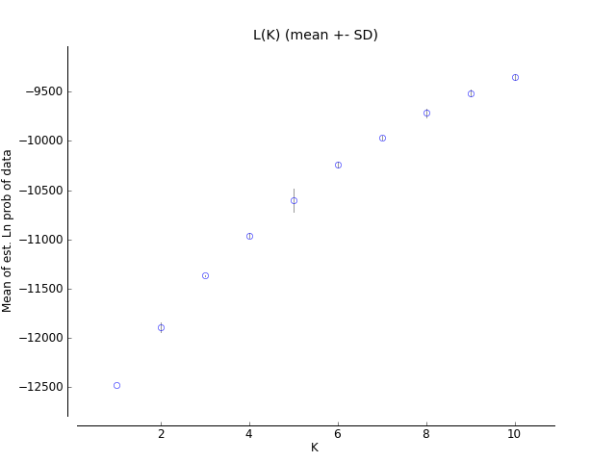
A

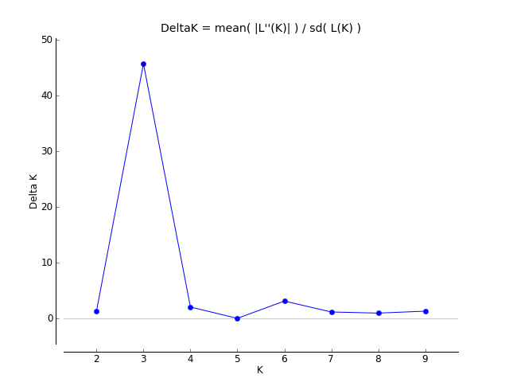
B

Fig. S1. Two different methods for determining optimal value of K: A. the ad hoc procedure described by Pritchard et al. (2000); B. the second order statistics (ΔK) developed by Evanno et al. (2005), for POPI.

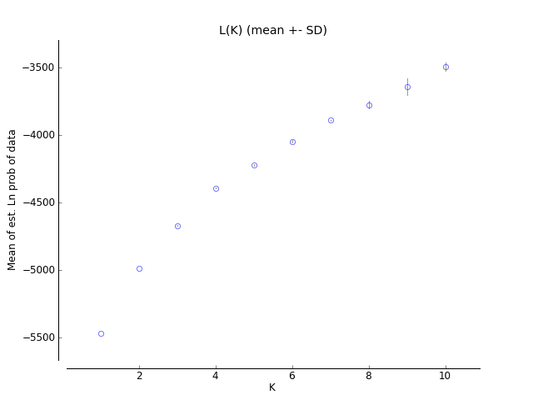
A

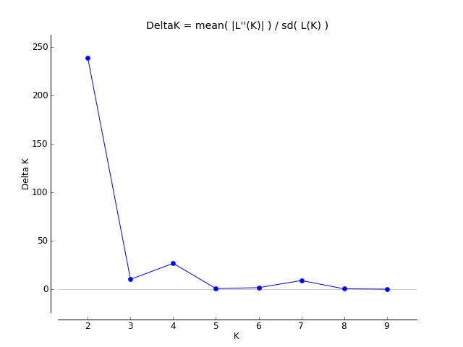
B

Fig. S2 Two different methods for determining optimal value of K: A. the ad hoc procedure described by Pritchard et al. (2000); B. the second order statistics (ΔK) developed by Evanno et al. (2005), for POPII.
Table S1. List of S. pimpinellifolium accessions used in this study, their country of origin and population

NO. | AVRDC ACCESSION NO. | DONOR CODE | COUNTRY OF ORIGIN | POPULATION
1 | VI005553 | LA 1261 SAM 343-1 | Ecuador | admixed
2 | VI005554 | LA 1263 SAL 345 | Ecuador | popII b
3 | VI005572 | LA 1382 SAL 466 | Peru | admixed
4 | VI005575 | LA 1416 SAL 504 | Ecuador | admixed
5 | VI005591 | LA 1466 | Peru | popII b
6 | VI005596 | LA 369 | Peru | popII b
7 | VI005797 | PI 79532; LA2348 | Peru | POPI C
8 | VI005879 | PI 110595 | United Kingdom | admixed
9 | VI005998 | PI 124039 | Peru | PopI admixed
10 | VI006035 | PI 126430 | Peru | admixed
11 | VI006037 | PI 126432 | Peru | POPI C
12 | VI006038 | PI 126433 | Peru | admixed
13 | VI006041 | PI 126436 | Peru | POPI C
14 | VI006072 | PI 126924 | Peru | POPI C
15 | VI006073 | PI 126925 | Peru | POPI C
16 | VI006075 | PI 126927 | Peru | PopI admixed
17 | VI006081 | PI 126933 | Peru | admixed
18 | VI006082 | PI 126934 | Peru | PopI admixed
19 | VI006084 | PI 126936 | Peru | PopI admixed
20 | VI006085 | PI 126937 | Peru | admixed
21 | VI006087 | PI 126939 | Peru | admixed
22 | VI006089 | PI 126941 | Peru | admixed
23ª | VI006090 | PI 126942 | Peru | popII b
24 | VI006095 | PI 126947 | Peru | admixed
25 | VI006100 | PI 126952 | Peru | admixed
26 | VI006101 | PI 126953 | Peru | admixed
27 | VI006102 | PI 126954 | Peru | PopI admixed
28 | VI006117 | PI 127805 | Peru | popII b
29 | VI006118 | PI 127806 | Peru | admixed
30 | VI006119 | PI 127807 | Peru | admixed
31 | VI006144 | PI 127833 | Peru | admixed
32 | VI006357 | PI 129062 | Colombia | popII b

NO. | AVRDC ACCESSION NO. | DONOR CODE | COUNTRY OF ORIGIN | POPULATION
33^{b} | VI006466 | PI 133542 | Ecuador | popII b
34 | VI006535 | PI 143524 | Peru | admixed
35 | VI006536 | PI 143527 | Peru | PopI admixed
36^{c} | VI006811 | PI 193408 | USA? | PopI admixed
37 | VI006934 | PI 205009 | USA | admixed
38 | VI006993 | PI 211838 | Peru | PopI admixed
39 | VI006994 | PI 211839 | Peru | PopI admixed
40 | VI006995 | PI 211840 | Peru | PopI admixed
41 | VI007001 | PI 212408 | Peru | PopI admixed
42 | VI007002 | PI 212409 | Venezuela | PopI admixed
43^{c} | VI007032 | PI 212441 | USA? | POPI A
44 ^{c} | VI007033 | PI 212442 | USA? | POPI A
45 ^{c} | VI007034 | PI 212443 | USA? | POPI A
46 ^{c} | VI007035 | PI 212444 | USA? | POPI A
47 ^{c} | VI007036 | PI 212445 | USA? | admixed
48 | VI007090 | PI 224709 | Mexico | popII b
49 | VI007091 | PI 224710 | Mexico | popII b
50 | VI007097 | PI 230327 | Ecuador | popII b
51 | VI007159 | PI 251315; LA0381 | Peru | admixed
52 | VI007160 | PI 251316; LA0384 | Peru | PopI admixed
53 | VI007161 | PI 251317; LA0397 | Peru | admixed
54 | VI007162 | PI 251318; LA0400 | Peru | POPI B
55 | VI007163 | PI 251319; LA0411 | Ecuador | popII b
56 | VI007164 | PI 251320; LA0412 | Ecuador | admixed
57 | VI007165 | PI 251321; LA0413 | Ecuador | admixed
58 | VI007167 |  | Ecuador | popII b
59 | VI007326 | PI 263589 | Mexico | popII b
60 | VI007510 | PI 270439 | Mexico | popII admixED
61 | VI007511 | PI 270440 | Mexico | popII admixED
62 | VI007512 | PI 270441 | Mexico | POPII A
63 | VI007513 | PI 270442 | Mexico | POPII A
64 | VI007514 | PI 270443 | Mexico | POPII A

NO. | AVRDC ACCESSION NO. | DONOR CODE | COUNTRY OF ORIGIN | POPULATION
65 | VI007515 | PI 270444 | Mexico | POPII A
66 | VI007516 | PI 270445 | Mexico | POPII A
67 | VI007517 | PI 270446 | Mexico | POPII A
68 | VI007518 | PI 270447 | Mexico | POPII A
69 | VI007519 | PI 270448 | Mexico | POPII A
70 | VI007520 | PI 270449 | Mexico | POPII A
71 | VI007521 | PI 270450 | Mexico | POPII A
72 | VI007522 | PI 270451 | Mexico | POPII A
73 | VI007523 | PI 270452 | Mexico | POPII A
74 | VI007524 | PI 270453 | Mexico | POPII A
75 | VI008092 | PI 274174 | Mexico | popII admixED
76 | VI008107 | PI 279373 | Guatemala | popII admixED
77 | VI008705 | PI 313943; LA1993 | Peru | PopI admixed
78 | VI009082 | PI 365906; LA1255 | Ecuador | admixed
79 | VI009083 | PI 365909; LA1236 | Ecuador | popII admixED
80 | VI009085 | PI 365912; LA1246 | Ecuador | admixed
81 | VI009087 | PI 365914; LA1259 | Ecuador | admixed
82 | VI009088 | PI 365915; LA1260 | Ecuador | admixed
83 | VI009089 | PI 365916; LA1261 | Ecuador | admixed
84 | VI009090 | PI 365917; LA1262 | Ecuador | admixed
85 | VI009091 | PI 365918; LA1263 | Ecuador | admixed
86ª | VI009093 | PI 365921 | Peru | popII admixED
87 | VI009103 |  | Unknown | admixed
88 | VI009104 | PI 365957; LA1269 | Peru | POPI C
89 | VI009105 | PI 365959; LA1335 | Peru | PopI admixed
90 | VI009106 | PI 365960; LA1342 | Peru | PopI admixed
91 | VI009107 | PI 365961; LA1343 | Peru | PopI admixed
92 | VI009108 | PI 365962; LA1344 | Peru | PopI admixed
93 | VI009109 | PI 365963; LA1349 | Peru | PopI admixed
94 | VI009110 | PI 365965; LA1357 | Peru | PopI admixed
95 | VI009111 | PI 365966; LA1359 | Peru | admixed
96 | VI009112 | PI 365967; LA1375 | Peru | POPI A

NO. | AVRDC ACCESSION NO. | DONOR CODE | COUNTRY OF ORIGIN | POPULATION
97 | VI009550 | LA 1589 | Peru | PopI admixed
98 | VI009619 | PI 379019; LA1279 | Peru | POPI C
99 | VI009620 | PI 379020; LA1341 | Peru | POPI C
100 | VI009621 | PI 379021; LA1345 | Peru | POPI C
101 | VI009622 | PI 379022; LA1348 | Peru | POPI C
102 | VI009623 | PI 379023; LA1370 | Peru | POPI C
103 | VI009624 | PI 379024; LA1371 | Peru | POPI C
104 | VI009625 | PI 379025; LA1374 | Peru | POPI C
105 | VI009771 | PI 390704 | Peru | PopI admixed
106 | VI010049 |  | Indonesia | popII b
107 | VI030545 | BL 358 | Mexico | popII b
108 | VI030546 | BL 359 | Mexico | popII b
109 | VI030547 | BL 360 | Mexico | popII b
110 | VI030548 | BL 361 | Mexico | PopI admixed
111 | VI030304 | BL 115; PI 422397 | Ecuador | popII b
112 | VI030378 | LA 121; BL 189 | Peru | PopI admixed
113 | VI030392 | BL 203; PI 306216 | Argentina | PopI admixed
114 | VI030394 | BL 205; PI 112215 | Ecuador | admixed
116* | VI037236* | LA 373 | Peru | PopI admixed
117 | VI037264 | LA 0114 | Peru | POPI B
118* | VI037265* | LA 400 | Peru | POPI B
119* | VI037266* | LA 411 | Ecuador | PopI admixed
120* | VI037267* | LA 417 | Ecuador | popII b
121* | VI037268* | LA 442 | Peru | PopI admixed
122* | VI037269* | LA 1237 | Ecuador | popII b
123* | VI037270* | LA 1245 | Ecuador | admixed
124* | VI037271* | LA 1246 | Ecuador | POPI B
125* | VI037272* | LA 1261 | Ecuador | PopI admixed
126* | VI037273* | LA 1279 | Peru | admixed
127* | VI037274* | LA 1301 | Peru | POPI A
128* | VI037275* | LA 1335 | Peru | PopI admixed
129* | VI037276* | LA 1371 | Peru | PopI admixed

NO. | AVRDC ACCESSION NO. | DONOR CODE | COUNTRY OF ORIGIN | POPULATION
130* | VI037277* | LA 1375 | Peru | PopI admixed
131* | VI037278* | LA 1478 | Peru | PopI admixed
132* | VI037279* | LA 1521 | Peru | POPI A
133* | VI037280* | LA 1547 | Ecuador | admixed
134* | VI037281* | LA 1576 | Peru | POPI A
135* | VI037282* | LA 1578 | Peru | PopI admixed
136* | VI037283* | LA 1582 | Peru | PopI admixed
137* | VI037284* | LA 1584 | Peru | PopI admixed
138* | VI037285* | LA 1586 | Peru | Popi admixed
139* | VI037286* | LA 1590 | Peru | PopI admixed
140* | VI037287* | LA 1593 | Peru | PopI admixed
141* | VI037288* | LA 1599 | Peru | PopI admixed
142* | VI037289* | LA 1602 | Peru | PopI admixed
143* | VI037290* | LA 1606 | Peru | admixed
144* | VI037292* | LA 1659 | Peru | PopI admixed
145* | VI037293* | LA 2102 | Ecuador | admixed
146* | VI037973* | LA 2183 | Peru | PopI admixed
147* | VI037974* | LA 2401 | Peru | PopI admixed
148* | VI037975* | LA 2533 | Peru | PopI admixed
149 | VI046131 |  | Laos | popII b
150* | VI037972* | LA 2181 | Peru | PopI admixed
151 | VI008476 | PI 303662 | Ecuador | popII b
152 | VI008674 | PI 309907 | Guatemala | popII b
153 | VI008872 | PI 340905 | Canada | admixed
154^{c} | VI008918 | PI 344102; | USA? | POPI A
155 ^{c} | VI008919 | PI 344103 | USA? | POPI A
156 | VI008942 | PI 346340 | Peru | PopI admixed
158 | VI009215 | PI 370093 | Canada | admixed
159 | VI009403 |  | Japan | popII b
160 | VI009450 |  | Panama | popII b
161 | VI009461 | LL 133 | Mexico | popII b
162 | VI009462 | LL 134 | Mexico | popII b

NO. | AVRDC ACCESSION NO. | DONOR CODE | COUNTRY OF ORIGIN | POPULATION
163 | VI009463 | LL 135 | Mexico | popII b
164 | VI009542 | LA 1577 | Peru | popII b
165 | VI009543 | LA 1581 | Peru | POPI B
166 | VI009545 | LA 1583 | Peru | PopI admixed
167 | VI009546 | LA 1585 | Peru | PopI admixed
168 | VI009548 | LA 1587 | Peru | POPI B
169 | VI009549 | LA 1588 | Peru | POPI B
170 | VI009551 | LA 1591 | Peru | PopI admixed
171 | VI009626 | PI 379026; LA1380 | Peru | PopI admixed
172 | VI009627 | PI 379027; LA1383 | Peru | POPI B
173 | VI009628 | PI 379028; LA1384 | Peru | PopI admixed
174 | VI009649 | PI 379057 | Ecuador | popII b
175 | VI009650 | PI 379058; LA1247 | Ecuador | admixed
176 | VI009651 | PI 379059; LA1258 | Ecuador | admixed
177 | VI009757 | PI 390688 | Peru | POPI B
178 | VI009758 | PI 390689 | Peru | POPI B
179 | VI009759 | PI 390692 | Peru | POPI B
180 | VI009760 | PI 390693 | Peru | POPI B
181 | VI009761 | PI 390694 | Peru | POPI B
182 | VI009762 | PI 390695 | Peru | POPI B
183 | VI009763 | PI 390696 | Peru | POPI B
184 | VI009764 | PI 390697 | Peru | POPI B
185 | VI009765 | PI 390698 | Peru | POPI B
186 | VI009766 | PI 390699 | Peru | POPI B
187 | VI009767 | PI 390700 | Peru | POPI B
188 | VI009768 | PI 390701 | Peru | PopI admixed
189 | VI009769 | PI 390702 | Peru | PoPI admixed
190 | VI009770 | PI 390703 | Peru | PopI admixed
191 | VI009772 | PI 390705 | Peru | PopI admixed
192 | VI009773 | PI 390706 | Peru | PopI admixed

*TGRC S. pimpinellifolium core; Accessions in bold selected as core set from current study
ªClassified as S. lycopersicum var. cerasiforme in GRIN and AVGRIS databases
^{b}Pedigree: S. lycopersicum x S. pimpinellifolium according to GRIN database
^{c}Origin USA is questionable; material was donated from US source; no collecting information available
Table S2. List of 48 SSR markers in positional order and their basic statistics across the 190 accessions of a S. pimpinellifolium germplasm panel
Marker | Chrom osome | Position  (cM)* | Major  Allele Freq | Genotype No | Allele No. | Gene Diversity (He) | Hetero-zygosity (Ho) | PIC
92 | 1 | 0 | 0.46 | 7 | 6 | 0.68 | 0.01 | 0.63
61 | 1 | 33.0 | 0.42 | 4 | 4 | 0.71 | 0.00 | 0.66
134 | 1 | 43.3 | 0.38 | 12 | 12 | 0.77 | 0.00 | 0.74
75 | 1 | 53.5 | 0.33 | 24 | 9 | 0.81 | 0.13 | 0.78
222 | 1 | 97.5 | 0.33 | 8 | 6 | 0.71 | 0.05 | 0.65
346 | 1 | 125.0 | 0.79 | 3 | 3 | 0.34 | 0.00 | 0.29
595 | 1 | 147.0 | 0.52 | 6 | 6 | 0.66 | 0.00 | 0.61
Tom11 | 2 | 3.0 | 0.53 | 5 | 5 | 0.63 | 0.00 | 0.58
66 | 2 | 25.0 | 0.47 | 12 | 7 | 0.66 | 0.07 | 0.60
356 | 2 | 44.0 | 0.33 | 9 | 9 | 0.81 | 0.00 | 0.79
331 | 2 | 78.0 | 0.30 | 13 | 7 | 0.80 | 0.06 | 0.77
125 | 2 | 110 | 0.49 | 4 | 4 | 0.54 | 0.08 | 0.44
86 | 3 | 50 | 0.43 | 4 | 4 | 0.64 | 0.00 | 0.56
111 | 3 | 73.9 | 0.41 | 9 | 5 | 0.71 | 0.03 | 0.66
22 | 3 | 99.0 | 0.37 | 9 | 5 | 0.71 | 0.04 | 0.65
14 | 3 | 162.5 | 0.18 | 22 | 12 | 0.88 | 0.08 | 0.87
300 | 3 | 166.0 | 0.42 | 3 | 3 | 0.63 | 0.00 | 0.55
593 | 4 | 15.0 | 0.52 | 6 | 6 | 0.64 | 0.00 | 0.59
603 | 4 | 37.0 | 0.57 | 6 | 6 | 0.63 | 0.00 | 0.60
94 | 4 | 60.0 | 0.30 | 15 | 15 | 0.81 | 0.00 | 0.78
Tom184 | 4 | 96.0 | 0.18 | 35 | 14 | 0.89 | 0.14 | 0.89
188 | 4 | 135.5 | 0.48 | 5 | 4 | 0.67 | 0.01 | 0.62
325 | 5 | 18.5 | 0.36 | 12 | 7 | 0.78 | 0.05 | 0.75
13 | 5 | 28.0 | 0.32 | 6 | 5 | 0.74 | 0.03 | 0.70
Tom152 | 5 | 56.0 | 0.19 | 16 | 16 | 0.89 | 0.00 | 0.88
162 | 5 | 119.0 | 0.37 | 8 | 8 | 0.69 | 0.00 | 0.63
47 | 6 | 6.5 | 0.20 | 15 | 13 | 0.87 | 0.01 | 0.86
128 | 6 | 35.0 | 0.47 | 12 | 8 | 0.67 | 0.06 | 0.62
122 | 6 | 101.0 | 0.41 | 6 | 4 | 0.63 | 0.06 | 0.56
285 | 7 | 2.0 | 0.38 | 9 | 9 | 0.75 | 0.00 | 0.71
304 | 7 | 30.5 | 0.37 | 8 | 6 | 0.73 | 0.03 | 0.68
45 | 7 | 60.0 | 0.24 | 12 | 12 | 0.85 | 0.00 | 0.84
344 | 8 | 4.0 | 0.21 | 12 | 12 | 0.87 | 0.00 | 0.85
15 | 8 | 22.7 | 0.25 | 11 | 8 | 0.82 | 0.03 | 0.79
63 | 8 | 50.7 | 0.21 | 13 | 13 | 0.87 | 0.00 | 0.85
SSRB105694 | 8 | 87.0 | 0.75 | 4 | 4 | 0.39 | 0.00 | 0.35
340 | 9 | 18.0 | 0.39 | 5 | 5 | 0.70 | 0.00 | 0.65
69 | 9 | 37.0 | 0.19 | 29 | 18 | 0.90 | 0.06 | 0.89
70 | 9 | 42.0 | 0.27 | 13 | 13 | 0.84 | 0.00 | 0.82
383 | 9 | 57.3 | 0.36 | 8 | 8 | 0.74 | 0.00 | 0.70
112 | 9 | 80.0 | 0.80 | 9 | 7 | 0.35 | 0.05 | 0.33
333 | 9 | 109.0 | 0.21 | 15 | 15 | 0.88 | 0.00 | 0.87
SSRB102358 | 10 | 0.0 | 0.29 | 10 | 10 | 0.79 | 0.00 | 0.76
34 | 10 | 25.3 | 0.31 | 8 | 8 | 0.82 | 0.00 | 0.80
318 | 10 | 34.5 | 0.31 | 6 | 6 | 0.73 | 0.00 | 0.68
223 | 10 | 75.0 | 0.32 | 5 | 5 | 0.73 | 0.00 | 0.68
80 | 11 | 20.0 | 0.68 | 2 | 2 | 0.44 | 0.00 | 0.34
76 | 11 | 37.5 | 0.74 | 3 | 3 | 0.40 | 0.00 | 0.35
Mean |  |  | 0.39 | 9.96 | 7.85 | 0.71 | 0.02 | 0.67
*Frary et al. (2005)

