Table S1. Summary of the 44 phenotypic traits used for characterizing the rice collection in Niger
Trait | Abbreviation | Number of phenotypic classes | Source
Coleoptile anthocyanin coloration | ColAC | 5 | Bioversity et al. (2007)
Seedling height (cm) | SeedH | 3 | Bioversity et al. (2007)
Leaf blade length (cm) | LfL | 5 | Bioversity et al. (2007)
Leaf blade width (cm) | LfW | 3 | Bioversity et al. (2007)
Flag leaf length (cm) | FLL | 5 | Bioversity et al. (2007)
Flag leaf width (cm) | FLW | 3 | Bioversity et al. (2007)
Panicle length (cm) | PanL | 5 | Bioversity et al. (2007)
Culm number (count) | CuTN | 4 | Sanni et al. (2008)
Culm length (cm) | CuHM | 9 | Bioversity et al. (2007)
Culm diameter at basal internode (mm) | CuDN | 2 | Bioversity et al. (2007)
Panicle number per plant (count) | PaNup | 3 | Bioversity et al. (2007)
Awn length (mm) | AwnL | 6 | Bioversity et al. (2007)
Lemma and palea colour | LPCoL | 11 | Bioversity et al. (2007)
Caryopsis pericarp colour | CarCol | 7 | Bioversity et al. (2007)
Basal leaf sheath colour | LSbaC | 4 | Bioversity et al. (2007)
Leaf sheath anthocyanin colouration | LSaC | 4 | Bioversity et al. (2007)
Leaf blade intensity of green colour | LBigC | 4 | Bioversity et al. (2007)
Leaf blade attitude | LBa | 3 | Bioversity et al. (2007)
Leaf blade pubescence | LBp | 3 | Bioversity et al. (2007)
Leaf blade pubescence on blade surface | LBpbS | 4 | Bioversity et al. (2007)
Auricle colour | AuC | 6 | Bioversity et al. (2007)
Collar colour | CoC | 5 | Bioversity et al. (2007)
Ligule shape | LiS | 8 | Bioversity et al. (2007)
Ligule colour | LiC | 6 | Bioversity et al. (2007)
Flag leaf attitude (early observation) | FLaE | 4 | Bioversity et al. (2007)
Culm habit | CuHb | 5 | Bioversity et al. (2007)
Culm lodging resistance | CuLoR | 5 | Bioversity et al. (2007)
Flag leaf attitude (late observation) | FLaL | 4 | Bioversity et al. (2007)
Stigma colour | StC | 5 | Bioversity et al. (2007)
Lemma colour of apiculus | LemAC | 9 | Bioversity et al. (2007)
Awns distribution | AwD | 6 | Bioversity et al. (2007)
Awns coloration | AwC | 9 | Bioversity et al. (2007)
Panicle attitude of main axis | PMaA | 4 | Bioversity et al. (2007)
Panicle attitude of branches | PBrA | 5 | Bioversity et al. (2007)

Table 1. (cont.)

Trait | Abbreviation | Number of phenotypic classes | Source
Panicle secondary branching | Pa2Br | 4 | Bioversity et al. (2007)
Panicle exsertion | PaEx | 5 | Bioversity et al. (2007)
Panicle shattering | PaSh | 5 | Bioversity et al. (2007)
Ligule length (mm) | LiL | 3 | Computed median, mean and quartiles
Grain width (mm) | GrWdh | 3 | Bioversity et al. (2007)
Grain thickness (mm) | GrThk | 3 | Bioversity et al. (2007)
First heading (days) | 1stHead | 5 | Sanni et al. (2008)
Maturity (days) | Mat | 5 | Sanni et al. (2008)
100 grain weight (g) | 100GWgt | 3 | Sanni et al. (2008)
Grain Length (mm) | GrLn | 3 | Sanni et al. (2008)

Table S2. Factor loadings of the 18 quantitative characters for the first four principal components and the percentage variance accounted for each component
Traits | PC1 | PC2 | PC3 | PC4
Seedling Height (cm) | 0.17 | 0.22 | 0.01 | 0.39
Leaf Length (cm) | 0.60 | 0.55 | 0.34 | -0.10
Leaf Width (cm) | 0.88 | -0.10 | 0.04 | -0.01
Flag Leaf Length (cm) | 0.62 | 0.60 | 0.17 | -0.14
Flag Leaf Width (cm) | 0.89 | -0.09 | 0.02 | -0.02
Panicle Length (cm) | 0.64 | 0.29 | 0.21 | -0.19
CuTN (number) | 0.71 | 0.06 | -0.22 | 0.26
CuHM (cm) | 0.48 | 0.59 | 0.20 | 0.00
Ligule Length (cm) | -0.66 | 0.40 | 0.28 | -0.09
CuDN (mm) | 0.02 | 0.67 | -0.22 | 0.09
PaNup (number) | 0.73 | 0.05 | -0.23 | 0.26
1st Head (days) | -0.45 | 0.75 | -0.30 | 0.23
Maturity (days) | -0.48 | 0.74 | -0.29 | 0.23
Awn Length (mm) | 0.37 | -0.25 | -0.06 | -0.08
100GWgt (g) | -0.14 | -0.16 | 0.70 | 0.15
Grain Length (mm) | -0.15 | 0.34 | 0.53 | -0.31
Grain Thickness (mm) | -0.32 | 0.01 | 0.61 | 0.40
Grain Width (mm) | 0.18 | -0.23 | 0.26 | 0.77
Variability (%) | 28.86 | 17.39 | 10.31 | 7.55
Cumulative (%) | 28.86 | 45.25 | 56.56 | 64.11
Culm number (CuTN), Culm length (CuHM), Culm diameter at basal internode (CuDN), Panicle number per plant (PaNup), First heading (1stHead), Maturity (Mat), 100 grain weight (100GWgt),

Table S3. Phenotypic groups and farmers knowledge of 270 accessions from Niger, and 8 checks (in shadow rows) after an agglomerative hierarchical cluster (AHC) analysis based on 18 quantitative descriptors
Accession Code | Phenotypic groups | Species | Ecology | Indigenous Knowledge or belief
Longist. | 1 | longistaminata | Floating
DS62-A1 | 2 | barthii | Lowland
DS72-C | 2 | barthii | Lowland
DF20-H | 2 | barthii | Lowland
DS34-K | 2 | barthii | Lowland
DS63-C | 2 | barthii | Lowland
DF13 | 3 | barthii | Lowland | Natural wild populations, harvest only by old women and widows for consumption
DS14-C | 2 | barthii | Lowland
DS66-C | 3 | barthii | Floating
DS1-B | 2 | barthii | Floating
DS6-A1 | 2 | barthii | Floating
DS1-C | 2 | barthii | Lowland
DS11-A1 | 2 | glaberrima | Lowland
DS14-B | 2 | barthii | Lowland
TH5-1 | 2 | barthii | Lowland
DS47-B | 3 | glaberrima | Lowland
DS52-E | 3 | glaberrima | Floating
TY7-J | 2 | barthii | Lowland
DF17-B | 3 | barthii | Lowland
DS34-E | 2 | barthii | Lowland
DF23 | 2 | barthii | Floating | Natural wild populations, harvest only by old women and widows for consumption
TY51-F | 2 | sativa | Irrigated
DS9-B | 2 | barthii | Lowland
DS2-E | 2 | barthii | Lowland
TY53 | 2 | glaberrima | Floating | High level spikelet sterility observed in fields
DS14-E1 | 2 | glaberrima | Lowland
TY7 | 2 | glaberrima | Lowland
TH5-B | 2 | glaberrima | Lowland
TH5-E | 2 | glaberrima | Lowland
DF12 | 1 | glaberrima | Lowland | Sensitive to weed
DS3-A | 2 | glaberrima | Lowland
DS83-C | 2 | glaberrima | Lowland
TH1-B | 2 | glaberrima | Floating
DS34-B | 2 | glaberrima | Lowland
MD1-A | 2 | glaberrima | Lowland
DS11-A | 2 | glaberrima | Lowland
DS47-C3 | 2 | glaberrima | Lowland
DS70-C | 2 | glaberrima | Lowland
DS45-B | 2 | glaberrima | Floating
DS47-C2 | 2 | glaberrima | Lowland
DS62-B | 2 | glaberrima | Lowland | Sensitive to weed
TY8-D1 | 3 | glaberrima | Lowland
DS14-F2 | 2 | glaberrima | Lowland
DS34-C1 | 2 | glaberrima | Lowland
DS14-F1 | 2 | glaberrima | Lowland
DS11-B | 2 | glaberrima | Lowland
TY50 | 3 | glaberrima | Floating
TH7 | 2 | glaberrima | Lowland
DS34-A | 2 | glaberrima | Lowland
TH6 | 2 | glaberrima | Lowland | Hard to thresh. A second harvest may be possible because of ratooning potential
DS4-B1 | 2 | glaberrima | Lowland
TH1-A1 | 2 | glaberrima | Lowland
TH5 | 2 | glaberrima | Lowland | Natural wild populations in marshes. Grow up with increase of the level of water and get mature as water level is stable. Only women are harvesting it for consumption and trade. Red caryopsis
TY7-D | 2 | glaberrima | Lowland
TH1-A | 2 | glaberrima | Floating
TY1 | 1 | sativa | Floating | Most frequent rice along the Niger river valley
TY3 | 3 | sativa | Lowland
TY4 | 3 | sativa | Lowland
TY5 | 3 | sativa | Lowland | Can support water deficiency
TY6 | 3 | sativa | Lowland
TY7-B | 3 | barthii | Lowland
TY7-E | 3 | barthii | Lowland
TY9 | 3 | sativa | Lowland | Sensitive to a weed called “Tchiro Tche” in Djerma’s language
TY10 | 1 | sativa | Lowland | Very sensitive to water deficiency
TY10-A | 1 | sativa | Lowland
TY10-E | 1 | sativa | Lowland
TY10-E1 | 3 | sativa | Lowland
TY10-J | 1 | sativa | Lowland
TY10-J1 | 1 | sativa | Lowland
TY11 | 3 | sativa | Lowland | Sensitive to rice striga
TY14 | 3 | sativa | Lowland | Very sensitive to water deficiency
TY15 | 3 | sativa | Lowland | early maturing but low weed competitiveness
TY16 | 3 | sativa | Lowland
TY17 | 3 | sativa | Lowland
TY18 | 3 | sativa | Lowland
TY19 | 3 | sativa | Lowland
TY20 | 3 | sativa | Lowland | Very sensitive to water deficiency
TY21 | 3 | sativa | Lowland
TY23 | 3 | sativa | Irrigated | Early maturing
TY24 | 3 | sativa | Lowland
TY25 | 3 | sativa | Irrigated
TY26-C | 1 | glaberrima | Floating | Seedling stage drought
TY27 | 1 | sativa | Lowland | Long maturing
TY28 | 3 | sativa | Lowland
TY30 | 1 | sativa | Floating | Long maturing
TY30-1 | 1 | sativa | Floating
TY31 | 3 | sativa | Floating
TY33 | 3 | glaberrima | Floating
TY35 | 1 | sativa | Floating
TY35-A | 1 | sativa | Floating
TY35-B | 1 | sativa | Floating
TY36 | 3 | sativa | Lowland | Very sensitive to water deficiency
TY37 | 3 | glaberrima | Floating
TY38 | 1 | sativa | Floating | Sensitive to a black nocturnal beetle
TY39 | 1 | sativa | Floating
TY39-F | 1 | sativa | Floating
TY40 | 1 | sativa | Floating
TY41 | 3 | sativa | Lowland | Very sensitive to water deficiency
TY41-F | 1 | sativa | Lowland
TY41-G | 1 | sativa | Lowland
TY41-G1 | 1 | sativa | Lowland
TY42 | 1 | sativa | Floating | Very sensitive to water deficiency
TY43 | 1 | sativa | Lowland
TY45 | 1 | glaberrima | Floating
TY45-A | 1 | glaberrima | Floating
TY46 | 1 | sativa | Lowland
TY48 | 1 | sativa | Floating | Susceptible to a disease (burning of leaves, whole plant death even when water is available)
TY49 | 3 | sativa | Irrigated | Susceptible to a disease (burning of leaves, whole plant death even when water is available)
TY50-C | 1 | glaberrima | Floating
TY51 | 3 | sativa | Irrigated | Selected by a farmers from variety IR1529. Seems to need low input, and support water deficiency more than IR1529
TY51-C | 3 | sativa | Irrigated
TY52 | 3 | sativa | Floating | Susceptible to a disease (yellowish leaves, stunted plants, may be RYMV), Hippos in the area
TY56 | 1 | glaberrima | Floating | White head due to a pest
TY57-A | 3 | glaberrima | Floating
TY62 | 1 | sativa | Lowland
TY63 | 1 | glaberrima | Floating | Fast cooking and aromatic
TY63-B | 1 | sativa | Floating
TY60 | 3 | sativa | Irrigated | Considered as adventive threatening to invade irrigated rice areas
TH1 | 2 | glaberrima | Floating | Sensitive to drought
TH1-C | 2 | glaberrima | Floating
TH2 | 1 | glaberrima | Floating | Good price on markets
TH3 | 3 | sativa | Lowland
TH4 | 3 | glaberrima | Lowland | Hard to thresh
TH5-B1 | 2 | glaberrima | Lowland
TH5-C | 2 | glaberrima | Lowland
TH7-A | 2 | glaberrima | Lowland
MD1 | 3 | sativa | Lowland
MD2 | 2 | sativa | Lowland | Well-adapted to the area. Sustained in the area more than 20 years, whereas new varieties coming and disappearing
MD3 | 2 | sativa | Lowland
MD4 | 1 | sativa | Lowland
MD5 | 2 | sativa | Lowland | Low tillering ability
MD7 | 2 | sativa | Lowland
ZR1 | 3 | glaberrima | Lowland | Some consider it as weedy rice, high shattering
ZR1-C | 3 | sativa | Lowland
ZR2 | 3 | sativa | Lowland | High leaf cover. Some farmers harvest the tips of the leaves for cattle feeding during the vegetative stage. High weed competitiveness. One manual weeding only
ZR4 | 3 | sativa | Lowland
NY1 | 3 | sativa | Irrigated
NY2 | 1 | sativa | Irrigated
NY3 | 3 | sativa | Irrigated
NY4 | 3 | sativa | Irrigated
NY5 | 3 | sativa | Irrigated
NY6 | 3 | sativa | Irrigated
NY8 | 3 | sativa | Irrigated
NY9 | 3 | sativa | Irrigated
NY10 | 3 | sativa | Irrigated
NY11 | 3 | sativa | Irrigated
NY12 | 3 | sativa | Irrigated
NY14 | 3 | sativa | Irrigated
DF1 | 1 | sativa | Floating
DF1-1 | 1 | sativa | Floating
DF1-A | 3 | sativa | Floating
DF1-B | 1 | sativa | Floating
DF2 | 3 | sativa | Irrigated | Low grain dormancy and risk of germination in the field
DF3 | 3 | sativa | Irrigated
DF4 | 3 | sativa | Irrigated
DF5 | 3 | sativa | Lowland
DF6 | 3 | sativa | Irrigated
DF11 | 1 | sativa | Lowland
DF11-A | 1 | glaberrima | Lowland
DF11-B | 1 | glaberrima | Lowland
DF14 | 1 | sativa | Lowland
DF15 | 3 | barthii | Lowland | Natural wild populations, harvest only by old women and widows for consumption
DF16-F | 3 | sativa | Floating
DF16-C | 3 | glaberrima | Floating
DF17 | 1 | glaberrima | Floating
DF18 | 1 | sativa | Irrigated | Get mature only when water is drained off. Good yield but hard to thresh
DF18-F | 3 | sativa | Irrigated
DF19 | 3 | sativa | Lowland
DF20 | 3 | sativa | Lowland
IN | 1 | sativa | Floating
DS1 | 1 | sativa | Floating | Very sensitive to water deficiency and the maturity is better when the weather is becoming cold (November to January in Niger)
DS2 | 1 | sativa | Lowland | Better yield, when leaves are cut before booting stage
DS3 | 3 | sativa | Lowland
DS4 | 3 | sativa | Lowland | Better maturity during cold period (November to January in Niger)
DS5 | 3 | sativa | Lowland
DS6 | 1 | sativa | Floating | Plant height depends of water level
DS8 | 1 | sativa | Lowland | does not need standing water to get mature
DS9 | 3 | sativa | Lowland
DS10 | 3 | sativa | Lowland | Good yield even in saline soils.
DS11-E | 2 | glaberrima | Lowland
DS12 | 3 | sativa | Lowland
DS13 | 3 | sativa | Lowland
DS14 | 3 | sativa | Lowland
DS14-E | 3 | glaberrima | Lowland
DS15 | 3 | sativa | Lowland
DS15-B | 3 | glaberrima | Lowland
DS15-D | 3 | glaberrima | Lowland
DS15-E | 3 | glaberrima | Lowland
DS16 | 3 | sativa | Lowland
DS17 | 3 | sativa | Lowland
DS18 | 3 | sativa | Irrigated
DS19 | 3 | sativa | Irrigated | Doughy when cooking, because of high starch
DS20 | 1 | sativa | Lowland
DS22 | 3 | sativa | Irrigated
DS23 | 3 | sativa | Irrigated
DS24 | 3 | sativa | Irrigated
DS25 | 3 | sativa | Irrigated
DS28 | 3 | sativa | Irrigated | More early maturing during dry cold season (November-January), than during wet season (June-September)
DS29 | 3 | sativa | Floating
DS30 | 3 | sativa | Irrigated
DS31 | 3 | sativa | Irrigated
DS33 | 3 | sativa | Lowland
DS34 | 3 | sativa | Lowland
DS34-F1 | 3 | glaberrima | Lowland
DS34-H | 3 | barthii | Lowland
DS35 | 1 | sativa | Floating | Good ratooning potential for 2nd harvest
DS36 | 3 | sativa | Lowland
DS37 | 3 | sativa | Lowland
DS38 | 3 | sativa | Lowland
DS39 | 1 | sativa | Floating
DS40 | 3 | sativa | Floating
DS41 | 3 | sativa | Lowland
DS42 | 3 | sativa | Lowland | Sensitive to water deficiency, sterile spikelets if maturing without water table
DS43 | 3 | sativa | Lowland
DS44 | 3 | sativa | Lowland
DS45 | 3 | sativa | Irrigated | does not support standing water during maturity
DS46 | 3 | sativa | Lowland
DS46-F | 3 | sativa | Lowland
DS47 | 3 | sativa | Lowland
DS47-C | 3 | glaberrima | Lowland
DS48 | 3 | sativa | Lowland
DS49 | 3 | sativa | Irrigated | Sensitive to water deficiency, sterile spikelets if maturing without water table
DS50 | 1 | sativa | Lowland
DS51 | 3 | sativa | Irrigated
DS51-A | 3 | sativa | Irrigated
DS52 | 1 | glaberrima | Floating
DS53 | 3 | sativa | Lowland
DS54 | 1 | sativa | Floating | In case of flood, root can untie from the soil and float. Sometimes farmers use fishing nets to keep the plant out of the water flow
DS55 | 3 | sativa | Irrigated | Aromatic, with high swelling ability during cooking
DS56 | 1 | sativa | Lowland
DS57 | 3 | sativa | Lowland
DS57-F | 3 | sativa | Lowland
DS57-E | 3 | sativa | Lowland
DS58 | 3 | sativa | Lowland
DS60 | 3 | sativa | Lowland
DS61-B | 3 | sativa | Lowland
DS62 | 3 | sativa | Lowland
DS62-A | 3 | glaberrima | Lowland
DS63 | 3 | sativa | Lowland
DS63-A | 3 | sativa | Lowland
DS64 | 3 | sativa | Lowland
DS65 | 1 | sativa | Lowland
DS68 | 3 | sativa | Lowland | Sensitive to water deficiency
DS68-A | 3 | sativa | Lowland
DS69 | 3 | sativa | Lowland | Sensitive to water deficiency
DS70 | 3 | sativa | Lowland
DS72 | 3 | sativa | Lowland
DS72-A | 3 | barthii | Lowland
DS72-B1 | 3 | glaberrima | Lowland
DS72-D | 3 | barthii | Lowland
DS74 | 3 | sativa | Lowland
DS75 | 1 | sativa | Lowland
DS76 | 1 | sativa | Lowland
DS78 | 1 | sativa | Lowland
DS79-A | 1 | sativa | Floating
DS80 | 3 | sativa | Floating
DS81 | 3 | sativa | Lowland
DS82 | 3 | sativa | Lowland
DS83 | 3 | sativa | Lowland
DS83-B | 3 | glaberrima | Lowland
DS84 | 1 | sativa | Lowland | Sensitive to drought and pests
DS85 | 1 | sativa | Floating
DS86 | 3 | sativa | Lowland
DS87 | 3 | sativa | Lowland | High swelling ability during cooking
DS87-E | 3 | glaberrima | Lowland
DS87-G | 3 | sativa | Lowland
DS87-I | 3 | sativa | Lowland
DS88 | 3 | sativa | Lowland
DS88-B | 3 | sativa | Lowland
DS89 | 3 | sativa | Lowland
 | 3 | glaberrima | Upland
CG14
Moroberekan | 3 | sativa | Upland
IR64 | 3 | sativa | Irrigated
RAM63 | 1 | sativa | Floating
B6144 | 3 | sativa | Irrigated
TOG7106 | 1 | glaberrima | Floating/Lowland
NERICAL41 | 3 | Interspecific | Lowland
NERICA 14 | 3 | Interspecific | Upland

Table S4. Phenotypic classes and relative frequencies of 19 most relevant qualitative traits used to study 270 accessions from Niger
Traits ^{z} | Category | Phenotypic classes | Relative Frequencies | Relative Percentage
ColaC | 3 | weak | 24 | 9.06
 | 0 | absent | 161 | 59.78
 | 1 | very weak | 55 | 20.29
 | 5 | medium | 13 | 4.71
 | 7 | strong | 17 | 6.16
CarCol | 3 | speckled brown | 103 | 39.49
 | 4 | red-purple | 42 | 15.22
 | 1 | white | 92 | 33.33
 | 2 | light brown | 33 | 11.96
LSbaC | 1 | green | 184 | 67.39
 | 2 | Green with purple lines | 66 | 24.64
 | 3 | Light purple | 14 | 5.80
 | 4 | Purple | 6 | 2.17
 | 0 | Absent | 204 | 75.36
 | 3 | Weak | 57 | 21.38
 | 5 | Medium | 8 | 2.90
 | 7 | Strong | 1 | 0.36
LSaC | 0 | Absent | 204 | 75.36
 | 3 | Weak | 57 | 21.38
 | 5 | Medium | 8 | 2.90
 | 7 | Strong | 1 | 0.36
LBa | 1 | erect | 225 | 82.61
 | 7 | horizontal | 26 | 10.14
 | 5 | drooping | 19 | 7.25
LBp | 3 | Pubescent | 204 | 75.36
 | 2 | Intermediate | 46 | 17.39
 | 1 | Glabrous (smooth—including ciliated margins) | 20 | 7.25
LBpbS | 2 | Hairy on upper surface | 244 | 90.58
 | 1 | Glabrous (no hairs) | 22 | 7.97
 | 4 | Hairy on both sides | 4 | 1.45
AuC | 2 | Yellowish green | 250 | 92.39
 | 4 | Light purple | 16 | 6.16
 | 1 | Whitish | 1 | 0.36
 | 5 | Purple lines | 1 | 0.36
 | 3 | Purple | 2 | 0.72
CoC | 2 | light green | 235 | 86.23
 | 1 | green | 19 | 7.97
 | 4 | Purple lines | 14 | 5.07
 | 3 | purple | 2 | 0.72
LiS | 7 | 2-cleft | 119 | 43.84
 | 3 | obtuse or rounded | 45 | 17.39
 | 4 | emerginate | 8 | 2.90
 | 5 | acute | 28 | 10.51
 | 6 | acuminate | 45 | 16.30
 | 2 | truncate | 25 | 9.06
LiC | 1 | green | 58 | 21.38
 | 2 | light green | 193 | 71.74
 | 3 | purple lines | 15 | 5.43
 | 4 | purple | 4 | 1.45
CuHb | 3 | Semi-erect (intermediate) (~20°) | 115 | 43.12
 | 5 | Open (~40°) | 60 | 22.10
 | 1 | Erect (<15°) | 3 | 33.70
 | 7 | Spreading (>60–80°, culms not resting on the ground) | 92 | 1.09
FLaL | 7 | Descending | 6 | 2.17
 | 3 | Semi-erect (intermediate) | 113 | 42.39
 | 5 | Horizontal | 68 | 25.36
 | 1 | Erect | 83 | 30.07
StC | 5 | Purple | 131 | 48.91
 | 1 | White | 69 | 25.72
 | 3 | Yellow | 18 | 6.52
 | 2 | Light green | 49 | 17.75
 | 4 | Light purple | 3 | 1.09
LemAC | 8 | purple apex | 51 | 19.93
 | 4 | green | 21 | 44.20
 | 6 | red apex | 120 | 7.61
 | 1 | white | 14 | 5.07
 | 9 | black | 1 | 0.36
 | 5 | red | 35 | 12.68
 | 7 | purple | 25 | 9.06
 | 2 | straw | 3 | 1.09
AwD | 5 | whole length | 44 | 16.67
 | 0 | none (awnless) | 152 | 55.80
 | 2 | upper quarter only | 8 | 3.26
 | 1 | tip only | 38 | 13.77
 | 4 | upper three-quarters only | 11 | 4.35
 | 3 | upper half only | 17 | 6.16
AwC | 5 | light green | 13 | 4.71
 | 7 | purple | 35 | 13.77
 | 0 | absent (awnless) | 7 | 55.80
 | 6 | red | 152 | 2.54
 | 3 | gold | 1 | 0.36
 | 1 | whitish | 58 | 21.38
 | 4 | brown (tawny) | 3 | 1.09
 | 2 | straw | 1 | 0.36
PMaA | 1 | Upright | 43 | 15.94
 | 2 | Semi-upright | 51 | 19.57
 | 3 | Slightly drooping | 105 | 38.41
 | 4 | Strongly drooping | 71 | 26.09
PaSh | 9 | Very high (>50%) | 24 | 8.70
 | 1 | Very low (<1%) | 57 | 21.74
 | 5 | Moderate (~15%) | 26 | 10.14
 | 7 | High (~35%) | 24 | 8.70
 | 3 | Low (~3%) | 139 | 50.72
^{z} Coleoptile anthocyanin coloration (ColAC), caryopsis pericarp colour (CarCol), basal leaf sheath colour (LSbaC), leaf sheath anthocyanin colouration (LSaC), leaf blade attitude (LBa), leaf blade pubescence (LBp), leaf blade pubescence on blade surface (LBpbS), auricle colour (AuC), collar colour (CoC), ligule shape (LiS), ligule colour (LiC), culm habit (CuHb), flag leaf attitude (late observation) (FLaL), stigma colour (StC), lemma colour of apiculus (LemAC), awns distribution (AwD), awns coloration (AwC), panicle attitude of main axis (PMaA), and panicle shattering (PaSh)

Table S5. Estimates of the Shannon-Weaver Diversity Index of 34 traits for a rice germplasm collection from Niger by eco-geographical zones and phenotypic groups detected by the ACH
Traits ^{z} | Eco- geographical zones |  |  |  |  | Phenotypic groups |  |  | Overall H’
 | CS (N=27) | DM (N=35) | LC (N=26) | NR (N=182) |  | Gp1 (N=64) | Gp2 (N=56) | Gp3 (N=150) | (N= 270)
SeedH | 0.46 | 0.57 | 0.75 | 0.66 |  | 0.41 | 0.63 | 0.70 | 0.65
ColAC | 0.51 | 0.84 | 0.70 | 0.69 |  | 0.80 | 0.67 | 0.62 | 0.73
LfL | 0.29 | 0.48 | 0.51 | 0.52 |  | 0.47 | 0.36 | 0.42 | 0.54
LfW | 0.46 | 0.53 | 0.62 | 0.70 |  | 0.61 | 0.25 | 0.65 | 0.68
FLL | 0.47 | 0.49 | 0.32 | 0.55 |  | 0.50 | 0.43 | 0.44 | 0.56
FLW | 0.60 | 0.78 | 0.47 | 0.61 |  | 0.53 | 0.61 | 0.42 | 0.67
PanL | 0.00 | 0.28 | 0.27 | 0.40 |  | 0.34 | 0.00 | 0.41 | 0.36
CuTN | 0.70 | 0.71 | 0.66 | 0.72 |  | 0.64 | 0.66 | 0.65 | 0.74
CuHM | 0.31 | 0.53 | 0.61 | 0.67 |  | 0.61 | 0.43 | 0.58 | 0.65
LiL | 0.68 | 0.94 | 0.89 | 0.89 |  | 0.58 | 0.47 | 0.89 | 0.93
CuDN | 0.61 | 0.99 | 0.89 | 0.98 |  | 0.50 | 0.91 | 0.84 | 0.98
PaNup | 0.81 | 0.85 | 0.56 | 0.89 |  | 0.84 | 0.70 | 0.80 | 0.91
1stHead | 0.67 | 0.78 | 0.86 | 0.96 |  | 0.17 | 0.24 | 0.88 | 0.96
Maturity | 0.65 | 0.68 | 0.68 | 0.81 |  | 0.05 | 0.12 | 0.83 | 0.83
100GWgt | 0.00 | 0.12 | 0.15 | 0.18 |  | 0.37 | 0.00 | 0.06 | 0.16
GrLn | 0.55 | 0.65 | 0.89 | 0.82 |  | 0.96 | 0.49 | 0.73 | 0.80
CarCol | 0.68 | 0.76 | 0.85 | 0.93 |  | 0.82 | 0.52 | 0.87 | 0.92
LSbaC | 0.59 | 0.57 | 0.37 | 0.59 |  | 0.33 | 0.61 | 0.49 | 0.61
LSaC | 0.41 | 0.49 | 0.42 | 0.48 |  | 0.35 | 0.53 | 0.49 | 0.48
LBa | 0.74 | 0.83 | 0.49 | 0.37 |  | 0.21 | 0.94 | 0.15 | 0.51
LBp | 0.57 | 0.58 | 0.84 | 0.59 |  | 0.77 | 0.85 | 0.44 | 0.64
LBpbS | 0.35 | 0.35 | 0.46 | 0.17 |  | 0.27 | 0.35 | 0.17 | 0.26
AuC | 0.09 | 0.16 | 0.20 | 0.17 |  | 0.12 | 0.16 | 0.18 | 0.18
CoC | 0.33 | 0.40 | 0.20 | 0.28 |  | 0.10 | 0.48 | 0.24 | 0.31
LiS | 0.72 | 0.74 | 0.69 | 0.67 |  | 0.54 | 0.52 | 0.67 | 0.73
LiC | 0.27 | 0.23 | 0.20 | 0.51 |  | 0.40 | 0.09 | 0.52 | 0.44
CuHb | 0.66 | 0.59 | 0.69 | 0.67 |  | 0.64 | 0.47 | 0.64 | 0.69
FLaL | 0.78 | 0.88 | 0.77 | 0.82 |  | 0.85 | 0.75 | 0.75 | 0.84
StC | 0.71 | 0.51 | 0.68 | 0.80 |  | 0.68 | 0.25 | 0.81 | 0.77
LemAC | 0.70 | 0.65 | 0.78 | 0.67 |  | 0.62 | 0.35 | 0.65 | 0.72
AwD | 0.78 | 0.67 | 0.79 | 0.68 |  | 0.55 | 0.86 | 0.68 | 0.73
AwC | 0.50 | 0.59 | 0.63 | 0.53 |  | 0.43 | 0.55 | 0.50 | 0.57
PMaA | 0.93 | 0.92 | 0.92 | 0.93 |  | 0.95 | 0.83 | 0.88 | 0.96
PaSh | 0.87 | 0.83 | 0.88 | 0.76 |  | 0.73 | 0.96 | 0.76 | 0.69
Mean | 0.54 | 0.62 | 0.60 | 0.64 |  | 0.54 | 0.52 | 0.59 | 0.65
Standard Error | 0.04 | 0.04 | 0.04 | 0.04 |  | 0.04 | 0.05 | 0.04 | 0.04
Eco-geographical zones: CS: Central-south, DM: Dallol Maouri, LC: Lake Chad, NR: Niger River.

^{z} Seedling height (SeedH), Coleoptile anthocyanin coloration (ColAC), leaf blade length (LfL), leaf blade width (LfW), flag leaf length (FLL), flag leaf width (FLW), panicle length (PanL), culm number (CuTN), culm length (CuHM), ligule length (LiL), culm diameter at basal internode (CuDN), panicle number per plant (PaNup), first heading (1stHead), maturity (Mat), 100 grain weight (100GWgt), grain length (GrLn), caryopsis pericarp colour (CarCol), basal leaf sheath colour (LSbaC), leaf sheath anthocyanin colouration (LSaC), leaf blade attitude (LBa), leaf blade pubescence (LBp), leaf blade pubescence on blade surface (LBpbS), auricle colour (AuC), collar colour (CoC), ligule shape (LiS), ligule colour (LiC), culm habit (CuHb), flag leaf attitude (late observation) (FLaL), stigma colour (StC), lemma colour of apiculus (LemAC), awns distribution (AwD), awns coloration (AwC), panicle attitude of main axis (PMaA), and panicle shattering (PaSh)

Table S6. Estimates of the Shannon-Weaver Diversity Index of 34 traits for a rice germplasm collection from Niger by Ecological zones and Species (The only O. longistaminata accession was not included)
Traits ^{z} | Ecology |  |  |  | Species
 | Lowland  (N= 158) | Irrigated  (N= 55) | Floating  (N= 57) |  | O. sativa  (N=177) | O. glaberrima  (N=67) | O. barthii  (N=25)
SeedH | 0.66 | 0.62 | 0.50 |  | 0.61 | 0.57 | 0.77
ColaC | 0.73 | 0.20 | 0.84 |  | 0.66 | 0.67 | 0.73
LfL | 0.55 | 0.35 | 0.53 |  | 0.47 | 0.60 | 0.54
LfW | 0.71 | 0.63 | 0.63 |  | 0.66 | 0.47 | 0.46
FLL | 0.56 | 0.39 | 0.56 |  | 0.50 | 0.59 | 0.57
FLW | 0.70 | 0.46 | 0.66 |  | 0.49 | 0.68 | 0.71
PanL | 0.36 | 0.38 | 0.39 |  | 0.40 | 0.34 | 0.10
CuTN | 0.87 | 0.76 | 0.76 |  | 0.69 | 0.87 | 0.73
CuHM | 0.76 | 0.59 | 0.79 |  | 0.78 | 0.60 | 0.64
LiL | 0.95 | 0.49 | 0.93 |  | 0.58 | 0.49 | 0.65
CuDN | 0.93 | 0.99 | 0.92 |  | 0.99 | 0.54 | 0.99
PaNup | 0.93 | 0.83 | 0.76 |  | 0.76 | 0.85 | 0.75
1stHead | 0.95 | 0.75 | 0.70 |  | 0.90 | 0.57 | 0.36
Maturity | 0.83 | 0.77 | 0.62 |  | 0.73 | 0.71 | 0.29
100GWgt | 0.06 | 0.18 | 0.36 |  | 0.16 | 0.24 | 0.00
GrLn | 0.73 | 0.87 | 0.93 |  | 0.85 | 0.59 | 0.70
CarCol | 0.94 | 0.65 | 0.78 |  | 0.88 | 0.60 | 0.52
LSbaC | 0.71 | 0.23 | 0.46 |  | 0.48 | 0.65 | 0.71
LSaC | 0.55 | 0.23 | 0.37 |  | 0.46 | 0.48 | 0.54
LBa | 0.59 | 0.11 | 0.44 |  | 0.12 | 0.81 | 0.99
LBp | 0.53 | 0.43 | 0.86 |  | 0.49 | 0.84 | 0.52
LBpbS | 0.21 | 0.09 | 0.37 |  | 0.15 | 0.41 | 0.23
AuC | 0.16 | 0.11 | 0.20 |  | 0.17 | 0.14 | 0.15
CoC | 0.35 | 0.20 | 0.26 |  | 0.19 | 0.44 | 0.45
LiS | 0.73 | 0.41 | 0.47 |  | 0.42 | 0.54 | 0.63
LiC | 0.44 | 0.46 | 0.42 |  | 0.54 | 0.00 | 0.09
CuHb | 0.70 | 0.49 | 0.71 |  | 0.58 | 0.54 | 0.55
FLaL | 0.79 | 0.73 | 0.81 |  | 0.75 | 0.75 | 0.74
StC | 0.80 | 0.57 | 0.67 |  | 0.86 | 0.25 | 0.26
LemAC | 0.70 | 0.37 | 0.79 |  | 0.53 | 0.73 | 0.39
AwD | 0.68 | 0.64 | 0.78 |  | 0.49 | 0.82 | 0.09
AwC | 0.56 | 0.35 | 0.61 |  | 0.31 | 0.66 | 0.47
PMaA | 0.95 | 0.50 | 0.99 |  | 0.69 | 0.68 | 0.78
PaSh | 0.85 | 0.48 | 0.77 |  | 0.50 | 0.95 | 0.80
Mean | 0.66 | 0.48 | 0.64 |  | 0.55 | 0.58 | 0.53
SE | 0.04 | 0.04 | 0.04 |  | 0.04 | 0.04 | 0.04
^{z} Seedling height (SeedH), Coleoptile anthocyanin coloration (ColAC), leaf blade length (LfL), leaf blade width (LfW), flag leaf length (FLL), flag leaf width (FLW), panicle length (PanL), culm number (CuTN), culm length (CuHM), ligule length (LiL), culm diameter at basal internode (CuDN), panicle number per plant (PaNup), first heading (1stHead), maturity (Mat), 100 grain weight (100GWgt), grain length (GrLn), caryopsis pericarp colour (CarCol), basal leaf sheath colour (LSbaC), leaf sheath anthocyanin colouration (LSaC), leaf blade attitude (LBa), leaf blade pubescence (LBp), leaf blade pubescence on blade surface (LBpbS), auricle colour (AuC), collar colour (CoC), ligule shape (LiS), ligule colour (LiC), culm habit (CuHb), flag leaf attitude (late observation) (FLaL), stigma colour (StC), lemma colour of apiculus (LemAC), awns distribution (AwD), awns coloration (AwC), panicle attitude of main axis (PMaA), and panicle shattering (PaSh)

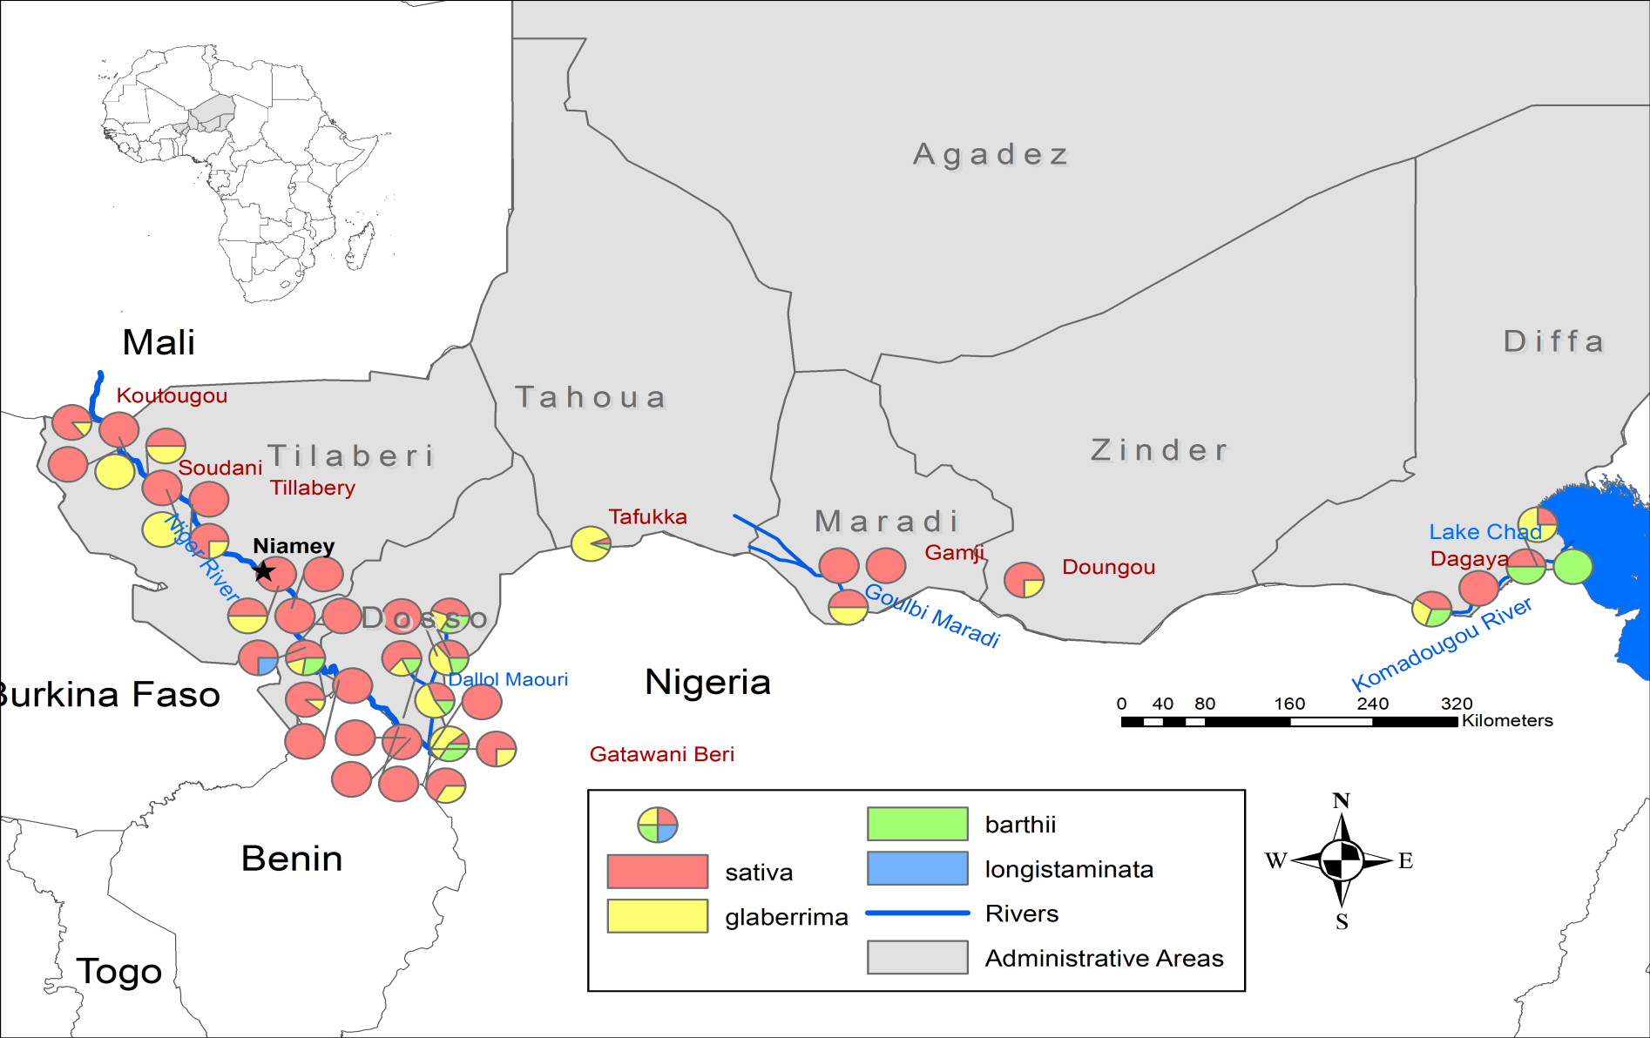

Central South
Figure S1. Maps of villages where seeds samples were collected. The colour of the points indicated the proportion of each rice species sampled in a village

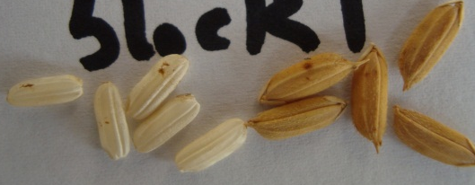  Accession TY41: O. sativa with white, medium-length grain | 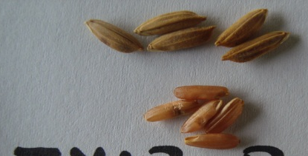  Accession TY13-B: O. sativa with brown, medium-length grain | 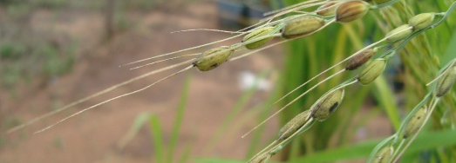  O. glaberrima with long awns
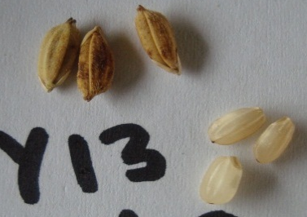  Accession TY13: O. sativa with white, round grain | 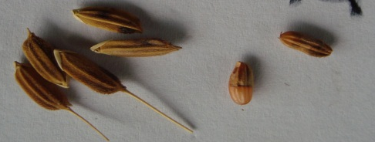  Accession TY35-E: O. sativa with white, medium-length grain with short awns, | 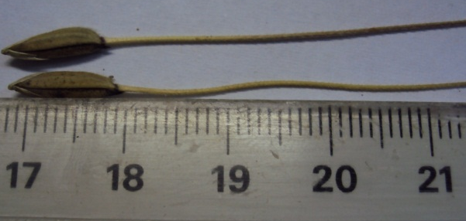  Accession DF13 : « true » O. barthii
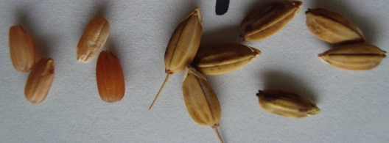  Accession DS17-A: O. glaberrima with short awn | 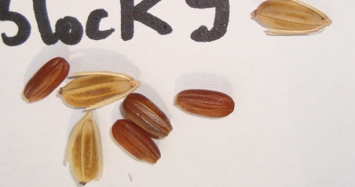  Accession TY55: O. glaberrima with long sterile lemma | 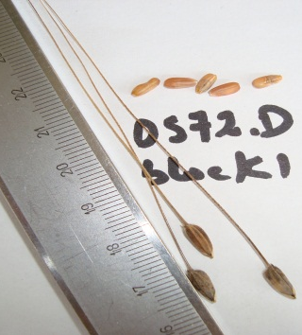  « False » O. barthii : natural interspecific

Figure S2. Grain features of some accessions from the rice collection from Niger

Figure S3. (a) Frequency distribution of (a) secondary branching of panicles (Pa2Br): sparse (one secondary branch with most spikelets borne directly on primary branches), dense (2-3 secondary branches with 50% spikelets borne directly on primary branches) and clustered (3-4 secondary branches per primary branch with all spikelets on secondary branches giving a clustered appearance); and (b) caryopsis coloration (CarCol) in the collection of 270 rice accessions from Niger

a | b
Figure S4. Discriminant analyses (DA) conducted on 270 accessions collected from Niger based on (a) 3 groups (group 1 = Gp1; group 2 = Gp2; group 3 = Gp3) defined by cluster analysis or (b) by eco-geographical zones of the collection (CS: Central-South, DM: Dallol Maouri, LC: Lake Chad, NR: Niger River)

a | b
Figure S5. Discriminant analyses (DA) conducted on the 270 accessions collected from Niger: (a) DA based on the agrosystem (f = floating; L = lowland; i = irrigated) as provided by farmers during the collection; (b) DA based on the species (b = O. barthii; g = O. glaberrima; s = O. sativa) determined using morphological traits.

