Supplementary materiel
Bottleneck and gene flow effects impact the genetic structure of seed-propagated apricot populations in Moroccan oasis agro-ecosystems
Ali Mamouni^{1,4}, Ahmed El Bakkali^{1,2}, Patrick Lambert³, Lamia Krichen⁵, Ahmed Oukabli¹, Jean Marc Audergon³, Philippe Chatelet², Cherkaoui El Modafar⁴ and Bouchaib Khadari^{2,6,*}
¹INRA, UR Amélioration des Plantes et Conservation des Ressources Phytogénétiques, Meknès, Morocco
²INRA, UMR 1334 Amélioration Génétique et Adaptation des Plantes (AGAP), F-34398 Montpellier, France
³INRA Centre PACA – UR1052 Génétique et Amélioration des Fruits et Légumes GAFL, Domaine St Maurice, CS60094, 84143 Montfavet Cedex, France
⁴Université Cadi Ayyad, Laboratoire AgroBiotech L02B005, Faculté des Sciences et Techniques Guéliz, 40000 Marrakech, Morocco
⁵Université Tunis El Manar, Faculté des Sciences de Tunis, Laboratoire de Génétique Moléculaire, Immunologie et Biotechnologie, Campus Universitaire El Manar, 2092 Tunis, Tunisie
⁶CBNMed, UMR 1334 AGAP, F-34398 Montpellier, France
*Corresponding author:
Tel.: +33 (0) 4 67 61 59 00
E-mail address: khadari@supagro.inra.fr

Table S1. List of the 99 Moroccan accessions analysed in the present study including 12 additional ones set up at Ain Taoujdate experimental Station (INRAM). Accessions are classified according to their geographical site (10 sites) and regions (4)

# accessions | Accession code | Accession name | Geographical site | Geographical region | Local name
1 | 8Maroc | BmA2 | Boumalen | Dades valley
2 | 9Maroc | BmA3 | Boumalen | Dades valley
3 | 10Maroc | BmA4 | Boumalen | Dades valley
4 | 11Maroc | BmA5 | Boumalen | Dades valley
5 | 12Maroc | Bmkh1 | Boumalen | Dades valley
6 | 13Maroc | BmJ2 | Boumalen | Dades valley
7 | 71Maroc | Bmkh2 | Boumalen | Dades valley
8 | 72Maroc | BmA1 | Boumalen | Dades valley
9 | 73Maroc | BmJ1 | Boumalen | Dades valley
10 | 74Maroc | BmJ3 | Boumalen | Dades valley
11 | 14Maroc | KMG2 | El-Kalaa M'Gouna | Dades valley
12 | 15Maroc | KMG5 | El-Kalaa M'Gouna | Dades valley
13 | 16Maroc | KMG6 | El-Kalaa M'Gouna | Dades valley
14 | 17Maroc | KMG7 | El-Kalaa M'Gouna | Dades valley
15 | 82Maroc | KMG1 | El-Kalaa M'Gouna | Dades valley
16 | 83Maroc | KMG3 | El-Kalaa M'Gouna | Dades valley
17 | 84Maroc | KMG4 | El-Kalaa M'Gouna | Dades valley
18 | 85Maroc | KMG8 | El-Kalaa M'Gouna | Dades valley
19 | 86Maroc | KMG9 | El-Kalaa M'Gouna | Dades valley
20 | 37Maroc | AgzA2 | Agdez | Draa valley
21 | 38Maroc | AgzA2a | Agdez | Draa valley
22 | 39Maroc | AgzA3 | Agdez | Draa valley
23 | 40Maroc | AgzA4 | Agdez | Draa valley
24 | 41Maroc | AgzA5 | Agdez | Draa valley
25 | 42Maroc | AgzA5a | Agdez | Draa valley
26 | 43Maroc | AgzA7 | Agdez | Draa valley
27 | 44Maroc | AgzA8 | Agdez | Draa valley
28 | 45Maroc | AgzIG1 | Agdez | Draa valley
29 | 46Maroc | AgzIG2 | Agdez | Draa valley
30 | 66Maroc | AgzA3a | Agdez | Draa valley
31 | 67Maroc | AgzA6 | Agdez | Draa valley
32 | 68Maroc | AgzC1 | Agdez | Draa valley
33 | 57Maroc | SKH | Skoura | Draa valley
34 | 58Maroc | SKH1 | Skoura | Draa valley
35 | 59Maroc | SKH2 | Skoura | Draa valley
36 | 60Maroc | SKH3 | Skoura | Draa valley
37 | 61Maroc | SKH4 | Skoura | Draa valley
38 | 62Maroc | SKT1 | Skoura | Draa valley
39 | 63Maroc | SKT3 | Skoura | Draa valley
40 | 64Maroc | SKT4 | Skoura | Draa valley
41 | 65Maroc | SKT5 | Skoura | Draa valley
42 | 96Maroc | SK2 | Skoura | Draa valley
43 | 97Maroc | SKA1 | Skoura | Draa valley
44 | 98Maroc | SKT2 | Skoura | Draa valley
45 | 1Maroc | Marouch n.3 | Barbeau (1980) | INRAM
46 | 2Maroc | Marouch n.4 | Barbeau (1980) | INRAM
47 | 3Maroc | Ait Gmat n.5 | Barbeau (1980) | INRAM
48 | 5Maroc | Mansouri n.15 | Barbeau (1980) | INRAM
49 | 6Maroc | Khorbat n.6 | Barbeau (1980) | INRAM
50 | 56Maroc | Marouch n.1 | Barbeau (1980) | INRAM
51 | 87Maroc | Marouch n.16 | Barbeau(1980) | INRAM
52 | 70Maroc | Amez n.1 | Marrakech | INRAM
53 | 4Maroc | Maoui |  | INRAM | Patria
54 | 7Maroc | Del Patriarca |  | INRAM | Del Patriarca
55 | 76Maroc | Canino |  | INRAM | Canino
56 | 78Maroc | Gélitano |  | INRAM
57 | 79Maroc | Gur1 | Guersif | Moulouya valley
58 | 80Maroc | Gur21 | Guersif | Moulouya valley
59 | 47Maroc | V1 | Missour | Moulouya valley
60 | 48Maroc | V1a | Missour | Moulouya valley
61 | 49Maroc | V3 | Missour | Moulouya valley
62 | 50Maroc | V15 | Missour | Moulouya valley
63 | 51Maroc | V17 | Missour | Moulouya valley
64 | 52Maroc | V18a | Missour | Moulouya valley
65 | 53Maroc | V18 | Missour | Moulouya valley
66 | 54Maroc | V22 | Missour | Moulouya valley
67 | 55Maroc | V24 | Missour | Moulouya valley
68 | 99Maroc | V12 | Missour | Moulouya valley
69 | 100Maroc | V2 | Missour | Moulouya valley
70 | 22Maroc | Out1 | Outat El-Haj | Moulouya valley
71 | 23Maroc | Out8 | Outat El-Haj | Moulouya valley
72 | 88Maroc | Out2 | Outat El-Haj | Moulouya valley
73 | 89Maroc | Out3 | Outat El-Haj | Moulouya valley
74 | 90Maroc | Out6 | Outat El-Haj | Moulouya valley
75 | 91Maroc | Out7 | Outat El-Haj | Moulouya valley
76 | 27Maroc | AJG1 | Aoufous | Ziz valley
77 | 29Maroc | ARB3 | Aoufous | Ziz valley
78 | 30Maroc | JR7 | Aoufous | Ziz valley
79 | 31Maroc | JR8 | Aoufous | Ziz valley
80 | 81Maroc | JK6 | Aoufous | Ziz valley
81 | 69Maroc | AJG2 | Aoufous | Ziz valley
82 | 24Maroc | RTA1 | Er-Rich | Ziz valley
83 | 26Maroc | RG1 | Er-Rich | Ziz valley
84 | 28Maroc | RK3 | Er-Rich | Ziz valley
85 | 32Maroc | Rtil1 | Er-Rich | Ziz valley
86 | 33Maroc | Rtil2 | Er-Rich | Ziz valley
87 | 34Maroc | Rtil3 | Er-Rich | Ziz valley
88 | 35Maroc | Rtil4 | Er-Rich | Ziz valley
89 | 36Maroc | Rtil5 | Er-Rich | Ziz valley
90 | 92Maroc | RK1 | Er-Rich | Ziz valley
91 | 93Maroc | RT1 | Er-Rich | Ziz valley
92 | 94Maroc | RT3 | Er-Rich | Ziz valley
93 | 95Maroc | RT4 | Er-Rich | Ziz valley
94 | 18Maroc | Gay1 | Goulmima | Ziz valley
95 | 19Maroc | Gay2 | Goulmima | Ziz valley
96 | 20Maroc | Gay4 | Goulmima | Ziz valley
97 | 21Maroc | GM1 | Goulmima | Ziz valley
98 | 25Maroc | GR1 | Goulmima | Ziz valley
99 | 77Maroc | Gay3 | Goulmima | Ziz valley

Table S2. List of the 97 Moroccan genotypes classified by their inferred ancestry (Q matrix) among K=2 and K = 3

# | accession code | Geographical site | Geographical region | K = 1 | K = 2 | Assigned cluster  (Under the assignation probability P (q) ≥ 0.8) | K = 1  'Del Patriarca' related genotypes | K = 2  'Canino' related genotypes | K = 3  Seed propagated genotypes | Assigned cluster  (Under the assignation probability P (q) ≥ 0.8)
1 | Gur2 | Guersif | Moulouya | 0.024 | 0.976 | 2 | 0.0038 | 0.9598 | 0.0364 | 2
2 | Gur21 | Guersif | Moulouya | 0.018 | 0.982 | 2 | 0.005 | 0.9695 | 0.0255 | 2
3 | Out1 | Outat Elhaj | Moulouya | 0.968 | 0.032 | 1 | 0.1454 | 0.1035 | 0.7511 | Admixed
4 | Out2 | Outat Elhaj | Moulouya | 0.01 | 0.99 | 2 | 0.005 | 0.9814 | 0.0136 | 2
5 | Out3 | Outat Elhaj | Moulouya | 0.011 | 0.989 | 2 | 0.008 | 0.9795 | 0.0125 | 2
6 | Out6 | Outat Elhaj | Moulouya | 0.03 | 0.97 | 2 | 0.015 | 0.9485 | 0.0365 | 2
7 | Out7 | Outat Elhaj | Moulouya | 0.013 | 0.987 | 2 | 0.0221 | 0.967 | 0.0109 | 2
8 | Out8 | Outat Elhaj | Moulouya | 0.991 | 0.009 | 1 | 0.2549 | 0.0151 | 0.73 | Admixed
9 | V1 | Missour | Moulouya | 0.989 | 0.011 | 1 | 0.0177 | 0.0141 | 0.9682 | 3
10 | V1a | Missour | Moulouya | 0.987 | 0.013 | 1 | 0.0159 | 0.0155 | 0.9686 | 3
11 | V12 | Missour | Moulouya | 0.015 | 0.985 | 2 | 0.016 | 0.9667 | 0.0173 | 2
12 | V15 | Missour | Moulouya | 0.978 | 0.023 | 1 | 0.004 | 0.0205 | 0.9755 | 3
13 | V17 | Missour | Moulouya | 0.905 | 0.095 | 1 | 0.0059 | 0.0783 | 0.9158 | 3
14 | V18 | Missour | Moulouya | 0.985 | 0.015 | 1 | 0.0107 | 0.0172 | 0.9721 | 3
15 | V18a | Missour | Moulouya | 0.992 | 0.008 | 1 | 0.0066 | 0.0088 | 0.9846 | 3
16 | V2 | Missour | Moulouya | 0.054 | 0.947 | 2 | 0.003 | 0.8762 | 0.1208 | 2
17 | V22 | Missour | Moulouya | 0.992 | 0.008 | 1 | 0.0045 | 0.0081 | 0.9874 | 3
18 | V24 | Missour | Moulouya | 0.993 | 0.007 | 1 | 0.003 | 0.007 | 0.99 | 3
19 | V3 | Missour | Moulouya | 0.925 | 0.076 | 1 | 0.0068 | 0.0772 | 0.916 | 3
20 | RG1 | Rich | Ziz | 0.994 | 0.006 | 1 | 0.004 | 0.006 | 0.99 | 3
21 | RK1 | Rich | Ziz | 0.011 | 0.99 | 2 | 0.029 | 0.9599 | 0.0111 | 2
22 | RK3 | Rich | Ziz | 0.99 | 0.011 | 1 | 0.01 | 0.0125 | 0.9775 | 3
23 | RT1 | Rich | Ziz | 0.011 | 0.989 | 2 | 0.0315 | 0.9575 | 0.011 | 2
24 | RT3 | Rich | Ziz | 0.01 | 0.99 | 2 | 0.0139 | 0.9744 | 0.0117 | 2
25 | RT4 | Rich | Ziz | 0.014 | 0.986 | 2 | 0.006 | 0.9756 | 0.0184 | 2
26 | RTA1 | Rich | Ziz | 0.993 | 0.007 | 1 | 0.995 | 0.002 | 0.003 | 1
27 | Rtil1 | Rich | Ziz | 0.991 | 0.009 | 1 | 0.0392 | 0.0174 | 0.9434 | 3
28 | Rtil2 | Rich | Ziz | 0.968 | 0.032 | 1 | 0.3351 | 0.0922 | 0.5727 | Admixed
29 | Rtil3 | Rich | Ziz | 0.994 | 0.006 | 1 | 0.003 | 0.0054 | 0.9916 | 3
30 | Rtil4 | Rich | Ziz | 0.974 | 0.026 | 1 | 0.0213 | 0.0479 | 0.9308 | 3
31 | Rtil5 | Rich | Ziz | 0.992 | 0.008 | 1 | 0.0483 | 0.0147 | 0.937 | 3
32 | AJG1 | Aoufous | Ziz | 0.995 | 0.005 | 1 | 0.0481 | 0.007 | 0.9449 | 3
33 | AJG2 | Aoufous | Ziz | 0.017 | 0.984 | 2 | 0.0187 | 0.9659 | 0.0154 | 2
34 | ARB3 | Aoufous | Ziz | 0.991 | 0.009 | 1 | 0.007 | 0.011 | 0.982 | 3
35 | JK6 | Aoufous | Ziz | 0.011 | 0.989 | 2 | 0.006 | 0.9799 | 0.0141 | 2
36 | JR7 | Aoufous | Ziz | 0.995 | 0.005 | 1 | 0.005 | 0.0053 | 0.9897 | 3
37 | JR8 | Aoufous | Ziz | 0.994 | 0.006 | 1 | 0.0051 | 0.006 | 0.9889 | 3
38 | Gay1 | Goulmima | Ziz | 0.95 | 0.05 | 1 | 0.0139 | 0.0623 | 0.9238 | 3
39 | Gay2 | Goulmima | Ziz | 0.992 | 0.008 | 1 | 0.0113 | 0.0091 | 0.9796 | 3
40 | Gay3 | Goulmima | Ziz | 0.007 | 0.993 | 2 | 0.007 | 0.985 | 0.008 | 2
41 | Gay4 | Goulmima | Ziz | 0.994 | 0.006 | 1 | 0.0846 | 0.0088 | 0.9066 | 3
42 | GM1 | Goulmima | Ziz | 0.993 | 0.007 | 1 | 0.0051 | 0.008 | 0.9869 | 3
43 | GR1 | Goulmima | Ziz | 0.994 | 0.006 | 1 | 0.0105 | 0.007 | 0.9825 | 3
44 | BmA1 | Boumalen | Dades | 0.006 | 0.994 | 2 | 0.006 | 0.988 | 0.006 | 2
45 | BmA2 | Boumalen | Dades | 0.991 | 0.009 | 1 | 0.007 | 0.0174 | 0.9756 | 3
46 | BmA3 | Boumalen | Dades | 0.994 | 0.006 | 1 | 0.0126 | 0.0077 | 0.9797 | 3
47 | BmA4 | Boumalen | Dades | 0.995 | 0.006 | 1 | 0.003 | 0.0066 | 0.9904 | 3
48 | BmA5 | Boumalen | Dades | 0.994 | 0.006 | 1 | 0.0063 | 0.007 | 0.9867 | 3
49 | BmJ1 | Boumalen | Dades | 0.008 | 0.992 | 2 | 0.004 | 0.986 | 0.01 | 2
50 | BmJ2 | Boumalen | Dades | 0.993 | 0.007 | 1 | 0.009 | 0.0076 | 0.9834 | 3
51 | BmJ3 | Boumalen | Dades | 0.005 | 0.995 | 2 | 0.005 | 0.989 | 0.006 | 2
52 | Bmkh1 | Boumalen | Dades | 0.996 | 0.004 | 1 | 0.0041 | 0.004 | 0.9919 | 3
53 | KMG1 | El-Kalaa M'Gouna | Dades | 0.013 | 0.987 | 2 | 0.006 | 0.9785 | 0.0155 | 2
54 | KMG2 | El-Kalaa M'Gouna | Dades | 0.984 | 0.017 | 1 | 0.0069 | 0.0268 | 0.9663 | 3
55 | KMG3 | El-Kalaa M'Gouna | Dades | 0.014 | 0.986 | 2 | 0.006 | 0.9766 | 0.0174 | 2
56 | KMG4 | El-Kalaa M'Gouna | Dades | 0.015 | 0.985 | 2 | 0.002 | 0.9687 | 0.0293 | 2
57 | KMG5 | El-Kalaa M'Gouna | Dades | 0.929 | 0.071 | 1 | 0.1962 | 0.2487 | 0.555 | Admixed
58 | KMG6 | El-Kalaa M'Gouna | Dades | 0.903 | 0.097 | 1 | 0.0699 | 0.2861 | 0.644 | Admixed
59 | KMG7 | El-Kalaa M'Gouna | Dades | 0.983 | 0.017 | 1 | 0.0133 | 0.0304 | 0.9563 | 3
60 | KMG8 | El-Kalaa M'Gouna | Dades | 0.01 | 0.99 | 2 | 0.004 | 0.9845 | 0.0115 | 2
61 | KMG9 | El-Kalaa M'Gouna | Dades | 0.015 | 0.985 | 2 | 0.0037 | 0.9726 | 0.0237 | 2
62 | AgzA2 | Agdez | Draa | 0.988 | 0.012 | 1 | 0.011 | 0.0161 | 0.9729 | 3
63 | AgzA2 | Agdez | Draa | 0.992 | 0.008 | 1 | 0.007 | 0.0089 | 0.9841 | 3
64 | AgzA3 | Agdez | Draa | 0.981 | 0.019 | 1 | 0.0311 | 0.0307 | 0.9382 | 3
65 | AgzA3 | Agdez | Draa | 0.013 | 0.987 | 2 | 0.02 | 0.9682 | 0.0118 | 2
66 | AgzA4 | Agdez | Draa | 0.993 | 0.007 | 1 | 0.006 | 0.007 | 0.987 | 3
67 | AgzA5 | Agdez | Draa | 0.992 | 0.008 | 1 | 0.005 | 0.0079 | 0.9871 | 3
68 | AgzA5 | Agdez | Draa | 0.991 | 0.009 | 1 | 0.005 | 0.0097 | 0.9853 | 3
69 | AgzA6 | Agdez | Draa | 0.009 | 0.991 | 2 | 0.0071 | 0.9829 | 0.01 | 2
70 | AgzA7 | Agdez | Draa | 0.995 | 0.005 | 1 | 0.0057 | 0.0058 | 0.9885 | 3
71 | AgzA8 | Agdez | Draa | 0.983 | 0.017 | 1 | 0.007 | 0.0196 | 0.9734 | 3
72 | AgzC1 | Agdez | Draa | 0.006 | 0.994 | 2 | 0.0336 | 0.9612 | 0.0052 | 2
73 | AgzIG1 | Agdez | Draa | 0.849 | 0.151 | 1 | 0.9881 | 0.0089 | 0.003 | 1
74 | AgzIG2 | Agdez | Draa | 0.994 | 0.006 | 1 | 0.0126 | 0.008 | 0.9794 | 3
75 | SKA1 | Skoura | Draa | 0.022 | 0.978 | 2 | 0.7328 | 0.2642 | 0.003 | Admixed
76 | SKH | Skoura | Draa | 0.995 | 0.005 | 1 | 0.003 | 0.005 | 0.992 | 3
77 | SKH1 | Skoura | Draa | 0.992 | 0.008 | 1 | 0.005 | 0.008 | 0.987 | 3
78 | SKH2 | Skoura | Draa | 0.981 | 0.02 | 1 | 0.005 | 0.0196 | 0.9754 | 3
79 | SKH3 | Skoura | Draa | 0.996 | 0.004 | 1 | 0.0154 | 0.005 | 0.9796 | 3
80 | SKH4 | Skoura | Draa | 0.993 | 0.007 | 1 | 0.025 | 0.0085 | 0.9665 | 3
81 | SKT1 | Skoura | Draa | 0.969 | 0.031 | 1 | 0.9699 | 0.01 | 0.0201 | 1
82 | SKT2 | Skoura | Draa | 0.038 | 0.962 | 2 | 0.009 | 0.9344 | 0.0566 | 2
83 | SKT3 | Skoura | Draa | 0.984 | 0.016 | 1 | 0.0228 | 0.0234 | 0.9538 | 3
84 | SKT4 | Skoura | Draa | 0.994 | 0.006 | 1 | 0.009 | 0.006 | 0.985 | 3
85 | SKT5 | Skoura | Draa | 0.988 | 0.012 | 1 | 0.0092 | 0.0156 | 0.9752 | 3
86 | Amez1 | INRAM |  | 0.007 | 0.993 | 2 | 0.006 | 0.9866 | 0.0074 | 2
87 | Canino 2 | INRAM |  | 0.013 | 0.987 | 2 | 0.005 | 0.9769 | 0.0181 | 2
88 | Del Patriarca | INRAM |  | 0.983 | 0.017 | 1 | 0.9875 | 0.0075 | 0.005 | 1
89 | Gélitano | INRAM |  | 0.004 | 0.996 | 2 | 0.0039 | 0.9911 | 0.005 | 2
90 | Ait Gmat n.5 | INRAM |  | 0.991 | 0.009 | 1 | 0.006 | 0.01 | 0.984 | 3
91 | Khorbat n.6 | INRAM |  | 0.994 | 0.006 | 1 | 0.8276 | 0.0197 | 0.1527 | 1
92 | Mansouri n.15 | INRAM |  | 0.968 | 0.032 | 1 | 0.0323 | 0.0932 | 0.8745 | 3
93 | Maoui | INRAM |  | 0.991 | 0.009 | 1 | 0.9952 | 0.002 | 0.0028 | 1
94 | Marouch n.16 | INRAM |  | 0.022 | 0.978 | 2 | 0.015 | 0.962 | 0.023 | 2
95 | Marouch n.3 | INRAM |  | 0.989 | 0.012 | 1 | 0.3686 | 0.034 | 0.5973 | Admixed
96 | Marouch n.4 | INRAM |  | 0.991 | 0.009 | 1 | 0.0226 | 0.0129 | 0.9645 | 3
97 | Marouch n.1 | INRAM |  | 0.986 | 0.014 | 1 | 0.003 | 0.0119 | 0.9851 | 3

Table S3. Number and proportion of Moroccan genotypes (97 genotypes) assigned to different clusters identified by Structure program
Geographical groups | Number of genotypes | At K = 2 clusters |  |  |  | At K = 3 clusters
Geographical groups | Number of genotypes | Assigned genotypes* | Cluster 1  (%)$ | Cluster 2 (%)$ |  | Assigned genotypes* | Cluster 1 (%)$ | Cluster 2 (%)$ | Cluster 3 (%)$
Moulouya valley | 19 | 19 (100%) | 11 (57.9%) | 8 (42.1%) |  | 17 (89.4%) | 0 (0%) | 8 (47%) | 9 (53%)
Ziz valley | 24 | 24 (100%) | 17 (70.8%) | 7 (29.2%) |  | 23 (95.8%) | 1 (4.4%) | 7 (30.4%) | 15 (65.2%)
Dades valley | 18 | 18 (100%) | 10 (55.5%) | 8 (44.5%) |  | 16 (88.8%) | 0 (0%) | 8 (50%) | 8 (50%)
Draa valley | 24 | 24 (100%) | 19 (79.1%) | 5 (20.9%) |  | 23 (95.8%) | 2 (8.7%) | 4 (17.4%) | 17 (73.9%)
INRAM | 12 | 12 (100%) | 8 (66.6%) | 4 (33.4%) |  | 11 (91.6%) | 3 (27.2%) | 4 (36.4%) | 4 (36.4%)
Total | 97 | 97 (100%) | 65 (67%) | 32 (33%) |  | 90 (92.7%) | 6 (6.6%) | 31 (34.5%) | 53 (58.9%)
At K = 3, cluster 1 corresponds to ‘Del Patriarca’-related genotypes, cluster 2 to ‘Canino’-related genotypes and cluster 3 to seed-propagated genotypes
*Under the assignation probability P (qI) ≥ 0.8
$Proportion of assigned genotypes within each group

Table S4. Pairwise genetic differentiation (F_{ST}) between groups
 | D groupª | C groupª | B groupª | A groupª | Testour | Kairouan | Ras Jbel | Dades valley | Draa valley | Moulouya valley
C groupª | 0.156
B groupª | 0.091 | 0.195
A groupª | 0.064 | 0.203 | 0.102
Testour | 0.174 | 0.301 | 0.202 | 0.123
Kairouan | 0.12 | 0.263 | 0.142 | 0.075 | 0.111
Ras Jbel | 0.102 | 0.265 | 0.178 | 0.075 | 0.069 | 0.064
Dades valley | 0.105 | 0.271 | 0.170 | 0.16 | 0.235 | 0.196 | 0.192
Draa valley | 0.122 | 0.283 | 0.193 | 0.14 | 0.213 | 0.175 | 0.148 | 0.049
Moulouya valley | 0.115 | 0.271 | 0.172 | 0.144 | 0.246 | 0.202 | 0.181 | 0.027 | 0.031
Ziz valley | 0.129 | 0.294 | 0.168 | 0.152 | 0.232 | 0.185 | 0.185 | 0.014 | 0.034 | 0.011

ªas defined by Hagen et al. (20012)

Table S5. Pairwise genetic differentiation (F_{ST}) between groups according to genetic data
 | Sub-cluster C1-1 | Sub-cluster C1-2 | Sub-cluster C1-3 | Sub-cluster C2-1 | Sub-cluster C2-2
Sub-cluster C1-2 | 0.087
Sub-cluster C1-3 | 0.086 | 0.126
Sub-cluster C2-1 | 0.140 | 0.153 | 0.16
Sub-cluster C2-2 | 0.322 | 0.320 | 0.349 | 0.318
Sub-cluster C2-3 | 0.134 | 0.155 | 0.191 | 0.109 | 0.321

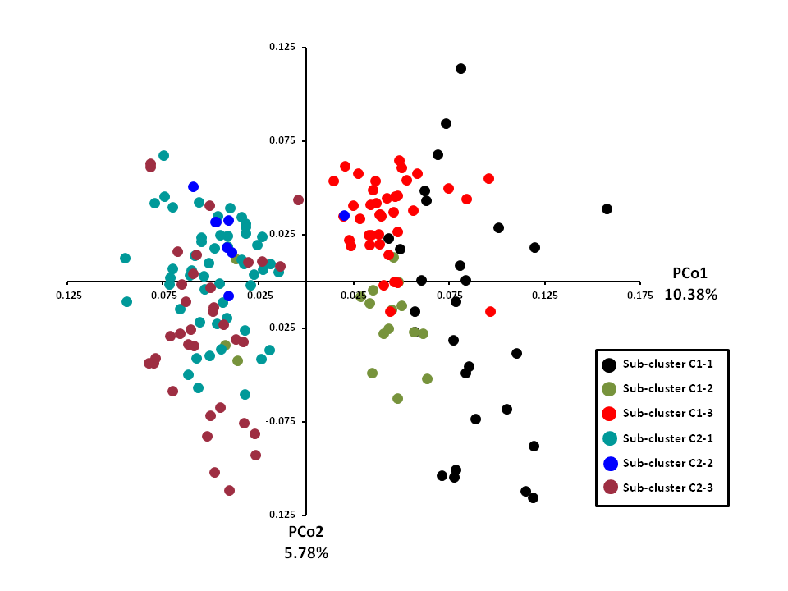
Figure S1. Two-dimensional distribution of the principal coordinate analysis (PCoA) for total apricot diversity (180 genotypes) using Simple Matching coefficient. Colours indicate the different sub-clusters as revealed with dendrogram (Figure 2). The genetic variation of each principal coordinate (PCo1 and PCo2) is indicated
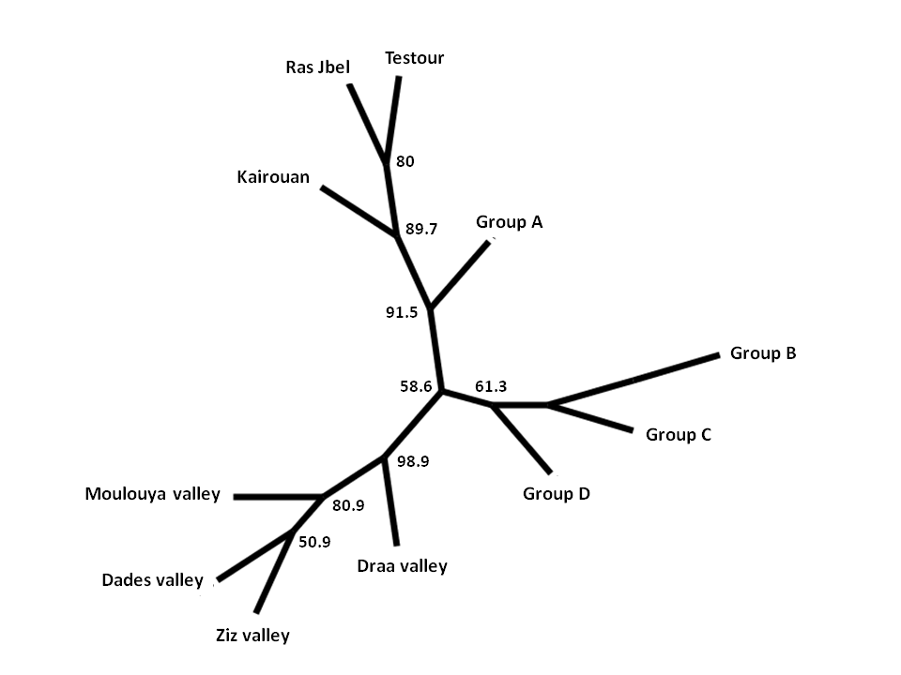
Figure S2. Dendrogram of groups according to area of origin constructed on the basis of F_{ST} genetic differentiation values and neighbor-joining clustering. Numbers at each node indicate bootstrap support using 1,000 pseudo replicates.

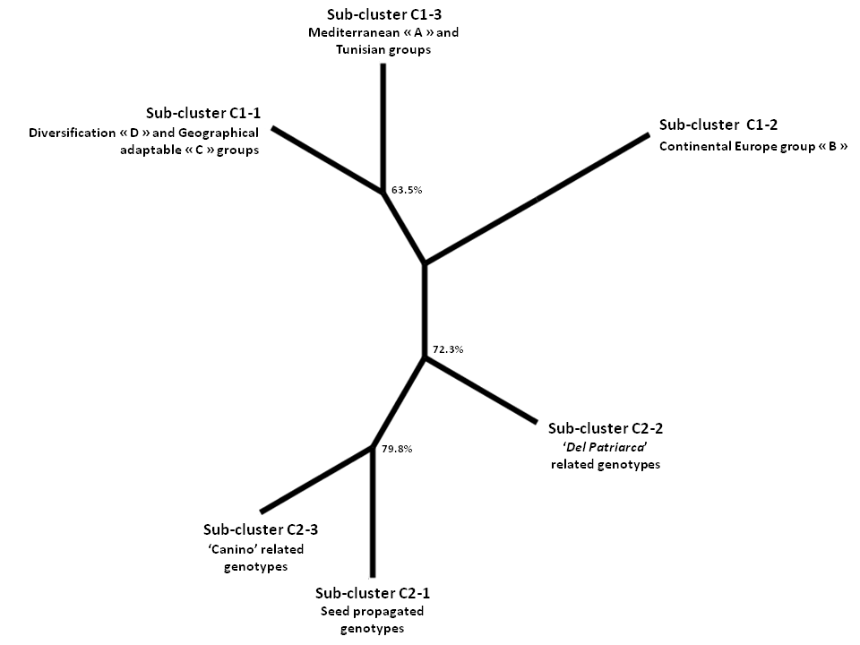
Figure S3. Dendrogram of groups according to genetic data, constructed on the basis of F_{ST} genetic differentiation values and neighbor-joining clustering. Numbers at each node indicate bootstrap support using 1,000 pseudo replicates

