Supplementary Figures
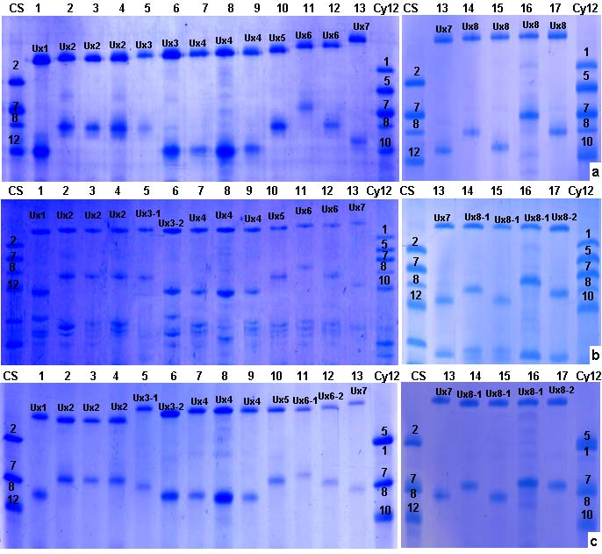

Fig. S1 SDS-PAGE pattern of Ux subunits in Aegilops umbellulata using 10% (a) and 15 % (b) non-denaturing gels and 10% denaturing gels (c). Lanes 1–17 are PI 554405, PI 298905, PI 554414, PI 542375, PI 486261, PI 486256, PI 227436, PI 276994, PI 542377, PI 554385, PI 542370, PI 542376, PI 542379, PI 554416, CIae 29, PI 542374, and PI 542364, respectively. The common wheat cultivars CS (Chinese Spring) and Cy 12 (Chuanyu 12) were used as references for HMW-GS

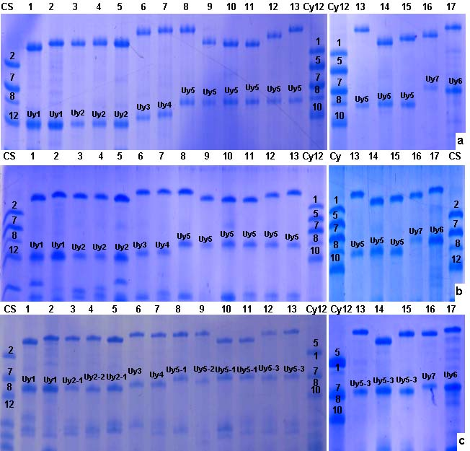

Fig. S2 SDS-PAGE pattern of Uy subunits in Aegilops umbellulata using 10% (a) and 15 % (b) non-denaturing gels and 10% denaturing gels (c). Lanes 1–17 are PI 554405, PI 276994, PI 227436, PI 542377, PI 486256, PI 542379, CIae29, PI 542364, PI 486261, PI 298905, PI 554414, PI 542376, PI 554416, PI 542375, PI 554385, PI 542370, and PI 542374, respectively. The common wheat cultivars CS (Chinese Spring) and Cy 12 (Chuanyu 12) were used as references for HMW-GS

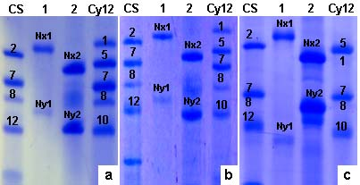

Fig. S3 SDS-PAGE pattern of Nx and Ny subunits in Aegilops uniaristata using 10% (a) and 15 % (b) non-denaturing gels and 10% denaturing gels (c). Lanes 1 and 2 are PI 554419 and PI 276995, respectively. The common wheat cultivars CS (Chinese Spring) and Cy 12 (Chuanyu 12) were used as references for HMW-GS

