Supplementary Material

Smale and Day-Rubenstein (2002) analyzed the types of germplasm requested, purpose of the request, traits requested, and actual utilization of germplasm samples, using survey data for 308 researchers over the world who requested germplasm from the US National Plant Germplasm System (US NPGS) during 1995–1999. Their results suggest that gene banks consider issues regarding utilization of their genetic resources from a user-oriented perspective and emphasized that grasping users’ demands for attributes of genetic resources can promote their utilization.
Day-Rubenstein and Smale (2004) provided empirical evidence that utilization of genetic resources can be promoted when information attributes fulfill users’ demands, by revealing that useful data and information attributes have had positive effects on the utilization of the genetic resources of the US NPDS.
Ukalska and Kociuba (2013) analyzed the variability in genotypes of winter triticale based on its phenotypic traits and determined the most differentiating features of a collection gathered by the Polish gene bank in the years 1982–2008. They also stated the importance of providing genetic resources that meet the needs of researchers and users.
Table S1. Korea’s legal system for managing genetic resources for R&D in biotechnology
Authorities | Laws
Ministry of Science, ICT and Future Planning (MSIP) | - National Science Museum Promotion Law (1991. 12)  - Biotechnology Promotion Law (1995. 7)  - Brain Research Promotion Law (1998. 6)  - Basic Law on Science and Technology (2001. 7)  - Law on Securement, Management and Use of Genetic Resources for Biotechnology R&D (2009. 5)
Ministry of Agriculture, Food and Rural Affairs (MAFRA) | - Law on Conservation, Management and Use of Agricultural Genetic Resources (1995. 7)  - Seed Industry Law (1995. 12)  - Law on Formation and Promotion of Arboretums (2001. 3)  - Mountainous Districts Management Law (2002. 12)  - Baekdudaegan Mountain Range Protection Law (2005. 1)  - Law on Management of National Forests (2006. 8)  - Law on Formation and Management of Forest Resources (2006. 8)  - Law on Securement, Management and Use of Biotechnology R&D Related to Agricultural and Fishery Genetic Resources (2011. 7)
Ministry of Trade, Industry and Energy (MOTIE) | - Patent Law (1961. 12)  - Law on Transboundary Movement of Living Modified Organisms (2001. 3)  - Law on Management of National Forest (2006. 8)
Ministry of Health and Welfare (MW) | - Law on Blood Management (1970. 8)  - New Natural Drug Products R&D Promotion Law (2000. 1)  - Law on Bioethics and Safety (2004. 1)  - Law on Safety and Management of Human Tissues (2004. 1)
Ministry of Environment (ME) | - Natural Environment Protection Law (1991. 12)  - Wildlife Animal and Plant Protection Law (2004. 2)  - Law on Conservation and Use of Biodiversity (2012. 2)
Ministry of Oceans and Fisheries (MOF) | - Fishery Law (1953. 9)  - Fishery Resources Protection Law (1953. 12)  - Basic Law on Development of Maritime Affairs and Fisheries (2002. 5)  - Fishery Resources Management Law (2009. 4)  - Law on Securement, Management and Use of Biotechnology R&D Related Marine Genetic Resources (2012. 6)
Source: Adapted from MSIP et al (2011, 2013) and KOBIC (2013).
Table S2. Hypothetical profiles for microbial genetic resource
Profile | Origin | Novelty based on taxonomy | User’s exclusive right to use | New functionality | Price  (KRW)
1 | General overseas region | Isolated strains of genus identified | Not given | High | 40,000
2 | Specific domestic environment | Unidentified isolated strain | Not given | Low | 300,000
3 | General domestic region | Isolated strains of genus identified | Given | High | 300,000
4 | Specific domestic environment | Reference strain | Partial limitation | High | 40,000
5 | Specific overseas environment | Reference strain | Not given | High | 300,000
6 | General domestic region | Novel isolated strain | Not given | Low | 40,000
7 | Specific domestic environment | Novel isolated strain | Given | High | 1,000,000
8 | Specific overseas environment | Unidentified isolated strain | Given | Low | 40,000
9 | General overseas region | Unidentified isolated strain | Not given | High | 1,000,000
10 | General overseas region | Novel isolated strain | Partial limitation | Low | 300,000
11 | General domestic region | Reference strain | Not given | Low | 1,000,000
12 | Specific domestic environment | Isolated strains of genus identified | Not given | Low | 1,000,000
13 | Specific overseas environment | Novel isolated strain | Not given | High | 1,000,000
14 | General overseas region | Reference strain | Given | Low | 1,000,000
15 | General domestic region | Unidentified isolated strain | Partial limitation | High | 1,000,000
16 | Specific overseas environment | Isolated strains of genus identified | Partial limitation | Low | 1,000,000
Note: Each cell indicates attribute levels. South Korean won to US Dollar currency and Euro currency exchange rates are 1166.80 and 1473.55, respectively as of June 15, 2012.
Table S3. Hypothetical profiles for plant genetic resource
Profile | Origin | Novelty based on taxonomy | User’s exclusive right to use | New functionality | Price  (KRW)
1 | Korean indigenous species | Plant genus unidentified | Partial limitation | Unknown | 200,000
2 | Korean indigenous species | Plant genus identified | Partial limitation | Low | 500,000
3 | Species native to Korea | Plant genus unidentified | Partial limitation | Low | 200,000
4 | Species from foreign countries | Plant genus identified | Partial limitation | Low | 20,000
5 | Korean indigenous species | Novel plant genus | Given | Low | 500,000
6 | Species native to Korea | Plant genus unidentified | Given | Low | 500,000
7 | Species native to Korea | Novel plant genus | Partial limitation | High | 500,000
8 | Species native to Korea | Plant genus identified | Given | High | 200,000
9 | Species native to Korea | Novel plant genus | Partial limitation | Unknown | 20,000
10 | Species from foreign countries | Plant genus unidentified | Partial limitation | High | 500,000
11 | Species from foreign countries | Plant genus unidentified | Given | Unknown | 500,000
12 | Species native to Korea | Plant genus unidentified | Given | Low | 20,000
13 | Species from foreign countries | Novel plant genus | Given | Low | 200,000
14 | Species native to Korea | Plant genus unidentified | Partial limitation | Low | 500,000
15 | Korean indigenous species | Plant genus unidentified | Given | High | 20,000
16 | Species native to Korea | Plant genus identified | Given | Unknown | 500,000
Note: Each cell indicates attribute levels. South Korean won to US Dollar currency and Euro currency exchange rates are 1134.80 and 1516.38, respectively as of June 14, 2013.
Table S4. Hypothetical profiles for animal genetic resource
Profile | Trait information | Genomic information | Standardization of resource | User’s exclusive right to use | Price  (KRW)
1 | Covered | Completely uncovered | Unstandardized | Not given | 500,000
2 | Covered | Covered | Unstandardized | Given | 1,000,000
3 | Covered | Partially uncovered | Standardized | Partial limitation | 1,000,000
4 | Partially uncovered | Completely uncovered | Unstandardized | Given | 100,000
5 | Partially uncovered | Covered | Standardized | Given | 500,000
6 | Partially uncovered | Completely uncovered | Standardized | Not given | 1,000,000
7 | Covered | Partially uncovered | Standardized | Given | 500,000
8 | Partially uncovered | Partially uncovered | Standardized | Not given | 100,000
9 | Completely uncovered | Covered | Partially standardized | Not given | 500,000
10 | Partially uncovered | Covered | Partially standardized | Partial limitation | 1,000,000
11 | Covered | Completely uncovered | Partially standardized | Partial limitation | 100,000
12 | Completely uncovered | Covered | Unstandardized | Partial limitation | 100,000
13 | Partially uncovered | Partially uncovered | Unstandardized | Partial limitation | 500,000
14 | Completely uncovered | Completely uncovered | Standardized | Partial limitation | 500,000
15 | Completely uncovered | Partially uncovered | Unstandardized | Not given | 1,000,000
16 | Completely uncovered | Partially uncovered | Standardized | Given | 100,000
Note: Each cell indicates attribute levels. South Korean won to US Dollar currency and Euro currency exchange rates are 1134.80 and 1516.38, respectively as of June 14, 2013.
Table S5. Sample characteristics
 |  | Microorganism |  |  | Plant |  |  | Animal
 |  | A | B (%) |  | A | B (%) |  | A | B (%)
Age | 30-39 | 17 | 17.0 |  | 22 | 28.6 |  | 18 | 22.8
Age | 40-49 | 51 | 51.0 |  | 44 | 57.1 |  | 42 | 53.2
Age | 50-59 | 31 | 31.0 |  | 7 | 9.1 |  | 17 | 21.5
Age | 60 or above | 1 | 1.0 |  | 4 | 5.2 |  | 2 | 2.5
Age | Total | 100 | 100.0 |  | 77 | 100.0 |  | 79 | 100.0
Affiliation | Research institute | 41 | 41.0 |  | 45 | 58.4 |  | 37 | 46.8
Affiliation | Company | 9 | 9.0 |  | 5 | 6.5 |  | 2 | 2.5
Affiliation | University | 49 | 49.0 |  | 24 | 31.2 |  | 40 | 50.6
Affiliation | Others | 1 | 1.0 |  | 3 | 3.9 |  | - | -
Affiliation | Total | 100 | 100.0 |  | 77 | 100.0 |  | 79 | 100.0
Use | R&D | 98 | 98.0 |  | 74 | 96.1 |  | 78 | 98.7
Use | Commercialization | 2 | 2.0 |  | 3 | 3.9 |  | 1 | 1.3
Use | Total | 100 | 100.0 |  | 77 | 100.0 |  | 79 | 100.0
Note: A and B indicate frequency and ratio, respectively.
Table S6. Part-worth utility of attribute levels and relative importance of attributes
Attribute | Attribute level | Microorganism |  |  | Plant |  |  | Animal
Attribute | Attribute level | A | B |  | A | B |  | A | B
Origin | General domestic region | -0.078 | 18.839
Origin | Specific domestic environment | 0.170
Origin | General overseas region | -0.072
Origin | Specific overseas environment | -0.020
Origin | Species native to Korea |  |  |  | -0.163 | 17.462
Origin | Korean indigenous species |  |  |  | 0.315
Origin | Species from foreign countries |  |  |  | -0.152
Novelty based on taxonomy | Reference strain | 0.128 | 20.982
Novelty based on taxonomy | Unidentified isolated strain | -0.468
Novelty based on taxonomy | Isolated strains of genus identified | 0.180
Novelty based on taxonomy | Novel isolated strain | 0.160
Novelty based on taxonomy | Plant genus unidentified |  |  |  | 0.062 | 20.728
Novelty based on taxonomy | Plant genus identified |  |  |  | -0.440
Novelty based on taxonomy | Novel plant genus |  |  |  | 0.378
User’s exclusive right to use | Given | 0.563 | 17.929 |  | 0.309 | 12.985 |  | 0.419 | 20.015
User’s exclusive right to use | Partial limitation | -0.103 |  |  | -0.309 |  |  | 0.035 | 20.015
User’s exclusive right to use | Not given | -0.460 |  |  |  |  |  | -0.454 | 20.015
New functionality | Low | -0.764 | 17.692 |  | -0.692 | 27.411
New functionality | High | 0.764 |  |  | 0.810
New functionality | Unknown |  |  |  | -0.119
Trait information | Completely uncovered |  |  |  |  |  |  | 0.613 | 20.716
Trait information | Partially uncovered |  |  |  |  |  |  | -0.041
Trait information | Covered |  |  |  |  |  |  | -0.572

Table S6 (continued)
Attribute | Attribute level | Microorganism |  |  | Plant |  |  | Animal
Attribute | Attribute level | A | B |  | A | B |  | A | B
Standardization of resource | Standardized |  |  |  |  |  |  | 0.622 | 20.091
Standardization of resource | Partially standardized |  |  |  |  |  |  | -0.119
Standardization of resource | Unstandardized |  |  |  |  |  |  | -0.503
Genomic information | Completely uncovered |  |  |  |  |  |  | 0.746 | 22.635
Genomic information | Partially uncovered |  |  |  |  |  |  | 0.018
Genomic information | Covered |  |  |  |  |  |  | -0.764
Price | 1,000,000 KRW | -0.867 | 24.558
Price | 300,000 KRW | -0.027
Price | 40,000 KRW | 0.893
Price | 500,000 KRW |  |  |  | -0.261 | 21.415
Price | 200,000 KRW |  |  |  | -0.209
Price | 20,000 KRW |  |  |  | 0.470
Price | 1,000,000 KRW |  |  |  |  |  |  | -0.233 | 16.543
Price | 500,000 KRW |  |  |  |  |  |  | -0.121
Price | 100,000 KRW |  |  |  |  |  |  | 0.354
Intercept |  | 4.589 |  |  | 4.995 |  |  | 4.128
Pearson’s R |  | 0.996 |  |  | 0.991 |  |  | 0.981
Note: A and B denote mean part-worth utility of attributed levels and mean relative importance (%) of attributes of genetic resources, respectively.
Figure S1. Distribution of preference weights among plant genetic resource attributes by researcher segments
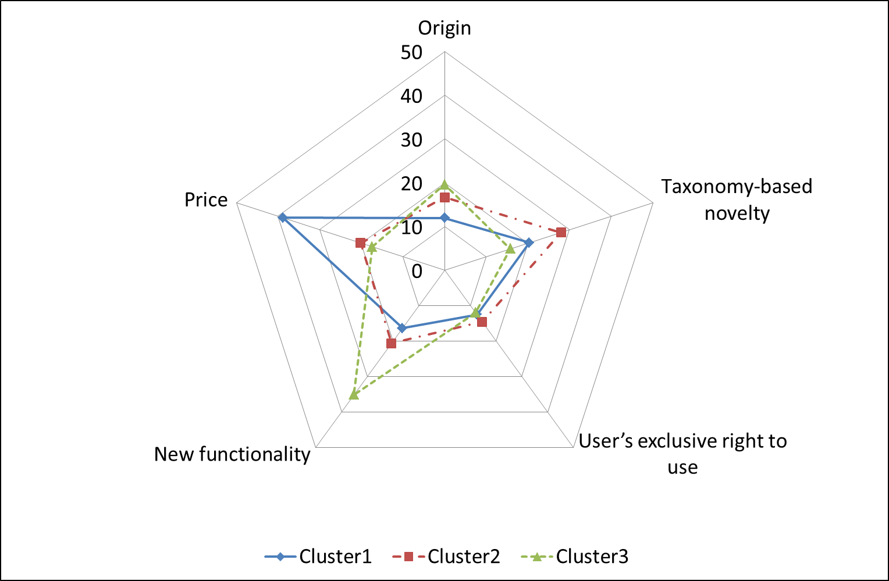

Figure S2. Distribution of preference weights among microbial genetic resource attributes by researcher segments
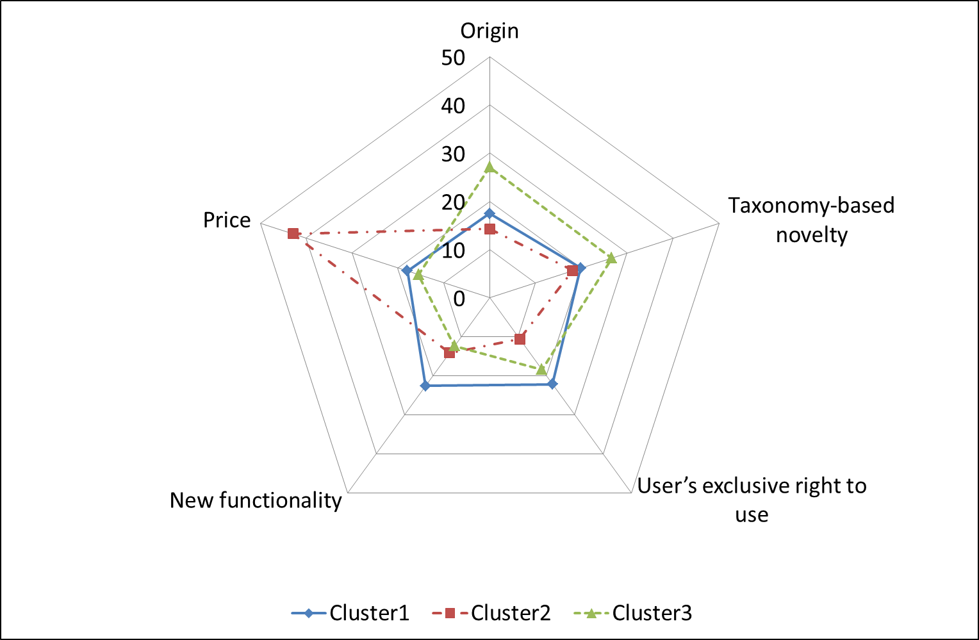
Figure S3. Distribution of preference weights among animal genetic resource attributes by researcher segments
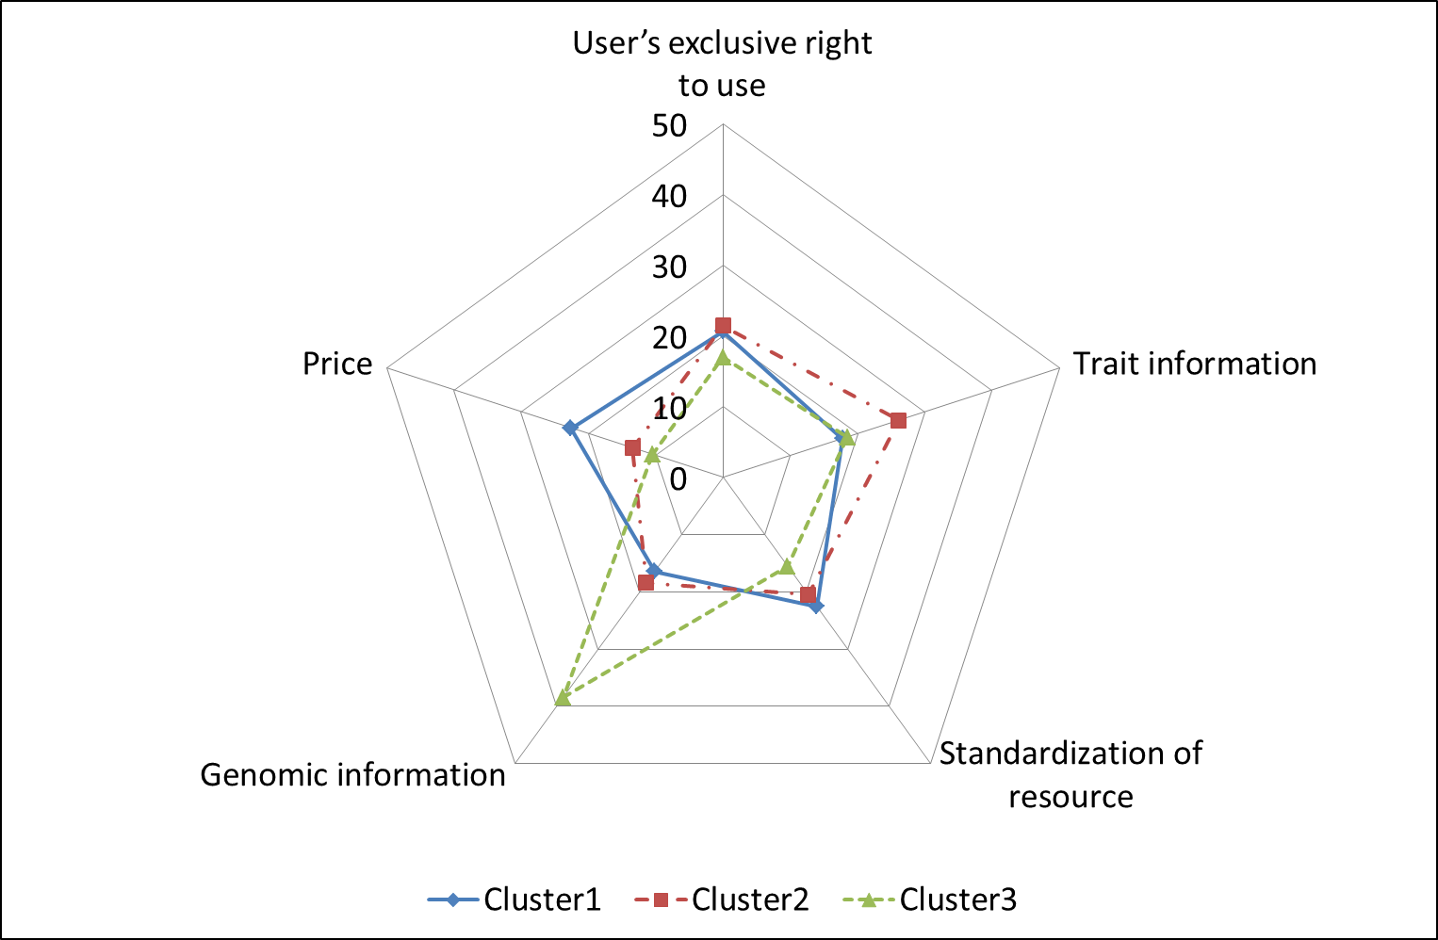

References

Day-Rubenstein K and Smale M (2004) International exchange of genetic resources, the role of information and implications for ownership: The case of the U.S. National Plant Germplasm System. EPTD Discussion Paper No.119, Environment and Production Technology Division, International Food Policy Research Institute, Washington.
KOBIC (Korean Bioinformation Center). 2013. Korean statistics for genetic resources for biotechnology R&D, 2012. Report to the Ministry of Science, ICT and Future Planning (MSIP), Korean Bioinformation Center, Daejeon, Korea.
MSIP, MAFRA, MOTIE et al. (2011) Basic Plan for Management of Genetic Resources for Biotechnology R&D (2011–2020), Korea.
MSIP, MAFRA, MOTIE et al. (2013) 2013 Plan for implementation of the basic plan for the management of genetic resources for biotechnology R&D (2011–2020), Korea.
Smale M and Day-Rubenstein K (2002) The demand for crop genetic resources: International use of the U.S. National Plant Germplasm System. World Development 30: 1639–1655.
Ukalska J and Kociuba W (2013) Phenotypical diversity of winter triticale genotypes collected in the Polish gene bank between 1982 and 2008 with regards to major quantitative traits. Field Crops Research 149: 203–212.

