**Table S1. Relative abundance of different types of trichomes in resistant lines of tomato against *T. absoluta***

|  |  |  |  |  |  |  |  |  |  |  |  |  |  |  |  |  |  |
| --- | --- | --- | --- | --- | --- | --- | --- | --- | --- | --- | --- | --- | --- | --- | --- | --- | --- |
| **Tomato wild genotypes** | **Accession no.** | **Abaxial surface** | | | | | | | | **Adaxial surface** | | | | | | | |
| **NG** | | | **G** | | | | | **NG** | | **G** | | | | | |
| **V** | **III** | **Total** | **I** | **IV** | **VI** | **VII** | **Total** | **V** | **III** | **Total** | **I** | **IV** | **VI** | **VII** | **Total** |
| ***S. pennellii*** | LA-1940 | 0.00 | 0.00 | 0.00 | 18.67 | 10.67 | 4.33 | 0.00 | 33.67 | 0.00 | 0.00 | 0.00 | 7.67 | 15.00 | 5.00 | 0.00 | 27.67 |
| ***S. chilense*** | LA-1963 | 79.33 | 147.67 | 227.00 | 0.33 | 0.00 | 0.00 | 0.00 | 0.00 | 40.00 | 20.33 | 60.33 | 0.00 | 0.00 | 0.67 | 2.00 | 2.67 |
| ***S. corneliomulleri*** | LA-1274 | 1.33 | 7.00 | 8.33 | 22.67 | 15.67 | 0.33 | 0.00 | 38.67 | 6.67 | 1.33 | 8.00 | 11.67 | 14.00 | 2.67 | 0.00 | 28.33 |
| LA-1292 | 47.33 | 17.67 | 65.00 | 0.33 | 0.00 | 3.00 | 0.00 | 3.33 | 13.33 | 1.00 | 14.33 | 0.00 | 0.00 | 10.00 | 1.67 | 11.67 |
| ***S. lycopersicum*** | LA-1257 | 37.67 | 193.33 | 231.00 | 0.00 | 1.33 | 9.00 | 0.00 | 10.33 | 112.00 | 1.33 | 113.33 | 0.00 | 0.00 | 5.67 | 13.33 | 19.00 |
| ***S. arcanum*** | LA-2157 | 7.33 | 0.00 | 7.33 | 0.00 | 0.00 | 0.67 | 4.00 | 4.67 | 2.33 | 0.00 | 2.33 | 0.00 | 0.00 | 1.00 | 5.67 | 6.67 |

**G-Glandular; NG-Non glandular**

**Table S2. Correlation matrix table for different parameters of *T. absoluta*  v/s leaf trichomes**

|  |  |  |  |  |  |  |  |  |  |
| --- | --- | --- | --- | --- | --- | --- | --- | --- | --- |
| **Parameters** | **Leaf surfaces** | **Non Glandular Trichomes** | | | **Glandular Trichomes** | | | | |
| **V** | **III** | **Total** | **I** | **IV** | **VI** | **VII** | **Total** |
| Larval no | Abaxial | -0.005 | 0.13 | 0.10 | -0.46 | -0.49 | 0.38 | -0.15 | -0.15 |
| Adaxial | -0.05 | 0.06 | -0.01 | -0.46 | -0.46 | 0.51 | -0.05 | 0.35 |
| Cumulative | -0.04 | 0.14 | 0.07 | -0.47 | -0.47 | 0.50 | -0.09 | 0.22 |
| % Damage | Abaxial | 0.11 | 0.22 | 0.22 | -0.33 | -0.31 | 0.03 | -0.20 | -0.31 |
| Adaxial | 0.27 | 0.53 | 0.44 | -0.29 | -0.35 | 0.10 | -0.19 | -0.06 |
| Cumulative | 0.23 | 0.33 | 0.32 | -0.32 | -0.34 | 0.09 | -0.23 | -0.17 |
| Adult activity | Abaxial | 0.12 | 0.05 | 0.09 | -0.29 | -0.27 | 0.54 | -0.13 | 0.02 |
| Adaxial | 0.02 | 0.05 | 0.03 | -0.25 | -0.30 | 0.70 | -0.01 | 0.54 |
| Cumulative | 0.08 | 0.06 | 0.08 | -0.29 | -0.31 | 0.52 | -0.15 | 0.22 |

b.

c.

d.

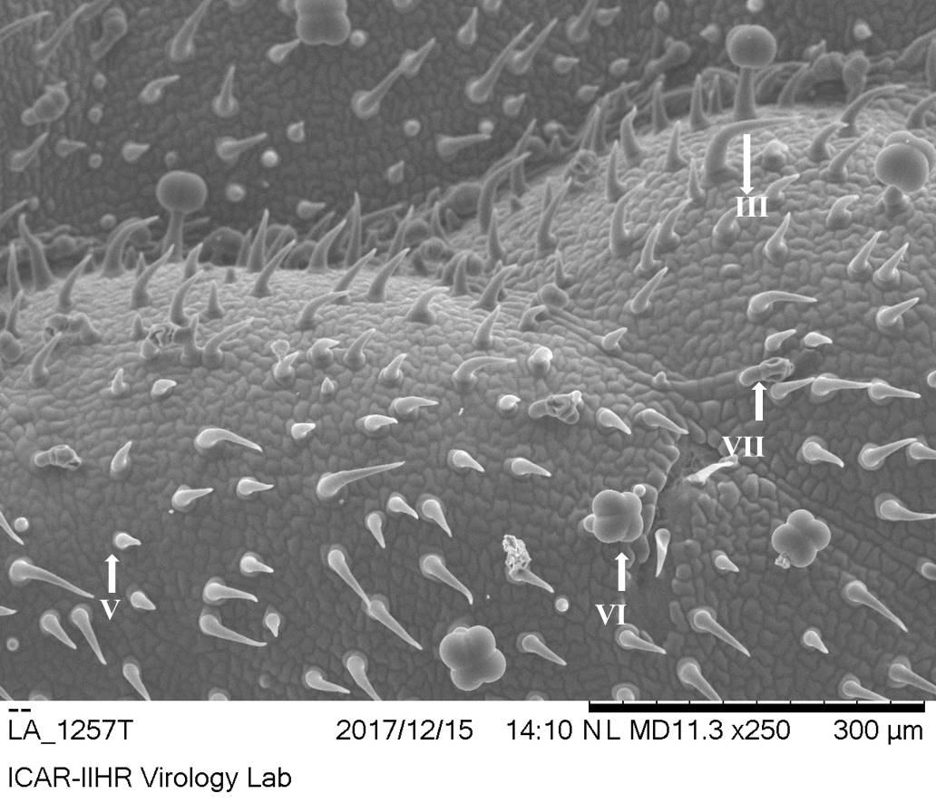



Fig. .S1(a-d). Trichome types in different tomato wild genotypes a) LA-1257 b) LA-1963 c) LA-2157 d) LA-1940

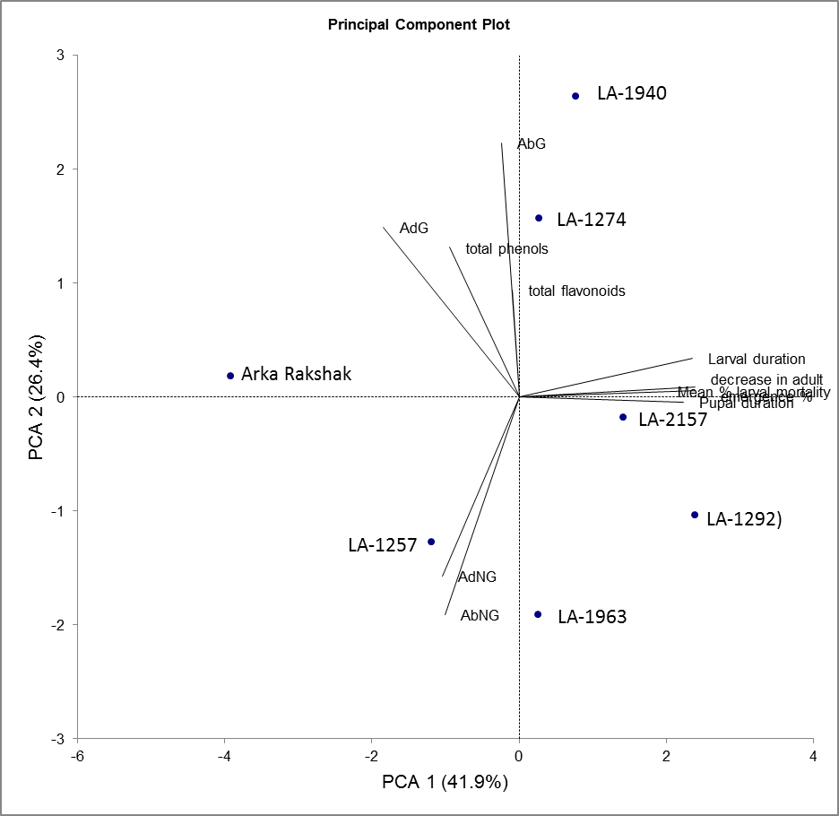

**Fig.S2. PCA biplot depicting variations in resistance against *T. absoluta* among different tomato genotypes**