Supplementary figure legends
Fig. S1 Multiple alignments of HMW-GS from Ae. comosa and Triticeae. The sites of nonconservative cyseine residues were marked by arrows. (A) Multiple alignments of 1Mx2.1 (HM794606) with published x-type HMW-GS; (B) Multiple alignments of 1My12.1 (HM794607) with published y-type HMW-GS.
Fig. S2 E. coli expression of 1Mx2.1 gene from Ae. comosa.

Fig. S1
(A)
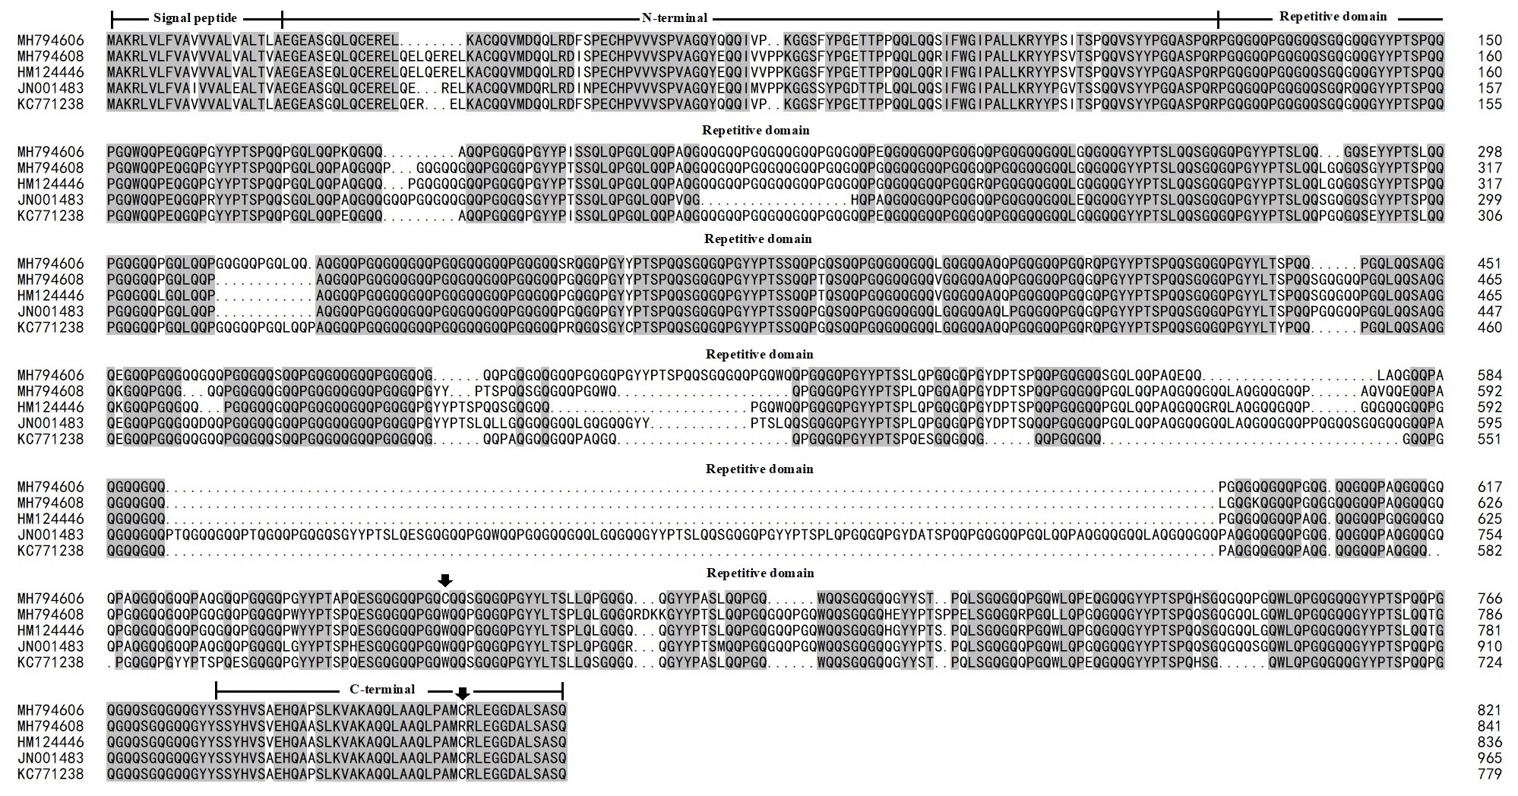
(B)
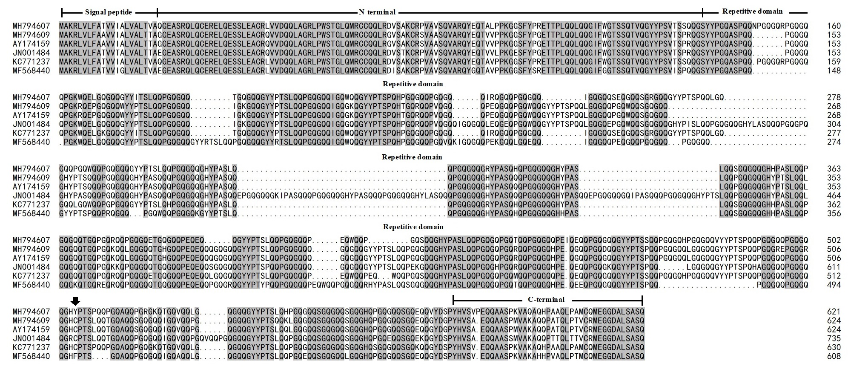

Fig. S2
