Table S1: List of polymorphic markers identified in parental polymorphic survey for PK 1180 x UPSL-298 and PK 1169 x SL 46 cross combinations.
Sl No. | Chromosome | Polymorphic markers | Position on LG (cM) | Motif | Allele size in Williams
1 | Ch1 (D1a) | Satt342 | 48.14 | (ATT)21 | 222
2 | Ch2 (D1b) | Satt296 | 52.61 | (ATT)20 | 185
3 | Ch2 (D1b) | Satt600 | 75.41 | (CAA)18 (TAA)15 | 195
4 | Ch2 (D1b) | Sat_351 | 20.61 | (AT)21 | -
5 | Ch3 (N) | Satt009 | 28.52 | (ATT)14 | 163
6 | Ch3 (N) | Satt257 | 92.56 | (ATT)10 | 252
7 | Ch4 (C1) | Satt565 | 0.00 | (ATT)19 | 186
8 | Ch5 (A1) | Satt619 | 69.21 | (ATT)11 | 126
9 | Ch5 (A1) | Sat_356 | 42.8 | (AT)26 | -
10 | Ch5 (A1) | Satt385 | 64.74 | (ATT)22 | 310
11 | Ch5 (A1) | Satt211 | 95.96 | (ATT)10 | 118
12 | Ch6 (C2) | Satt460 | 117.77 | (ATT)26 | 156
13 | Ch6 (C2) | Satt277 | 107.59 | (ATT)40 | 243
14 | Ch7 (M) | Satt308 | 130.76 | (ATT)21 | 170
15 | Ch7 (M) | Satt463 | 50.10 | (ATT)19 (CAA)17 (ATT)13 | 226
16 | Ch7 (M) | Satt175 | 66.99 | (ATT)16 | 163
17 | Ch7 (M) | Sat_244 | 48.86 | (AT)27 | 224
18 | Ch8 (A2) | Sct_067 | 14.99 | (CT)19 | -
19 | Ch8 (A2) | Satt378 | 165.73 | (ATT)11 | 166
20 | Ch8 (A2) | Satt538 | 159.63 | (ATT)12 | 109
21 | Ch8 (A2) | Satt228 | 154.11 | (ATT)19 | 250
22 | Ch9 (K) | Satt260 | 80.12 | (ATT)22 | 229
23 | Ch10 (O) | Sat_282 | 63.81 | (AT)21 | 175
24 | Ch10 (O) | Satt173 | 58.40 | (ATT)18 | 197
25 | Ch10 (O) | Satt581 | 106.03 | (ATT)11 | 144
26 | Ch10 (O) | Sat_190 | 129.80 | (AT)9 | 193
27 | Ch12(H) | Satt676 | 68.86 | (ATT)22 | 285
28 | Ch12(H) | Satt442 | 46.95 | (ATT)35 | 265
29 | Ch12(H) | Satt541 | 53.35 | (ATT)22 | 174
30 | Ch13 (F) | Sat_317 | 72.97 | (AT)24 | 222
31 | Ch13 (F) | Satt325 | 2.23 | (ATT)19 | 250
32 | Ch14 (B2) | Satt534 | 87.59 | (ATT)25 | 188
33 | Ch14 (B2) | Satt556 | 73.21 | (ATT)14 | 167
34 | Ch14 (B2) | Satt063 | 93.49 | (ATT)20 | 145
35 | Ch14 (B2) | Sat_189 | 72.92 | (AT)10 | 117
36 | Ch15 (E) | Satt685 | 56.70 | (ATT)14 | 213
37 | Ch16 (J) | Satt285 | 25.51 | (ATT)19 | 236
38 | Ch16 (J) | Satt686 | 40.50 | (ATT)14 | 286
39 | Ch17 (D2) | Satt311 | 84.62 | (ATT)13 | 174
40 | Ch18 (G) | Satt288 | 76.77 | (ATT)17 | 228
41 | Ch18 (G) | Satt199 | 62.16 | (ATT)15 | 198
42 | Ch18 (G) | Satt012 | 66.55 | (ATT)19 | -
43 | Ch18 (G) | Sat_223 | 61.64 | (AT)24 | 194
44 | Ch18 (G) | Sat_164 | 68.67 | (AT)19(CT)22 | -
45 | Ch19 (L) | Sat_245 | 115.07 | (AT)27 | 176
46 | Ch19 (L) | Sat_408 | 1.31 | (AT)32 | -
47 | Ch19 (L) | Sat_150 | 53.67 | (AT)24 | 212
48 | Ch19 (L) | Satt652 | 30.88 | (ATT)18 | 217
49 | Ch20 (I) | Satt292 | 80.78 | (ATT)16 | 236
50 | Ch20 (I) | Sat_418 | 74.26 | (AT)26 | -

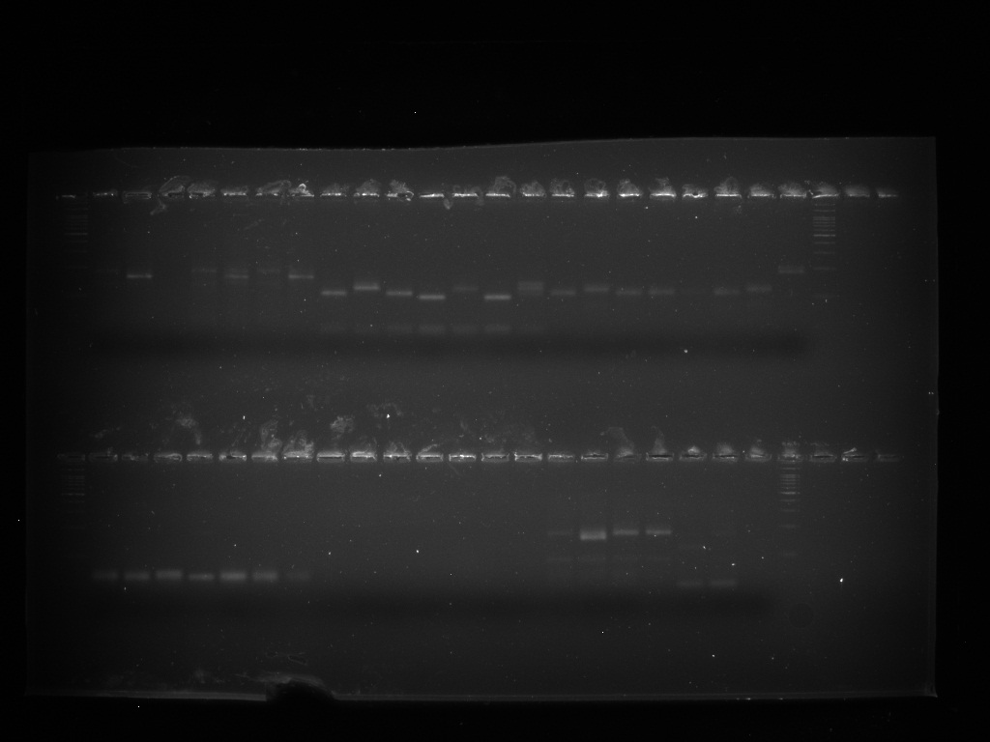
Satt277
A B C P₁ P₂ P₃ P₄
L
L

Fig S1: Polymorphism of SSR markers, Satt277 on the parental lines used for crosses: (P₁= UPSL 298, P₂ = PK 1180, P₃ = PK 1169, P₄ = SL 46 and L = Ladder).
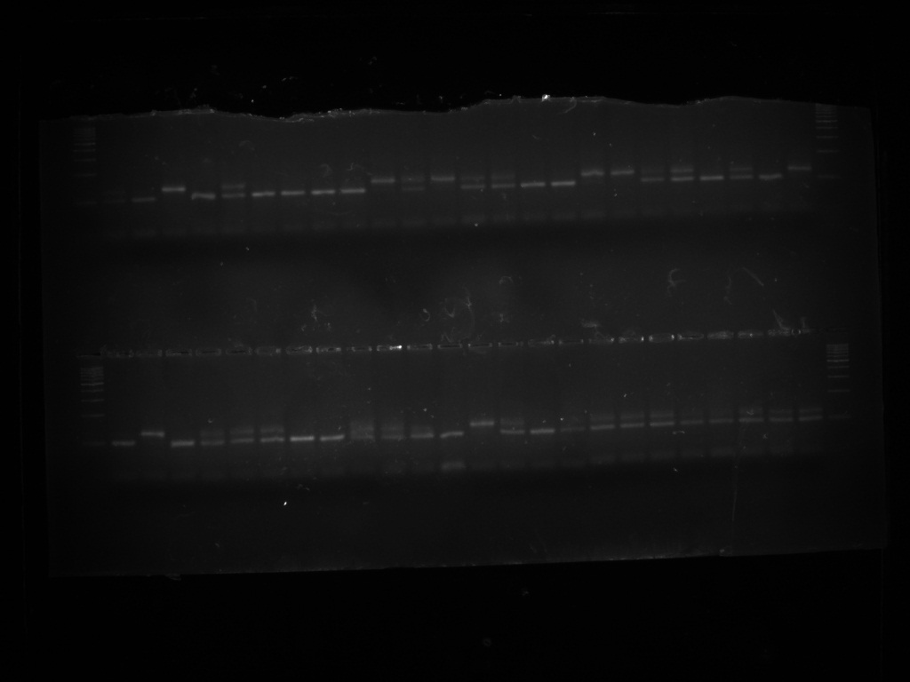
P₁ P₂ SB TB
L
Satt277

(L= Ladder, P1= susceptible parent (UPSL 298), P2= Tolerant parent (PK 1180), SB= Susceptible bulk (UPSL 298) and TB= Tolerant bulk (PK 1180))

Fig S2: Bulk segregant analysis of parental lines (P₁ and P₂), tolerant (TB) and susceptible bulks (SB) using SSR marker Satt277.

L P₁ P₂ SB TB T T S S T T T S T T S T T T T T T T T T L
Satt 277
L G P₁ P₂ SB TB S S S S T T T T T S S T T T T S T S R L

(L= Ladder, P₁= susceptible parent, P₂= Tolerant parent, SB= Susceptible bulk, TB= Tolerant bulk, T= Tolerant reaction and S= Susceptible reaction, G= Gap)
Fig S3: Molecular screening of F₂ population derived from a cross PK 1169 x SL 46 for seedling survival drought tolerance under hydroponics conditions using polymorphic SSR marker Satt277.

Tol locus
Centromere
Satt277
3.4 cM

Fig S4: Genetic map of drought tolerance gene combining SSR marker on chromosome 6 in validation population of a cross PK 1169 x SL 46.
Figure legends
L= Ladder
G = Gap
P1 = Susceptible Parent
P2 = Tolerant parent
P3 = Other parent
P4 = Other parent
SB = Susceptible Bulk
TB = Tolerant Bulk
T = Tolerant reaction
S = Susceptible reaction
Tol locus = Tolerant locus

