Table S 1. Fruit characteristics of different jackfruit genotypes.
Genotype  (ICAR RCER JS) | Fruit Shape | Fruit surface colour | Fruit weight (kg) | Fruit length (cm) | Fruit diameter (cm) | Rind thickness (mm) | Rind weight (kg) | Core length (cm) | Core diameter (mm) | Core weight (kg) | Pulp weight (kg) | Pulp %
5/6 | Oblong | Yellow green | 15.32 | 59.54 | 21.07 | 15.46 | 6.79 | 45.30 | 65.78 | 1.01 | 6.60 | 43.08
3/8 | Oblong | Yellow green | 18.50 | 40.59 | 35.35 | 13.24 | 5.03 | 30.54 | 175.95 | 1.06 | 10.07 | 54.44
1/3 | Oblong | Yellow green | 4.10 | 29.64 | 30.28 | 14.36 | 2.93 | 20.34 | 52.17 | 0.29 | 0.43 | 10.58
2/1 | Cylindrical | Brown | 13.60 | 44.21 | 25.42 | 11.79 | 5.54 | 33.63 | 82.73 | 0.79 | 5.39 | 39.65
1/4 | Oblong | Yellow green | 6.21 | 31.55 | 20.40 | 9.15 | 2.46 | 25.19 | 72.80 | 0.49 | 2.54 | 40.84
2/9 | Oblong | Brown | 7.01 | 34.17 | 21.13 | 10.04 | 2.97 | 29.63 | 98.62 | 0.57 | 2.43 | 34.61
1/7 | Oblong | Green yellow | 9.21 | 36.62 | 22.22 | 7.40 | 3.03 | 27.43 | 90.33 | 0.72 | 4.35 | 47.27
2/4 | Oblong | Yellow green | 15.03 | 39.83 | 32.75 | 11.08 | 4.45 | 28.62 | 165.26 | 1.16 | 7.48 | 49.75
1/10 | Long | Brown | 8.06 | 45.29 | 20.57 | 13.72 | 4.31 | 35.23 | 50.29 | 0.63 | 2.77 | 34.34
6/1 | Long | Yellow green | 8.24 | 47.33 | 20.65 | 13.68 | 5.87 | 31.5 | 68.05 | 0.52 | 0.44 | 5.39
4/4 | Cylindrical | Green | 7.41 | 34.24 | 19.47 | 15.77 | 3.36 | 27.34 | 48.59 | 0.46 | 2.99 | 40.33
5/9 | Oval | Brown | 5.41 | 31.22 | 21.43 | 11.78 | 2.72 | 25.05 | 59.70 | 0.38 | 1.77 | 32.72
6/3 | Oblong | Yellow green | 9.35 | 39.29 | 20.19 | 12.10 | 2.85 | 34.27 | 44.43 | 0.45 | 5.63 | 60.26
6/8 | Oblong | Yellow green | 9.12 | 38.63 | 20.27 | 15.37 | 3.47 | 34.43 | 65.20 | 0.50 | 4.24 | 46.51
7/7 | Oblong | brown | 17.58 | 42.80 | 33.60 | 14.20 | 5.61 | 32.78 | 122.21 | 0.20 | 9.99 | 56.80
1/8 | Oval | Yellow green | 3.84 | 25.28 | 17.55 | 8.73 | 1.42 | 21.22 | 59.35 | 0.31 | 1.64 | 42.69
8/5 | Long | Yellow green | 8.10 | 44.21 | 19.42 | 7.79 | 3.72 | 37.77 | 83.73 | 0.66 | 3.45 | 42.60
6/5 | Cylindrical | Yellow green | 5.24 | 33.65 | 19.32 | 10.33 | 2.91 | 24.64 | 64.04 | 0.46 | 1.45 | 27.73
3/1 | Cylindrical | Brown | 5.33 | 33.16 | 20.77 | 14.40 | 3.55 | 25.83 | 87.30 | 0.44 | 0.90 | 16.91
1/6 | Cylindrical | Yellow green | 6.12 | 34.23 | 20.63 | 14.60 | 3.22 | 23.23 | 42.10 | 0.30 | 2.27 | 37.12
10/2 | Cylindrical | Yellow green | 5.72 | 31.46 | 20.67 | 8.79 | 2.36 | 25.26 | 72.00 | 0.55 | 2.09 | 36.54
7/3 | Elongate | Brown | 12.36 | 44.21 | 25.42 | 12.79 | 5.52 | 35.72 | 94.73 | 1.15 | 4.76 | 38.49
8/3 | Elongate | Brown | 11.86 | 41.29 | 25.57 | 15.71 | 5.38 | 30.53 | 40.28 | 0.49 | 5.41 | 45.60
3/4 | Oblong | Brown | 8.84 | 43.31 | 22.61 | 9.70 | 5.47 | 35.54 | 67.17 | 0.44 | 2.26 | 25.58
7/8 | Oblong | Yellow green | 7.66 | 35.24 | 21.49 | 17.76 | 2.87 | 24.05 | 42.54 | 0.34 | 3.45 | 45.02
4/2 | Oblong | Brown | 11.84 | 41.45 | 23.55 | 14.90 | 7.29 | 29.21 | 50.35 | 0.65 | 3.20 | 26.99
10/3 | Oval | Green | 7.03 | 29.43 | 21.37 | 14.06 | 2.19 | 21.61 | 75.89 | 0.31 | 3.83 | 54.45
7/4 | Oblong | Brown | 4.83 | 29.41 | 17.43 | 9.98 | 2.51 | 19.30 | 36.71 | 0.23 | 1.88 | 38.91

Table S 2. Flake characteristics of different jackfruit genotypes.
Genotype | Flake shape | Flake colour | No. of bulbs | Average flake weight (g) | Average flake length (mm) | Average flake diameter (mm)
5/6 | Oblong | Yellow | 234.46 | 30.70 | 56.82 | 33.33
3/8 | Oblong | Light yellow | 308.03 | 42.73 | 78.24 | 37.42
1/3 | Oblong | Yellow | 105.00 | 14.25 | 53.22 | 29.43
2/1 | Oblong | Yellow | 395.82 | 21.05 | 67.05 | 25.29
1/4 | Conical | Yellow | 188.82 | 21.75 | 53.45 | 29.28
2/9 | Oblong | Light yellow | 230.62 | 18.30 | 47.87 | 23.67
1/7 | Oblong | Light yellow | 280.00 | 18.10 | 54.60 | 26.44
2/4 | Conical | Light yellow | 370.33 | 33.71 | 67.42 | 34.43
1/10 | Oblong | Light yellow | 105.00 | 16.90 | 60.41 | 24.46
6/1 | Conical | Light yellow | 225.62 | 38.76 | 61.43 | 37.64
4/4 | Conical | yellow | 173.00 | 18.90 | 51.68 | 30.82
5/9 | Conical | Light yellow | 98.00 | 41.75 | 64.26 | 40.66
6/3 | Elongated | yellow | 142.61 | 42.25 | 66.86 | 37.42
6/8 | Conical | Light yellow | 113.00 | 44.15 | 71.66 | 37.41
7/7 | Elongated | Light yellow | 533.00 | 23.45 | 62.46 | 27.65
1/8 | Conical | Light yellow | 123.66 | 23.25 | 46.44 | 26.83
8/5 | Elongated | Yellow | 222.00 | 14.95 | 56.27 | 23.48
6/5 | Conical | Light yellow | 135.00 | 21.50 | 51.84 | 28.45
3/1 | Conical | yellow | 90.25 | 28.32 | 54.65 | 32.66
1/6 | Conical | Light yellow | 85.17 | 43.95 | 58.76 | 39.23
10/2 | Conical | Yellow | 86.00 | 35.05 | 62.44 | 37.25
7/3 | Elongated | Light yellow | 373.00 | 16.75 | 59.88 | 24.62
8/3 | Elongated | Light yellow | 115.48 | 46.80 | 86.03 | 32.64
3/4 | Elongated | Light yellow | 86.00 | 46.85 | 66.34 | 42.72
7/8 | Elongated | Yellow | 168.00 | 30.15 | 70.54 | 26.14
4/2 | Elongated | Light yellow | 140.71 | 41.85 | 67.23 | 39.25
10/3 | Conical | Light yellow | 144.00 | 28.90 | 67.23 | 31.54
7/4 | Conical | Yellow | 48.00 | 40.07 | 62.34 | 40.43

Table S 3. Seed characteristics of different jackfruit genotypes.
Genotype | Average seed weight (g) | Total seed weight (kg/fruit) | Average seed length (mm) | Average seed diameter (mm)
5/6 | 3.95 | 0.92 | 25.24 | 16.63
3/8 | 7.60 | 2.34 | 36.62 | 20.74
1/3 | 4.25 | 0.45 | 28.84 | 20.40
2/1 | 4.75 | 1.88 | 31.23 | 16.28
1/4 | 3.85 | 0.72 | 28.88 | 18.43
2/9 | 4.55 | 1.05 | 31.65 | 17.42
1/7 | 3.95 | 1.11 | 30.27 | 16.58
2/4 | 5.25 | 1.94 | 31.83 | 19.12
1/10 | 3.35 | 0.35 | 22.48 | 12.27
6/1 | 6.25 | 1.41 | 29.83 | 18.83
4/4 | 3.50 | 0.60 | 24.42 | 17.00
5/9 | 5.52 | 0.54 | 27.35 | 20.44
6/3 | 2.96 | 0.42 | 24.68 | 14.27
6/8 | 8.13 | 0.92 | 34.24 | 21.52
7/7 | 3.35 | 1.79 | 25.07 | 14.89
1/8 | 3.81 | 0.47 | 24.86 | 16.82
8/5 | 1.24 | 0.27 | 24.64 | 12.49
6/5 | 3.10 | 0.42 | 21.88 | 15.42
3/1 | 4.90 | 0.44 | 31.84 | 18.86
1/6 | 3.83 | 0.33 | 26.62 | 17.44
10/2 | 8.44 | 0.73 | 31.68 | 16.80
7/3 | 2.50 | 0.93 | 26.43 | 12.83
8/3 | 5.07 | 0.58 | 31.47 | 17.68
3/4 | 7.75 | 0.67 | 32.28 | 22.17
7/8 | 5.95 | 1.00 | 34.82 | 17.80
4/2 | 5.06 | 0.71 | 33.45 | 20.82
10/3 | 4.81 | 0.69 | 28.61 | 17.77
7/4 | 4.41 | 0.21 | 26.46 | 16.27

Table S 4. Clustering of jackfruit genotypes based on fruit traits.
Cluster | Number of genotype | Accessions (ICAR RCER JS)
1 | 1 | 7/7
2 | 4 | 3/8, 2/4, 2/1, 7/3
3 | 18 | 1/3, 1/10, 5/9, 10/2, 3/4, 1/6, 3/1, 6/3, 4/2, 6/8, 8/3, 1/8, 6/5, 10/3, 1/4, 4/4, 7/8, 7/4
4 | 5 | 2/9, 8/5, 5/6, 6/1, 1/7

Genotype  (ICAR RCER JS) | Fruit | Bulb | Seed
JS 10/3 | 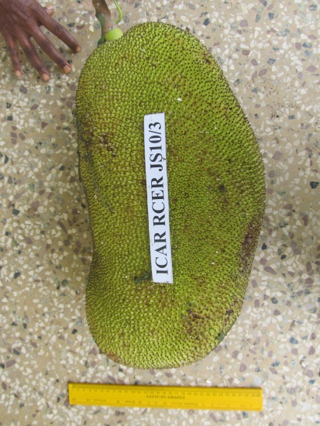 | 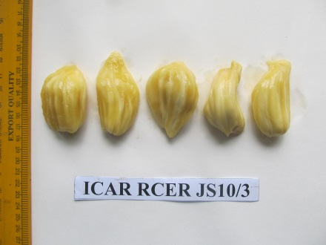 | 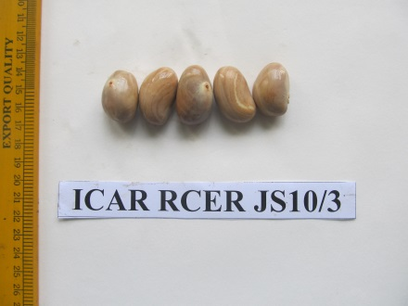
JS 8/3 | 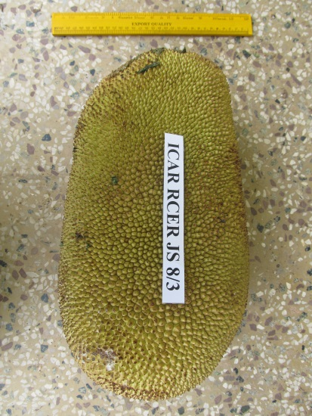 | 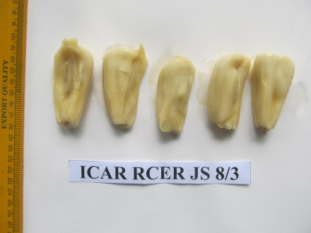 | 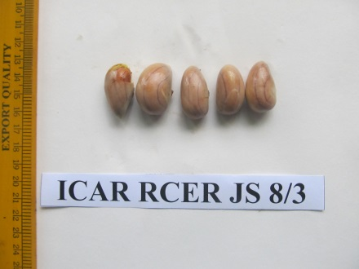
JS 6/3 | 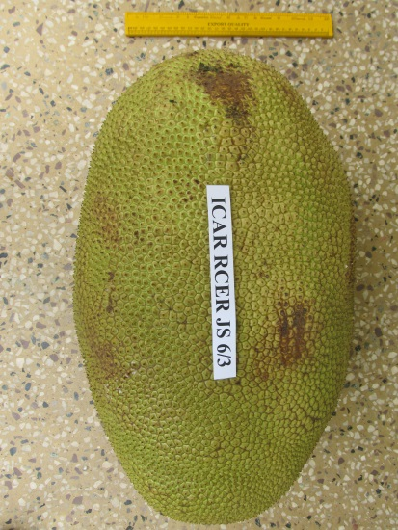 | 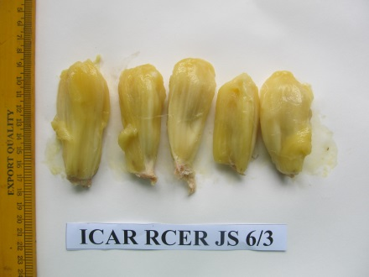 | 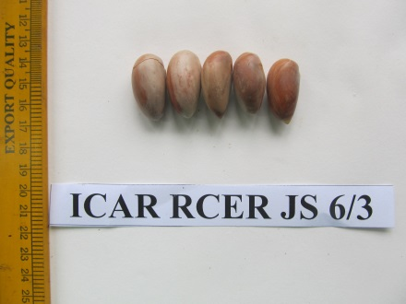
Figure S 1. Promising genotypes of jackfruit

