Table S1. Passport data of the collected Cordia sinensis germplasm

Sl.No. | Collector number | Site of Collection  (Village/Block/District | Latitude  (N˚) | Longitude  (E˚) | Altitude  (m) | Habitat | Topography | Frequency | Threat of erosion
 |  | Seed
1 | CBCG-1 | Kotda Ugamana/Bhuj/Kachchh | 23.072390 | 69.471840 | 139 | Scrub forest | Undulating | Frequent | Low
2 | CBCG-2 | Bhujodi/Bhuj/Kachchh | 23.233605 | 69.736678 | 94 | Field boundary | Level | Frequent | Low
3 | CBCG-3 | Madhapar/Bhuj/Kachchh | 23.235611 | 69.731691 | 99 | Field boundary | Level | Frequent | Low
4 | CBCG-4 | Pragpar/Rapar/Kachchh | 23.547210 | 70.731310 | 100 | Backyard | Level | Occasional | Low
5 | CBCG-5 | Pragpar/Rapar/Kachchh | 23.562876 | 70.705631 | 83 | Road side | Level | Occasional | Low
6 | CBCG-6 | Tapkeshwari/Bhuj/Kachchh | 23.181474 | 69.667371 | 203 | Scrub forest | Hilly | Frequent | Low
7 | CBCG-7 | Tapkeshwari/Bhuj/Kachchh | 23.181237 | 69.666934 | 221 | Scrub forest | Hilly | Frequent | Low
8 | CBCG-8 | Tapkeshwari/Bhuj/Kachchh | 23.181392 | 69.667748 | 191 | Scrub forest | Hilly | Frequent | Low
9 | CBCG-9 | Madhapar/Bhuj/Kachchh | 23.216438 | 69.724547 | 105 | Field boundary | Level | Frequent | Low
10 | CBCG-10 | Madhapar/Bhuj/Kachchh | 23.215763 | 69.722822 | 103 | Field boundary | Undulating | Frequent | Low
11 | CBCG-11 | Saiyedpar/Bhuj/Kachchh | 23.195081 | 69.856437 | 140 | Backyard | Level | Frequent | Low
12 | CBCG-12 | Dahisar/Mandvi/Kachchh | 23.082890 | 69.521908 | 162 | Road side | Undulating | Abundance | Low
13 | CBCG-13 | Koday/Mandvi/Kachchh | 22.535740 | 69.233690 | 0 | Road side | Undulating | Abundance | Low
14 | CBCG-14 | Kodaypul/Mandvi/Kachchh | 22.891516 | 69.407694 | 32 | Road side | Undulating | Abundance | Low
15 | CBCG-15 | VRTI/Mandvi/Kachchh | 22.846240 | 69.374692 | 13 | Field boundary | Level | Abundance | Low
16 | CBCG-16 | Vijay Vilas Palace/Mandvi/Kachchh | 22.857327 | 69.291856 | 11 | Field boundary | Level | Abundance | Low
 |  | Cutting
17 | CBCG-17 | Kharoi/Bhachau/Kachchh | 23.325812 | 70.343536 | 28 | Field boundary | Level | Frequent | Low
18 | CBCG-18 | Ustiya/Abdasa/Kachchh | 23.381088 | 68.966800 | 55 | Road side | Level | Frequent | Low
19 | CBCG-19 | Kothara/Abdasa/Kachchh | 23.139855 | 68.957296 | 38 | Field boundary | Level | Frequent | Low
20 | CBCG-20 | Ranara Mota/Nakhatrana/Kachchh | 23.299100 | 69.451830 | 118 | Scrub forest | Level | Occasional | Low

Table S2. Soil chemical status of the surveyed sites
Parameters | Soil depth (cm) | Range |  | Mean | SD | CV (%) | SE
Parameters | Soil depth (cm) | Min | Max
pH | 0-15 | 7.1 | 9.0 | 8.21 | 0.51 | 6.25 | 0.13
pH | 16-30 | 7.3 | 8.9 | 8.31 | 0.43 | 5.13 | 0.11
EC (dSm⁻¹) | 0-15 | 0.1 | 2.7 | 0.44 | 0.64 | 144.37 | 0.16
EC (dSm⁻¹) | 16-30 | 0.1 | 2.5 | 0.41 | 0.60 | 144.71 | 0.15
OC (%) | 0-15 | 0.0 | 0.5 | 0.13 | 0.12 | 91.81 | 0.03
OC (%) | 16-30 | 0.0 | 0.2 | 0.10 | 0.05 | 49.31 | 0.01
Av. P (kg h⁻¹) | 0-15 | 0.1 | 5.7 | 1.57 | 1.34 | 85.39 | 0.35
Av. P (kg h⁻¹) | 16-30 | 0.1 | 5.2 | 1.55 | 1.71 | 110.27 | 0.44
Av. Na (kg h⁻¹) | 0-15 | 132.2 | 979.2 | 365.08 | 215.84 | 59.12 | 55.73
Av. Na (kg h⁻¹) | 16-30 | 147.8 | 647.4 | 354.07 | 146.70 | 41.43 | 37.88
Av. K (kg h⁻¹) | 0-15 | 60.5 | 705.6 | 245.80 | 226.51 | 92.15 | 58.48
Av. K (kg h⁻¹) | 16-30 | 58.2 | 694.4 | 233.48 | 200.03 | 85.68 | 51.65
Ca (mg L⁻¹) | 0-15 | 20.0 | 185.0 | 91.33 | 51.01 | 55.85 | 13.17
Ca (mg L⁻¹) | 16-30 | 20.0 | 200.0 | 91.00 | 54.52 | 59.91 | 14.08
Mg (mg L⁻¹) | 0-15 | 10.0 | 160.0 | 70.07 | 51.85 | 73.99 | 13.39
Mg (mg L⁻¹) | 16-30 | 20.0 | 110.0 | 60.33 | 29.00 | 48.06 | 7.49

Table S3. Nursery multiplication of C. sinensis germplasm
Characteristics | Mean | Range
Seed germination (%) | 35 | 28- 42
Days to seed germination (days) | 12 | 8 - 23
Cutting sprouting (%) | 25 | 17 – 32
Days to sprouting (days) | 17 | 15 – 25

Table S4. Food and fodder value of C. sinensis
Food value (Fruits) | (%) | Fodder value of leaves | (%)
Moisture | 73 | DM | 41.2
CP | 12.6 | CP | 13.8
Fat | 1.8 | Ash | 18.9
Simple sugar | 68.8 | NDF | 56.6
Dietary fiber | 11.6 | aADF | 43.3
Energy (kJ (kcal)/100 g dry wt.) | 18.9 | bADL | 18.9
Murray et al., (2001); Kuria et al., (2005)

Table S5. Medicinal uses of C. sinensis
Plant part | Active compound | Use | Reference
Stem bark | Caumarins, glycol-alkaloids | Astringent | Vikrant and Kumar (2011)
Stem bark | Flavonoids | Diarrhoea, chest pains | Omwenga et al., (2009)
Stem bark | kaempferide-3-O-D-gluco-pyranoside (62.4%) and kaempferol-3-O-D-gluco-pyranoside (59.6%) | Anti-inflammatory  Antioxidant, Digestive and Respiratory system disorder | Al-Musayeib et al., (2011)
Leaves | p-Coumaric | Antimicrobial | Gumgumjee and Hajar (2015)
Leaves | trans-caffeic acid,  rosmarinic acid | Anti-inflammatory,  Antioxidant | Al-Musayeib et al., (2011)
Young branches | - | Oral hygiene (used as chewing sticks) | Nyambe (2014)

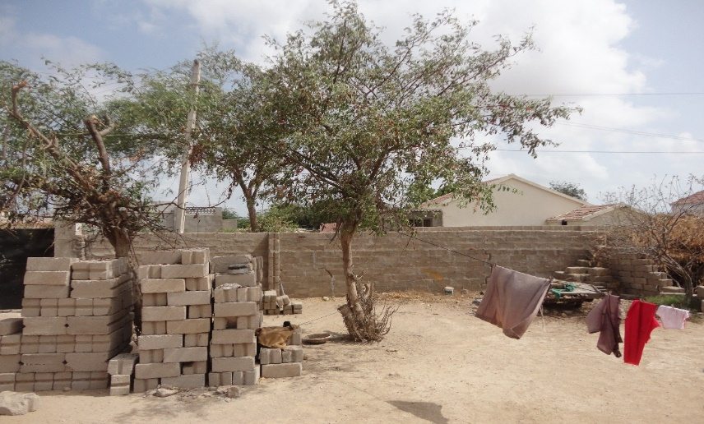
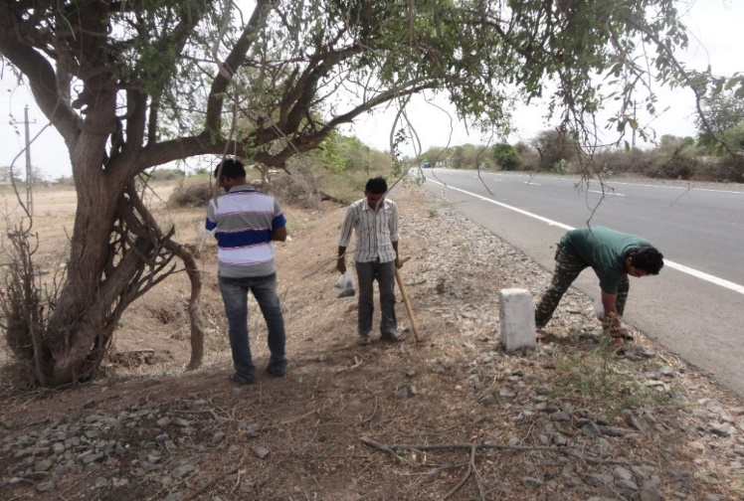
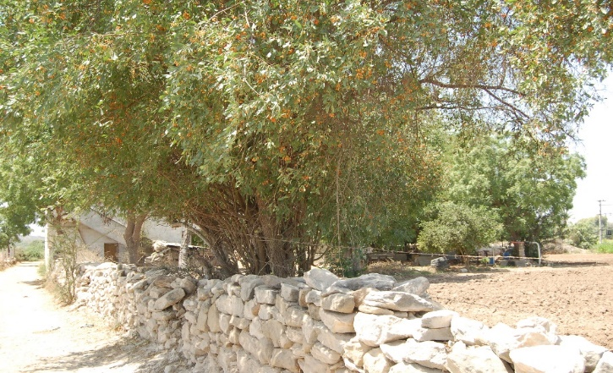
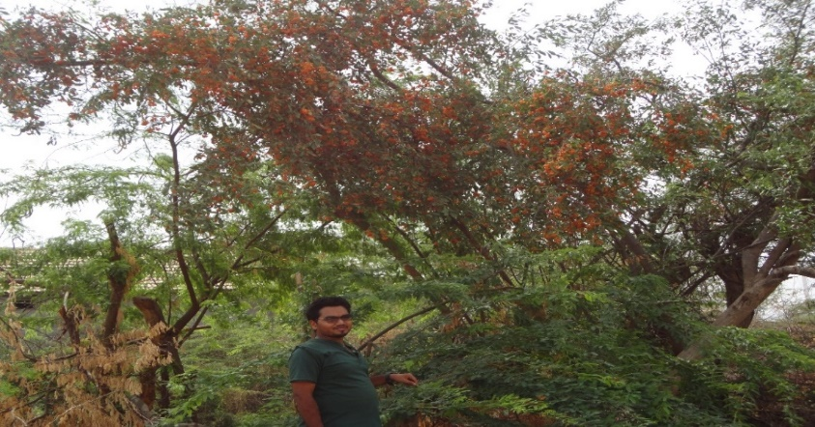
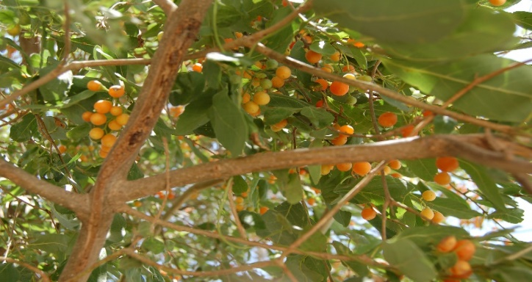
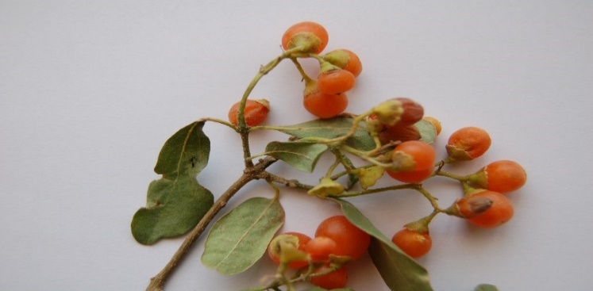
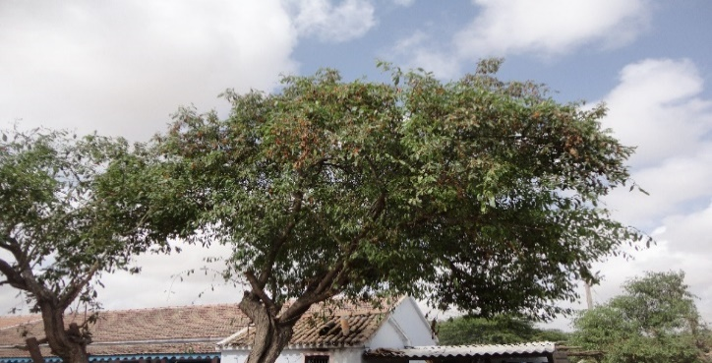
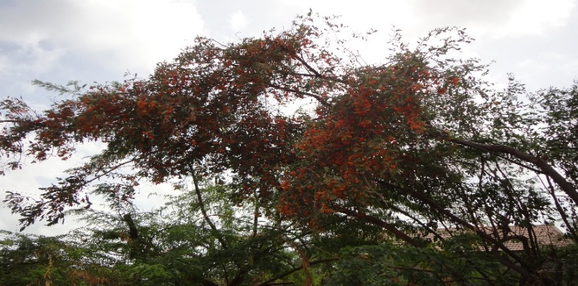
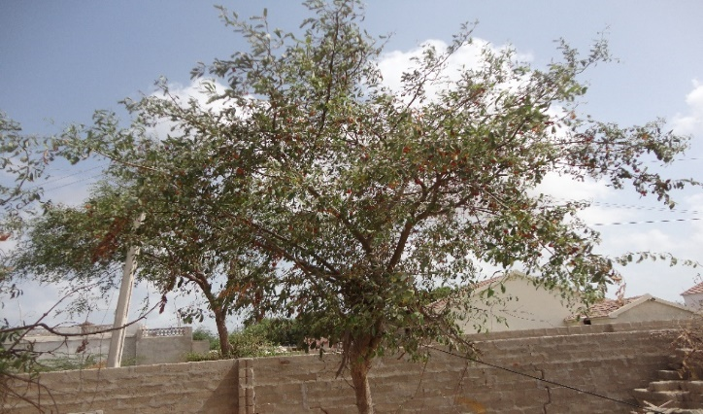
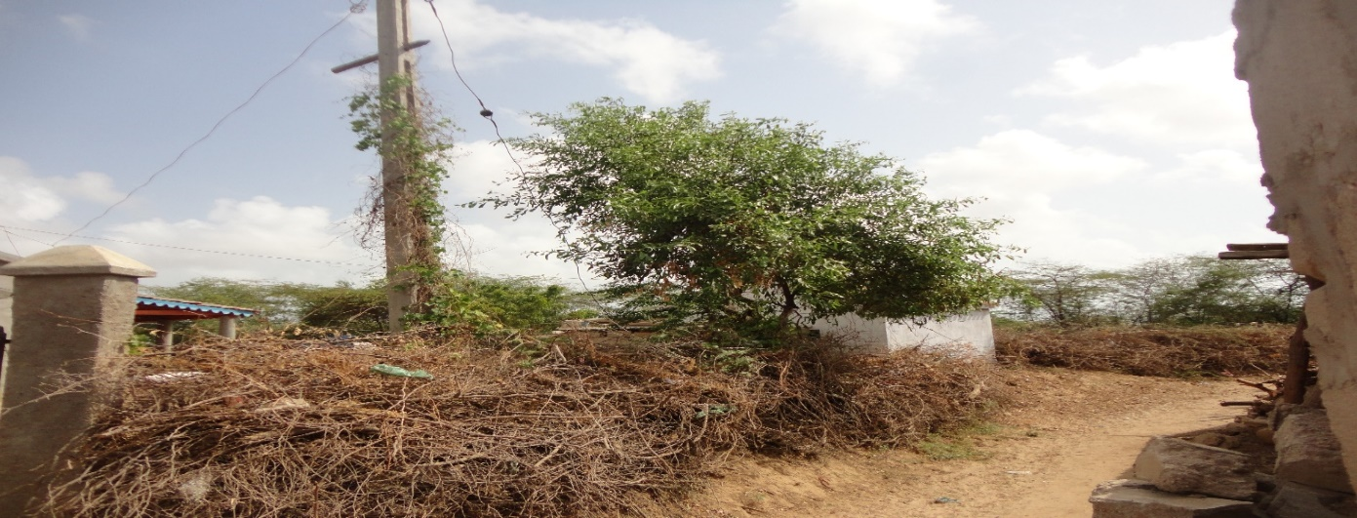
a
c
b
d
e
g
f
h
i
j

Fig. S1 Habitat and Morphological diversity; a: Tree in backyard; b: Tree on roadside; c: Tree on field boundary; d: tree in the wild; e-f: colour of fruits (light to dark orange); g-h: Bearing habit (light – profuse); i-j: Canopy spread (spreading to compact).

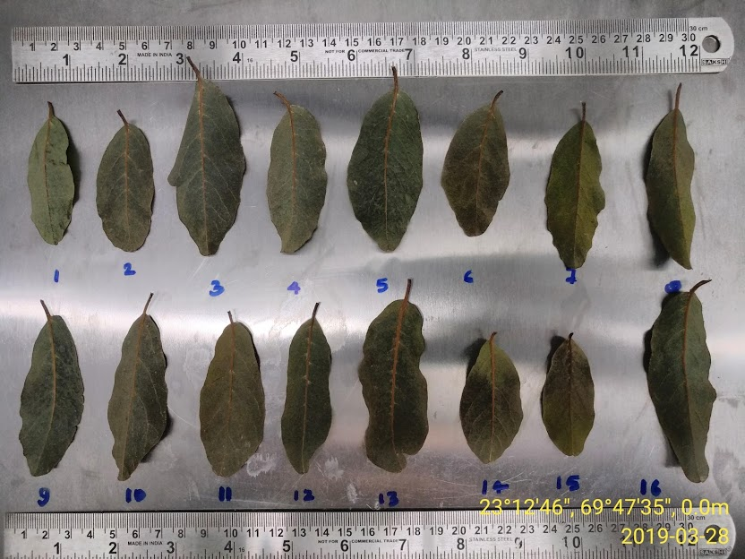
Fig. S2 Morphological variation in the leaves of collected C. sinensis germplasm

