**Supplementary material**

**Table S1** Olive SRBs accession numbers and qRT-PCR primers.

|  |  |  |  |  |
| --- | --- | --- | --- | --- |
| Genbank accession | Gene | Description | Primer sequence (5' – 3') | Size (bp) |
| KF953476 | *OeMO1* | Monooxygenase 1 | GATAAATGAAGTTGGAGAAGCAATTG | 171 |
|  |  |  | ACCAACTGGATCACGAAACAGAATG |  |
| KF953477 | *OeCCX1* | Cation calcium exchanger 1 | CTTCATTTTTAGGGCTCACGGTACTAGC | 169 |
|  |  |  | AAGAGTGACAATCCCAAACCCACC |  |
| KF953478 | *OeSTO* | Salt tolerance protein | CGGAATTCAGGTTGCTTTAAACTCC | 163 |
|  |  |  | TTGAAGCAAATCGTCGATAGCCC |  |
| KF953479 | *OePMP3* | Proteolipid membrane potential modulator | GATATGGCTGCAAGGTTGAATTTTGG  ATCAACACCATCCAGCAAGAAAGG | 182 |
| KF953480 | *OeUSP2* | Universal stress protein | ATAGTCAAGGATCCAGATTTTCACAAGC | 177 |
|  |  |  | CAACACCGTAACCAGAAACAATTCATCT |  |
| KF953481 | *OeAP-4* | Adaptor protein complex 4 medium mu4 subunit | GAAGCTAACGTTTCCACAGGAGTTGC  CACCCAACGATATGGGTTGTAAGC | 160 |
| KF953482 | *OeWRKY1* | WRKY1 transcription factor | CGTCCATGCAAGCACCATCG | 178 |
|  |  |  | ACATTGCATCCAGCATGTGTGC |  |
| KF953483 | *OeKT2* | Potassium transporter 2 | GAATCTGAACTCATTAGTAGACTGGCGG | 170 |
|  |  |  | AATGCAGGTAAGCCAGAGAATGTC |  |
| - |  | Actin 1 | TTAATAGGAATGGAATCTGCAGGAATCC | 167 |
|  |  |  | CAAGAGCTGTAATTTCCTTACTCATGCG |  |

**Table S2** GO terms associated with olive SRBs.

|  |  |  |  |  |
| --- | --- | --- | --- | --- |
|  | Protein | GO | Term | Type* |
| 1 | OeMO1 | GO:0005783  GO:0009617 | Endoplasmic reticulum  Response to bacterium | C  P |
| 2 | OeCCX1 | GO:0005432  GO:0010260  GO:0046482  GO:0035725  GO:0016021 | Calcium:sodium antiporter activity  Organ senescence  Para-aminobenzoic acid metabolic process  Sodium ion transmembrane transport  Integral to membrane | F  P  P  P  C |
| 3 | OeSTO | GO:0016301  GO:0016310  GO:0005622  GO:0008270 | Kinase activity  Phosphorylation  Intracellular  Zinc ion binding | F  P  C  F |
| 4 | OePMP3 | GO:0016023  GO:0016021 | Cytoplasmic membrane-bounded vesicle  Integral to membrane | C  C |
| 5 | OeUSP2 | GO:0009506  GO:0005886  GO:0006950 | Plasmodesma  Plasma membrane  Response to stress | C  C  P |
| 6 | OeAP-4 | GO:0006623  GO:0030125  GO:0016192  GO:0005829  GO:0030131  GO:0005515 | Protein targeting to vacuole  Clathrin vesicle coat  Vesicle-mediated transport  Cytosol  Clathrin adaptor complex  Protein binding | P  C  P  C  C  F |
| 7 | OeWRKY1 | GO:0003700  GO:0006355  GO:0043565 | Sequence-specific DNA binding transcription factor activity  Regulation of transcription, DNA-dependent  Sequence-specific DNA binding | F  P  F |
| 8 | OeKT2 | GO:0015079  GO:0071805  GO:0016020 | Potassium ion transmembrane transporter activity  Potassium ion transmembrane transport  Membrane | F  P  C |

* C = cellular component, F = molecular function and P = biological process. ± SE.

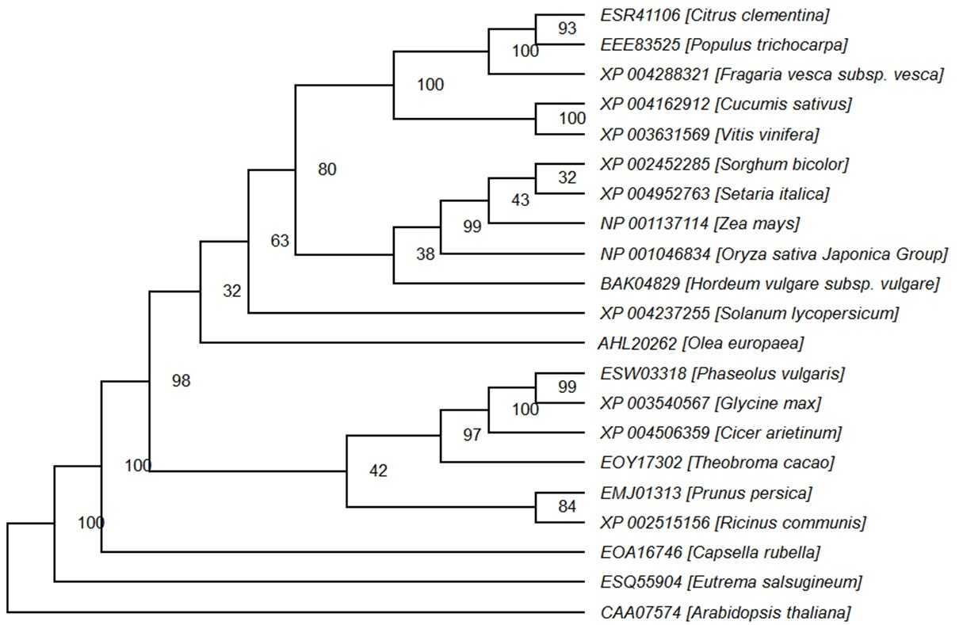

**Fig. S1** Phylogeny of OeMO1 and homologs from related plant species based on parsimony method. Accession numbers are indicated left to scientific names. Branching points showing bootstrap values.

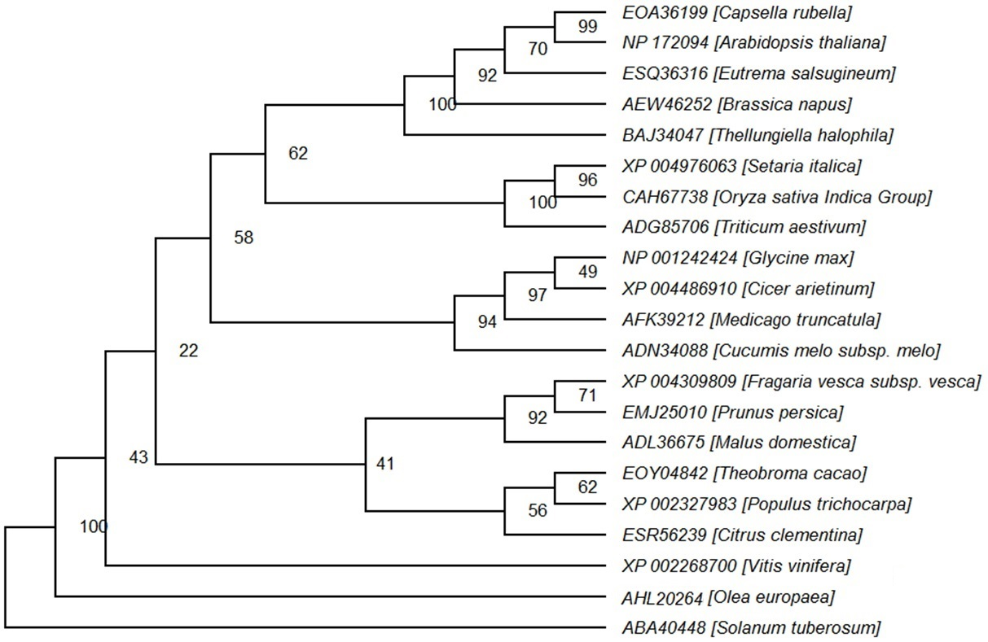

**Fig. S2** Phylogeny of OeSTO and homologs from related plant species based on parsimony method. Accession numbers are indicated left to scientific names. Branching points showing bootstrap values.



**Fig. S3** Phylogeny of OePMP3 and homologs from related plant species based on parsimony method. Accession numbers are indicated left to scientific names. Branching points showing bootstrap values.



**Fig. S4** Phylogeny of OeUSP2 and homologs from related plant species based on parsimony method. Accession numbers are indicated left to scientific names. Branching points showing bootstrap values.



**Fig. S5** Phylogeny of OeAP-4 and homologs from related plant species based on parsimony method. Accession numbers are indicated left to scientific names. Branching points showing bootstrap values.



**Fig. S6** Phylogeny of OeKT2 and homologs from related plant species based on parsimony method. Accession numbers are indicated left to scientific names. Branching points showing bootstrap values.