Figure legends
Supplementary Figure S1 (a) SDS-PAGE analysis of HMW-GS in Elymus sibiricus. (b) PCR amplification of HMW-GS coding genes from E. sibiricus. CS: Chinese spring; M: DNA ladder.
Supplementary Figure S2 (a) E. coli expression of 1Sty13 in BL21(DE3). Lane 1: HMW-GS of GS12, lane 2: BL21(DE3) without IPTG induction; lane 3: BL21(DE3) containing empty vector induced with IPTG; lane 4: BL21(DE3) containing plasmid pET-1Sty13 induced with IPTG. (b) Western blot analysis of 1Sty13 and bacterial expression products. Lane 1, 1Sty13 in Elymus sibiricus; lane 2, total cell proteins from E. coli containing pET-1Sty13 and induced with IPTG ; lane 3, total cell proteins from E. coli containing pET-1Sty13 without IPTG induction.

Supplementary Figure S1
(a)
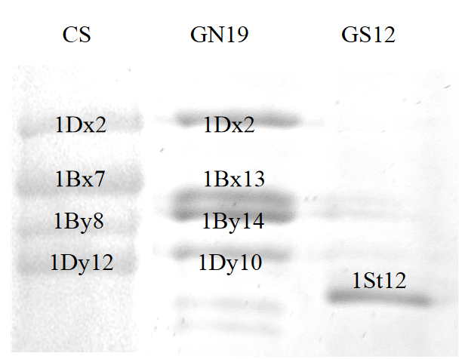
(b)
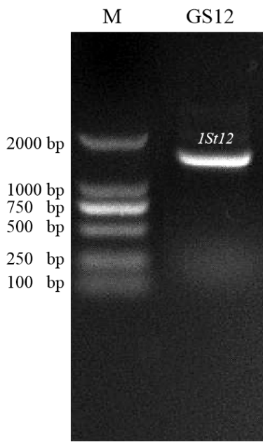

Figure S2
(a)
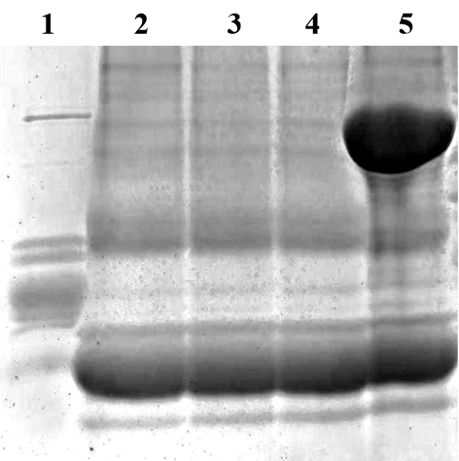
(b)
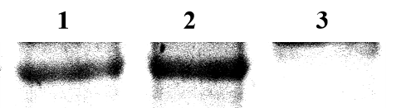

Table S1 Primers used in this study. Nde I and EcoR I restriction sites in P3 and P4, respectively are underlined.
Primers | Sequence (5′-3′) | Description
P1 | ATGGCTAAGCGGC/TTA/GGTCCTCTTTG | Amplification of coding sequence of 1Sty13.
P2 | CTATCACTGGCTG/AGCCGACAATGCG | Amplification of coding sequence of 1Sty13.
P3 | CATATGTTTGGGCAACTACAGTGTGAGCG | Construction of a prokaryotic expression vector.
P4 | GAATTCCTGGCTAGCCGACAATGCGTCG | Construction of a prokaryotic expression vector.

