Supplementary Material

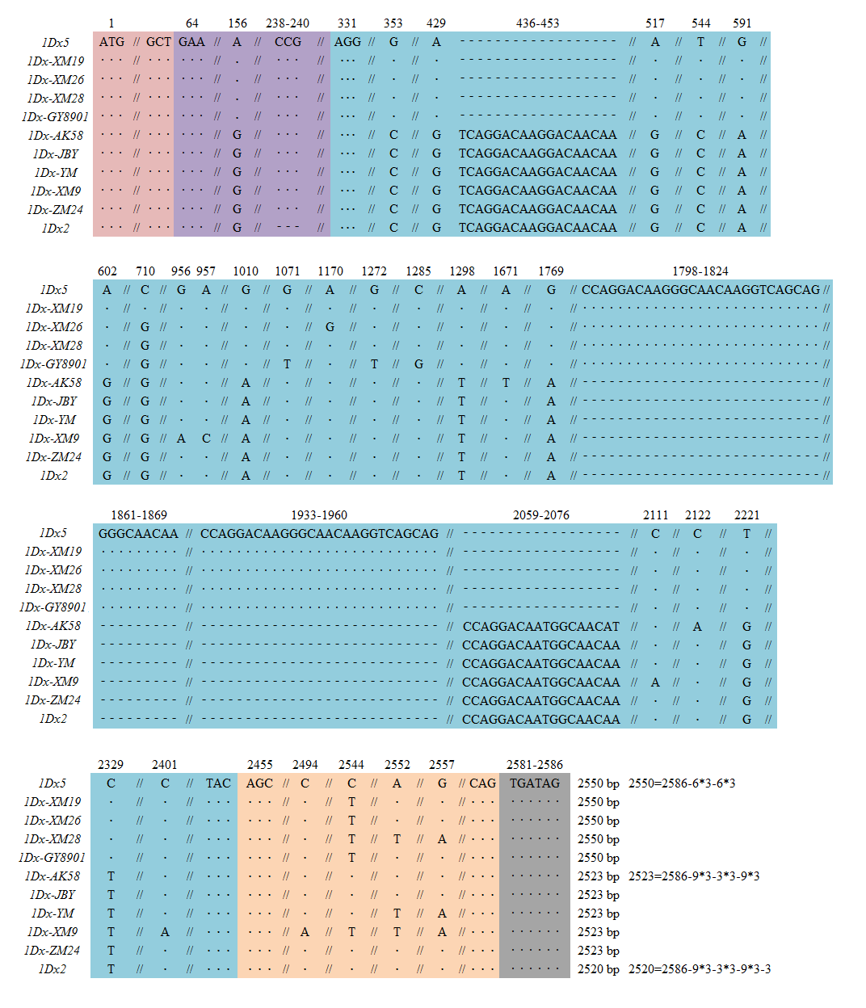

Supplementary Fig.1 Multiple alignment of the DNA sequences
: Signal peptide, : N-terminal domain, : Central repetitive, : C-terminal domain, : Stop codon, ·: same base, -: deletion, //: abbreviated same sequence.

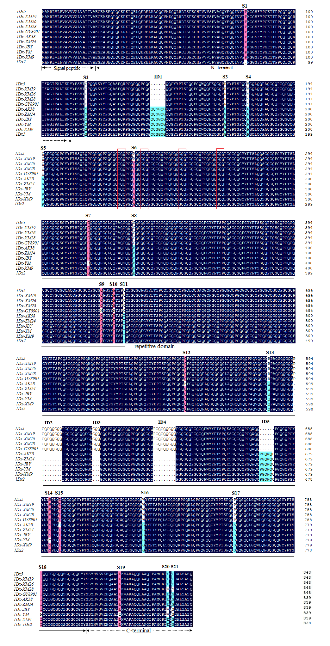
Supplementary Fig.2 Multiple alignment of the deduced amino acid sequences
S1~S21: amino acid variable sites, ID1~ID5: insertion/deletion site,Signal peptide: signal peptide domain, N-terminal:N-terminal domain, repetitive domain :central repeat domain, C-terminal : C-terminal domain, :parts of tripeptides.

