**ONLINE APPENDICES**

**APPENDIX A – Survey Tool**

Please select the appropriate responses below. Opioid use disorders are defined as problematic patterns of opioid use leading to clinically significant impairment or distress within a 12-month period.

1. How often do you care for people with opioid use disorders?
   1. Less than once a week
   2. 1-5 times a week
   3. 6-10 times a week
   4. More than 10 times a week
2. How often do you do the following for patients with opioid use disorders?

|  |  |  |  |  |  |
| --- | --- | --- | --- | --- | --- |
|  | Never | Rarely | Sometimes | Often | Always |
| Give them buprenorphine in the ED |  |  |  |  |  |
| Prescribe clonidine to treat withdrawal |  |  |  |  |  |
| Give them an outpatient script for buprenorphine |  |  |  |  |  |
| Give them an outpatient script for opioids to prevent withdrawal |  |  |  |  |  |
| Give them take-home naloxone |  |  |  |  |  |
| Advise them to get naloxone from Public Health or a pharmacy |  |  |  |  |  |
| Send them to withdrawal  management services  (detox) |  |  |  |  |  |
| Refer them to a  particular methadone or  buprenorphine clinic |  |  |  |  |  |
| Refer them to an  addiction clinic where  they could be seen  within a few days |  |  |  |  |  |
| Advise them to see their  family doctor for help  with their opioid problem |  |  |  |  |  |

1. How satisfied are you with the care that patients receive in your ED who present with a primary complaint related to opioid use disorder (e.g., opioid intoxication, opioid withdrawal, requests for early refills of opioid prescriptions)
   1. Very dissatisfied
   2. Somewhat dissatisfied
   3. Neither satisfied nor dissatisfied
   4. Somewhat satisfied
   5. Very satisfied
2. What changes do you think would be helpful in improving care for opioid-addicted patients in the ED?

|  |  |  |  |  |  |  |
| --- | --- | --- | --- | --- | --- | --- |
|  | Not at all helpful | Not very helpful | Slightly helpful | Helpful | Very helpful | Not applicable |
| Pre-printed order sets for buprenorphine |  |  |  |  |  |  |
| Take home naloxone kits in the ED |  |  |  |  |  |  |
| Phone access to clinical support from addiction specialist |  |  |  |  |  |  |
| On-site consults from addiction specialist |  |  |  |  |  |  |
| On-site case manager |  |  |  |  |  |  |
| Referring patients to an addiction clinic where they could be seen within a few days |  |  |  |  |  |  |

1. Are there any other changes that would be helpful in improving care for opioid-addicted patients in the ED?
2. How useful do you think you would find the following supports?

|  |  |  |  |  |  |
| --- | --- | --- | --- | --- | --- |
|  | Not at all useful | Slightly useful | Moderately useful | Very useful | Extremely useful |
| In-person presentation on treating opioid-related conditions |  |  |  |  |  |
| Brief online learning module on treating opioid-related conditions |  |  |  |  |  |
| Written protocols for treating opioid-related conditions |  |  |  |  |  |

1. Are there other supports not mentioned above that would be helpful to you in treating patients with opioid addiction?

Please select the appropriate responses below.

1. What is your age?
   1. 20-29
   2. 30-39
   3. 40-49
   4. 50-59
   5. 60-69
   6. 70-79
   7. 80 or older
2. What is your gender?
   1. Female
   2. Male
   3. Non-binary
   4. Prefer not to say
   5. Prefer to self-describe
3. Your level of training:
   1. Attending physician
   2. Resident: PGY1
   3. Resident: PGY2
   4. Resident: PGY3
   5. Resident: PGY4
   6. Resident: PGY5
   7. Resident: PGY6 or higher/fellow
4. How long have you been practicing emergency medicine?
   1. Less than 5 years
   2. 5 to 9 years
   3. 10 to 14 years
   4. 15 to 19 years
   5. 20 or more years
   6. Prefer not to answer
   7. Not applicable (in training or not practicing clinically)
5. Where did you do your emergency medicine training?
   1. Alberta
   2. British Columbia
   3. Manitoba
   4. New Brunswick
   5. Newfoundland and Labrador
   6. Northwest Territories
   7. Nova Scotia
   8. Nunavut
   9. Ontario
   10. Prince Edward Island
   11. Quebec
   12. Saskatchewan
   13. Yukon
   14. USA
   15. I did not do emergency medicine training
   16. Prefer not to answer
   17. Other country (please specify):
6. In which province/territory do you currently practice emergency medicine?
   1. Alberta
   2. British Columbia
   3. Manitoba
   4. New Brunswick
   5. Newfoundland and Labrador
   6. Northwest Territories
   7. Nova Scotia
   8. Nunavut
   9. Ontario
   10. Prince Edward Island
   11. Quebec
   12. Saskatchewan
   13. Yukon
   14. USA
   15. I did not do emergency medicine training
   16. Prefer not to answer
   17. Other country (please specify):
7. What category best described the hospital where you do the majority of your practice?
   1. Academic/tertiary care hospital
   2. Community teaching hospital
   3. Community non-teaching hospital
   4. Rural hospital (i.e., hospital located outside the commuting zone for larger urban centers [defined as a population of 10,000 or more]
   5. Military hospital
   6. Not applicable (I am not practicing clinically)
   7. Other (please specify):
8. What patient population do you work with?
   1. Adult patients only
   2. Pediatric patients only
   3. Mixed patient population
   4. Not applicable (I am not practicing clinically)
9. What is the annual ED patient volume where you do the majority of your practice?
   1. <15,000/year
   2. 15,001- 30,000/year
   3. 30,001-50,000/year
   4. 50,001-70,000/year
   5. 70,001-100,000/year
   6. >100,000/year
   7. Don’t know/not sure
   8. Not applicable (I am not practicing clinically)

**APPENDIX B**

**Table 1:** Participant Characteristics

|  |  |
| --- | --- |
| **Gender (n=179)** | No. (%) of participants |
| Male | 108 (60.7) |
| Female | 70 (39.3) |
| Prefer not to answer | 1 (0.6) |
| **Age (n = 179)** |  |
| 20-29 | 23 (12.8) |
| 30-39 | 52 (29.0) |
| 40-49 | 47 (26.4) |
| 50-59 | 42 (23.5) |
| 60+ | 15 (8.4) |
| **Region of Practice (n=179)** |  |
| British Columbia | 33 (19.2) |
| Prairies (Alberta, Saskatchewan, Manitoba) | 40 (23.2) |
| Ontario | 72 (41.9) |
| Quebec | 11 (6.4) |
| Maritimes (New Brunswick, Nova Scotia, Newfoundland & Labrador, Prince Edward Island | 15 (8.7) |
| Territories | 1(0.01) |
| Not applicable | 7(3.9) |
| **Hospital type (n = 179)** |  |
| Academic | 96 (53.6) |
| Community | 83 (46.3) |
| **Estimated annual ED visits (n=179)** |  |
| <30,000 | 15 (8.4) |
| >30,000 | 145 (81.0) |
| Unknown | 19 (10.6) |
| **Years of Practice (n=179)** |  |
| <5 years | 54 (30.2) |
| 5-9 years | 19 (10.6) |
| 10-14 years | 22 (12.2) |
| 15-19 years | 26 (14.5) |
| 20 or more years | 49 (27.4) |
| Not Applicable | 9 (5.0) |
| **Level of Training (n=179)** |  |
| Attending Physician | 150 (83.8) |
| PGY1, 2 | 9 (5.0) |
| PGY 3,4,5,6, or Fellow | 20 (11.2) |
| **Frequency of OUD treated per week per physician (n = 179)** |  |
| Less than once a week | 36 (20.1) |
| 1-5 times per week | 83 (46.4) |
| 6-10 times per week | 26 (14.5) |
| More than 10 times per week | 34 (19.0) |

**APPENDIX C**

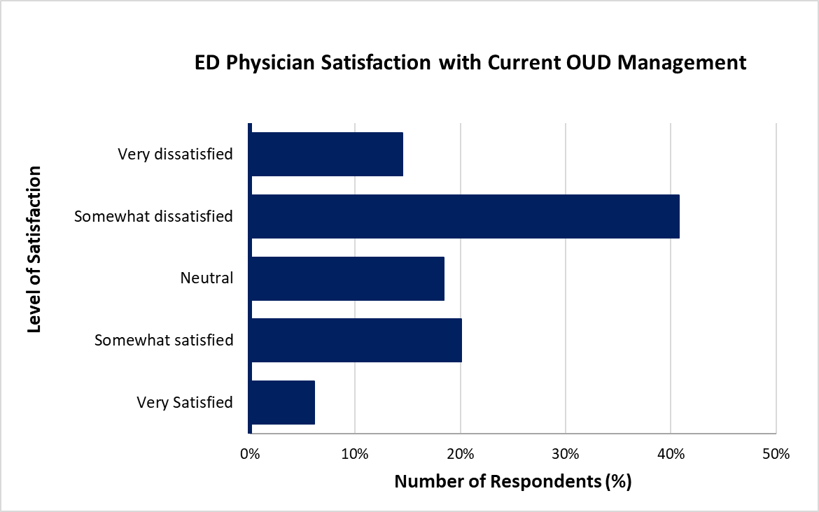

**Figure 2.** Emergency physician satisfaction with care provided to patients with OUD in the ED

**Appendix D**

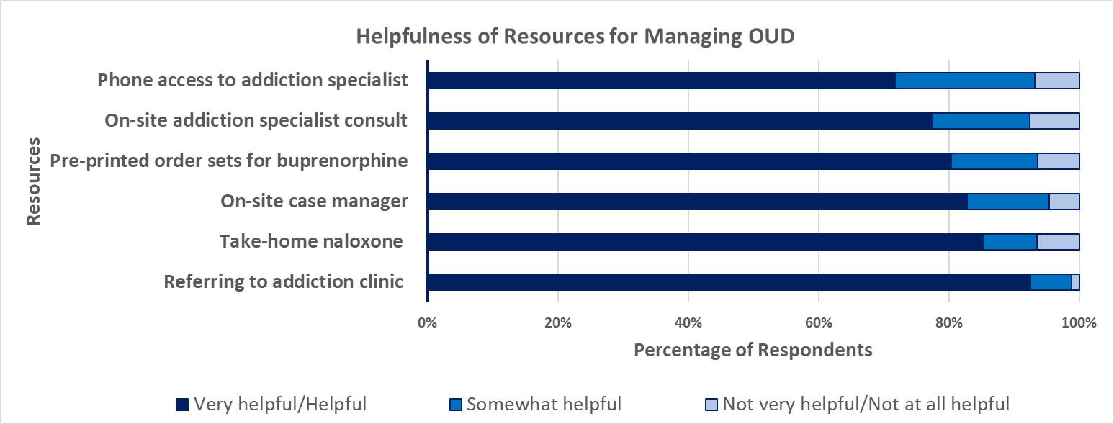

**Figure 3:** Helpfulness of Resources to Support Care for Patients with OUD in the ED

**Appendix E**

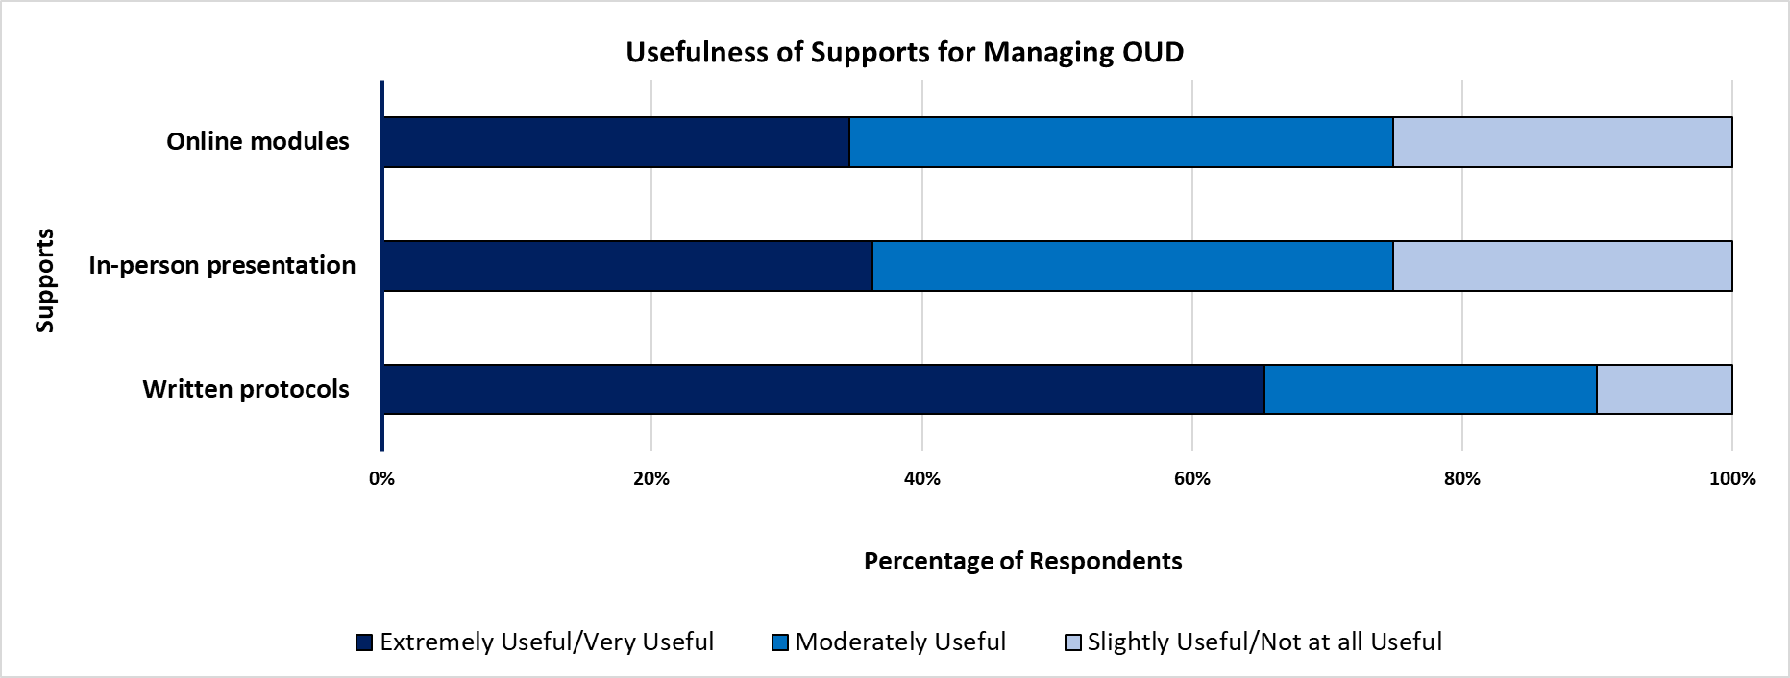

**Figure 4:** Usefulness of Supports for Managing Patients with OUD in the ED

**Appendix F**

**Table 2:** Log Binomial Analysis Results for Frequency of OUD Treatment and OUD Management

|  |  |  |
| --- | --- | --- |
|  | **Relative Risk (95% Confidence Interval)** | **P Value** |
| **BN in the ED** |  |  |
| 1-5 times per week | 2.02 (0.61 – 6.67) | 0.24 |
| 6-10 times per week | 2.14 (0.56-8.21) | 0.27 |
| >10 times per week | **5.60 (1.77-17.67)** | **0.003** |
| < once per week | Reference |  |
| **Clonidine for withdrawal** |  |  |
| 1-5 times per week | 1.58 (0.81-3.09) | 0.18 |
| 6-10 times per week | 1.61 (0.73-3.55) | 0.23 |
| >10 times per week | 1.99 (0.97-4.08) | 0.06 |
| < once per week | Reference |  |
| **Outpatient prescription for BN** |  |  |
| 1-5 times per week | 1.59 (0.56-4.51) | 0.38 |
| 6-10 times per week | 1.55 (0.46-5.26) | 0.48 |
| >10 times per week | 2.61 (0.89-7.66) | 0.08 |
| < once per week | Reference |  |
| **Outpatient script for opioids** |  |  |
| 1-5 times per week | 0.33 (0.08-1.41) | 0.14 |
| 6-10 times per week | 0.66 (0.13-3.35) | 0.62 |
| >10 times per week | 2.72 (0.94-7.87) | 0.06 |
| < once per week | Reference |  |
| **Take home naloxone** |  |  |
| 1-5 times per week | 3.17 (0.99-10.12) | 0.05 |
| 6-10 times per week | 3.23 (0.88-11.94) | 0.08 |
| >10 times per week | 4.40 (1.17-16.46) | 0.03 |
| < once per week | Reference |  |
| **Naloxone from public health or pharmacy** |  |  |
| 1-5 times per week | 1.84 (0.92-3.69) | 0.08 |
| 6-10 times per week | 1.09 (0.43-2.78) | 0.86 |
| >10 times per week | 1.17 (0.48-2.85) | 0.74 |
| < once per week | Reference |  |
| **Send to withdrawal management services** |  |  |
| 1-5 times per week | 1.22 (0.85-1.76) | 0.27 |
| 6-10 times per week | 1.04 (0.64-1.67) | 0.88 |
| >10 times per week | 1.35 (0.91-2.01) | 0.13 |
| < once per week | Reference |  |
| **Refer to methadone or BN clinic** |  |  |
| 1-5 times per week | **5.80 (1.92-17.48)** | **0.002** |
| 6-10 times per week | 4.15 (1.22-14.09) | 0.023 |
| >10 times per week | **6.74 (2.17-20.87)** | **0.001** |
| < once per week | Reference |  |
| **Refer to addiction clinic** |  |  |
| 1-5 times per week | 1.18 (0.71-1.97) | 0.53 |
| 6-10 times per week | 1.20 (0.64-2.26) | 0.56 |
| >10 times per week | 1.75 (1.02-2.97) | 0.04 |
| < once per week | Reference |  |
| **Refer to family physician** |  |  |
| 1-5 times per week | 0.93 (0.65-1.32) | 0.67 |
| 6-10 times per week | 0.71 (0.41-1.23) | 0.22 |
| >10 times per week | 0.96 (0.64-1.44) | 0.84 |
| < once per week | Reference |  |

**Appendix G**

**Table 3:** Log Binomial for Satisfaction by Location of Practice, Type of Hospital and ED volume.

|  |  |  |  |
| --- | --- | --- | --- |
|  | Relative Risk (95% Confidence Interval) | ProbChiSq | Pr>ChiSq |
| **Location of Practice** |  |  | **0.36** |
| British Columbia | 1.00 (0.54-1.86) | 1.00 |  |
| Alberta, Saskatchewan, Manitoba | 0.64 (0.32-1.27) | 0.20 |  |
| New Brunswick, Nova Scotia, Newfoundland, Prince Edward Island | 0.61 (0.25-1.50) | 0.28 |  |
| North West Territories, Nunavut, Yukon | 0.00 (0.00) | 0.10 |  |
| Ontario | 0.87 (0.48-1.57) | 0.63 |  |
| Quebec | Reference | Reference |  |
| **Type of Hospital** |  |  | **0.22** |
| Academic/Tertiary Care Hospital | 1.23 (0.88-1.72) | 0.22 |  |
| Community Teaching Hospital/Community Non-Teaching Hospital/ Rural | Reference | Reference |  |
| **ED Volume** |  |  | **0.26** |
| 30,001-100,00 and >100,00 | 0.75 (0.48-1.17) | 0.20 |  |
| <15,000 and 15,001-30,000 | Reference | Reference |  |

**Appendix H**

**Table 4:** Log Binomial Analysis for Satisfaction and Management of OUD

|  |  |  |
| --- | --- | --- |
|  | **Relative Risk (95% Confidence Interval)** | **P value** |
| **BN in the ED** |  |  |
| Neither satisfied nor dissatisfied | 1.03 (0.35-3.04) | 0.95 |
| **Somewhat satisfied/very satisfied** | **4.41 (2.33-8.33)** | **<0.0001** |
| Very dissatisfied/somewhat dissatisfied | Reference |  |
| **Clonidine for withdrawal** |  |  |
| Neither satisfied nor dissatisfied | 0.80 (0.43-1.49) | 0.48 |
| Somewhat satisfied/very satisfied | 1.42 (0.92-2.19) | 0.11 |
| Very dissatisfied/somewhat dissatisfied | Reference |  |
| **Outpatient prescription for BN** |  |  |
| Neither satisfied nor dissatisfied | 1.54 (0.55-4.28) | 0.41 |
| **Somewhat satisfied/very satisfied** | **4.51 (2.21-9.22)** | **<0.0001** |
| Very dissatisfied/somewhat dissatisfied | Reference |  |
| **Outpatient script for opioids** |  |  |
| Neither satisfied nor dissatisfied | 2.83 (0.98-8.20) | 0.05 |
| Somewhat satisfied/very satisfied | 2.41 (0.85-6.77) | 0.10 |
| Very dissatisfied/somewhat dissatisfied | Reference |  |
| **Take home naloxone** |  |  |
| Neither satisfied nor dissatisfied | 0.81 (0.33-2.02) | 0.66 |
| Somewhat satisfied/very satisfied | 1.62 (0.77-3.39) | 0.20 |
| Very dissatisfied/somewhat dissatisfied | Reference |  |
| **Naloxone from public health or pharmacy** |  |  |
| Neither satisfied nor dissatisfied | 0.79 (0.45-1.39) | 0.43 |
| Somewhat satisfied/very satisfied | 0.43 (0.20-0.93) | 0.03 |
| Very dissatisfied/somewhat dissatisfied | Reference |  |
| **Send to withdrawal management services** |  |  |
| Neither satisfied nor dissatisfied | 1.00 (0.76-1.33) | 0.98 |
| Somewhat satisfied/very satisfied | 0.98 (0.71-1.36) | 0.92 |
| Very dissatisfied/somewhat dissatisfied | Reference |  |
| **Refer to methadone or BN clinic** |  |  |
| Neither satisfied nor dissatisfied | 1.18 (0.72-1.95) | 0.51 |
| Somewhat satisfied/very satisfied | 1.23 (0.74-2.04) | 0.43 |
| Very dissatisfied/somewhat dissatisfied | Reference |  |
| **Refer to addiction clinic** |  |  |
| Neither satisfied nor dissatisfied | 0.91 (0.58-1.43) | 0.68 |
| Somewhat satisfied/very satisfied | 0.91 (0.50-1.66) | 0.76 |
| Very dissatisfied/somewhat dissatisfied | Reference |  |
| **Advice to see Family physician** |  |  |
| Neither satisfied nor dissatisfied | 0.98 (0.68-1.41) | 0.92 |
| Somewhat satisfied/very satisfied | 0.86 (0.60-1.23) | 0.40 |
| Very dissatisfied/somewhat dissatisfied | Reference |  |