Data and Methods Appendix

Variables Used in Models:

“Private Financing”—Private financing of health care, World Health Organization 2008. The measure reports private sector expenditure on health as a percentage of total health expenditure.
“Trust”—Main DV, trust in government institutions, 11-point scale, summed from five institutional trust variables in ESS2008 (B4-8) and divided by 5. Original variables range from 0 (“No trust at all”) to 10 (“Complete trust”).
Question: “Using this card, please tell me on a score of 0-10 how much you personally trust each of the institutions I read out. 0 means you do not trust an institution at all, and 10 means you have complete trust.”
Five component institutions: Parliament, Legal System, Police, Politicians, Political Parties.
“Health care system (HCS) evaluation”—ESS2008 variable B29, measuring health system satisfaction, 11 point scale. “Please say what you think about the state of health services in country nowadays.” Responses range from 0 (“Extremely Bad”) to 10 (“Extremely Good”).
“Risk”—ESS2008 variable D50. “During the next 12 months how likely is it that you will not receive the health care you really need if you become ill?” Responses include: 1 (“Not at all likely”), 2 (“Not very likely”), 3 (“Likely”), and 4 (“Very likely”).
“Income”—ESS variable F33, four-point scale. Question: “Which of the descriptions on this card comes closest to how you feel about your household's income nowadays?” Possible answers include: 1 (“Living comfortably on present income”), 2 (“Coping on present income”), 3 (“Finding it difficult on present income”), and 4 (“Finding it very difficult on present income”). Variable is recoded (flipped) in order to make interpretation easier.
“Nordic”—Dummy for Nordic country constructed by authors.
“Postcommunist”—Dummy for Postcommunist country constructed by authors.
“Interpersonal Trust”—Measure for interpersonal trust. ESS variable A8. “Would you say that most people can be trusted, or that you can't be too careful in dealing with people.” Responses on an 11-point scale range from 0 (“You can’t be too careful”) to 10 (“Most people can be trusted”).
“Happiness”—ESS variable C1, 11 point scale, “Taking all things together, how happy would you say you are?” 0 (“Extremely unhappy”) to 10 (“Extremely happy”).
“Voted for Governing Party”—A dummy variable constructed by authors to gauge respondent’s support for the current government. We cross-referenced the party composition of governing coalitions at the time of survey administration with the ESS variables for voting choices in the respondent’s country (B12). We used official government websites and Wikipedia entries on cabinets to establish the party composition of each ruling coalition.
“Economic Satisfaction”—ESS variable B24, “How satisfied with present state of economy in country.” Responses range from 0 (“Extremely dissatisfied”) to 10 (“Extremely satisfied”).
“Political Interest”—ESS variable B1, “How interested would you say you are in politics.” Responses range from 1 (“Very interested”) to 4 (“Not at all interested”).
“Discriminated group”—Dummy for being a member of a discriminated against group, based on ESS variable C24, “Would you describe yourself as being a member of a group that is discriminated against in this country?” This is an indicator variable, assigned a value of 0 if respondent replied “No” and assigned 1 if respondent replied “Yes.”
“Pro-state Ideology”—Index for respondent preferences regarding the state’s role in social provision, composed of ESS variables D15-D20. Each question assessed the extent to which a respondent believes it is the government’s responsibility to: “Ensure a job for everyone who wants one?”; “Ensure adequate health care for the sick?”; “Ensure a reasonable standard of living for the old?”; “Ensure a reasonable standard of living for the unemployed?”; “Ensure sufficient child care services for working parents?”; “Provide paid leave from work for people who temporarily have to care for sick family members?” For each of these questions, respondents were presented with a 0 to 10 answer scale. A response of zero denotes “Should not be governments’ responsibility at all,” while a 10 indicates “Should be entirely governments’ responsibility.” Responses to the six variables are averaged to obtain an 11-point index (0-10).
“Age”—Age of respondent in years, ESS variable B31b, calculated from birth year.
“Age Squared”—A squared age term to account for non-linearities in the relationship between age and some of the response variables.
"Sick" – Self-reported health, 5-point scale, ESS variable C15. “How is your health in general? Would you say it is . . .” Responses include 1 (“Very good”), 2 (“Good”), 3 (“Fair”), 4 (“Bad”), and 5 (“Very bad”).
“Medical Education”—A dummy for medical education, based on ESS question F6a (“In which one of these fields or subjects is your highest qualification?”) This indicator variable is coded 1 if the respondent replied with category 8 (“Medical, health services, nursing, etc.”) and 0 otherwise.
Standardizing the coefficients in the multilevel models
We scaled all coefficients in the multilevel models using grand mean centering. No major differences were observed in terms of significance between the scaled and unscaled models. Using group-mean centering (scaling within groups) as an alternative also produced negligible differences.

Robustness Checks
- We reran Models 2 through 5 using multiply imputed missing data. All results were substantively and statistically close to the models run without imputation of missing data.

- As a secondary robustness check, we excluded voted for governing party from our models, increasing the number of individuals to about 40,000. All results remain unchanged with the exception of one: with the full set of cases (over 48,000 observations as opposed to 25,000 with cases omitted for missing data), the coefficient on pro-state ideology is no longer significant in models 2 and 5. This is likely related to the fact that the majority of the missingness in the data comes from voted for governing party, for which approximately 19,000 observations were missing values.

- As a further robustness check, we reran the multi-level models excluding Switzerland. The country has an unusually (for Europe) privatized health care system, with private financing over 40 percent. The sole difference in the model results is that the coefficient for private financing in Model 2 is much more stable: higher levels of privateness are firmly associated with lower trust. This finding is not surprising, given that Switzerland’s average level of trust in government is high (5.7 on an 11 point scale; see table 1). Excluding the case results in a stronger association between financing and trust at the country level, though we should not forget the relatively limited degrees of freedom at that level of analysis (N=25).
Figure A1. Violin plots of mean trust in government at the country level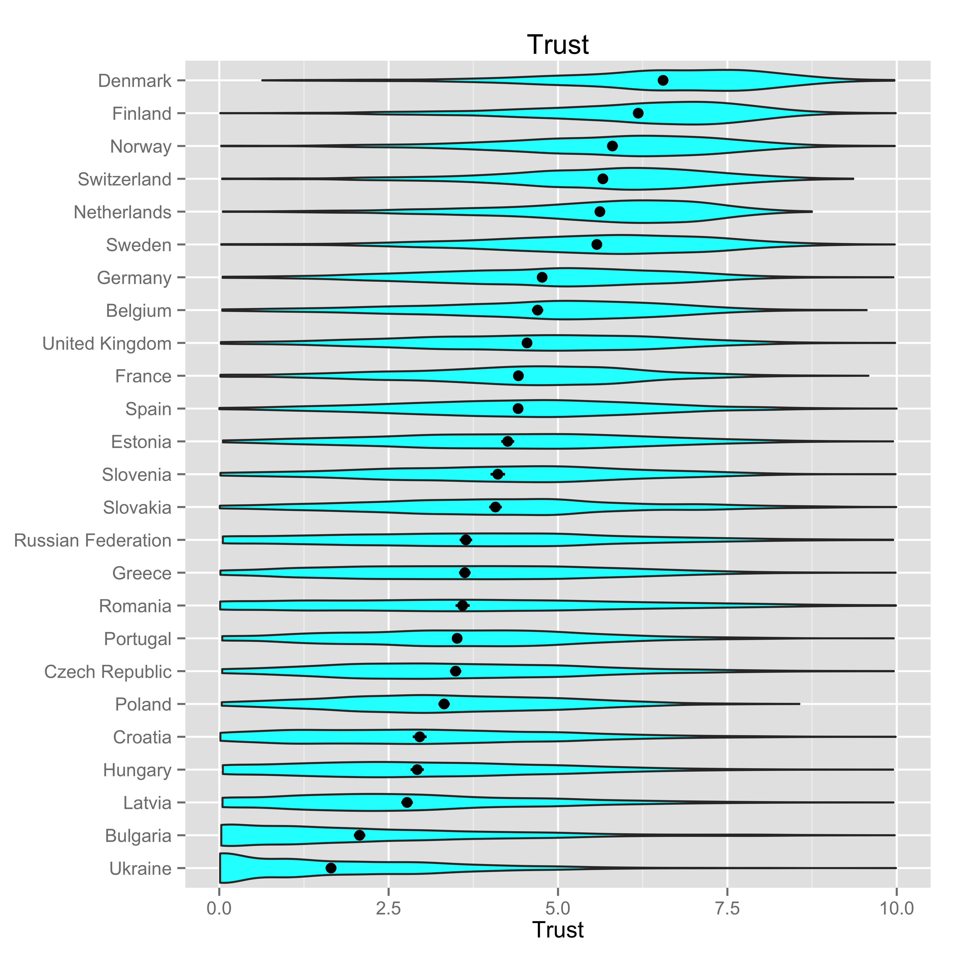

Figure A2. Violin plots of mean attitudes towards government responsibility to care for the sick at the country level 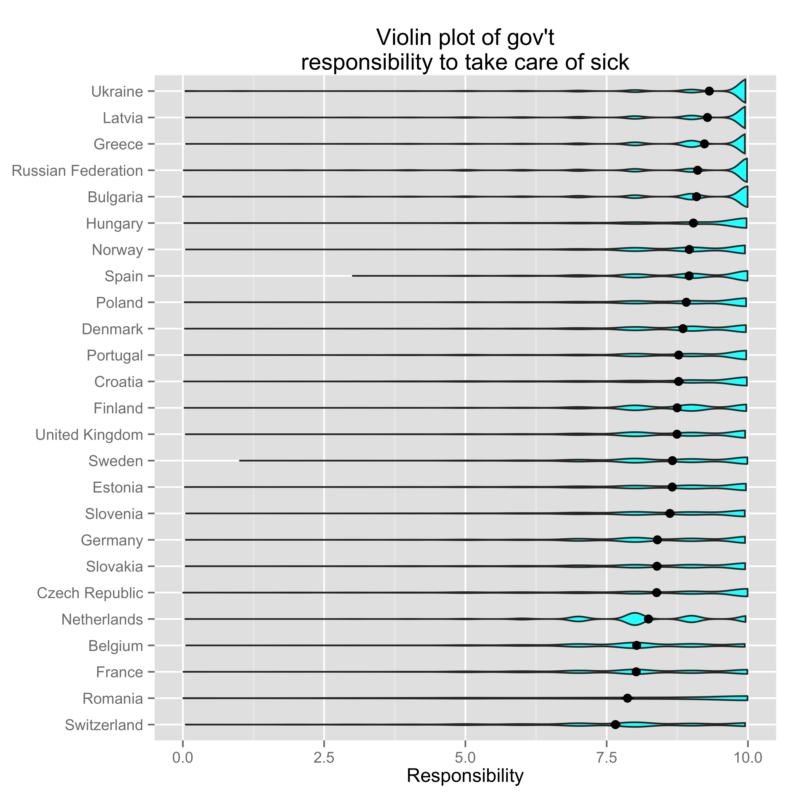

Table A1. Descriptive statistics of the individual- and country-level variables

 | MEAN | MIN | MAX | SD | N
Individual-level covariates
Trust | 4.18 | 0 | 10 | 2.19 | 45801
Income | 2.82 | 1 | 4 | 0.91 | 48336
Risk | 2.04 | 1 | 4 | 0.87 | 46130
Health system evaluation | 4.92 | 0 | 10 | 2.59 | 48300
Interpersonal trust | 4.77 | 0 | 10 | 2.53 | 48687
Happiness | 6.95 | 0 | 10 | 2.1 | 48496
Voted for governing party | 0.5 | 0 | 1 | 0.5 | 29791
Economic evaluation | 3.8 | 0 | 10 | 2.47 | 47684
Political interest | 2.36 | 1 | 4 | 0.89 | 48708
Discriminated group | 0.07 | 0 | 1 | 0.26 | 48147
Age | 48.1 | 15 | 123 | 18.5 | 48727
Age squared | 2655.78 | 225 | 15129 | 1854.14 | 48727
Sick | 2.32 | 1 | 5 | 0.94 | 48803
Medical education | 0.06 | 0 | 1 | 0.25 | 45379
Pro-state Ideology | 7.78 | 0 | 10 | 1.6 | 46685
Country-level Covariates
Private Financing | 26.48 | 13.28 | 43.26 | 9.11 | 48867
Nordic | 0.15 | 0 | 1 | 0.35 | 48867
Postcommunist | 0.45 | 0 | 1 | 0.5 | 48867
Alternative covariates
GDP pc logged | 10.04 | 8.81 | 10.81 | 0.47 | 48867
Out of pocket financing | 20.24 | 2.7 | 45 | 11.25 | 48867
Close to party | 0.49 | 0 | 1 | 0.5 | 22117
Left-Right scale | 5.13 | 0 | 10 | 2.21 | 40763

Table A2. Bivariate correlations of country-level variables

 | Nordic | Postcommunist | GDP per capita (log) | Income inequality (Gini) | Government effectiveness | Perceived  corruption | Total health expenditure per capita
Nordic | 1
Postcommunist | -0.38 | 1
GDP per capita (log) | 0.41 | -0.81 | 1
Income inequality (Gini) | -0.53 | 0.08 | -0.19 | 1
Government effectiveness | 0.52 | -0.76 | 0.92 | -0.35 | 1
Perceived  corruption | 0.54 | -0.79 | 0.86 | -0.36 | 0.97 | 1
Total health expenditures per capita | 0.41 | -0.87 | 0.92 | -0.29 | 0.9 | 0.89 | 1

Sources:
Nordic—Dummy for Nordic country constructed by authors.
Postcommunist—Dummy for Postcommunist country constructed by authors.
Income inequality (GINI)—World Development Indicators, except Czech and Slovak Republics (CIA World Factbook, 2005 values).
Government effectiveness—Kaufmann, Kraay, and Mastruzzi 2009.
Perceived corruption—Kaufmann, Kraay, and Mastruzzi 2009
Total health expenditures per capita—World Health Organization 2008.

Table A3. Raw (unscaled) model coefficients
 | Model 2 | Model 3 | Model 4 | Model 5
 | (DV=Trust) | (DV=Risk) | (DV=HC System Evaluation) | (DV=Trust)
Individual-level covariates
Income | 0.013 | -0.087 *** | -0.202 *** | 0.001
 | 0.014 | 0.019 | 0.053 | 0.014
Risk |  |  | -0.744 *** | -0.040 **
 |  |  | 0.051 | 0.013
Health system evaluation |  |  |  | 0.194 ***
 |  |  |  | 0.005
Interpersonal trust | 0.153 *** | -0.015 *** | 0.086 *** | 0.137 ***
 | 0.004 | 0.002 | 0.006 | 0.004
Happiness | 0.069 *** | -0.036 *** | 0.096 *** | 0.045 ***
 | 0.006 | 0.003 | 0.008 | 0.006
Voted for governing party | 0.290 *** | -0.015 | 0.241 *** | 0.239 ***
 | 0.02 | 0.009 | 0.026 | 0.02
Economic evaluation | 0.281 *** | -0.022 *** | 0.272 *** | 0.221 ***
 | 0.005 | 0.002 | 0.006 | 0.005
Political interest | 0.254 *** | -0.027 *** | -0.067 *** | 0.265 ***
 | 0.012 | 0.006 | 0.015 | 0.012
Discriminated group | -0.301 *** | 0.205 *** | -0.136 ** | -0.259 ***
 | 0.041 | 0.019 | 0.053 | 0.04
Age | -0.012 *** | 0.005 ** | -0.036 *** | -0.005
 | 0.003 | 0.002 | 0.004 | 0.003
Age squared | 0.000 *** | -0.000 *** | 0.000 *** | 0
 | 0 | 0 | 0 | 0
Sick | -0.037 ** | 0.076 *** | -0.031 | -0.02
 | 0.013 | 0.006 | 0.017 | 0.013
Medical education | -0.023 | -0.051 ** | -0.216 *** | 0.007
 | 0.037 | 0.017 | 0.047 | 0.036
Pro-state ideology | 0.019 ** |  |  | 0.020 **
 | 0.007 |  |  | 0.007
Country-level Covariates
Private financing | -0.021 * | 0.015 ** | -0.078 *** | -0.012
 | 0.01 | 0.005 | 0.018 | 0.009
Nordic | 0.354 | 0.152 | -0.583 | 0.492 *
 | 0.253 | 0.118 | 0.432 | 0.247
Postcommunist | -0.817 *** | 0.318 *** | -1.009 *** | -0.582 ***
 | 0.18 | 0.084 | 0.306 | 0.175
Cross-level interactions
Financing*income |  | -0.004 *** | 0.006 **
 |  | 0.001 | 0.002
Financing*risk |  |  | 0.011 ***
 |  |  | 0.002
Constant | 2.263 *** | 2.206 *** | 7.263 *** | 1.361 ***
 | 0.31 | 0.15 | 0.542 | 0.306
N (Individuals) | 25437 | 25951 | 25830 | 24468
N (Countries) | 25 | 25 | 25 | 25
ICC | 0.06 | 0.06 | 0.11 | 0.07
AIC | 93968 | 56968 | 108656 | 88511
log Likelihood | -46966 | -28466 | -54308 | -44235

