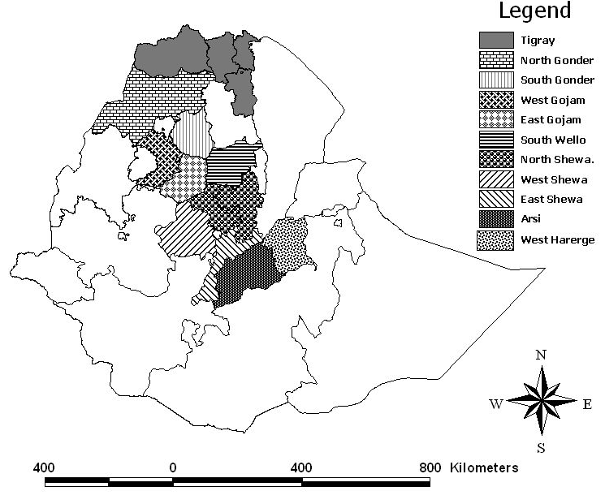

Annex B. Map of Ethiopia showing the approximate areas of origins (shaded region) of the 139 germplasm accessions (NB: all boundaries are approximate and nothing to do with political borders)

