Supplemental Materials for “Food Waste in Campus Dining Operations: Inventory of Pre- and Post-Consumer Mass by Food Category, and Estimation of Embodied Greenhouse Gases”

Tables: 4
Figures: 2
Total Pages: 8
Table S1. Example of information recorded during pre-consumer food waste inventory, February 17 to April 29

 | Grains |  |  | Fruits |  | Vegetables |  | Meat |  | Other |  | Dairy |  | Total Weight
 | Inedible | Edible |  | Inedible | Edible | Inedible | Edible | Inedible | Edible | Inedible | Edible | Inedible | Edible | Inedible (kg) | Edible (kg)
2/21/14
Descriptions | -- | biscuits, cous cous, pasta noodles, rolls | tomato ends, pineapple rinds |  | 0 | lettuce cores, onion skins, cucumber ends, pepper cores | lima beans, baked potatoes, chips, mashed potatoes, corn cob, onion, pickles | sliced turkey ends | 0 | coffee grounds | hard boiled eggs | 0 | 0 | 68.0 | 25.4
3/10/14
Descriptions | -- | biscuits, cous cous, pasta noodles, rolls | tomato ends, pineapple rinds |  | 0 | lettuce cores, onion skins, cucumber ends, pepper cores | lima beans, baked potatoes, chips, mashed potatoes, corn cob, onion, pickles | sliced turkey ends | 0 | coffee grounds | hard boiled eggs | 0 | 0 | 13.6 | 31.7

Table S2. Example of information recorded during pre-consumer food waste inventory, April 30 to May 16
Categories | Grains |  |  | Fruits and Vegetables |  | Meat and Protein |  | Dairy
Categories | Inedible |  | Edible | Inedible | Edible | Inedible | Edible | Inedible | Edible
5/6/14
kg | 0 | 45.3 |  | 13.59 | 13.59 | 0 | 13.59 | 0 | 0
descriptions | -- | pasta, rolls, rice |  | tomato prep, spoiled green pepper, moldy strawberries, coffee grounds | baked potatoes , sweet potatoes, green peppers, green beans, creamed spinach, corn on cob, shredded carrots, celery, lettuce | -- | pork loin, sliced roast beef, chicken patties | -- | --
5/7/14
kg | 0 |  | 36.24 | 33.975 | 18.12 | 0 | 4.077 | 0 | 1.359
descriptions | -- |  | bread, pasta, toasted ravioli | carrot shavings, lettuce cores, pepper cores, tomato prep, onion skins, zucchini ends, rotten eggplant | jalapeños, onions, sauerkraut, pickles, tomatoes, sugar snap peas, lettuce, carrots, broccoli, peas, chips, pickles | -- | shredded beef, chicken patties, pulled pork, beans, baked beans, chicken breasts, hamburger, chicken wings, sliced turkey | -- | cheese, queso, cheesecake

Table S3. Example of information recorded during post-consumer food waste inventory, April 30 to May 16

Location | Date | Wheat products |  |  | Beef products |  |  | Poultry products
Location | Date | Edible Weight (g) | Inedible Weight (g) | Description | Edible Weight (g) | Inedible Weight (g) | Description | Edible Weight (g) | Inedible Weight (g) | Description
Rollins | 3/4/14 | 2105.7 | 0 | pasta, pie crust, bread | 194.2 | 0 | meat loaf, hamburger | 44.1 | 0 | chicken bits
Plaza 900 | 4/1/14 | 1402.5 | 0 | pasta, tortillas, bagel, bread, muffin, (and rice) | 286.1 | 0 | ground beef, burger patty | 26.6 | 0 | chicken strips, breasts
Dobbs | 3/17/14 | 1435.6 | 0 | Bread, Buns, Pasta | 142.6 | 0 | burgers, roast beef | 428.7 | 0 | Chicken Breast
The Mark | 4/29/14 | 1682.2 | 0 | pizza crust, buns, white bread, crouton | 360.7 | 0 | hamburger patties, beef sirloin | 464.9 | 0 | chicken patties, chicken breast, turkey
Location | Date | Pork products |  |  | Dairy products |  |  | Vegetables
Location | Date | Edible Weight (g) | Inedible Weight (g) | Description | Edible Weight (g) | Inedible Weight (g) | Description | Edible Weight (g) | Inedible Weight (g) | Description
Rollins | 3/4/14 | 27.1 | 0 | ham lunch meat | 124.6 | 0 | Cheese | 1208.7 | 0 | olives, carots, oinions, peppers, french fries, pumkin pie batter, celery, mushrooms, peas
Plaza 900 | 4/1/14 | 52.1 | 0 | ham slices | 25 | 0 | cheese | 722.9 | 0 | lettuce, brocoli, french fries, peppers, beans (and rice), carrots, tomatoes
Dobbs | 3/17/14 | 0 | 0 | N/A | 0 | 0 | N/A | 957.4 | 0 | Carrots, celery, cauliflower, brocoli, peas
The Mark | 4/29/14 | 0 | 0 | -- | 0 | 0 | -- | 873.3 | 0 | squash, carrots, peas, peppers, brocoli
Location | Date | Fruit |  |  | Eggs |  |  | Fish
Location | Date | Edible Weight (g) | Inedible Weight (g) | Description | Edible Weight (g) | Inedible Weight (g) | Description | Edible Weight (g) | Inedible Weight (g) | Description
Rollins | 3/4/14 | 206.8 | 432.2 | edible: Tomatos, banana, apple; inedible: grapefruit peel, applecore, banana peel | 77.6 | 0 | Scrambled eggs | 0 | 0 | 0
Plaza 900 | 4/1/14 | 128.1 | 663.1 | inedible - banana peels, apple cores; edible - banana, orange | 132.3 | 0 | hard-boiled | 0 | 0 | None
Dobbs | 3/17/14 | 290.2 | 618.5 | Inedible: banana peels, apple cores, orange peels, grape vines; Edible: banana, tomatoes, grapes | 33.6 | 0 | Hard Boiled Eggs | 0 | 0 | None
The Mark | 4/29/14 | 961.2 | 988.5 | Edible - banana, apple, canteloupe; Inedible - banana, apple peels | 0 | 0 | -- | 0 | 0 | --

Table S4. Estimated total pre-consumer food waste
Location |  | Grains |  | Fruits and Vegetables |  | Meat and Protein |  | Dairy |  | Total
 |  | Inedible | Edible | Inedible | Edible | Inedible | Edible | Inedible | Edible | Inedible | Edible
Dobbs | kg | 80 | 1,690 | 1,040 | 1,070 | 20 | 260 | 0 | 50 | 1,140 | 3,070
Dobbs | % of total pre-consumer waste | 1.9 | 40.1 | 24.6 | 25.5 | 0.5 | 6.1 | 0 | 1.3 | 27 | 73
Total, across all four facilities | kg | 260 | 5,550 | 3,410 | 3,510 | 80 | 840 | 0 | 170 | 3,750 | 10,070

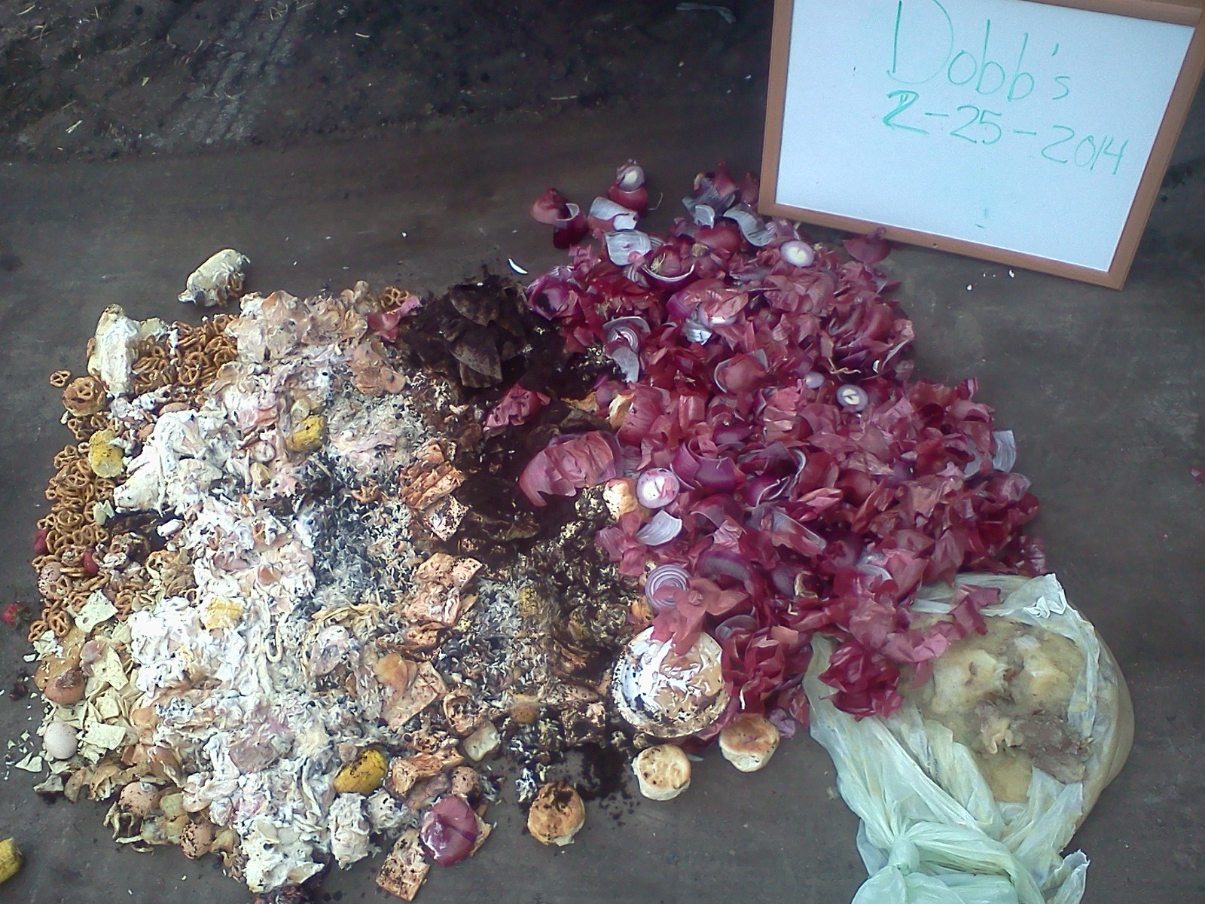
Figure S1. Pre-consumer food waste collected from the Dobbs dining facility 2/25/14

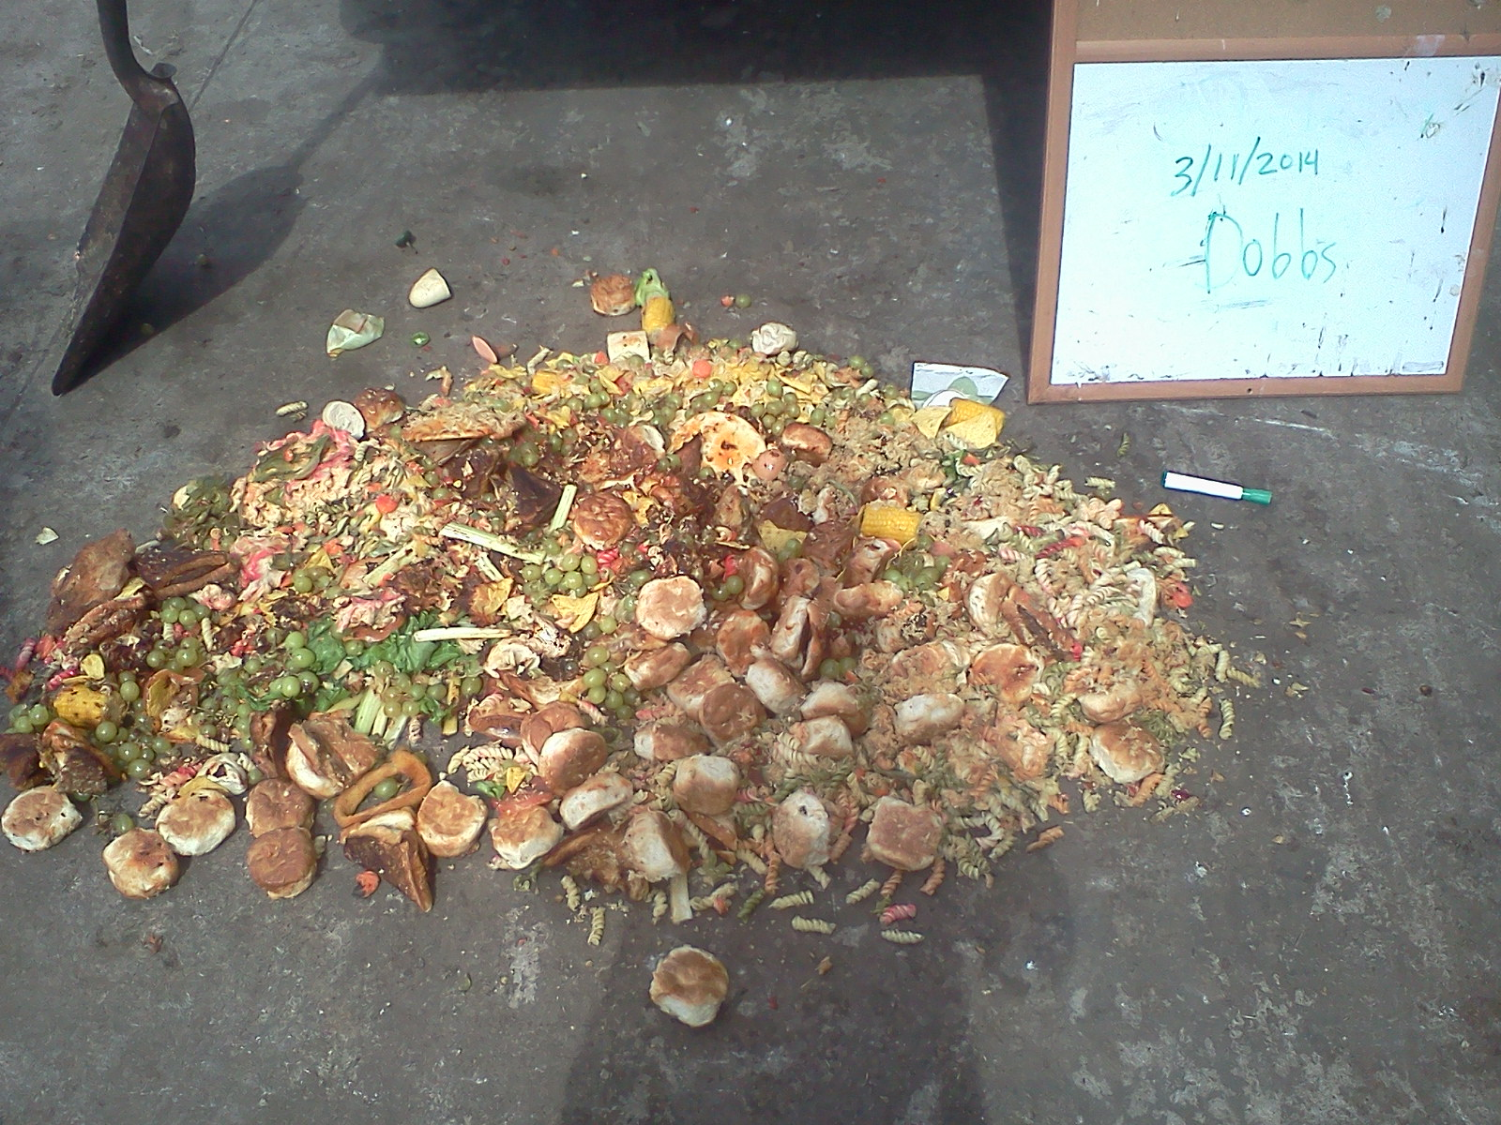
Figure S2. Pre-consumer food waste collected from the Dobbs dining facility 3/11/2014

