SM2: Assumptions and formulation of the probabilistic model.
We base our mathematical model on the following assumptions:
- We have a group of K flasks with triatomines, and all of them are fed on the same host. We also assume (although it is not known) that the host has already received faeces from infected triatomines on its skin (we refer to that host as infected).
- We indicate n as the number of triatomines in a flask and p the probability that one insect among the n triatomines becomes infected when the flask is exposed to an infected host.
- We also assume (and we will later have to relax this rule) that there is no horizontal transmission within a flask; i.e., if a triatomine becomes infected when feeding on an infected host, it will not transmit the virus directly to other triatomines within the same flask. The assumption is that each triatomine infection in a flask is independent of the other insects in the same flask.
- The total number of triatomines at risk of infection will be N= K * n.
- β is the level of desired reliability to detect the infection of a triatomine after feeding on an infected hen. This reliability level is known as the power of the test, and β -values of 0.95 is commonly used.
- x is the sample size of all the flasks of an insectary (i.e., the number of triatomines to be analysed by PCR) that must be taken to detect the infection under the above conditions.
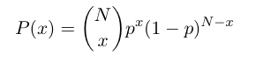
- The probability that exactly x triatomines become infected among the N triatomines in the flasks (remember that N= K * n) follows a binomial distribution expressed by:

- The probability of not detecting an infected triatomine among the N= K * n triatomines in a sample size of s when there are x infected triatomines will be given by:
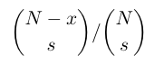
where the probability is zero if the sample size s is greater than N-x.

- The probability of not detecting at least one infected triatomine among all of the flasks may be calculated as a conditional probability of x as given by the equation:
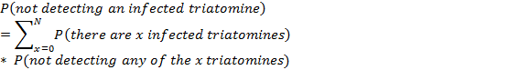

where the symbol "*" indicates a product. Therefore:

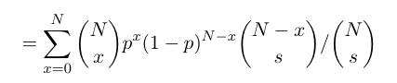

Thus, the detection probability, Pd, to detect infection in a colony with N insects out of which x are infected, is calculated as 1 minus the previous equation.

