**Online Appendix for When and Where Do Women’s Legislative Caucuses Emerge?**

**Table 1 Caucus Formation Sources**

|  |  |  |
| --- | --- | --- |
| State | Year Caucus Founded | Source Used |
| Alaska | 1985 | DeVries, Edna. Email Communication. 12 July 2016. (former state legislator) |
| Arkansas | 1991 | Spring 1992 CAWP newsletter |
| California | 1985 | Caucus website |
| Colorado | 2009 | Middleton, Karen. Telephone Interview. 11 March 2011. (founder, former legislator) |
| Delaware | 1993 | Summer/Fall CAWP newsletter in 1994 |
| Florida | 1975 | Bloom, Elaine. Telephone Interview. 29 June 2016. (co-founder and former state legislator) |
| Georgia | 1990 | Orrock, Nan. Personal Interview. 26 July 2009. (state legislator) |
| Hawaii | 1986 | Summer 1994 CAWP newsletter |
| Illinois | 1979 | Caucus website |
| Indiana | 1993 | Gard, Beverly. Telephone Interview. 9 May 2011. (state legislator) |
| Iowa | 1981 | Winter 1989 CAWP newsletter |
| Kansas | 1983 | Wagnon, Joan. Telephone Interview. 24 June 2016. (former state legislator) |
| Louisiana | 1986 | Caucus website |
| Maryland | 1972 | Caucus website |
| Massachusetts | 1975 | Caucus website |
| Mississippi | 1988 | Spring 1992 CAWP newsletter |
| Missouri | 1980 | Mueller (1984) edited volume |
| Nebraska | 1992 | Schimek, Diana. Telephone Interview. 19 October 2015. (former state legislator) |
| New Mexico | 1997 | Spring 1998 CAWP newsletter |
| New York | 1983 | New York State General Assembly |
| North Carolina | 1981 | Summer 1994 CAWP newsletter |
| Oregon | 1973 | Cease, Jane. Telephone Interview. 1 July 2016. (former state legislator) |
| Pennsylvania | 1987 | Ritter, Karen. Telephone Interview. 20 October 2015. (former state legislator) |
| Rhode Island | 1988 | Letter from Linda Kushner, then president of the organization, requesting meeting space in December 1988 /*also mentioned in Spring 1989 CAWP newsletter  Kushner, Linda. Personal Interview. 2 August 2011. (former state legislator) |
| South Carolina | 2004 | Kanthak, Kristin, and George A. Krause. 2012. The Diversity Paradox: Political Parties, Legislatures, and the Organizational Foundations of Representation in America. New York: Oxford University Press. 138. |
| Texas | 1992 | Spring 1992 CAWP newsletter |
| Vermont | 1980 | Confirmed by State Archives and Records Administration/Personal communication |
| Virginia | 1981 | Spring 1989 CAWP newsletter |
| West Virginia | 1988 | Summer 1994 CAWP |
| Wisconsin | 1985 | Robson, Judith. Telephone Interview. 21 March 2016. (founder and former state legislator) |
| Wyoming | 2006 | Turley, Melissa. Telephone Interview. 22 February 2011. |

Sources: Bloom, Elaine. Telephone Interview. 29 June 2016.

California Legislative Women’s Caucus. n.d. *Caucus History*. Retrieved from

http://womenscaucus.legislature.ca.gov/caucus-history

Cease, Jane. Telephone Interview. 1 July 2016.

Center for American Women in Politics. Spring 1989. *CAWP News & Notes* 7(1): 1-31.

———. Winter 1989. *CAWP News & Notes* 7(2): 1-21.

———. Spring 1989. *CAWP News & Notes* 7(1): 1-31.

———. Spring 1992. *CAWP News & Notes* 8(2): 1-31.

———. Summer 1994. *CAWP News & Notes* 9(3): 1-36.

———. Summer/Fall 1994. *CAWP News & Notes* 9(3A): 1-36.

———. Spring 1998. *CAWP News & Notes* 11(3): 1-16.

Conference of Women Legislators of the Illinois General Assembly. 2016. *About Us.*

Retrieved from http://cowlil.com/about-us/

DeVries, Edna. Email Communication. 12 July 2016.

Gard, Beverly. Telephone Interview. 9 May 2011.

Kanthak, Kristin, and George A. Krause. 2012. The Diversity Paradox: Political Parties,

Legislatures, and the Organizational Foundations of Representation in America. New York: Oxford University Press. 138.

Kushner, Linda. Personal Interview. 2 August 2011.

Louisiana Legislative Women’s Caucus. n.d. *About Us*. Retrieved from

http://llwc.louisiana.gov/llwc_AboutUs.htm

Massachusetts Caucus of Women Legislators. n.d. *Home Page*. Retrieved from

http://www.mawomenscaucus.com/

Middleton, Karen. Telephone Interview. 11 March 2011.

Mueller, Carol. 1984. “Women’s Organizational Strategies in State Legislatures.” In

Political Women: Current Roles in State Government, ed. Janet A Flammang. Beverly Hills: Sage Publications.

New York State Assembly. n.d. *Legislative Women’s Caucus-News-History*. Retrieved

from http://assembly.state.ny.us/comm/women_caucus/20120316/

Office of the Vermont Secretary of State. n.d. Retrieved from

https://www.sec.state.vt.us/media/246442/A-062.pdf

Orrock, Nan. Personal Interview. 26 July 2009.

Ritter, Karen. Telephone Interview. 20 October 2015.

Robson, Judith. Telephone Interview. 21 March 2016.

Schimek, Diana. Telephone Interview. 19 October 2015.

Turley, Melissa. Telephone Interview. 22 February 2011.

Wagnon, Joan. Telephone Interview. 24 June 2016.

Women Legislators of Maryland. 2016. *Our History*. Retrieved from

<http://www.womenlegislatorsmd.org/history.htm>

**Table 2 Pearson’s Correlation Between Independent Variables**

|  |  |  |  |  |  |  |  |
| --- | --- | --- | --- | --- | --- | --- | --- |
| Variables | % Women State  Legislators | % Women State Legislators Squared | Dem. Control of State Legislature | Black Caucus | Leg. Prof. | Party Competition (Ranney Index) | % Women State  Legislators* Dem.  Control of State  Legislature |
| % State Legislators | 1.00 | -- | -- | -- | -- | -- | -- |
| % Women State Legislators  Squared | .965 | 1.00 | -- | -- | -- | -- | -- |
| Dem. Control of State Legislature | -.332 | -.263 | 1.00 | -- | -- | -- | -- |
| Black Caucus | -.236 | -.224 | .228 | 1.00 | -- | -- | -- |
| Leg. Prof. | -.159 | -.143 | .067 | .397 | 1.00 | -- | -- |
| Party Competition | .345 | .286 | -.392 | .019 | .191 | 1.00 | -- |
| % of Women State Legislators*  Dem. Control of State Legislature | .265 | .275 | .672 | .029 | -.011 | -.002 | 1.00 |

**Table 3 Estimating Women’s Caucus Emergence with Different Assumptions about Duration Dependency**

|  |  |  |  |  |
| --- | --- | --- | --- | --- |
| Variables | No Duration Dependency | Linear | Quadratic | Natural Log |
| Percentage of Women State Legislators | .093  (.061) | .11  (.069) | .099  (.062) | .07  (.088) |
| Percentage of Women State Legislators Squared | -.001  (.001) | -.001  (.001) | -.001  (.001) | -.001  (.002) |
| Democratic Control of State Legislature | .138  (.648) | -.009  (.599) | -.133  (.607) | .039  (.639) |
| Black Caucus | -.296  (.728) | -.137  (.718) | -.105  (.714) | -.444  (.708) |
| Legislative Professionalism | .579  (1.86) | .053  (2.14) | -.073  (2.07) | .883  (2.11) |
| Party Competition (Ranney Index) | -.613  (1.53) | -.833  (1.45) | -.909  (1.46) | -.23  (1.47) |
| Percentage of Women State Legislators*Democratic Control of State Legislature | .031  (.028) | .038  (.026) | .044*  (.026) | .034  (.027) |
| Duration Dependency | -- | -.023  (.022) | -.001*  (.0004) | .079  (.308) |
| Constant | -3.99**  (.159) | -3.64**  (1.49) | -3.54**  (1.5) | -4.23***  (1.52) |
| Number of Observations | 1217 | 1217 | 1217 | 1168 |
| Log Pseudolikelihood | -218.26 | -217.56 | -216.71 | -213.39 |
| Pseudo R-Squared | .076 | .079 | .082 | .075 |

Note: Table entries are estimated coefficients of a logistic regression model. Robust standard errors are in parentheses and are clustered by state.

*p≤.10, ** p≤.05. and *** p≤.01

**Table 4 Results from the Test of the Proportional Hazards Assumption**

|  |  |  |  |
| --- | --- | --- | --- |
| Test | Chi-Squared | Degrees of Freedom | P>Chi-Squared |
| Schoenfeld residuals (global test) | 36.25 | 7 | .0001 |

Note: Rejection of the null hypothesis indicates that the proportional hazards assumption has not been met, thus making the Cox proportional hazards model an inappropriate one to employ.

**Table 5 Estimating Women’s Caucus Emergence with Different Cutoff Points about which States are At-Risk**

|  |  |  |  |  |
| --- | --- | --- | --- | --- |
| Variables | 5% Cutoff for % Women State Legislators | 10% Cutoff for % Women State Legislators | 15% Cutoff Point for % Women State Legislators | 20% Cutoff Point for % Women State Legislators |
| Percentage of Women State Legislators | -.008  (.114) | -.041  (.207) | -.002  (.37) | 1.04***  (.395) |
| Percentage of Women State Legislators Squared | .001  (.002) | .001  (.004) | .001  (.007) | -.017***  (.007) |
| Democratic Control of State Legislature | .18  (.675) | .292  (.867) | -.472  (1.71) | -4.31*  (2.55) |
| Black Caucus | -.532  (.731) | -.886  (.808) | -1.23  (1.11) | -2.59*  (1.52) |
| Legislative Professionalism | 1.24  (2.27) | 1.16  (2.63) | -1.7  (4.34) | -1.57  (6.6) |
| Party Competition (Ranney Index) | -.357  (1.7) | 1.17  (1.94) | 1.77  (1.95) | 2.21  (2.49) |
| Percentage of Women State Legislators*Democratic Control of State Legislature | .029  (.028) | .026  (.031) | .053  (.052) | .176**  (.074) |
| Duration Dependency | 11.8  (15.6) | 9.38  (16) | .417  (23.5) | -10.6  (30.3) |
| Constant | -3.73*  (2.01) | -4.35  (2.93) | -4.25  (4.66) | -19.2***  (6.62) |
| Number of Observations | 1038 | 732 | 513 | 343 |
| Log Pseudolikelihood | -210.04 | -167.92 | -125.17 | -81.2 |
| Pseudo R-Squared | .061 | .066 | .093 | .183 |

Note: Table entries are estimated coefficients of a logistic regression model. Robust standard errors are in parentheses and are clustered by state.

*p≤.10, ** p≤.05. and *** p≤.01

**Figure 1 The Creation of Women’s Caucuses for States Where Women Hold at Least 20 Percent of Seats, Varying Democratic Control**

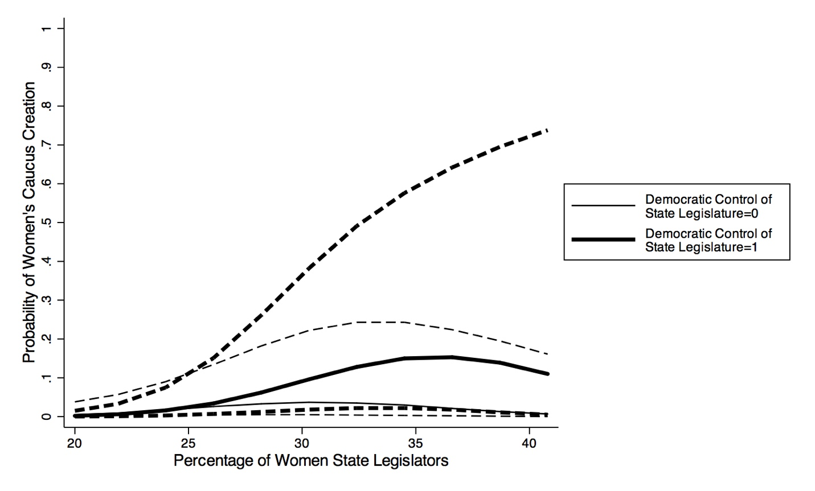

Caption for Figure 1

Note: The results come from the logit model in Table 5 in the online appendix.