Addendum

Since it could be likely that the DNA detected may be too small to be of any biological significance, we later investigated whether larger DNA fragments could be detected in milk samples. To this purpose, primers GMO9/GMO5 amplifying a fragment of 447 bp, which encodes the p-35S/CP4epsps gene (Cardarelli et al., 2005) were used. The sequences of the latter were: GMO9-CATGAAGGACCGGTGGGAGAT/GMO5-CCACTGACGTAAGGGATGACG.
PCR amplifications were performed on a Gene Amp PCR System 2400 (Applied Biosystems, Foster City, CA). DNA was amplified using Taq DNA polymerase (Invitrogen, Carlsbad, CA) in accordance with the manufacturer's instructions. Amplifications were performed as follows: denaturation for 3min at 95°C; amplification (25 cycles) for 30s at 95°C, for 30s at 60°C, for 40s at 72°C; final extension for 3min at 72°C.
The p-35S/CP4epsps gene fragment (447 bp) sequence was detected in 57% of milk samples that were found positive for smaller transgenic fragment. In the figure, a representative example is presented.

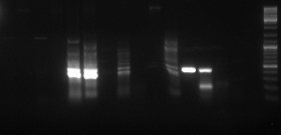
1 2 3 4 5 6 7 8 9 10 11 12 13 14 15 16 17

1 and 2 - negative control, GM free milk samples
3 to 11 - milk samples
12 and 13 positive control (RR soybean)
14 and 15 negative control (conventional soybean)
16 negative control (blank)
17 marker containing a 1000 bp DNA ladder

