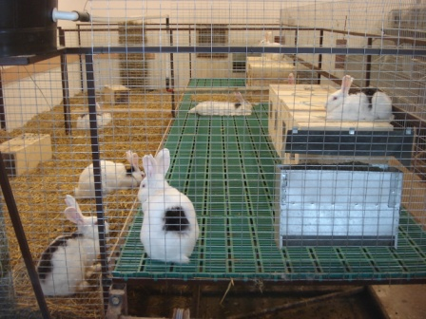
Photo
Group-housing of rabbit does (The spots on the rabbits are used for individual identification)

