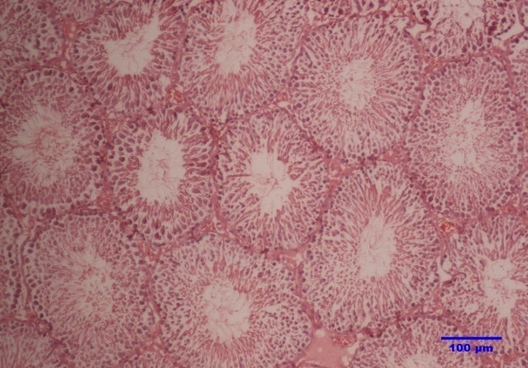
a

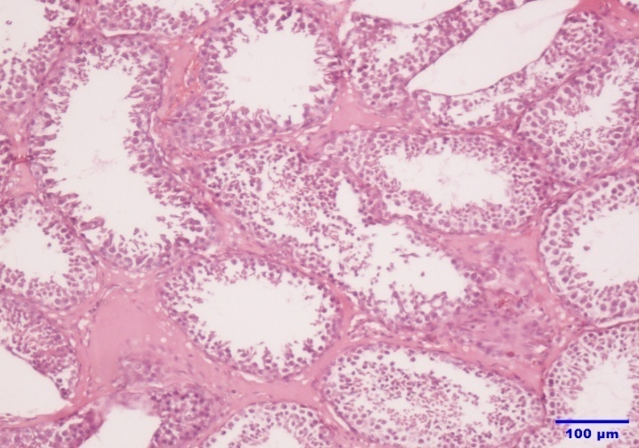
b

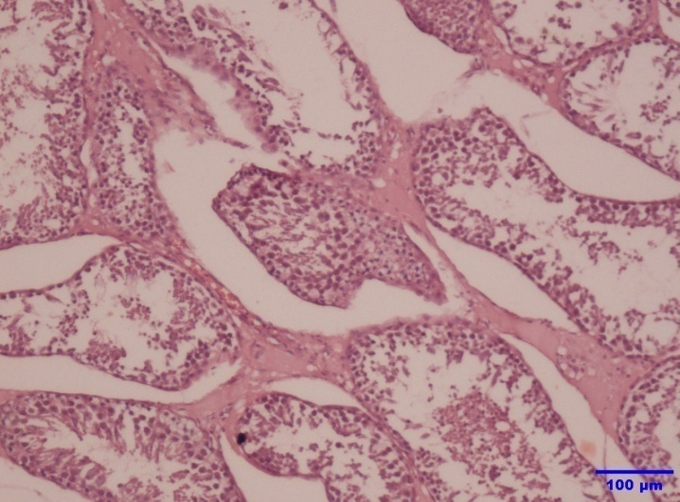
c

Supplementary Figure S1 Effect of feeding two levels of dKC as a replacement for soyabean cake in the concentrate mixture on testicular structure in rams. a: control, testes showing normal architecture, b: dKC-50 group, testes showing inter tubular edema (dashed line) and c: dKC-75 group, testes showing severe damage to seminiferous tubules (solid line) and inter-tubular structure (dashed line). H&E, Scale bar=100μm.

