A) | B)
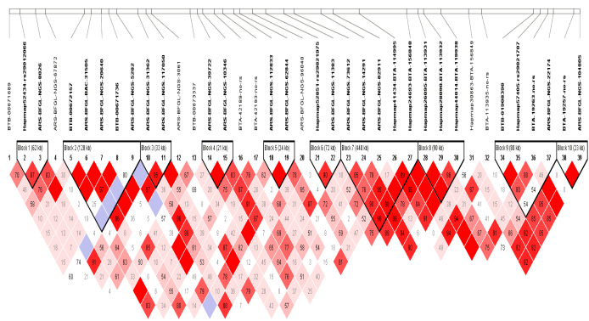 | 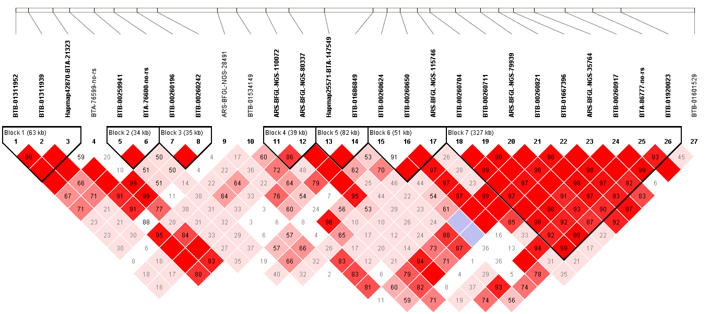
C) | D)
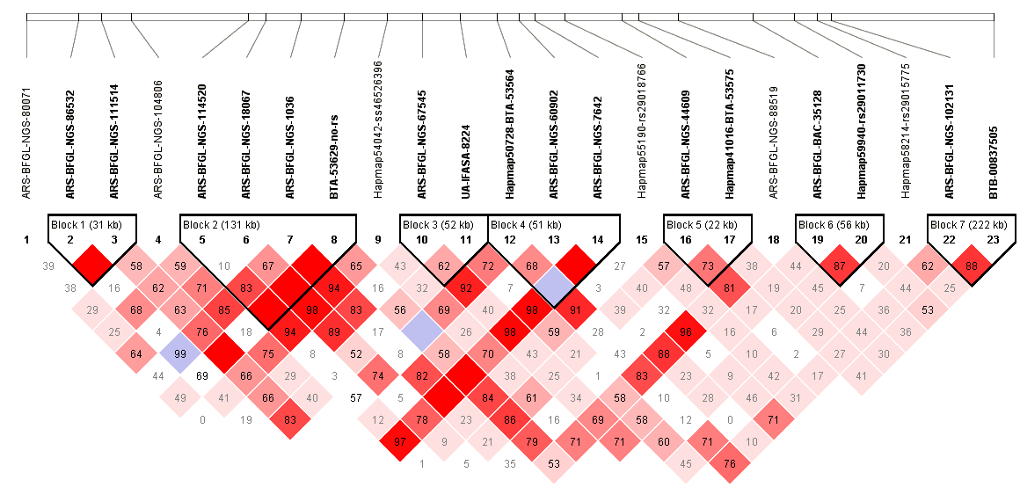 | 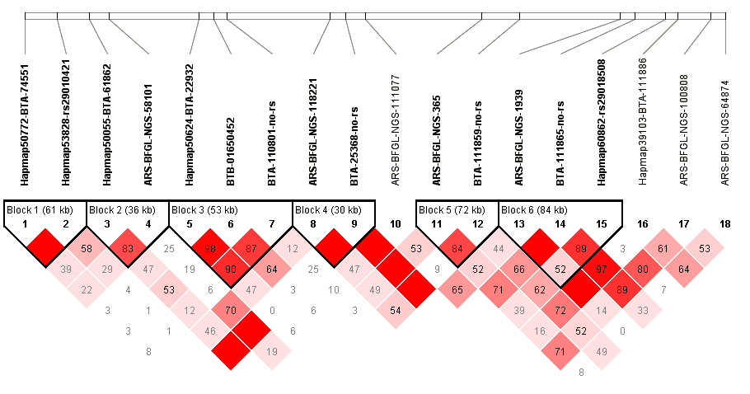
E) | F)
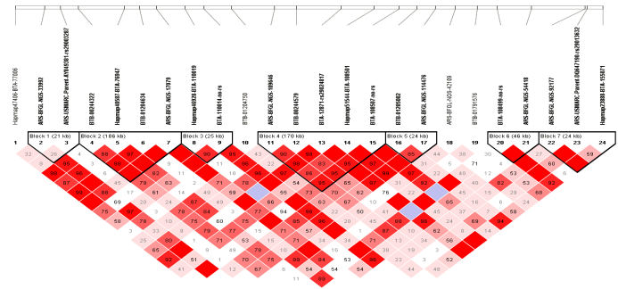 | 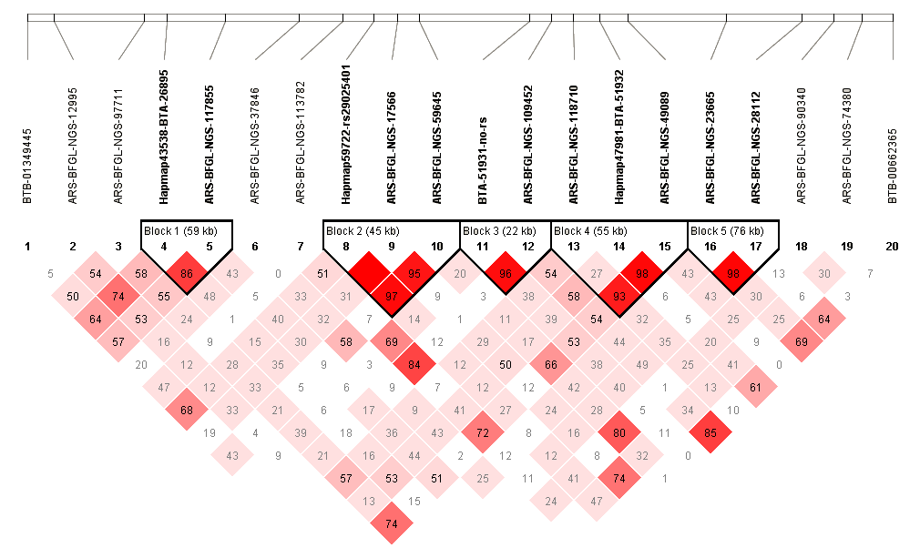
G)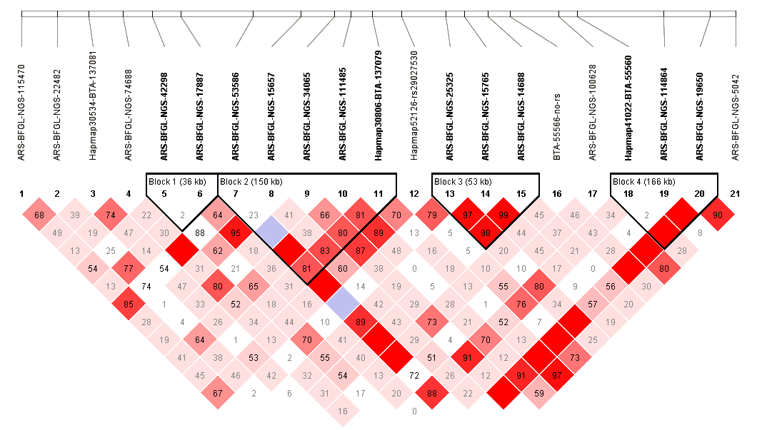 | H)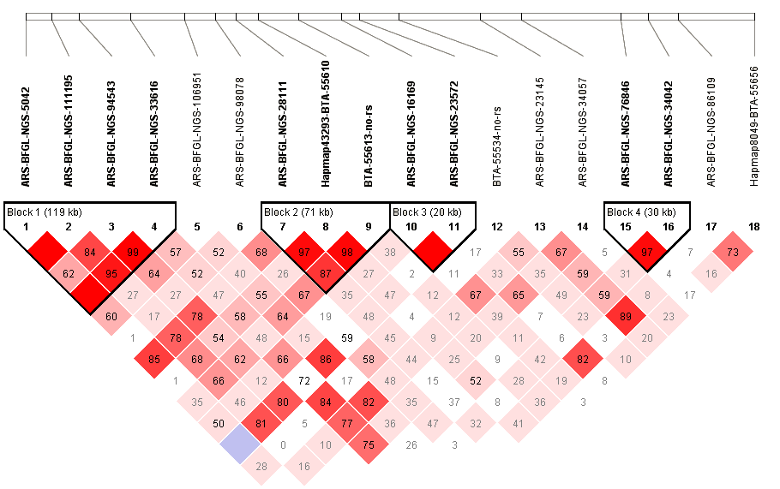
Supplementary Figure S1: Haplotype analysis of 500kb up and downstream of remaining nine most associated SNPs for direct calving difficulty. The SNP of interest is outlined in red. A) haploview plot for ss117972188 and ss86289496 on BTA 17,B) haploview plot for rs42803925 on BTA 6, C) haploview plot for ss86297822 on BTA 22D) haploview plot for rs41575151 on BTA 5, E) haploview plot for ss86284183 on BTA 6, F) haploview plot for rs41602564 on BTA 16, G) haploview plot for ss86339077 on BTA 23, H) haploview plot for ss86328687 on BTA 23.

