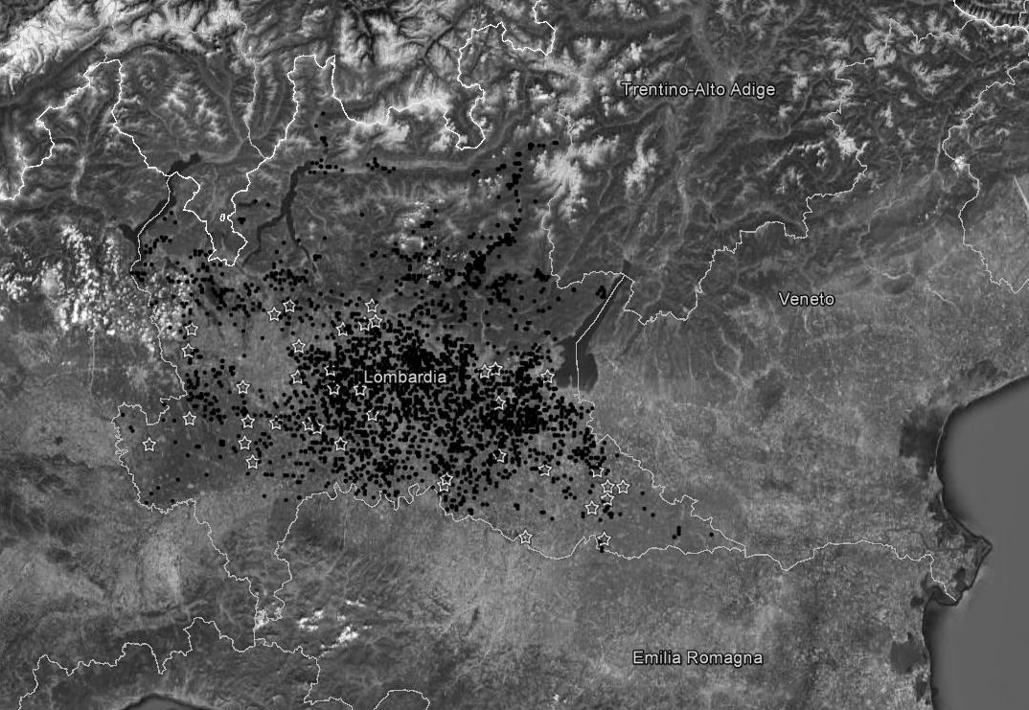
Supplementary Figure S1 Map of the study area (North Italy, Po valley, Lombardy Region). The white stars indicate the 40 weather stations consulted to acquire daily temperature and relative humidity data; the black dots indicate the Holstein dairy farms where milk composition was recorded.

