Supplementary material S1

References used in the meta-analysis

Bergman, E.N., M.L. Katz, and C.F. Kaufman. 1970. Quantitative aspects of hepatic and portal glucose metabolism and turn-over in sheep. Am. J. Physiol. 219:785-793.
De Visser, HA, Klop A, Van der Meulen J and Van Vuuren AM. 1998. Influence of maturity of grass silage and flaked corn starch on the production and metabolism of volatile fatty acids in dairy cows. Journal of Dairy Science 81, 1028-1035.
DeVisser, HA, Valk H, Klop A, Van der Meulen J, Bakker JGM and Huntington GB. 1997. Nutrient fluxes in splanchnic tissue of dairy cows: Influence of grass quality. Journal of Dairy Science 80, 1666-1673.
Eisemann, JH, Huntington GB and Catherman DR. 1996. Patterns of nutrient interchange and oxygen use among portal-drained viscera, liver and hindquarters of beef steers from 235 to 525 kg body weight. Journal of Animal Science 74, 1812-1831.
Freetly, HC and Ferrell CL. 1998. Net flux of glucose, lactate, volatile fatty acids, and nitrogen metabolites across the portal drained viscera and liver of pregnant ewes. Journal of Animal Science 76, 3133–3145.
Goetsch, AL, and Ferrell CL. 1995. Effect of dietary maize level on net flux across splanchnic tissues of oxygen and nutrients in wethers consuming ad-libitum different forages. Animal Science 61, 43-55.
Goetsch, AL, Ferrel CL and Freetly HC. 1994. Effect of different supplements on splanchnic oxygen consumption and net fluxes of nutrients in sheep consuming bromegrass (Bromus inermis) hay ad libitum. British journal of Nutrition 72, 701-712.
Harmon, DL, Gross KL, Kreikemeier KK, Coffey KP, Avery TB and Klindt J. 1991. Effects of feeding endophyte-infected fescue hay on portal and hepatic nutrient flux in steers. Journal of Animal Science 69, 1223-1231.
Heitmann, RN, Sensenig SC, Reynolds CK, Fernandez JM and Dawes DJ. 1986. Changes in energy metabolite and regulatory hormone concentrations and net fluxes across splanchnic and peripheral tissues in fed and progressively fasted ewes. Journal of Nutrition 116, 2516-2524.
Huntington, GB, Zetina E, Whitt JM and Potts W. 1996. Effects of dietary concentrate level on nutrient absorption, liver metabolism, and urea kinetics of beef steers fed isonitrogenous and isoenergetic diets. Journal of Animal Science 74, 908-916.
Katz, ML and Bergman EN. 1969. Hepatic and portal metabolism of glucose, free fatty acids, and ketone bodies in the sheep. American Journal of Physiology 216, 953-960.
Krehbiel, C.R., C.L. Ferrell, and H.C. Freetly. 1998. Effects of frequency of supplementation on dry matter intake and net portal and hepatic flux of nutrients in mature ewes that consume low-quality forage. J. Anim. Sci. 76:2464-2473.
Lapierre, H, Reynolds CK, Elsasser TH, Gaudreau P, Brazeau P and Tyrrell HF. 1992. Effects of growth hormone-releasing factor and feed-intake on energy-metabolism in growing beef steers - net hormone metabolism by portal-drained viscera and liver. Journal of Animal Science 70, 742-751.
Linington, MJ, Meyer JHF and van der Walt JG. 1998. Ruminal VFA production rates, whole body metabolite kinetics and blood hormone concentrations in sheep fed high- and low-fibre diets. South African Journal of Animal Science 28, 82-98.
Lozano, O, Theurer CB, Alio A, Huber JT, Delgado-Elorduy A, Cuneo P, DeYoung D, Sadik M and Swingle RS. 2000. Net absorption and hepatic metabolism of glucose, Llactate, and volatile fatty acids by steers fed diets containing sorghum grain processed as dry-rolled or steam-flaked at different densities. Journal of Animal Science 78, 1364-1371.
Majdoub, L., M. Vermorel, and I. Ortigues-Marty. 2003. Ryegrass-based diet and barley supplementation: Partition of energy-yielding nutrients among splanchnic tissues and hind limbs in finishing lambs. J. Anim. Sci. 81:1068-1079.
Maltby, SA, Lomax MA, Beever DE and Pippard CJ. 1992. The effect of increased ammonia and amino acid supply on post prandial portal-drained viscera and hepatic metabolism in growing steers fed maize silage. In 12th Symposium on Energy Metabolism of Farm Animals (eds Wenk C and Boessinger C), pp 20-22. EAAP Publication, Zurich (Switzerland).
Ortigues, I, Visseiche AL and Durand D. 1994. Adaptation to undernutrition in ewes: Net nutrient fluxes across the portal drained viscera, the liver and the hindquarters. In 13th Symposium on Energy Metabolism of Farm Animals (eds Aguilera JF), pp 89-92. EAAP Publication, Granada (Spain).
Patil AR, Goetsch AL, Park KK, Kouakou B, Galloway DL and Johnson ZB. 1995a. Influence of grass source on net flux of nutrients across splanchnic tissues in sheep with restricted intake. Archives of Animal Nutrition 48, 257-269.
Patil AR, Goetsch AL, Park KK, Kouakou B, Galloway DL, West CP and Johnson ZB. 1995b. Net flux of nutrients across splanchnic tissues in sheep fed tropical vs temperate grass hay of moderate or low qualities. Livestock Production Science 43, 49-61.
Reynolds CK, Aikman PC, Lupoli B, Humphries DJ and Beever DE 2003. Splanchnic metabolism of dairy cows during the transition from late gestation through early lactation. Journal of Dairy Science 86, 1201-1217.
Reynolds PJ and Huntington GB 1988. Net portal absorption of volatile fatty acids and L(+)-lactate by lactating holstein cows. Journal of Dairy Science 71, 124-133.
Reynolds CK, Huntington GB, Tyrrell HF and Reynolds PJ. 1988a. Net portal-drained visceral and hepatic metabolism of glucose, L-lactate and nitrogenous compounds in lactating Holstein cows. Journal of Dairy Science 71,1803-1812.
Reynolds CK, Huntington GB, Tyrrell HF and Reynolds PJ. 1988b. Net metabolism of volatile fatty acids, D-beta-hydroxybutyrate, nonesterifield fatty acids, and blood gasses by portal-drained viscera and liver of lactating Holstein cows. Journal of Dairy Science 71, 2395-2405.
Reynolds CK and Tyrrell HF. 1991. Effects of mesenteric vein L-alanine infusion on liver metabolism in beef heifers fed on diets differing in forage - concentrate ratio. British Journal of Nutrition 66, 437-450.

Supplementary Material S2.
Comparison of models elaborated using the GLM and Mixed procedures of SAS.

To evaluate the use of our models for predictive purposes beyond their strict range of validity, we also analyzed the data with the MIXED procedure of SAS software. The comparison of models is presented in Supplementary table S7.Model parameters were not significantly modified by the choice of fixed vs. mixed procedures, except for the BHBA models for which the variance-covariance matrix (obtained by the COVTEST option of the SAS system) differed. For the BHBA models from RfOMI and EB, coefficients for EB² were statistically different. Differences were mostly due to the effect of the animal physiological status on the slope associated to EB², which are highly different between the models. For example, the effect of the ‘growing’ status associated to the slope was equal to -0.000721 ± 0.00013 (P < 0.0001) with the GLM model whereas it was equal to -0.00166 ± 0.000264 (P = 0.0002) with the MIXED model. Furthermore, when removing the interaction term (EB × PHY), the Mixed and GLM models were not statistically different:
Mixed model: NHF-BHBA = 0.0574^{ns} ± 0.0656 + 0.0146* ± 0.0058 × RfOMi + 0.000366*** ± 0.000083 × EB²
GLM model: NHF-BHBA = 0.0763^{ns} ± 0.0541 + 0.0147** ± 0.0049 × RfOMi + 0.000344*** ± 0.000051 × EB²
This clearly demonstrates that the difference between the Mixed and GLM models is due to the influence of physiological status on the slope of EB². This is probably due to an unbalanced number of observations in each physiological status. In particular the number of available data in lactation (when the cow mobilized energy) is low. Supplementary Figure S2 shows the effect of physiological status on the slope EB of the model and illustrates the greatest difference obtained for the dairy cows. In these animals, observed values (Supplementary Figure S3) ranged from 0.143 to 0.70 mmol/h/kg BW.

Evidence was obtained that the Mixed model does not correctly predict the influence of physiological status on the EB² slope. We predicted the net hepatic release of beta-hydroxybutyrate with the GLM and Mixed models using the same data as those used to establish the models as shown in Supplementary Figure S4 (it is a way to check if models are biased). Results indicate that the Mixed model largely overestimates the net hepatic release of beta-hydroxybutyrate in the dairy cows. Therefore, at this stage of the study, we consider it is not really appropriate to generalize the model with the Mixed procedure, and suggest to keep the GLM model waiting for additional data on dairy cows.

Supplementary Table S1: Comparison of GLM and Mixed models of responses of net hepatic and net splanchnic fluxes of acetate (NSR-C2), butyrate (NHF-C4) and ß-hydroxybutyrate (NHF-BHBA) to variations in net portal appearance (NPA), rumen-fermentable OM intake (RfOMI) or energy balance (EB).
Nutrient | Model | Equations | RMSE | Effect
 |  |  |  | PHY | X * PHY
NSR-C2 | GLM | 0.098 ± 0.175^{ns} + 1.033*** ± 0.077 × NPA-C2 | 0.208 | < 0.001¹ | NS
 |  | 0.65 ± 0.303 ^{ns} + 0.0106*** ± 0.0022 × RfOMI² | 0.399 | < 0.001² | NS
 | MIXED | -0.083 ± 0.261 ^{ns} + 1.073*** ± 0.066 × NPA-C2 | 0.200 | 0.024³ | NS
 |  | 0.69 ± 0.42 ^{ns} + 0.0107*** ± 0.0018 × RfOMI² | 0.397 | < 0.001⁴ | NS
NHF-C4 | GLM | -0.0056 ± 0.010^{ns} - 0.752*** ± 0.067 × NPA-C4 | 0.010 | 0.04⁵ | 0.02⁶
 | MIXED | 0.0065 ± 0.077^{ns} - 0.864*** ± 0.115 × NPA-C4 | 0.010 | NS | 0.091⁷
NHF-BHBA | GLM | 0.0828 ± 0.0607 ^{ns} + 0.6098** ± 0.3096 × NPA-C4 + 0.000779*** ± 0.000186 × EB² | 0.050 | NS | 0.01⁸
 |  | -0.0212 ± 0.053 ^{ns} + 0.0203** ± 0.0052 × RfOMI + 0.00083** ± 0.000092 × EB² | 0.035 | NS | <0.001⁹
 | MIXED | 0.0485 ± 0.0877 ^{ns} + 0.593* ± 0.263× NPA-C4 + 0.00175 ± 0.00031 × EB² | 0.049 | NS | <0.001¹⁰
 |  | -0.0732 ±0.0788 ^{ns} + 0.0216*** ± 0.00471 × RfOMI + 0.00180** ± 0.00023 × EB² | 0.034 | NS | <0.001¹¹
RMSE = Residual means square error for the GLM models and Residuals for the MIXED models; PHY = physiological status effect
¹ physiological status effect on the intercept: Δ=0.294 for growing animals and -0.144 for gestation
² physiological status effect on the intercept: Δ=-0.699 for non-productive adults, 0.555 for growing animals, -0.492 for gestation and 0.636 for lactation.
³ physiological status effect on the intercept: Δ=0.394 for growing animals
⁴ physiological status effect on the intercept: Δ=0.411 for gestation, and 0.390 for growing animals
⁵ physiological status effect on the intercept: Δ=-0.035 for growing animals
⁶ physiological status effect on the slope: Δ=0.264 for growing animals
⁷ physiological status effect on the slope: Δ=0.266 for growing animals
⁸ physiological status effect on the EB² slope: Δ=-0.00071 for non-productive adults, and 0.00098 for lactation
⁹ physiological status effect on the EB² slope: Δ=-0.00041 for non-productive adults, -0.00065 for growing animals, and 0.00106 for lactation. Gestation was not determined.
¹⁰ physiological status effect on the EB² slope: Δ=-0.00141 for non-productive adults, -0.00166 for growing animals, and 0.00307 for lactation.
¹¹ physiological status effect on the EB² slope: Δ=-0.0017 for non-productive adults, -0.00149 for growing animals
Supplementary Figure S1. Adjusted models of the prediction of the net hepatic release of β-hydroxybutyrate from rumen-fermentable OM intake and energy balance, according to the physiological status of the animal. The solid lines represent the predicted values by GLM model, the dotted lines represent predicted values by MIXED model

Supplementary Figure S2. Observed range of variation of net hepatic release of β-hydroxybutyrate

Supplementary Figure S3. Relationship between predicted (from rumen-fermentable OM intake and energy balance) and observed values of net hepatic release of β-hydroxybutyrate depending on the model used for the prediction (GLM or MIXED)

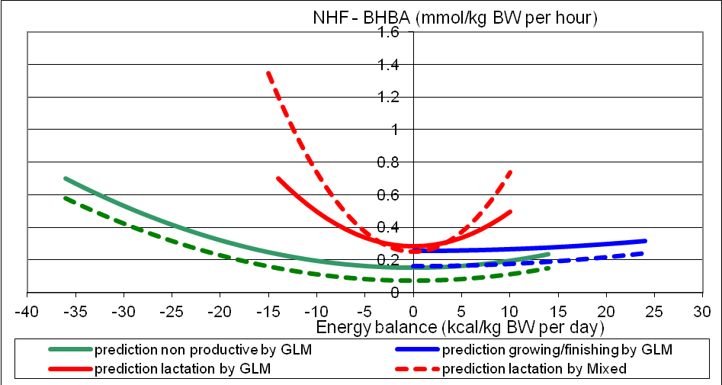
Supplementary Figure S1

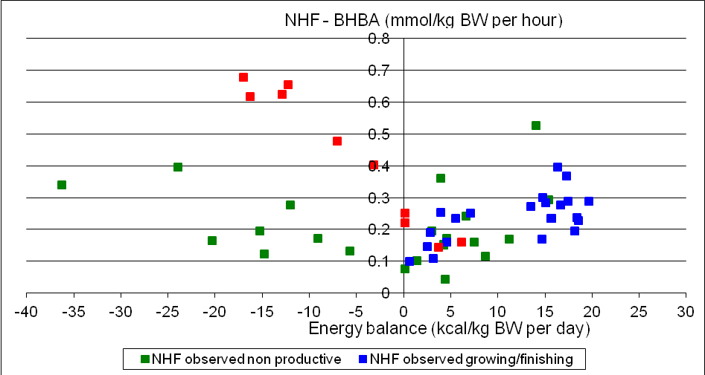
Supplementary Figure S2

Supplementary Figure S3

