Supplementary files

Preselection statistics and random forest classification identify population informative single nucleotide polymorphisms in cosmopolitan and autochthonous cattle breeds

F. Bertolini, G. Galimberti, G. Schiavo, S. Mastrangelo, R. Di Gerlando, M.G. Strillacci, A. Bagnato, B. Portolano and L. Fontanesi

Table S1. The SNPs composition of the 96 and 48 (marked with the letter a) SNP panels. For each panel (one each reduction approaches) and each SNP, breed information is reported: Major allele (MA), Minor Allele Frequency (MAF) and LD>0.6 (defined with the symbol “*” in the MA box). For each SNP, the list of closest gene and the distance in kb from the considered marker is also reported (gene symbol).
SEE EXCEL FILE

Table S2. Assignment error (%) of the reference population (WHOLE) and the single breed test populations using the 4 pre-filtering steps. For the single breeds, the number of animals used for the test population is reported between brackets.
-ok: 100% of the animals were correctly assigned
-number followed by a letter is the number of animals not correctly assigned and the breed to which the animals were allocated: b= Brown, h= Holstein, s= Simmental, c= Cinisara, m= Modicana, r= Reggiana.
 | 96-SNP PANEL |  |  |  | 48-SNP PANEL
 | DELTA | Fst | PCA-wole | PCA-chrom | DELTA | Fst | PCA-wole | PCA-chrom
WHOLE (%) | 0.89 | 0.8 | 1.32 | 0.53 | 1.86 | 0.53 | 1.6 | 1.33
BROWN (74) | 1s | ok | 3p | 1p | 1s | 1p | 3p | 1p, 1f
HOLSTEIN (209) | 1b | 1s | 1b | ok | 1b | ok | 1b | 1b
SIMMENTAL (47) | ok | ok | ok | ok | ok | ok | ok | ok
CINISARA (7) | 1h | 1h, 1m | 1m | ok | 5s | 2h, 1s, 1m | 1m | 1p, 1r
MODICANA (7) | ok | ok | ok | ok | ok | ok | ok | ok
REGGIANA (16) | ok | ok | 1h, 1p | ok | 1h | ok | 1b, 1f | 1f

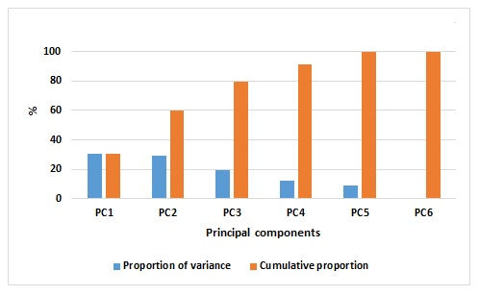
Figure S1. Proportion of variance and cumulative proportion of the 6 Principal components.

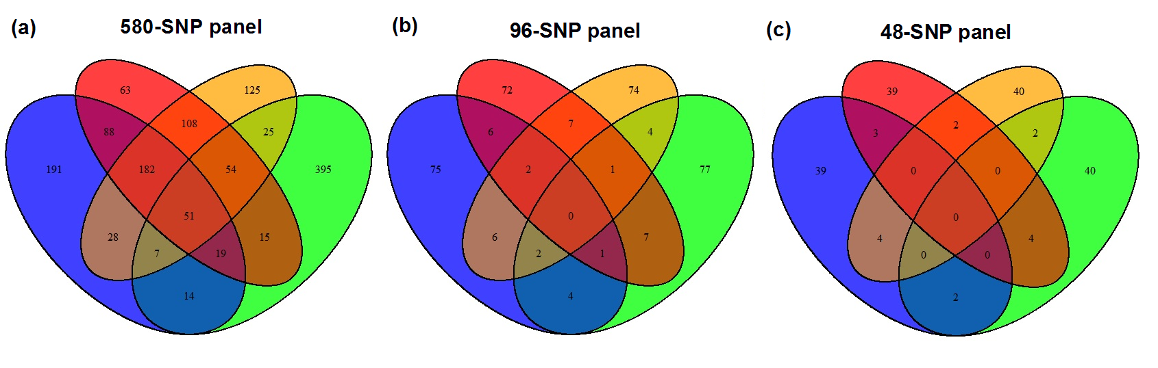
Figure S2. Venn diagram of for the number of common SNPs shared by the 580-SNP panels (a), the 96-SNP panels (b) and the 48-SNP panels (c) derived from delta (blue), Fst (red), PCA-whole (red) and PCA-chrom (orange) approaches.

