Targeted metabolomics: New insights into pathobiology of retained placenta in dairy cows and potential risk biomarkers
E.Dervishi, G. Zhang, R. Mandal, D. S. Wishart, and B. N. Ametaj

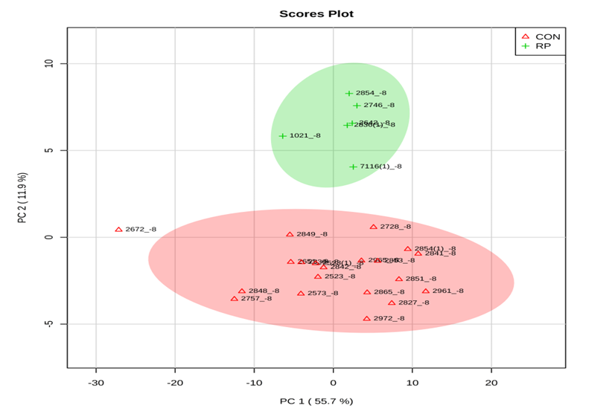

Supplementary Figure S1 Principal component analysis (PCA) of 20 control (CON) and 6 RP cows at -8 weeks before parturition showing 2 separated clusters for 2 groups.

