Targeted metabolomics: New insights into pathobiology of retained placenta in dairy cows and potential risk biomarkers
E.Dervishi, G. Zhang, R. Mandal, D. S. Wishart, and B. N. Ametaj

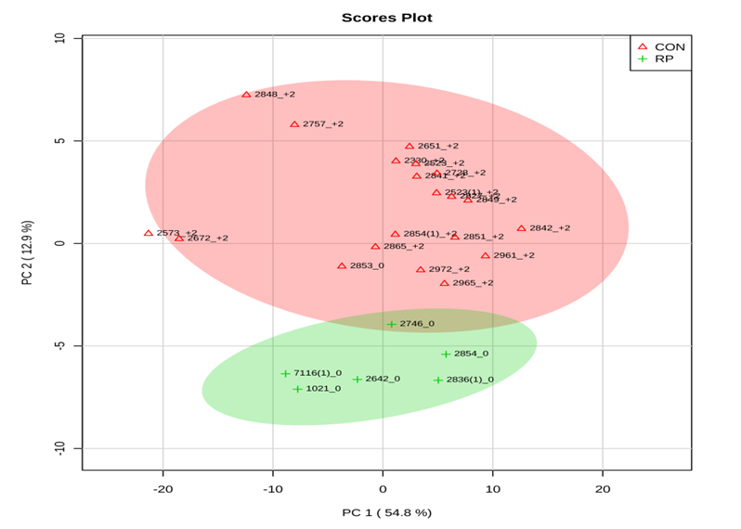

Supplementary Figure S3 Principal component analysis (PCA) of 20 control (CON) and 6 RP cows at disease diagnosis week showing 2 separated clusters for 2 groups.

