Targeted metabolomics: New insights into pathobiology of retained placenta in dairy cows and potential risk biomarkers
E.Dervishi, G. Zhang, R. Mandal, D. S. Wishart, and B. N. Ametaj

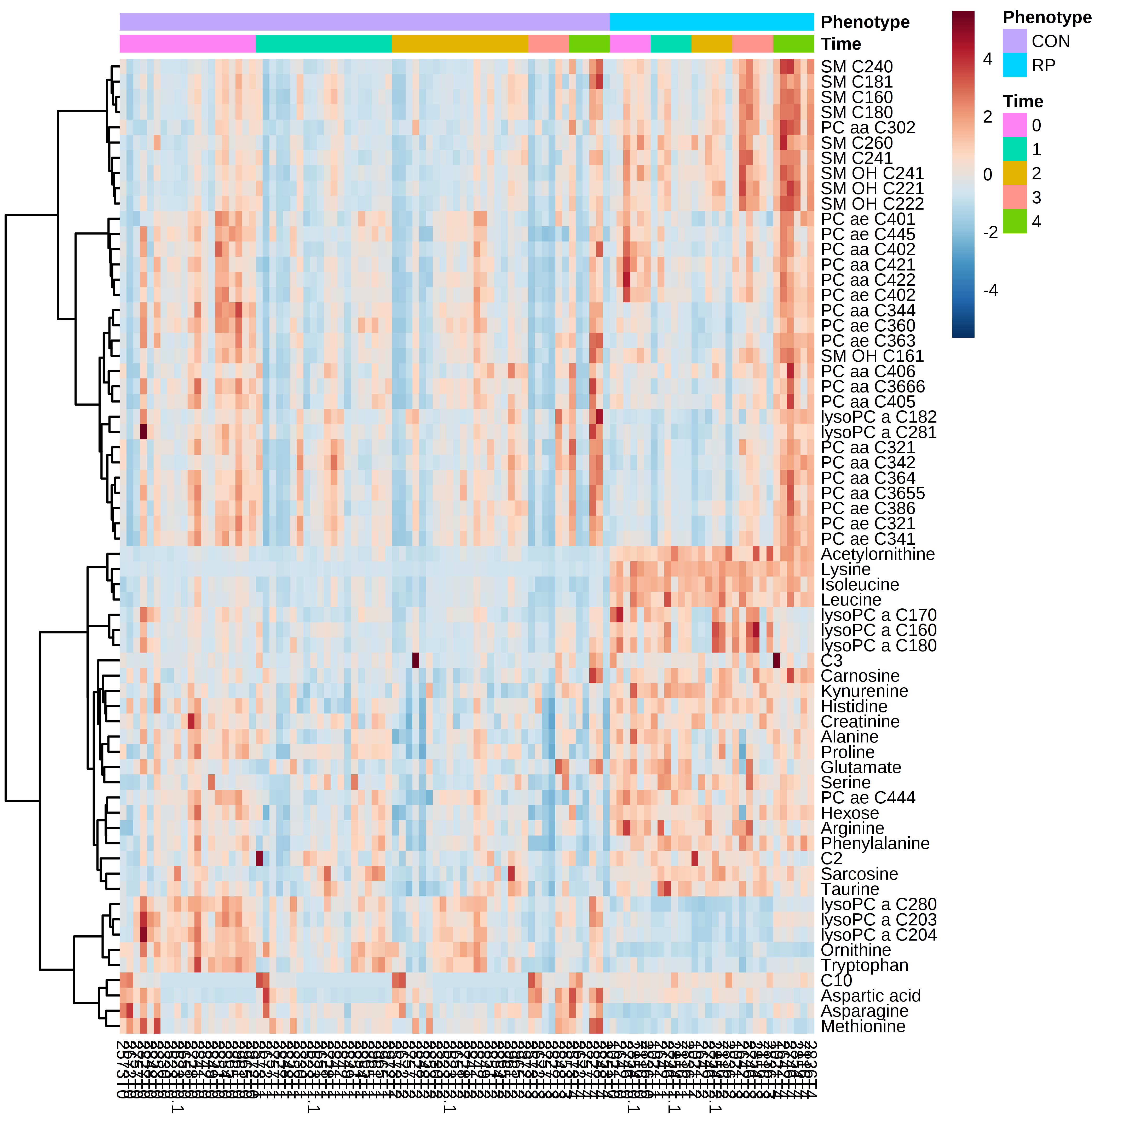
Supplementary Figure S6 Hierarchical clustering analysis of the metabolites in RP and CON cows at -8 weeks, -4 weeks, before parturition, disease diagnosis, +4 weeks and +8 weeks after parturition (timeline 0,1,2,3,4 respectively). Cells are colored based on the signal intensity measured. Dark brown represents high metabolites concentration levels, blue indicates low signal intensity, and gray indicates the intermediate level

