Supplementary File - for Online Publication Only

Evaluation of the effects of different diets on microbiome diversity and fatty acid composition of rumen liquor in dairy goat.
P. Cremonesi, G. Conte, M. Severgnini, F. Turri, A. Monni, E. Capra, L. Rapetti, S. Colombini, S. Chessa, G. Battelli, S.P. Alves, M. Mele and B. Castiglioni

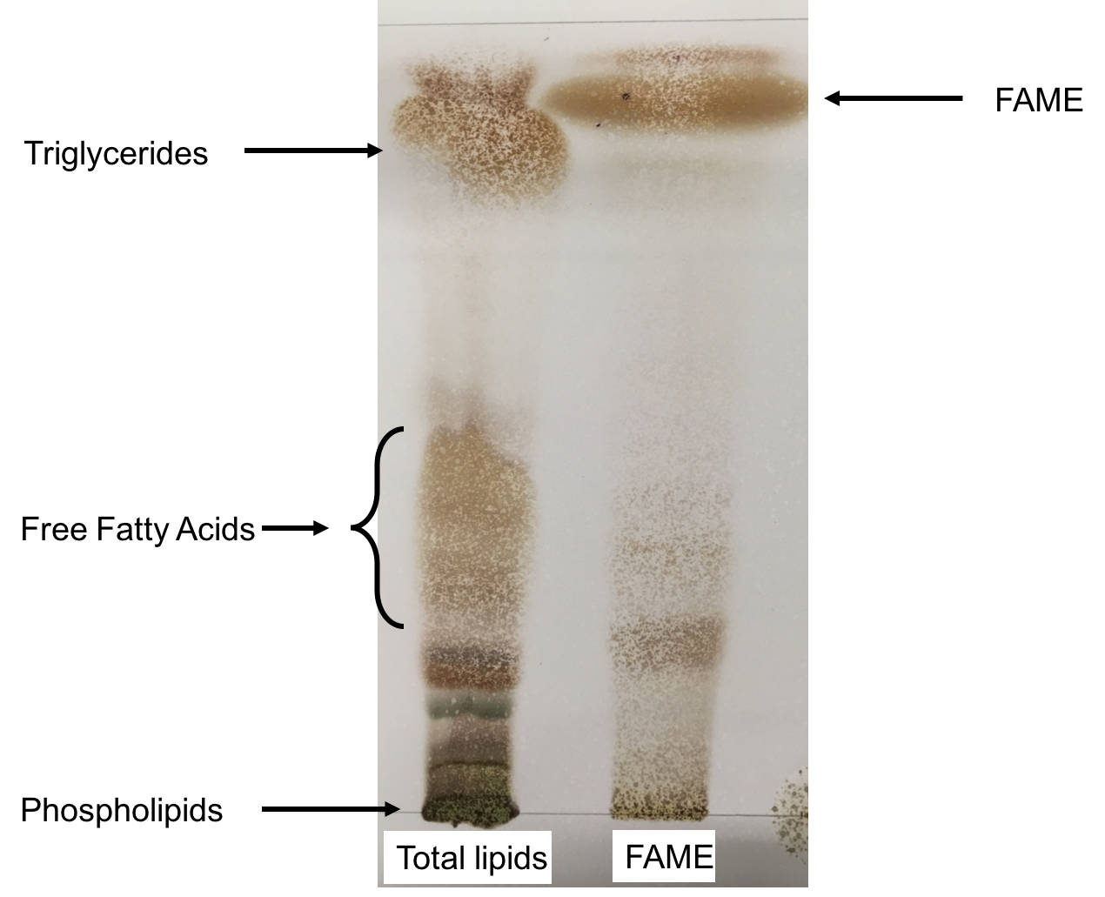
Supplementary Figure S1 TLC analysis to verify the complete esterification of the samples.
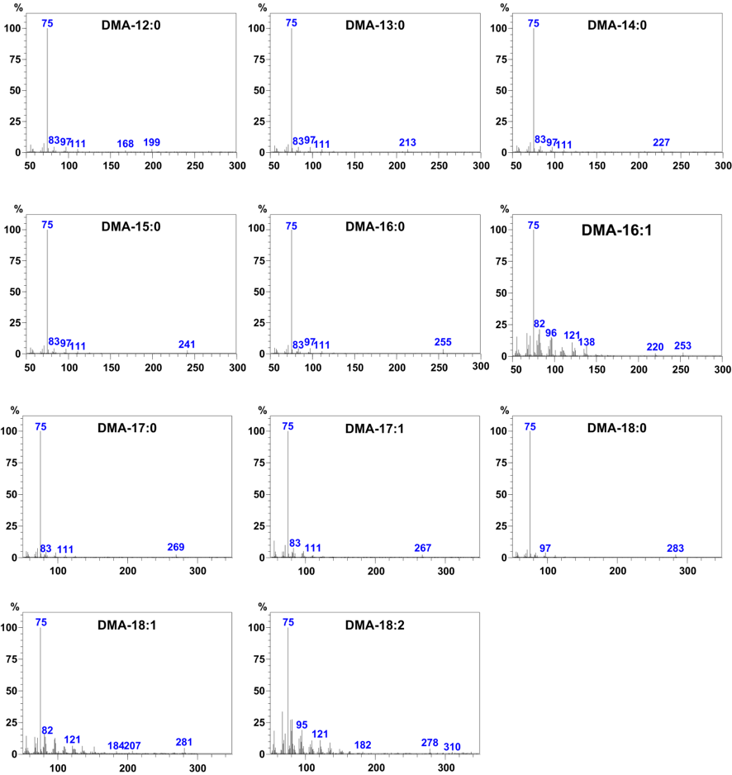
Supplementary Figure S2 MS spectra of satured fatty acid DMA.
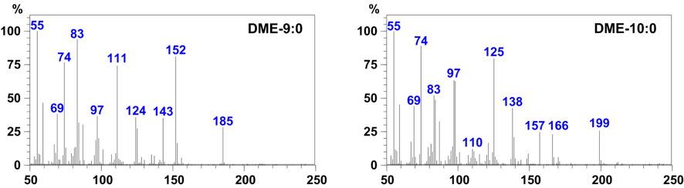

Supplementary Figure S3 MS spectra of branched fatty acid DME.
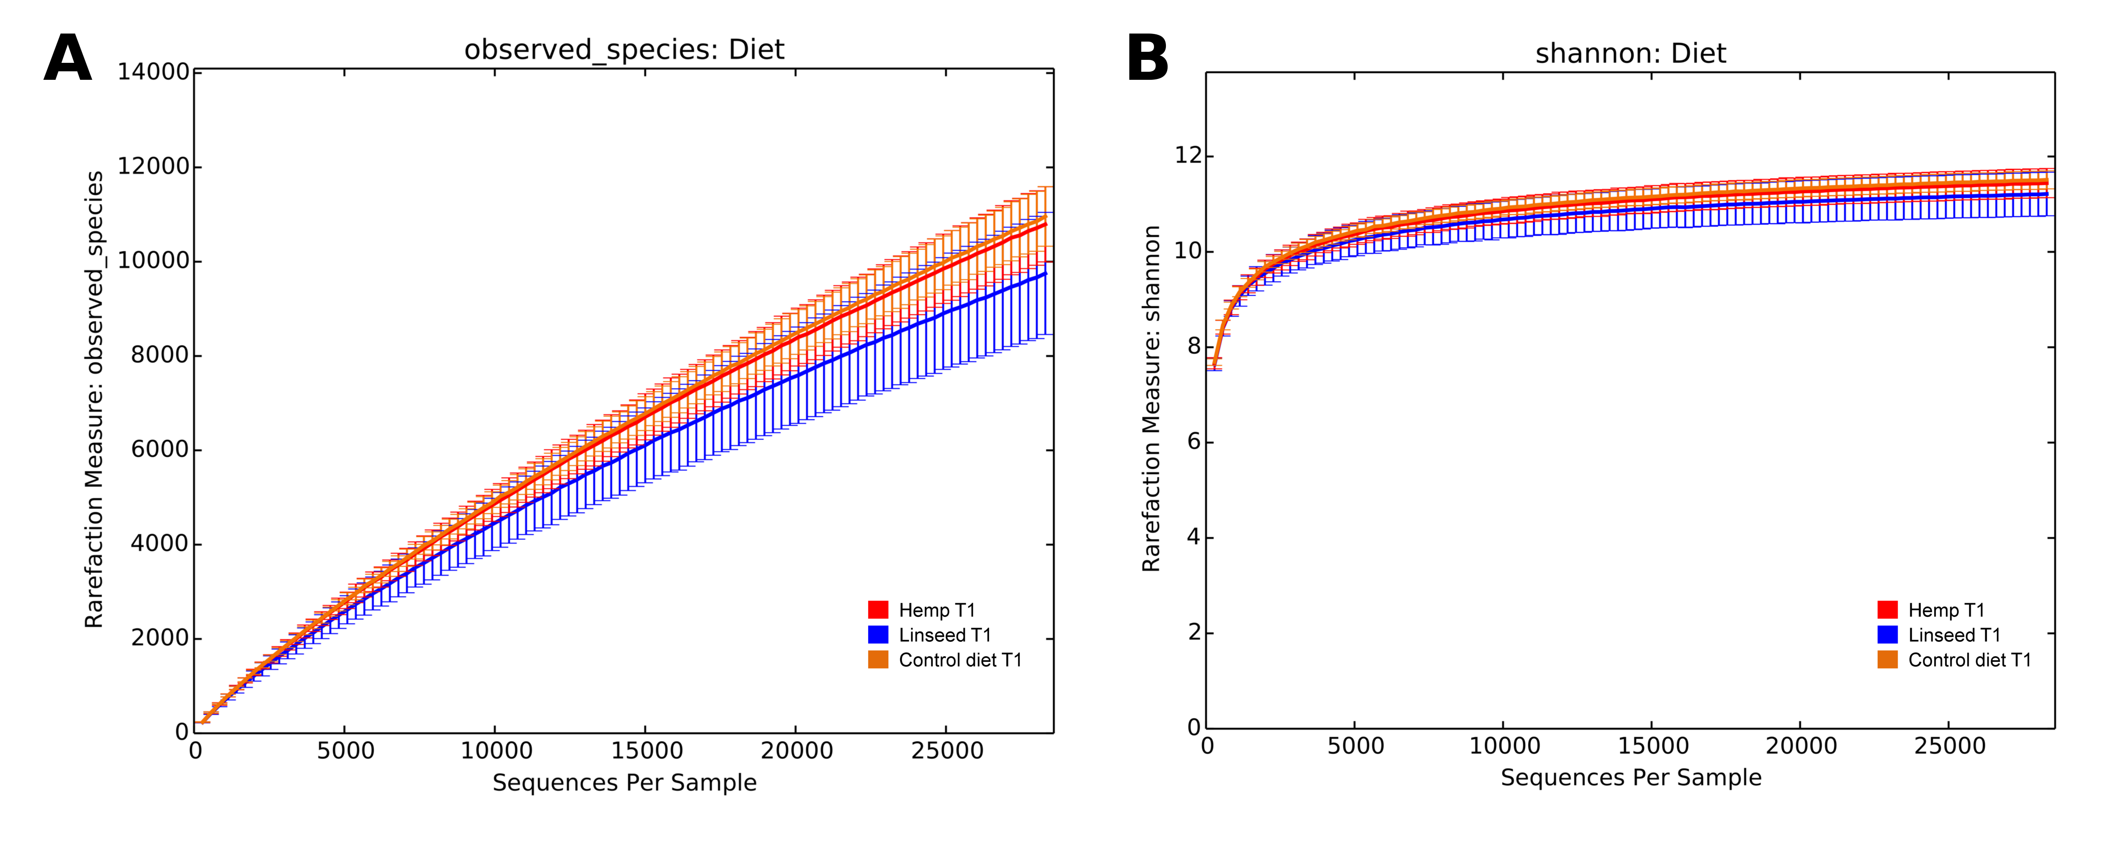

Supplementary Figure S4 Bacterial rarefaction curves analysis calculated by Observed species and Shannon metrics.
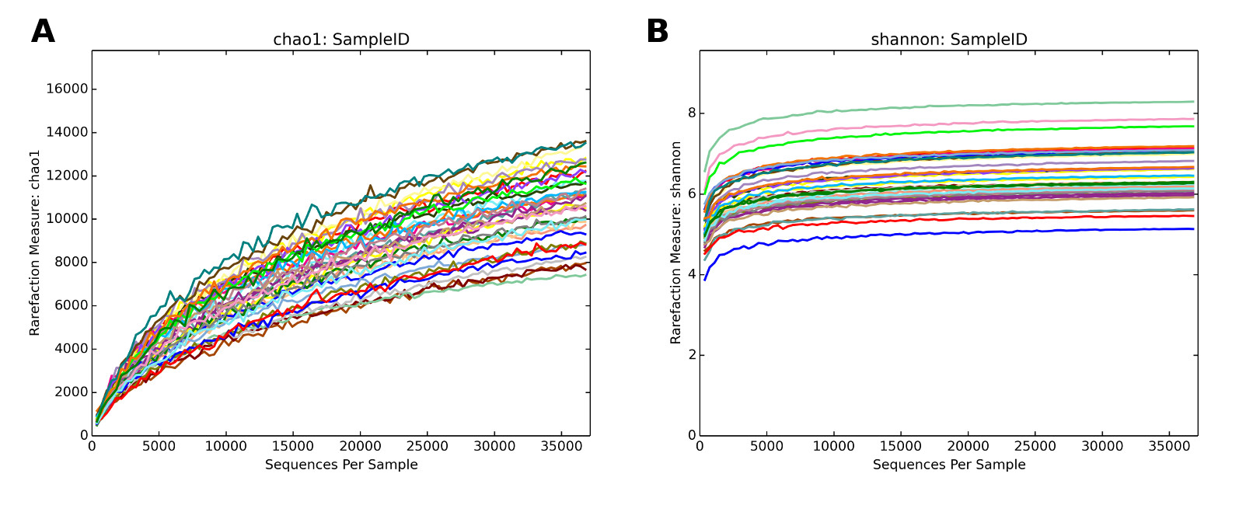

Supplementary Figure S5 Archaeal rarefaction curves calculated according to different microbial diversity metrics for all samples and represented for each different diets (Control: C; Hemp: H; Linseed. L) at the 2 time points (T0 and T1). Curves were drawn using the least sequenced sample (having ~ 36000 reads) as upper limit for the rarefactions.

