Animal Journal
Effects of curcumin on performance, antioxidation, intestinal barrier and mitochondrial function in ducks fed corn contaminated with ochratoxin A
D. Ruan^{1,2a}, W. C. Wang¹, C. X. Lin², A. M. Fouad^{2,3}, W. Chen², W. G. Xia², S. Wang², X. Luo², W. H. Zhang⁴, S. J. Yan⁴, C. T. Zheng² and L. Yang^{1†}
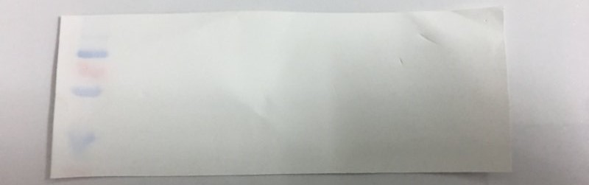
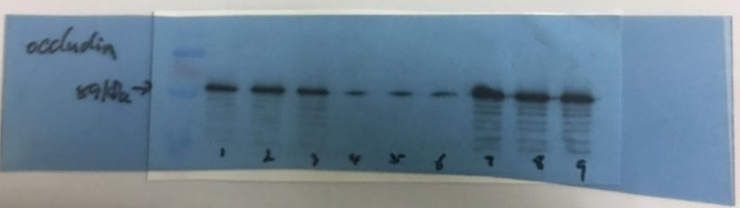


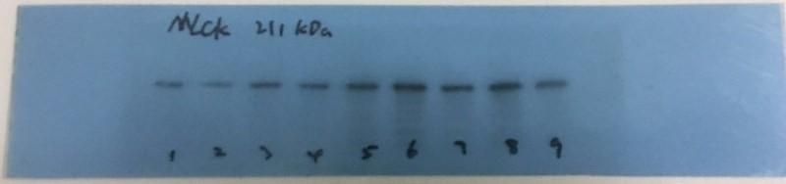
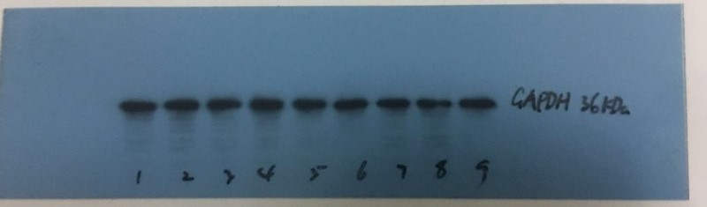
Figure S1 full gels with molecular weight ladder and the appropriate controls. No.1 to No.3 bands were control group, No.4 to No.6 bands were ochratoxin A (OTA) group, and No.7 to No.9 bands were curcumin with ochratoxin A (CUR+OTA) group.

