Induction of nuclear factor-κB signal-mediated apoptosis and autophagy by reactive oxygen species is associated with H₂O₂-impaired growth performance of broilers
Xiangxing Chen, Renqi Gu, Lin Zhang, Jiaolong Li, Yun Jiang, Guanghong Zhou and Feng Gao

The name of the journal: animal journal

Suppementary Table S1 The composition and nutrient levels of the basal diets
Items | 1 to 21 d | 22 to 42 d
Ingredients (%)
Corn | 57.61 | 62.27
Soybean meal | 31.00 | 23.00
Corn gluten meal¹ | 3.29 | 6.00
Soybean oil | 3.11 | 4.00
Limestone | 1.20 | 1.20
Dicalcium phosphate | 2.00 | 2.00
L-Lysine | 0.34 | 0.35
DL-Methionine | 0.15 | 0.08
Salt | 0.30 | 0.30
Premix² | 1.00 | 1.00
Calculated nutrient levels
ME (MJ/kg) | 12.56 | 13.19
Crude protein (%) | 21.10 | 19.60
Calcium (%) | 1.00 | 0.95
Available phosphorus (%) | 0.46 | 0.39
Lysine (%) | 1.20 | 1.05
Methionine (%) | 0.50 | 0.42
Methionine + cysteine (%) | 0.85 | 0.76
ME = metabolizable energy. ¹Crude protein content was 60%.
²Premix provided per kilogram of diet: retinyl acetate for vitamin A, 12000 IU; cholecalciferol for vitamin D₃, 2500 IU; DL-α-tocopheryl acetate for vitamin E, 20 IU; menadione sodium bisulphate, 1.3 mg; thiamin, 2.2 mg; riboflavin, 8.0 mg; nicotinamide, 40 mg; choline chloride, 400 mg; calcium pantothenate, 10 mg; pyridoxine HCl, 4 mg; biotin, 0.04 mg; folic acid, 1 mg; vitamin B₁₂ (cobalamin), 0.013 mg; Fe (from ferrous sulfate), 80 mg; Cu (from copper sulphate), 8.0 mg; Mn (from manganese sulphate), 110 mg; Zn (from zinc sulfate), 60 mg; I (from calcium iodate), 1.1 mg; Se (from sodium selenite), 0.3 mg

Suppementary Table S2 Effects of oxidative stress induced by H₂O₂ on death number and mortality of broilers
Items | Treatments
Items | Control | Saline | H₂O_{2(0.74)} | H₂O_{2(1.48)} | H₂O_{2(2.96)}
Death number | 0 | 0 | 0 | 1 | 7
Mortality, % | 0 | 0 | 0 | 1.57 | 10.10
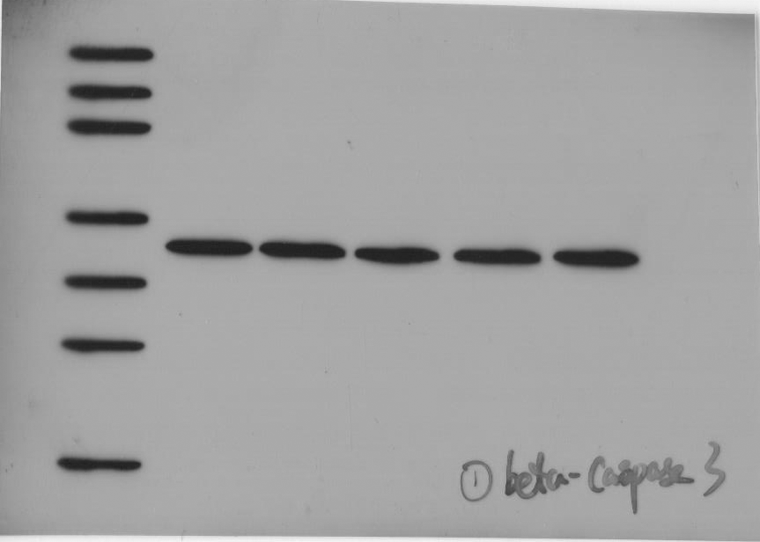
Supplementary Figure S1 The full membrane with molecular weight ladder used for western blot analysis of β-actin of caspase-3 in the liver of broilers exposed to H₂O₂ at 42 days.

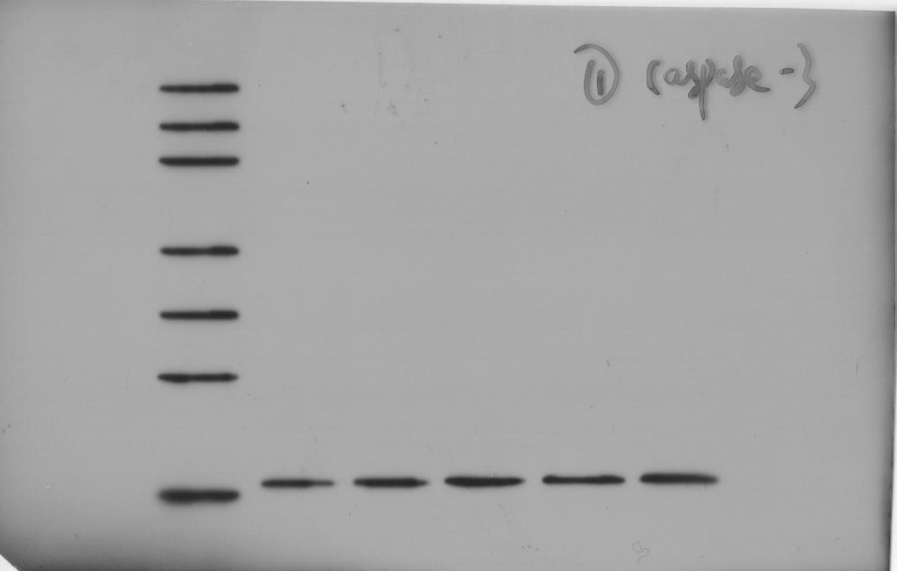
Supplementary Figure S2 The full membrane with molecular weight ladder used for western blot analysis of caspase-3 in the liver of broilers exposed to H₂O₂ at 42 days

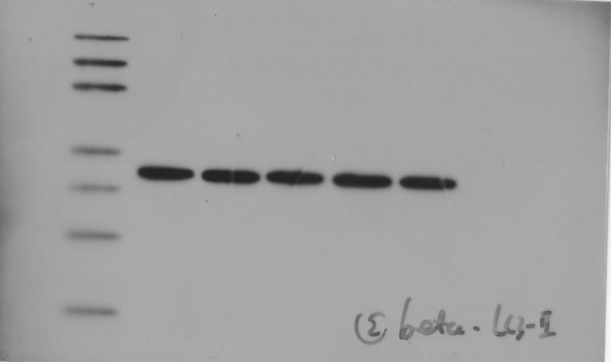
Supplementary Figure S3 The full membrane with molecular weight ladder used for western blot analysis of β-actin of LC3-II in the liver of broilers exposed to H₂O₂ at 42 days

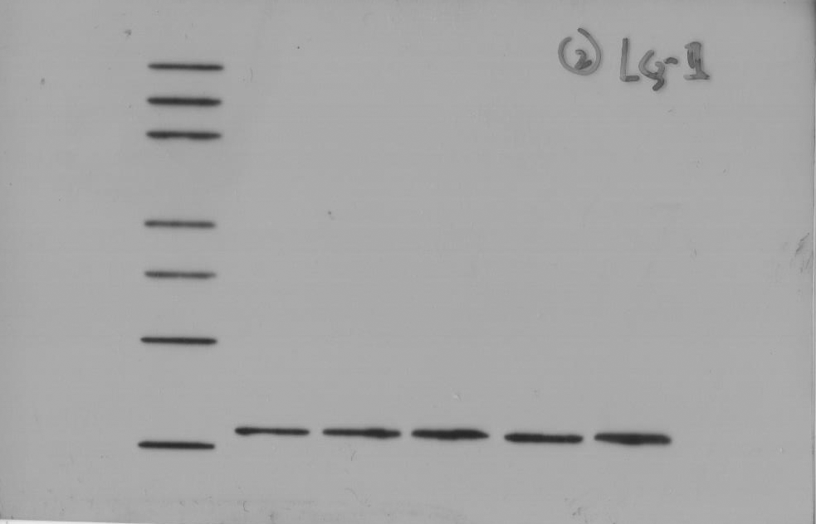
Supplementary Figure S4 The full membrane with molecular weight ladder used for western blot analysis of LC3-II in the liver of broilers exposed to H₂O₂ at 42 days

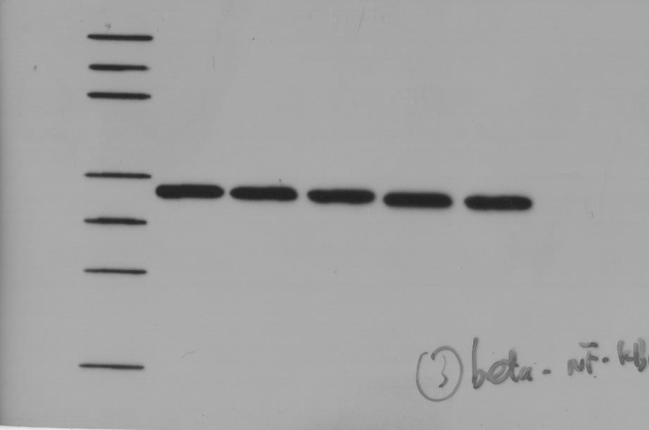
Supplementary Figure S5 The full membrane with molecular weight ladder used for western blot analysis of β-actin of NF-κB in the liver of broilers exposed to H₂O₂ at 42 days

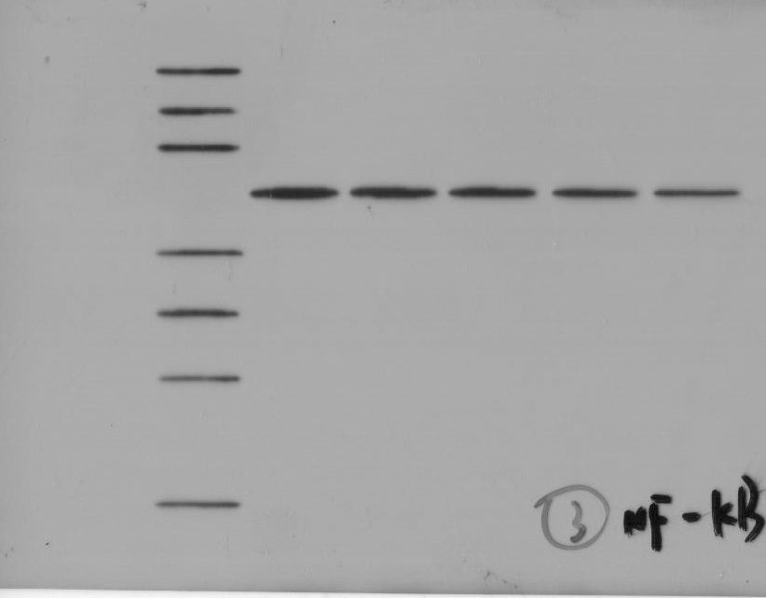
Supplementary Figure S6 The full membrane with molecular weight ladder used for western blot analysis of NF-κB in the liver of broilers exposed to H₂O₂ at 42 days

