**(-)-Epigallocatechin-3-gallate and hydroxytyrosol improved antioxidative and anti-inflammatory responses in bovine mammary epithelial cells**

*L****.*** *Basiricò¥, P. Morera¥, D. Dipasquale¥, R. Bernini¥, L. Santi¥, A. Romani‡, N. Lacetera¥, U. Bernabucci¥2*

¥Dipartimento di Scienze Agrarie e Forestali (DAFNE), Università degli Studi della Tuscia, via San Camillo de Lellis, 01100, Viterbo, Italy

**‡**Dipartimento di Statistica, Informatica, Applicazioni (DiSiA) “Giuseppe Parenti”, Università degli Studi di Firenze, via Morgagni 59, 50134, Firenze, Italy

2Corresponding author: Umberto Bernabucci, email: [bernab@unitus.it](mailto:bernab@unitus.it)

***animal* journal**



**Figure S1**. Chemical structure of (-)-epigallocatechin-3-gallate (EGCG) and hydroxytyrosol (HTyr).



**Figure S2**. Synthetic procedure of hydroxytyrosol (HTyr).

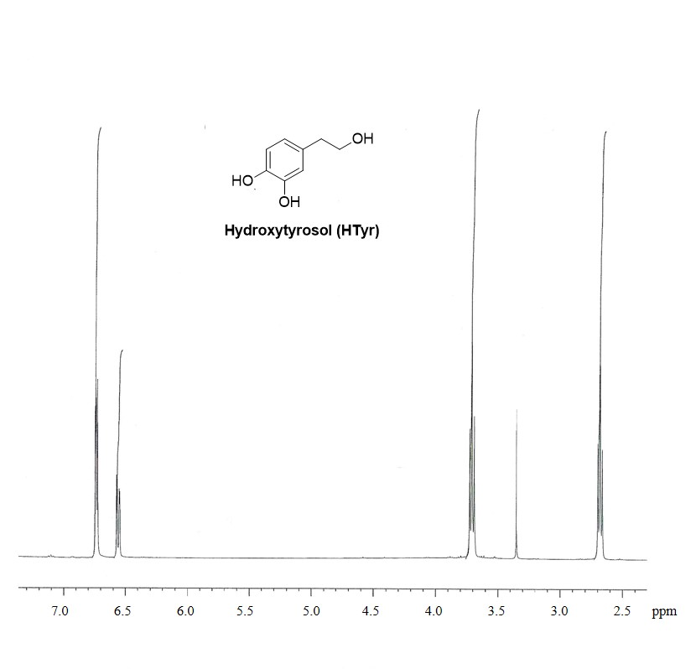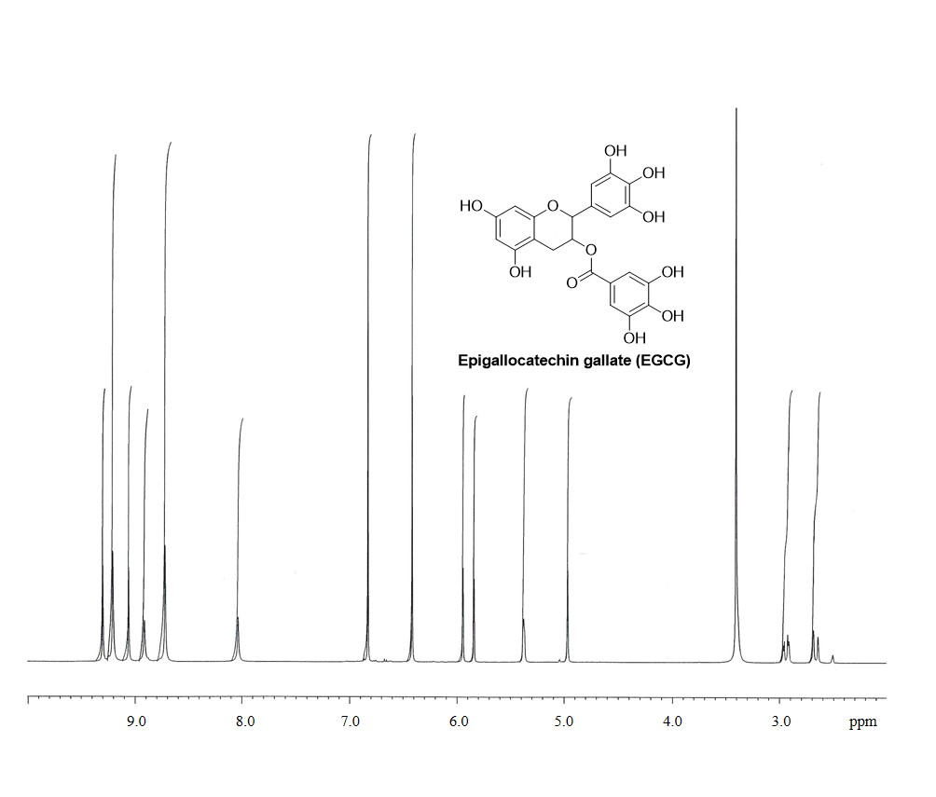

**Figure S3.** 1H-NMR spectra of (-)-epigallocatechin-3-gallate (EGCG) found in Teavigo® (Imperatori e*t al*., 2018) and synthetic hydroxytyrosol (HTyr) (Bernini *et al*., 2008).

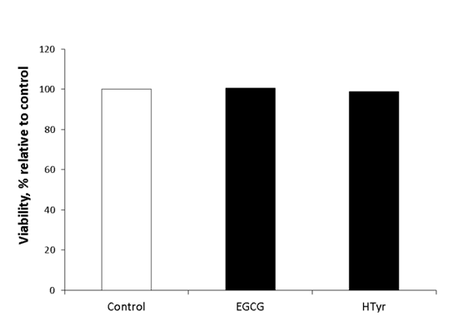

**Figure S4.** Cell viability of bovine mammary epithelial cells (BME-UV1) evaluated after 48 h exposure to 50 µM (-)-epigallocatechin-3-gallate (EGCG) or hydroxytyrosol (HTyr). Absorbance was measured at 450 nm, and data are reported as least squares means ± SEM.