(-)-Epigallocatechin-3-gallate and hydroxytyrosol improved antioxidative and anti-inflammatory responses in bovine mammary epithelial cells
L. Basiricò¥, P. Morera¥, D. Dipasquale¥, R. Bernini¥, L. Santi¥, A. Romani‡, N. Lacetera¥, U. Bernabucci^{¥2}

¥Dipartimento di Scienze Agrarie e Forestali (DAFNE), Università degli Studi della Tuscia, via San Camillo de Lellis, 01100, Viterbo, Italy
‡Dipartimento di Statistica, Informatica, Applicazioni (DiSiA) “Giuseppe Parenti”, Università degli Studi di Firenze, via Morgagni 59, 50134, Firenze, Italy

²Corresponding author: Umberto Bernabucci, email: bernab@unitus.it

animal journal

Figure S1. Chemical structure of (-)-epigallocatechin-3-gallate (EGCG) and hydroxytyrosol (HTyr).

Figure S2. Synthetic procedure of hydroxytyrosol (HTyr).
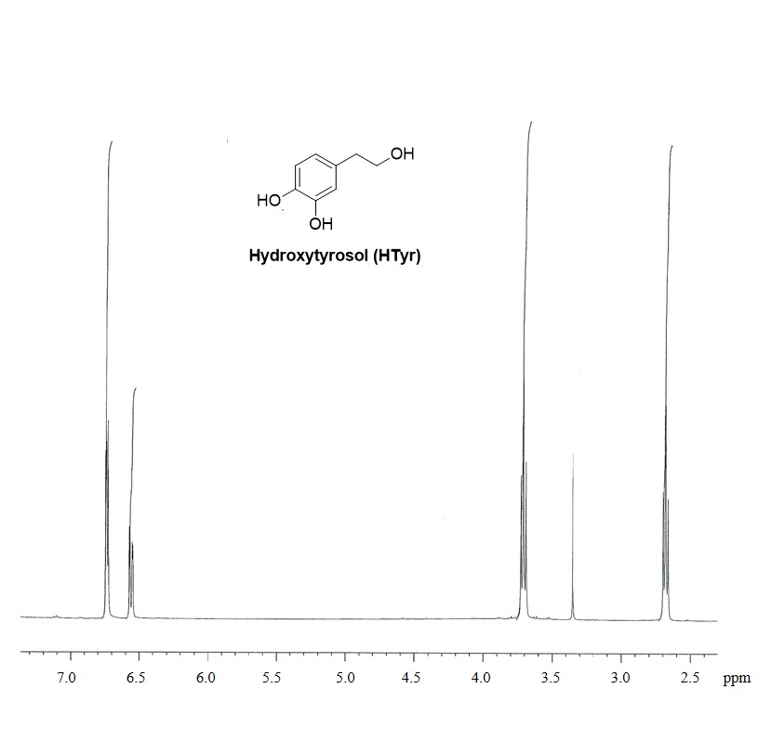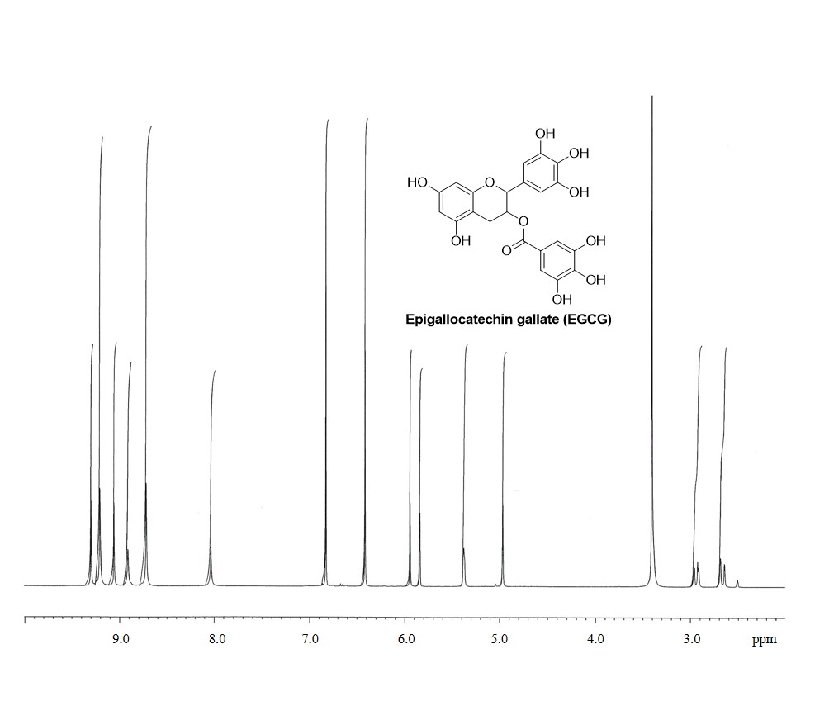

Figure S3. ¹H-NMR spectra of (-)-epigallocatechin-3-gallate (EGCG) found in Teavigo® (Imperatori et al., 2018) and synthetic hydroxytyrosol (HTyr) (Bernini et al., 2008).

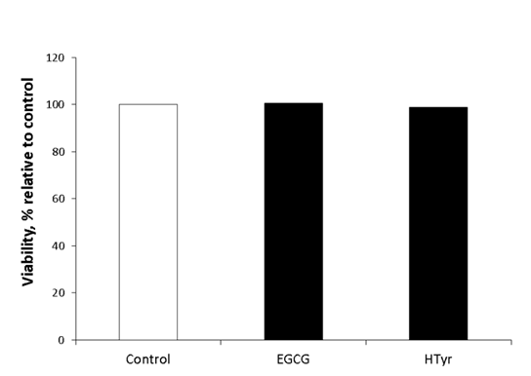

Figure S4. Cell viability of bovine mammary epithelial cells (BME-UV1) evaluated after 48 h exposure to 50 µM (-)-epigallocatechin-3-gallate (EGCG) or hydroxytyrosol (HTyr). Absorbance was measured at 450 nm, and data are reported as least squares means ± SEM.

