animal journal

Effect of early antibiotic intervention on specific bacterial communities and immune parameters in the small intestine of growing pigs fed different protein level diets

C. J. Zhang, M. Yu, Y. X. Yang, C. L. Mu, Y. Su, W. Y. Zhu†

Supplementary material

Material S1 Quantitative real-time polymerase chain reaction analysis of the bacterial 16S ribosomal RNA gene
Quantitative real-time PCR of bacterial 16S ribosomal RNA gene was performed on StepOnePlusTM Real-Time PCR System (Life Technologies, Carlsbad, CA, USA) using SYBR Premix Ex Taq dye (TaKaRa Biotechnology, Dalian, China). The PCR mixture consisted of 10 μL of 2 × SYBR Green PCR Master Mix, 0.4 μL of each primer, 2.0 μL of template DNA, 0.4 μL of ROX Reference Dye and 6.8 μL PCR-grade sterile water. The program for PCR amplification was performed using the following conditions: 30 s at 95°C and 40 cycles of 5 s at 95°C, 30 s at 60°C and one cycle of 15 s at 95°C, 1 min at 60°C and 15 s at 95°C. All samples were performed in triplicate. The bacterial copy numbers in jejunum and ileum were quantified according to standard curve of bacterial groups which were generated from serial dilutions of the plasmid. For each reference strain, the 16S ribosomal RNA gene fragment was amplified by PCR with specific primers (Supplementary Table S3), and cloned into a pMD-19 T Vector System (TaKaRa Biotechnology, Dalian, China).
Material S2 Short-chain fatty acid analysis
Short-chain fatty acid concentrations in the jejunal and ileal digesta were determined by gas chromatograph. Briefly,0.4 g of jejunal and ileal digesta was mixed with 1.6 mL of water. The mixture was vortexed and centrifuged at 13 000×g for 10 min at 4°C. 1 mL supernatant was mixed with 0.2 mL 25% (w/v) metaphosphoric acid, and samples were stored at −80°C for 12 h. After thawing, the mixture was centrifuged at 13 000×g for 10 min. The supernatant was filtered with a 0.22-mm syringe filter and then analyzed on an Aglient 7890B system with a flame ionization detector (Agilent Technologies Inc., Santa Clara, CA, USA).
Material S3 Biogenic amines analysis
Concentrations of biogenic amines were determined by high-performance liquid chromatography with precolumn dansylation. Briefly, 0.5 g jejunal and ieal digesta was mixed with 1.5 mL 5% (w/v) trichloroacetic acid solution for precipitating the proteins and peptides. After extraction by n-hexane, sample was derived using dansyl chloride. The gradient elution of two mobile phase were used as follows: mobile phase A consisted of HPLC grade water and mobile phase B was acetonitrile. The flow rate was 1.0 mL/min. The wavelength of ultraviolet detector was 254 nm and the column temperature was 30°C.
Material S4 Quantitative real-time polymerase chain reaction analysis of genes involved in intestinal mucosal immunity
Quantitative real-time PCR of genes involved in intestinal mucosal immunity was carried out on StepOnePlusTM Real-Time PCR System (Life Technologies, Carlsbad, CA, USA) through fluorescence detection using SYBR Premix Ex Taq dye (TaKaRa Biotechnology, Dalian, China). The PCR mixture contained 2.0 μL of complementary DNA template, 10 μL of 2 × SYBR Green PCR Master Mix, 0.4 μL of each primer, 0.4 μL of ROX Reference Dye and PCR-grade sterile water to a final volume of 20 μL. Amplification conditions were as follows: 95°C for 30 s, followed by 40 cycles composed of 5 s at 95°C and 30 s at 60°C, and one cycle of 15 s at 95°C, 60 s at 60°C and 15 s at 95°C. All measurements were made in triplicate, and the mean threshold cycle was calculated. The results were normalized to that of Beta-actin mRNA used as a housekeeping gene, and the data were calculated according to the 2^{-ΔΔCt} method.
Material S5 Generalized linear model procedure and model description
A two-way GLM procedure was introduced to analyse antibiotic effect, protein levels effect and their interaction on bacterial community, bacterial metabolite and immune parameters.
The model is defined as:
Y_{ijk} = μ +A_{i} +P_{j} +AP_{ij} +e_{ijk}
where Y = dependent variable, μ = overall mean, Ai = the fixed effect of antibiotic (i = antibiotic v. control), P_{j} = the fixed effect of dietary protein levels (j = low-CP diet v. normal-CP diet), AP_{ij} = interaction of antibiotic and protein levels
e_{ijk} = residual error.
Results S1 Results of quality control procedures

For dominant bacterial communities in jejunal and ileal digesta

The PCR amplification efficiencies for 16S rRNA gene of total bacteria, Bifidobacterium, Clostridium cluster IV, Clostridium cluster XIVa, Enterobacteriaceae and Lactobacillus ranged from 96.71% to 103.85%.

For Gene expression in the jejunal and ileal mucosa
The PCR amplification efficiencies for all genes ranged from 95.55% to 106.23%.

For cytokines and immunoglobulins concentrations in the jejunal and ileal mucosa
The concentrations of interleukin-8 (IL-8), IL-10, interferon-γ, tumor necrosis factor-α, secretory immunoglobulin A (SIgA) and IgG in the jejunal and ileal mucosa were measured using commercially available ELISA kits according to manufacturer’s instructions (The intra-assay and inter-assay coefficients of variation were < 10%).

Table S1 Ingredients and nutrient composition of commercial creep diet for piglets (%, as-fed basis)¹
Items | Content
Ingredients (%)
Corn | 40.0
Rice, broken | 15.0
Soybean meal, fermented | 10.0
Soybean meal, de-hulled | 6.00
Spray dried animal plasma | 5.00
Whey powder | 7.00
Fish meal | 4.00
Sugar | 4.50
Glucose | 3.00
Soybean oil | 1.50
L-Lysine-HCl (98%) | 0.30
L-Methionine | 0.15
L-Threonine | 0.20
L-Tryptophan | 0.05
L-Isoleucine | 0.05
L-Valine | 0.05
Salt | 0.30
Limestone | 1.10
CaHPO4 | 0.80
Vitamin mixture² | 0.20
Mineral mixture³ | 0.80
Total | 100
Calculated content
Digestible energy (Mcal/kg) | 3.40
Total calcium | 0.85
Total phosphorus | 0.70
Digestible Lysine | 1.45
Digestible Methionine+Cysteine | 0.79
Digestible Threonine | 0.81
Digestible Tryptophan | 0.23
Digestible Isoleucine | 0.74
Digestible Leucine | 1.45
Digestible Valine | 0.89
Analyzed nutrient composition, %
Crude protein | 20.2
¹ Values for Ingredients and nutrient composition of commercial creep diet according to Yu et al. (2017)
Reference
Yu M, Mu C, Yang Y, Zhang C, Su Y, Huang Z, Yu K and Zhu W 2017. Increases in circulating amino acids with in-feed antibiotics correlated with gene expression of intestinal amino acid transporters in piglets. Amino Acids 49, 1587-1599.
² Vitamin mixture supplied the following per kg complete diet: vitamin A, 15 000 IU; vitamin D3, 3 000 IU; vitamin E, 150 mg; vitamin K3, 3 mg; vitamin B1, 3 mg; vitamin B2, 6 mg; vitamin B6, 5 mg; vitamin B12, 0.03 mg; niacin, 45 mg; vitamin C, 250 mg; calcium pantothenate, 9 mg; folic acid, 1 mg; biotin, 0.3 mg; choline chloride, 500 mg.
³ Mineral mixture supplied the following per kg complete diet: Fe, 170 mg; Cu, 150 mg; I, 0.90 mg; Se,0.2 mg; Zn, 150 mg; Mg, 68 mg; Mn, 80 mg; Co, 0.3 mg.
Table S2 Ingredients and nutrient composition of experimental diet for growing pigs (%, as-fed basis)1,2
Items | Day 42 to day 77 |  |  | Day 77 to day 120
Items | LP-16% | NP-20% |  | LP-14% | NP-18%
Ingredient, %
Corn | 68.0 | 63.7 |  | 68.9 | 58.0
Soybean meal | 18.0 | 21.0 |  | 18.8 | 29.4
Wheat bran | - | - |  | 6.00 | 8.00
Whey powder | 4.30 | 4.30 |  | - | -
Fishmeal | 3.20 | 8.00 |  | - | -
Soybean oil | 2.70 | 0.70 |  | 2.56 | 1.60
Dicalcium phosphate | 0.85 | 0.10 |  | 0.78 | 0.65
Calcium carbonate | 0.50 | 0.36 |  | 0.89 | 0.89
Sodium chloride | 0.30 | 0.30 |  | 0.30 | 0.30
Mineral-vitamin premix³ | 1.00 | 1.00 |  | 1.00 | 1.00
L-Lysine | 0.65 | 0.33 |  | 0.49 | 0.17
DL-Methionine | 0.20 | 0.09 |  | 0.10 | -
L-Threonine | 0.24 | 0.10 |  | 0.15 | 0.01
L-Tryptophan | 0.06 | 0.02 |  | 0.03 | -
Calculated content, %
ME,MJ/kg | 14.0 | 14.0 |  | 13.8 | 13.8
SID Lysine | 1.23 | 1.23 |  | 0.99 | 0.98
SID Methionine+Cysteine | 0.68 | 0.68 |  | 0.56 | 0.56
SID Threonine | 0.73 | 0.73 |  | 0.59 | 0.60
SID Tryptophan | 0.20 | 0.20 |  | 0.17 | 0.20
SID Isoleucine | 0.56 | 0.70 |  | 0.50 | 0.67
SID Leucine | 1.26 | 1.49 |  | 1.17 | 1.40
SID Valine | 0.61 | 0.77 |  | 0.55 | 0.70
Analyzed nutrient composition, %
CP | 16.6 | 20.1 |  | 14.0 | 18.0
Ash | 5.68 | 5.80 |  | 5.81 | 5.87
EE | 5.50 | 4.31 |  | 4.60 | 4.85
CF | 2.52 | 2.62 |  | 3.15 | 3.75
Starch | 42.7 | 40.0 |  | 44.5 | 38.0
NP = normal crude protein; LP = low crude protein; ME = metabolizable energy; SID = standardized ileal digestibility; CP = crude protein; EE = ether extract; CF = crude fiber.
¹ Values for Ingredients and nutrient composition of experimental diets according to zhang et al. (2016)
Reference
Zhang C, Yu M, Yang Y, Mu C, Su Y and Zhu W 2016a. Differential effect of early antibiotic intervention on bacterial fermentation patterns and mucosal gene expression in the colon of pigs under diets with different protein levels. Applied Microbiology and Biotechnology 101, 2493-2505.
² Diets with or without in-feed antibiotic (Control vs. Antibiotic) were fed from day 7 to day 42 of age. Thereafter, control and antibiotic groups were further randomly divided to 1 of 2 treatment groups, which provides a normal (20% CP from day 42 to day 77 and 18% CP from day 77 to day 120) or low CP diet (16% CP from day 42 to day 77 and 14% CP from day 77 to day 120) until day 120.
³ Provided per kilogram of complete diet: vitamin A, 28 500 IU; vitamin D3, 6 000 IU; vitamin E, 67.5 IU; vitamin K3, 7.5 mg; vitamin B1, 7.5 mg; vitamin B2, 15 mg; vitamin B6, 9 mg; vitamin B12, 0.075 mg; niacin, 75 mg; vitamin C, 250 mg; calcium pantothenate, 37.5 mg; folic acid, 3 mg; biotin, 0.0375 mg; choline chloride, 500 mg; Fe, 170 mg; Cu, 153.6 mg; I, 0.39 mg; Se, 0.3 mg; Zn, 48 mg; Mg, 76.9 mg; Mn, 81 mg; Co, 5 mg.

Table S3 List of primers for intestinal bacterial communities of pigs used in this study
Bacteria | Forward primer (5'-3') | Reverse primer (5'-3') | Reference¹ | Annealing temperature (°C)
Bifidobacterium | TCGCGTCYGGTGTGAAAG | GGTGTTCTTCCCGATATCTACA | (Walker et al., 2011) | 60
Clostridium cluster IV | GCACAAGCAGTGGAGT | CTTCCTCCGTTTTGTCAA | (Matsuki et al., 2004) | 60
Clostridium cluster XIVa | CGGTACCTGACTAAGAAGC | AGTTTYATTCTTGCGAACG | (Bartosch et al., 2004) | 60
Enterobacteriaceae | CATGCCGCGTGTATGAAGAA | CGGGTAACGTCAATGAGCAAA |  | 60
Lactobacillus | AGCAGTAGGGAATCTTCCA | ATTCCACCGCTACACATG | (Khafipour et al., 2009) | 60
Total bacteria | GTGSTGCAYGGYYGTCGTCA | ACGTCRTCCMCNCCTTCCTC |  | 60
¹ References
Bartosch S, Fite A, Macfarlane GT and McMurdo ME 2004. Characterization of bacterial communities in feces from healthy elderly volunteers and hospitalized elderly patients by using real-time PCR and effects of antibiotic treatment on the fecal microbiota. Applied and Environmental Microbiology 70, 3575-3581.
Hiroshi M, Chiyo F, Yasuhiro H, Takemasa M, Susumu K, Millan P, Hideo A, Ichiro T, Fusanori N and Shogo T 2010. Quantitative real-time PCR using TaqMan and SYBR Green for Actinobacillus actinomycetemcomitans, Porphyromonas gingivalis, Prevotella intermedia, tetQ gene and total bacteria. FEMS Immunology and Medical Microbiology 39, 81-86.
Khafipour E, Li S, Plaizier JC and Krause DO 2009. Rumen microbiome composition determined using two nutritional models of subacute ruminal acidosis. Applied and Environmental Microbiology 75, 7115-7124.
Matsuki T, Watanabe K, Fujimoto J, Takada T and Tanaka R 2004. Use of 16S rRNA gene-targeted group-specific primers for real-time PCR analysis of predominant bacteria in human feces. Applied and Environmental Microbiology 70, 7220-7228.
Roussel C, Sivignon A, Vallée AD, Garrait G, Denis S, Tsilia V, Ballet N, Vandekerckove P, Wiele TVD and Barnich N 2018. Anti-infectious properties of the probiotic Saccharomyces cerevisiae CNCM I-3856 on enterotoxigenic E . coli (ETEC) strain H10407. Applied Microbiology and Biotechnology 102, 6175-6189.
Walker AW, Ince J, Duncan SH, Webster LM, Holtrop G, Ze X, Brown D, Stares MD, Scott P, Bergerat A, Louis P, McIntosh F, Johnstone AM, Lobley GE, Parkhill J and Flint HJ 2011. Dominant and diet-responsive groups of bacteria within the human colonic microbiota. The ISME Journal 5, 220-230.

Table S4 Primer pairs for pig genes
Gene | Forward primer (5'-3') | Reverse primer (5'-3') | Reference¹ | Annealing temperature (°C)
Beta-actin | AGAGCGCAAGTACTCCGTGT | ACATCTGCTGGAAGGTGGAC | (Pieper et al., 2012) | 60
TLR2 | TCACTTGTCTAACTTATCATCCTCTTG | TCAGCGAAGGTGTCATTATTGC | (Collado-Romero et al., 2010) | 60
TLR4 | TCAGTTCTCACCTTCCTCCTG | GTTCATTCCTCACCCAGTCTTC | (Liu et al., 2012) | 60
TLR5 | CAGCGACCAAAACAGATTGA | TGCTCACCAGACAGACAACC | (Collado-Romero et al., 2010) | 60
IL-8 | ACTGGCTGT TGCCTTCTT | CAGTT CTCTTCAAAAATATCTG | (Zhou et al., 2014) | 60
IL-10 | GTCCGACTCAACGAAGAAGG | GCCAGGAAGATCAGGCAATA | (Pieper et al., 2012) | 60
IFN-γ | TCCAGCGCAAAGCCATCAGTG | ATGCTCTCTGGCCTTGGAACATAGT | (Villodre Tudela et al., 2015) | 60
TNF-α | CCACGCTCTTCTGCCTACTGC | GCTGTCCCTCGGCTTTGAC | (Zhou et al., 2014) | 60
MUC2 | CTGCTCCGGGTCCTGTGGGA | CCCGCTGGCTGGTGCGATAC | (Pieper et al., 2012) | 60
OCLN | ATGCTTTCTCAGCCAGCG TA | AAG GTTCCATAGCCTCGGTC | (Zhou et al., 2014) | 60
ZO-1 | GAGGATGGTCACACCGTGGT | GGAGGATGCTGTTGTCTCGG | (Zhou et al., 2014) | 60
TLR = Toll-like receptor; IL = interleukin; IFN-γ = interferon-γ; TNF-α = tumor necrosis factor-α; MUC2 = mucin-2; OCLN = occludin; ZO-1 = zonula occludens-1
¹ References
Collado-Romero M, Arce C, Ramirez-Boo M, Carvajal A and Garrido JJ 2010. Quantitative analysis of the immune response upon Salmonella typhimurium infection along the porcine intestinal gut. Veterinary Research 41, 23.
Liu Y, Chen F, Odle J, Lin X, Jacobi SK, Zhu H, Wu Z and Hou Y 2012. Fish oil enhances intestinal integrity and inhibits TLR4 and NOD2 signaling pathways in weaned pigs after LPS challenge. The Journal of Nutrition 142, 2017-2024.
Pieper R, Kroger S, Richter JF, Wang J, Martin L, Bindelle J, Htoo JK, von Smolinski D, Vahjen W, Zentek J and Van Kessel AG 2012. Fermentable fiber ameliorates fermentable protein-induced changes in microbial ecology, but not the mucosal response, in the colon of piglets. The Journal of Nutrition 142, 661-667.
Villodre Tudela C, Boudry C, Stumpff F, Aschenbach JR, Vahjen W, Zentek J and Pieper R 2015. Down-regulation of monocarboxylate transporter 1 (MCT1) gene expression in the colon of piglets is linked to bacterial protein fermentation and pro-inflammatory cytokine-mediated signalling. British Journal of Nutrition 113, 610-617.
Zhou XL, Kong XF, Lian GQ, Blachier F, Geng MM and Yin YL 2014. Dietary supplementation with soybean oligosaccharides increases short-chain fatty acids but decreases protein-derived catabolites in the intestinal luminal content of weaned Huanjiang mini-piglets. Nutrition Research 34, 780-788.

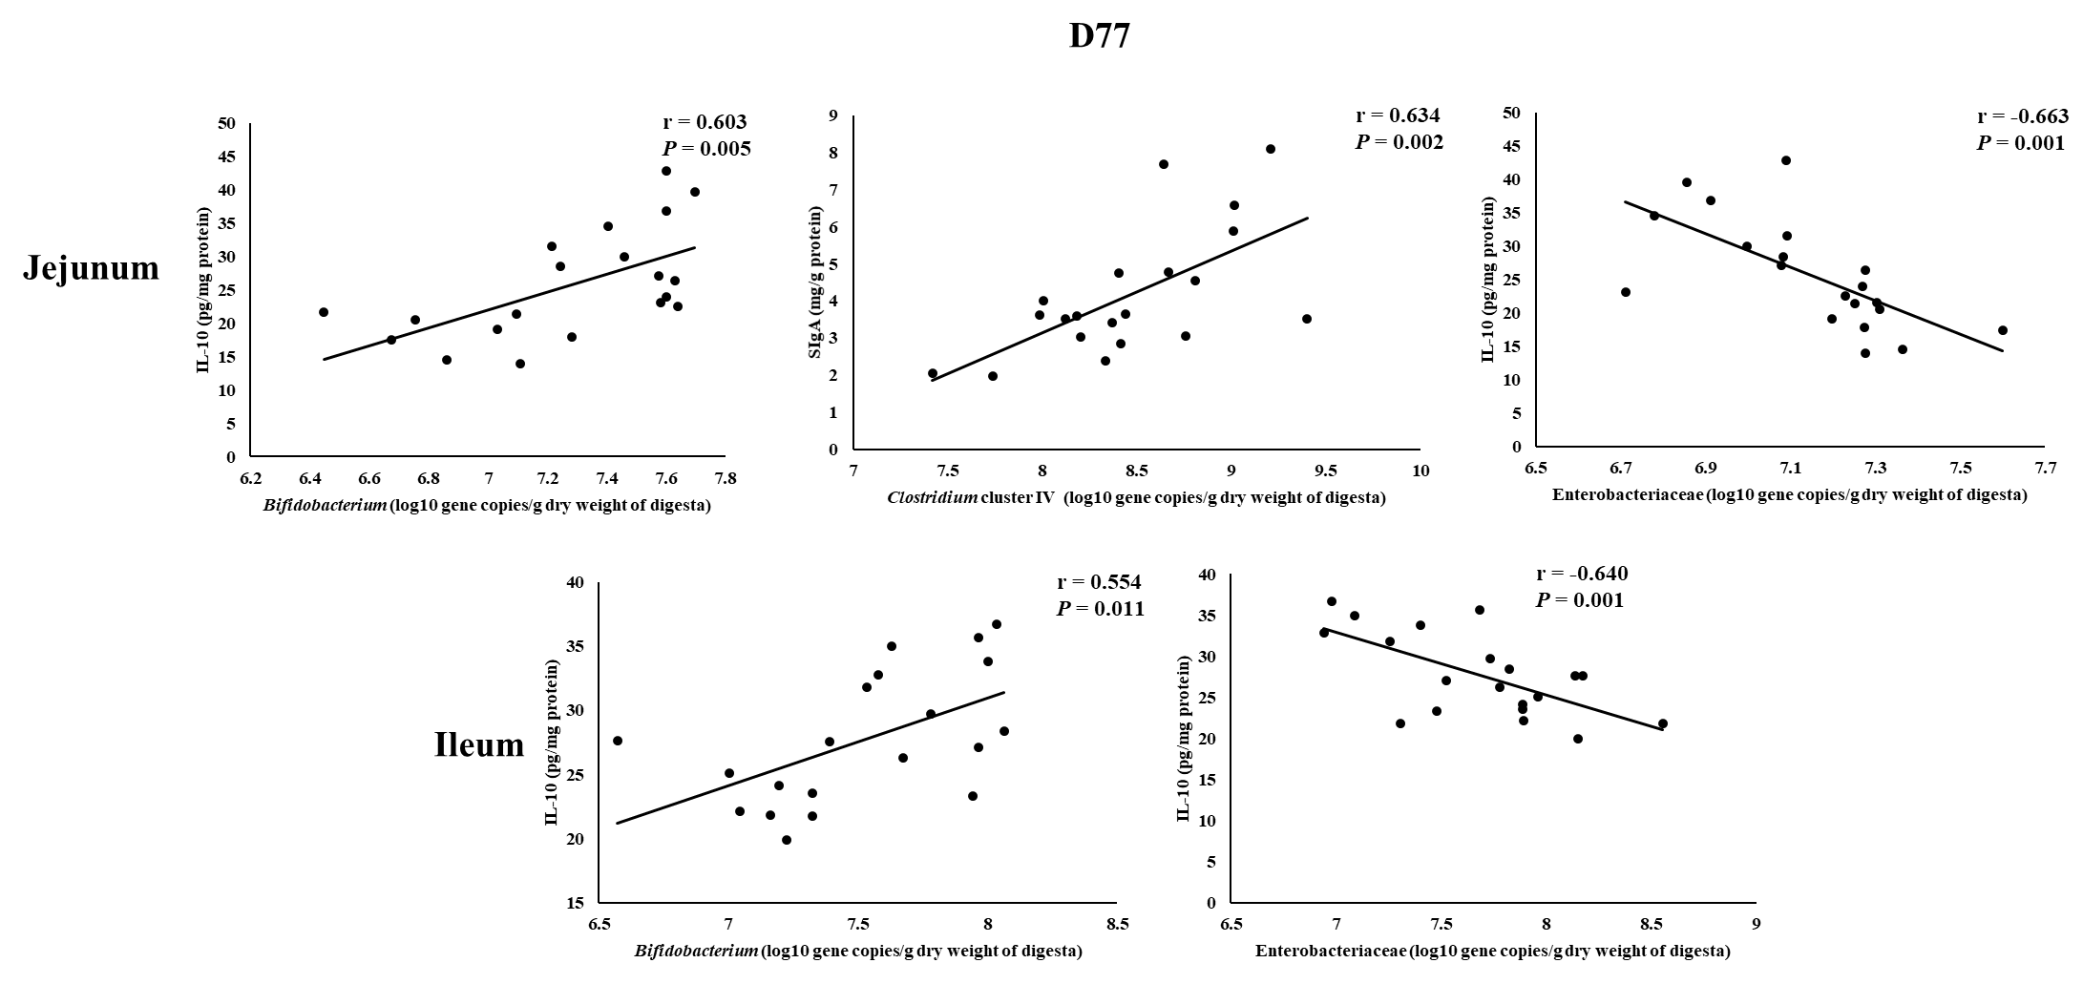

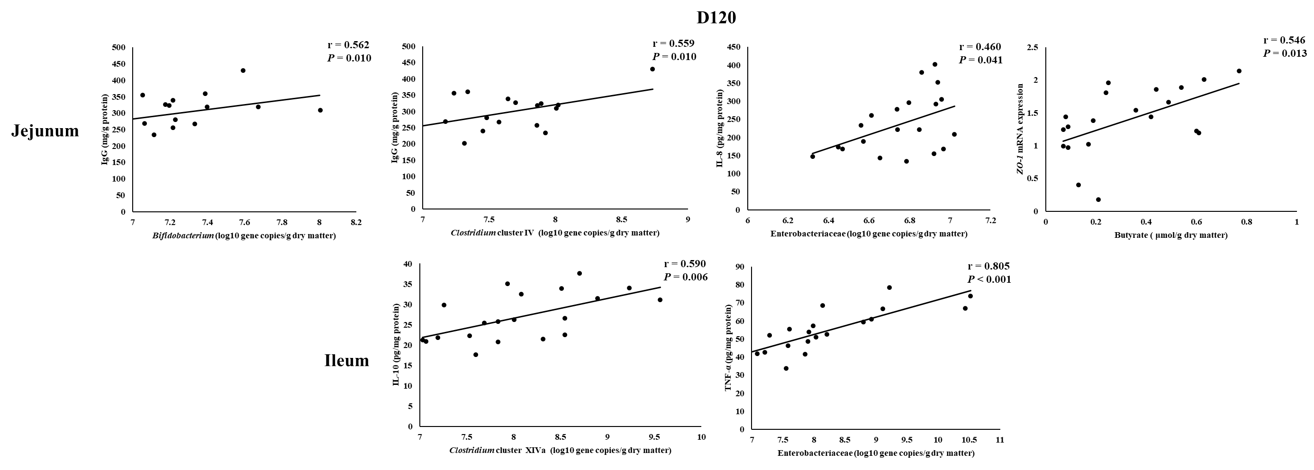
Figure S1 Scatterplots demonstrating correlation of jejunal and ileal immune parameters with specific bacterial communities or butyrate in pigs. IL-8 = interleukin-8; IL-10 = interleukin-10; TNF-α = tumor necrosis factor-α; sIgA = secretory immunoglobulin A; IgG = immunoglobulin G; ZO-1 = zonula occludens-1.

