**Genetic variability of dromedary camel populations based on microsatellites markers**

M. Piro, F.E. Mabsoute, N. El Khattaby, H. Laghouaouta and I. Boujenane

**Animal journal**

**Supplementary material**

**Supplementary Table S1** *Characteristics of the microsatellite loci usedfor dromedary camels*

|  |  |  |  |
| --- | --- | --- | --- |
| Locus | Sequence (forward + reverse) | Size range (bp) | Reference |
| CVRL05 | F: CCTTGGACCTCCTTGCTCTG  R: GCCACTGGTCCCTGTCATT | 155-185 | Mariasegaram*etal*. (2002) |
| CVRL07 | F:AATACCCTAGTTGAAGCTCTGTCCT  R: GAGTGCCTTTATAAATATGGGTCTG | 270-300 | Mariasegaram*etal*. (2002) |
| CMS13 | F: TAGCCTGACTCTATCCATTTCTC  R: ATTATTTGGAATTCAACTGTAAGG | 121-252 | Evdotchenko*etal*. (2003) |
| CMS15 | F: AAATACTTAAAGGTTCCCAGA  R: TTGTAAACTAAAGCCAGAAAG | 121-144 | Evdotchenko*etal*. (2003) |
| CMS50 | F: TTTATAGTCAGAGAGAGTGCTG  R: TGTAGGGTTCATTGTAACA | 170-190 | Evdotchenko et *al*. (2003) |
| CMS121 | F: CAAGAGAACTGGTGAGGATTTTC  R:AGTTGATAAAAATACAGCTGGAAAG | 148-166 | Evdotchenko*etal*. (2003) |
| LCA63 | F: TTACCCAGTCCTTCGTGGG  R: GGAACCTCGTGGTTATGGAA | 198-232 | Penedo*etal*. (1999) |
| LCA66 | F: GTGCAGCGTCCAAATAGTCA  R: CCAGCATCGTCCAGTATTCA | 224-242 | Penedo*et al*. (1999) |
| VOLP03 | F: AGACGGTTGGGAAGGTGGTA  R: CGACAGCAAGGCACAGGA | 144-176 | Obreque*etal*. (1998) |
| VOLP08 | F: CCATTCACCCCATCTCTC  R: TCGCCAGTGACCTTATTTAGA | 131-153 | Obreque*etal*. (1998) |
| VOLP10 | F: CTTTCTCCTTTCCTCCCTACT  R: CGTCCACTTCCTTCATTTC | 236-264 | Obreque*etal*. (1998) |
| VOLP32 | F: GTGATCGGAATGGCTTGAAA  R: CAGCGAGCACCTGAAAGAA | 256-262 | Obreque*etal*. (1998) |
| VOLP67 | F: TTAGAGGGTCTATCCAGTTTC  R: TGGACCTAAAAGAGTGGAG | 145-213 | Obreque*etal*. (1998) |
| YWLL08 | F: ATCAAGTTTGAGGTGCTTTCC  R: CCATGGCATTGTGTTGAAGAC | 130-162 | Lang *etal*. (1996) |
| YWLL09 | F: AAGTCTAGGAACCGGAATGC  R: AGTCAATCTACACTCCTTGC | 156-166 | Lang *etal*. (1996) |
| YWLL38 | F: GGCCTAAATCCTACTAGAC  R: CCTCTCACTCTTGTTCTCCTC | 180-190 | Lang *etal*. (1996) |

**Supplementary Table S2** *P-values and standard errors (SE) of departures from Hardy-Weinberg equilibrium of each locus in the entire camel population*

|  |  |  |
| --- | --- | --- |
| Locus | P-value | SE |
| CMS121 | 0.0011 | 0.0003 |
| CVRL05 | 0.0001 | 0.0001 |
| LCA66 | 0.6150 | 0.0086 |
| LCA63 | 0.1981 | 0.0078 |
| VOLP03 | 0.0793 | 0.0096 |
| CMS50 | 0.0000 | 0.0000 |
| VOLP08 | 0.0005 | 0.0001 |
| VOLP10 | 0.0004 | 0.0001 |
| VOLP32 | 0.0005 | 0.0001 |
| YWLL38 | 0.0105 | 0.0008 |
| VOLP67 | 0.0000 | 0.0000 |
| CMS13 | 0.0030 | 0.0008 |
| YWLL08 | 0.0383 | 0.0067 |
| CMS15 | 0.1972 | 0.0094 |
| CVRL07 | 0.0000 | 0.0000 |
| CVRL01 | 0.0000 | 0.0000 |

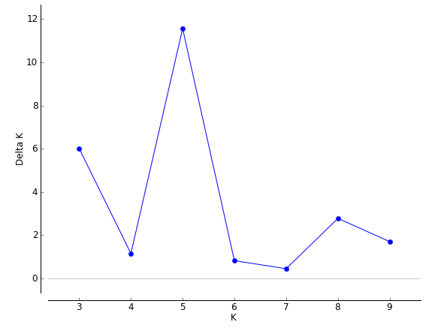

**Supplementary Figure S1**Results of the STRUCTURE HARVESTER analysis showing the optimum number of clusters Kfor dromedary camel populations studied

**References**

Evdotchenko D, Han Y, Bartenschlager H, Preuss S and Geldermann H 2003. New polymorphic microsatellite loci for different camel species. Molecular Ecology Notes 3, 431-434.

Lang KDM, Wang Y and Plante Y 1996. Fifteen polymorphic dinucleotide microsatellites in llamas and alpacas. Animal Genetics27, 293.

Mariasegaram M, Pullenayegum S, Jahabar MA, Shah RS, Penedo MCT, Wernery U and Sasse J 2002.  Isolation and characterization of eight microsatellite markers in *Camelusdromedarius* and cross species amplification in *C. bactrianus* and *Lama pacos*. Brief note. Animal Genetics 33, 377-405.

Obreque V, Coogle L, Henney PJ, Bailey E, Mancilla R, García-Huidobro J, Hinrichsen P, and Cothran EG*1*998.Characterization of 10 polymorphic alpaca dinucleotide microsatellites. Animal Genetics 29, 461-462.

Penedo MCT, Caetano AR and Cordova K 1999. Eight microsatellites markers for South American camelids. Animal Genetics 30, 161-168.