TRE-2016-0084_Xu et al. - Supplementary material

Main contents:
Tables S1, S2
Figs S1, S2, S3
Supplemental references
Table S1 Primers and PCR conditions used for the Quantitative PCR
Target group | Primer | Sequence（5'→3')ª | Thermal profile for real-time PCR | Reference
bacterial 16S rRNA | 341F  517R | CCTACGGGAGGCAGCAG  ATTACCGCGGCTGCTGG | 5 min at 95°C, followed by 40 cycles of 10 s at 95°C, and 30 s at 55°C. | ¹
nirK | nirK-1F | GGMATGGTKCCSTGGCA | 5 min at 95°C, followed by 45 cycles of 10 s at 95°C, 45 s at 60 °C, and 30 s at 72°C. | ²
nirK | nirK-5R | GCCTCGATCAGRTTRTGG |  | ²
nirS | cd3aF | GTSAACGTSAAGGARACSGG | 5 min at 95°C, followed by 45 cycles of 10 s at 95°C, 30 s at 62°C, and 30 s at 72°C. | ³
nirS | R3cd | GASTTCGGRTGSGTCTTGA |  | ³
nosZ | nosZ-F | CGYTGTTCMTCGACAGCCAG | 5 min at 95°C, followed by 50 cycles of 10 s at 95°C, 30 s at 60°C, and 30 s at 72°C. | ⁴
nosZ | nosZ-R | CGSACCTTSTTGCCSTYGCG |  | ⁴
Note: ªY = C or T; M = Aor C; R = A or G; K = G or T; S = C or G.

Table S2 Correlationª between potential denitrifying activity and soil chemical properties
 | PDA | DOC | NH₄⁺ | NO₃⁻ | Moisture | Soil pH | Total nitrogen | Total carbon | C/N | Bacteria | nirK | nirS | nosZ
PDA | 1 | - | - | - | - | - | - | - | -
DOC | 0.275** | 1 | - | - | - | - | - | - | -
NH₄⁺ | 0.497** | 0.388** | 1 | - | - | - | - | - | -
NO₃⁻ | 0.357** | 0.136 | 0.468** | 1 | - | - | - | - | -
Moisture | 0.332** | 0.329** | 0.585** | 0.201** | 1 | - | - | - | -
Soil pH | 0.054 | 0.112 | -0.315** | -0.158* | -0.261** | 1 | - | - | -
Total nitrogen | 0.504** | 0.369** | 0.621** | 0.410** | 0.640** | -0.246** | 1 | - | -
Total carbon | 0.450** | 0.387** | 0.486** | 0.358** | 0.467** | -0.064 | 0.866** | 1 | -
C/N | 0.141* | 0.125 | -0.011 | 0.102 | -0.150* | 0.322** | 0.128 | 0.492** | 1
Bacteria | 0.365** | 0.120 | 0.383** | 0.288** | 0.370** | -0.204** | 0.508** | 0.396** | 0.061 | 1
nirK | 0.273** | 0.110 | 0.148* | 0.134 | 0.084 | 0.062 | 0.191** | 0.156* | 0.083 | 0.665** | 1
nirS | 0.247** | 0.047 | 0.175* | 0.224** | 0.190** | 0.046 | 0.248** | 0.210** | 0.058 | 0.656** | 0.653** | 1
nosZ | 0.259** | 0.079 | 0.308** | 0.226** | 0.280** | -0.198** | 0.396** | 0.289** | 0.009 | 0.856** | 0.760** | 0.713** | 1
Note: Spearman’s rank coefficient was used in the correlation analyses. *: The correlation is significant at 0.05 level; **: The correlation is significant at 0.01 level. PDA: potential denitrifying activity; DOC: dissolved organic carbon.
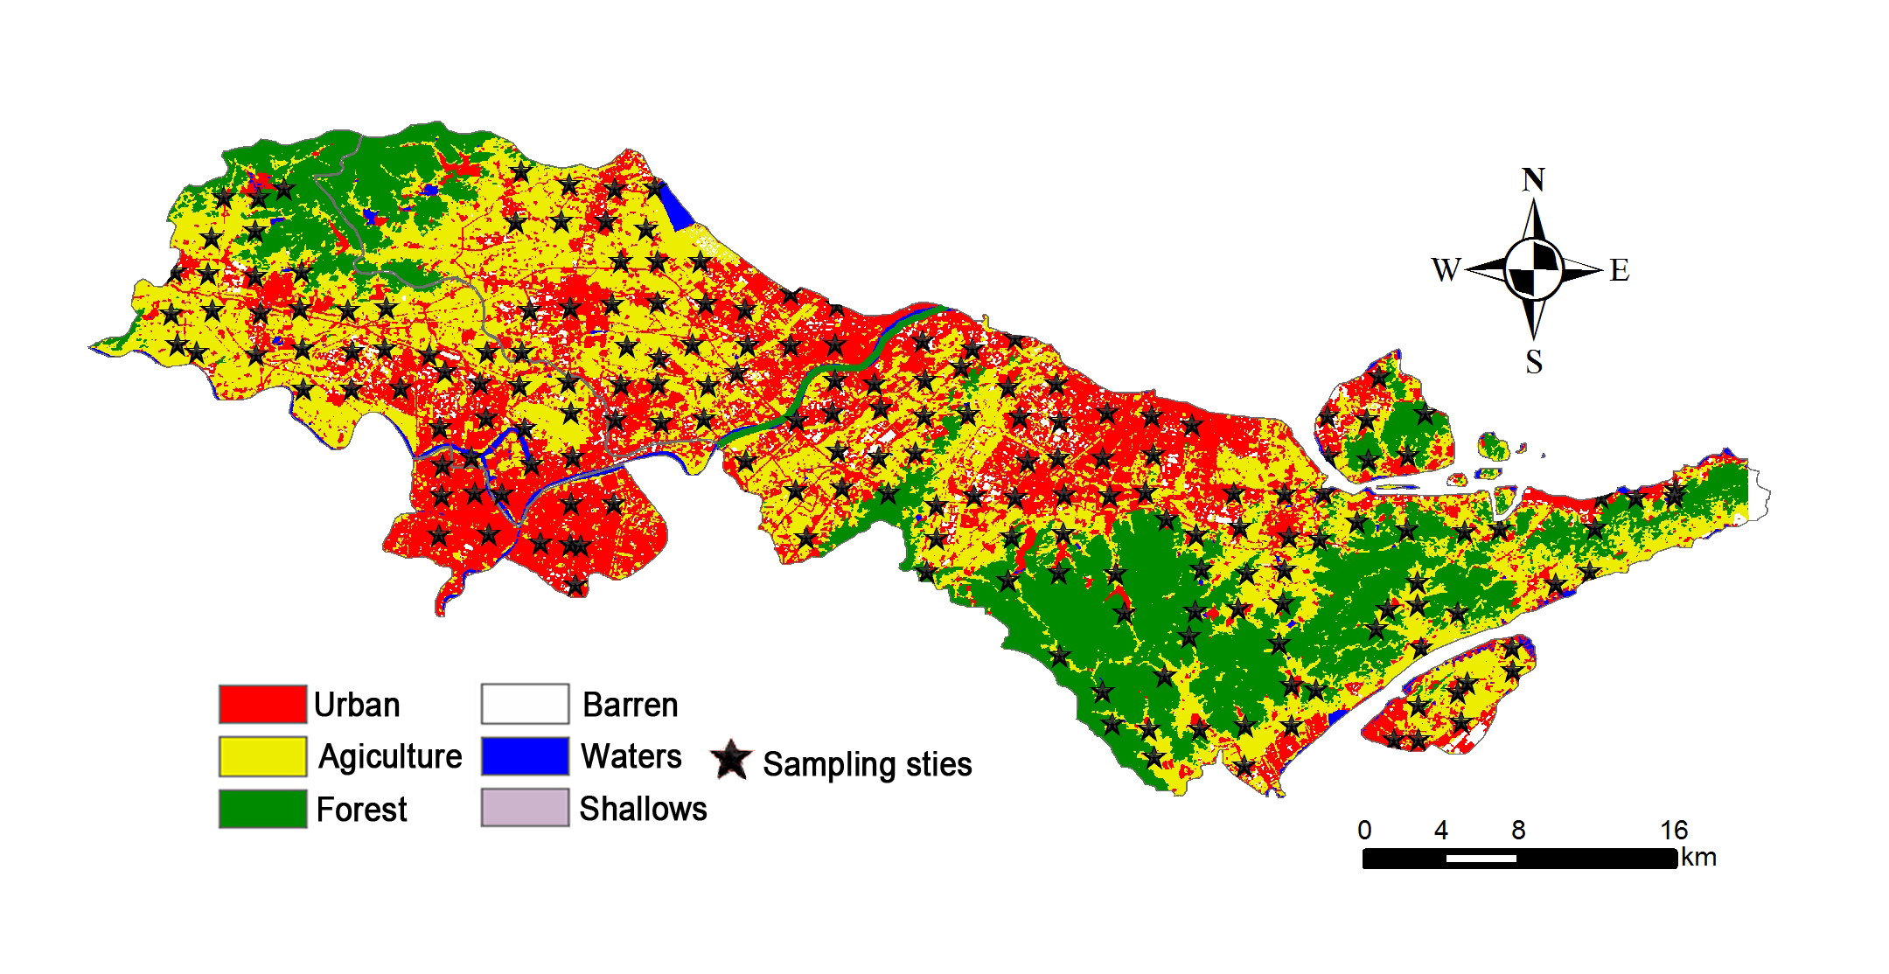
Figure S1 The land-use map with sampling sites of the studied area interpreted from remoting sensing image in 2013
Figure S2 Ratio of (nirK+nirS)/ nosZ in different land-use soils. The significances between groups are indicated by different letters (P < 0.05), which were determined by Duncan test. The bars were the average of samples in each category. The error bar is standard error.

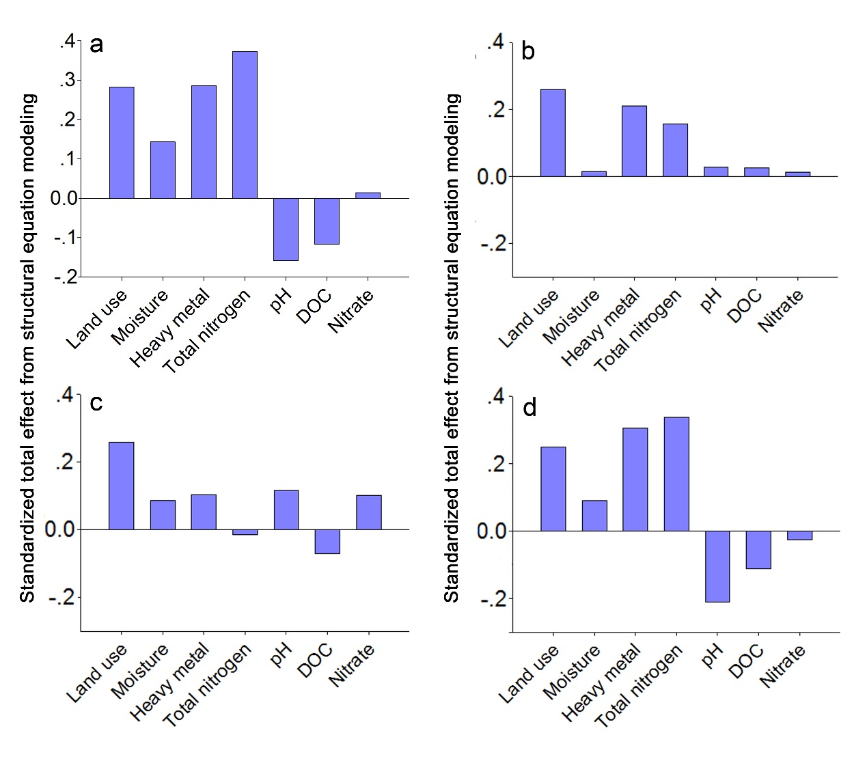
Figure S3 Standardized total effects of Bacteria (a), nirK (b), nirS (c), and nosZ (d) from structural equation modeling. DOC: Dissolved organic carbon.

Supplementary References
1. Muyzer, G.; Dewaal, E. C.; Uitterlinden, A. G., Profiling of complex microbial-populations by denaturing gradient gel-electrophoresis analysis of polymerase chain reaction-amplified genes-coding for 16S ribosomal-RNA. Appl. Environ. Microbiol. 1993, 59, 695-700.
2. Braker, G.; Fesefeldt, A.; Witzel, K. P., Development of PCR primer systems for amplification of nitrite reductase genes (nirK and nirS) to detect denitrifying bacteria in environmental samples. Appl. Environ. Microbiol. 1998, 64, 3769-3775.
3. Throbäck, I. N.; Enwall, K.; Jarvis, Ǻ.; Hallin, S., Reassessing PCR primers targeting nirS, nirK and nosZ genes for community surveys of denitrifying bacteria with DGGE. FEMS Microbiol. Ecol. 2004, 49, 401-417.
4. Kloos, K.; Mergel, A.; Rosch, C.; Bothe, H., Denitrification within the genus Azospirillum and other associative bacteria. Austral. J. of Plant Physiol. 2001, 28, 991-998.

