Online Supplementary Appendix – Measuring Valence using Keesing World Reports

Keesing’s Coding Guidelines
Overview
News reports from Keesings Record of World Events were compiled and manually coded by a coding team. Coders read reports to identify valence events (see codebook below) that would affect a political party’s competence, integrity, or unity. Importantly, these events are distinct from policy positions they adopt along the Left-Right ideological spectrum. Frequently, these news reports focus on party officials, and we make the assumption that party members’ actions will affect their overall party reputation.
Coders would:
- Identify news reports that contained events that would affect a party’s competence, integrity, or unity.
- To award any event identified as affecting a given party a score, or valence score of either -2, -1, +1, or +2.

Below are the guidelines that coders were given to content analyse Keesings.
Content Analysis: What NOT to Code
Keesing’s covers a wide variety of political events, some of which could comfortably be assumed to affect parties’ character-based valence. However, for various reasons, and exceptions not withstanding, the following kinds of events appearing in news reports should not be coded:

- Reports related to economic conditions. Coders will likely encounter reports presenting and discussing newly released economic data such as employment figures, and indicators of economic growth such as GDP. Reports such as these are not to be coded. Related to this kind of economic coverage, news reports may also discuss strikes or protests that appear to reflect poorly on the governing party or parties. We do not code these reports for two reasons. First, economic data is readily available from other sources, and second, it is unclear whether strikes or protests over economic conditions are symptoms or causes of possible government weakness. We are interested in the latter rather than the former.
Possible exceptions: If a report discussing a strike or protest discussed that party officials had disagreed publicly with one another, or confronted each other in some way regarding a strike or protest then, contingent on the details provided, this would constitute a valence event, which should be coded in the “unity” category. Similarly, it is possible that the publishing of economic reports, or a report detailing the handling of some form of economic crisis may result in internal party divisions, and perhaps the resignation (or reassignment) of officials with responsibility for aspects of economic policy. The former would result in a coding in the “unity” category while the latter would result in a coding in the “competence” category contingent on the information provided.

- Reports of events related to parties’ policy positions. The clearest example here would be reports discussing policy announcements by governing parties, or a critique of governing parties’ policies. The latter may include protests against governing parties’ policies, and opposition parties’ criticisms of governing parties’ policies. Since we expect opposition parties to criticise government policies it doesn’t make sense to code such criticisms as valence events.

Possible exceptions: If a well known third party organisation (Amnesty International, for example) was critical of a particular policy or decision made by a party, or parties, then this would constitute a valence event that would need coding, particularly if the news report in question also provided evidence that the criticism had proven embarrassing in some way, or had undermined the party, or parties, affected.

- Other events that can be viewed as symptoms of parties’ strengths and weaknesses rather than causes. These include (but are not limited to):

  - Governing parties’ proposed legislation being rejected in parliament.
  - Changes in party leadership
  - Leadership disagreements. In the case of France, for example, the president and the prime minister can engage each other in pointed political debate, particularly in the run-up to elections. This is typical of politics in France.
Possible exceptions: If a news report notes that the jostling for a leadership position was causing damaging splits within a given party then these would need to be taken into consideration. If a report indicates a negative effect on the party in question, then coders should consider the details of any fallout, and whether a small, or more consequential, division has resulted.
  - Votes of no confidence in the legislature.
Possible exceptions: In the aftermath of a vote of no confidence, a report might indicate that divisions within a party had emerged, and depending on their seriousness, these events may result in the awarding of a score to the party in question in the “unity” category. If high-ranking party officials resigned or were reassigned, for example, then the fallout would make for a more serious valence event.

- Ambiguous events – if an event appears to be of importance but coders have genuine uncertainty as to how the event should be coded, then the rule of thumb is “don’t.” These events should be noted by the coder so they can be discussed at a later date. Coders should note that the level of detail provided by a Keesing’s report is not a helpful way to approach ambiguity. Keesing’s reports often provide plenty of information from which a coder can make an informed decision about whether to assign a score, in what category, and of what magnitude, with relative ease. However, on occasion, Keesing’s reports will spotlight important valence-related events affecting parties, but with few details. For example, a report may simply note that a high-ranking party official resigned after admitting to engaging in some form of illegal activity (e.g. embezzlement) or embarrassing situation (an affair). Regardless of whether a report provides extensive detail of such events, or relatively few details, such events should be coded according to the guidelines keeping in mind “who was involved, what did they do, and with what result?”

Content Analysis: What to Code
What follows is a list of some of the more common kinds of events coders should look for in Keesing’s news reports.

- Behaviour that violates accepted codes of conduct for political elites i.e. bribery, affairs (whatever their nature), personal misconduct (drug or alcohol-related problems), fighting, insensitive or inappropriate statements, embezzlement, and other abuses of office for personal gain, the breaking of national and international laws.

- Incidents or events suggestive of poor performance (incompetence) on the part of party officials, or parties in general. Events of this kind would include reports condemning the government’s actions, or handling of a given situation or crisis, by a third party (or possibly praise), and statements regarding the underestimation of costs associated with various programs or policies.

- Events that indicate intra-party divisions. When members of a party argue with one another openly (or in private but subsequently leaked) over a policy position or other matter (the handling of a crisis for instance), then this would indicate a potentially damaging party division. Keesing’s reports often state as much, but not always. Examples of these types of events include party elites resigning in protest over a government policy, quarrels between party elites that Keesing’s notes has caused internal problems for the party in question, and party elites leaving one party to join another.
- Suicides. These incidents should be treated carefully. A suicide per se, should not be regarded as detrimental to the affected party unless it is clear from the report that the suicide has some bearing on the broader public’s view of the party in question, or that there is some evidence of embarrassing or illegal conduct, which prompted the suicide and may reflect poorly on the party in question. For example, a party official may commit suicide because damaging personal information may have become public, such as their involvement in an affair, or abuse of the powers of their office.

Types of Events By Category
- Unity. Events that pertain to the valence-related attribute of unity would include all those which reflect upon a party’s sense of “togetherness” or “division.” Such events include:
  - Party members resigning over conflicts with other party members (usually this is over policy disagreements but could be over the handling of a certain situation).
  - Party members leaving to go to other parties because of differences of opinion with other party members.

Possible exceptions: As noted above, not all party conflict is expected to cause damage as, for example, in the case of the run-up to elections, different party elites may exchange “barbs” as part of the election process. In such instances, a score should only be awarded if the report states that damage had been caused to the party in question.

- Competence. Events that pertain to the performance, or relative “wisdom,” of party officials are to be placed in this category. These are the main examples:

  - Party officials making ill-thought, or insensitive comments or remarks in public (or that become public), such as those which are racist, sexist, homophobic, anti-Semitic, or generally deemed as politically incorrect.
  - Statements or admissions by party officials that the cost of a program or policy initiative had been miscalculated and would actually cost more than expected. In such instances, party officials may state they need to generate more revenue through new taxes, or through cost-cutting elsewhere, or that the program or policy in question will have to be shelved, or scaled back.
  - Reports or statements, which criticise governing parties for their actions (or inactions) in responding to resolve a problem or crisis. Reports may come from respected third parties, such as Amnesty International, and may be accompanied by the reassignment or resignation of a party official.

- Integrity. Events that pertain to the honesty of politicians, as well as their (mis)conduct in various ways, should be placed in this category. Perhaps most obvious here are events in which party officials violate official rules, or norms, regarding the legal or expected conduct of party officials. These are the main examples:

  - Drug and alcohol-related issues (e.g. caught in possession of illegal drugs, or being drunk and abusive in public).
  - Sexual affairs (particularly those involving married participants).
  - Taking bribes or offering bribes, as well as improper payments to other officials.
  - Embezzlement or misappropriation of funds.
  - Lying, or concealing expenses, or personal wealth, for the purpose of financial gain.
  - Past indiscretions, or criminal activity, becoming known (e.g. it comes to light that a party official spent taxpayer money for their personal benefit in the recent past).
  - Allegations of criminal conduct or other behaviour which violate expected norms of behaviour/conduct regarding party officials. As noted elsewhere, unless allegations are accompanied by evidence, they should not be considered as seriously as proven charges, or those for which a party official has been found guilty.
  - Any other activity which would bring embarrassment or widespread condemnation to the party official involved.

Awarding Scores of Differing Magnitudes
Events are awarded a score of either -1 (negative one), -2 (negative two), +1 (plus one), or +2 (plus two) depending on their magnitude or seriousness. Most events reported in Keesing’s that involve party officials, and affect parties as a consequence, are negative. This isn’t too surprising given that politicians and parties are rarely broadly praised for their actions. For example, it is likely that the report of a sordid affair by a politician will be generally frowned upon by the public, especially if the politician in question had presented themselves in a virtuous light, or was responsible for promoting “moral values” for their party. Alternately, no one pays particular attention when a politician is still married after 30 years, and it certainly doesn’t receive media coverage. In short, negative events constitute the vast majority of events that are to be coded. Specifically with regard to events that would be viewed negatively, deciding on whether to award an identified event as either -1 or -2 is one of the more difficult aspects of the coding process. As has been noted elsewhere, if a coder feels the reporting of a specific event is too ambiguous to be certain as to how to code the event then the default position is not to code the event, but to make a note of it so it can be discussed at a later date. If a coder feels an event is worthy of being awarded a score, but is unsure of whether the event should receive a score of -1 or -2 then the default position is to award the event a score of -1. To assist with the process of awarding scores, and to ensure consistency (i.e. that similar events are awarded similar scores), here are some guidelines to follow:

- How much space Keesing’s devotes to the report of a specific event in column inches. More serious events are usually – but not always – given more space. An event of major significance will usually receive more than a column inch of space. However, this is perhaps the weakest of guidelines to follow since it is regularly found in Keesing’s that events of minor significance can be discussed in some detail, while events of major significance are sometimes discussed relatively briefly.

- The language or expression used in accounting an event, such as:
  - “The party was dealt a serious blow when…..”
  - “Politician X was highly embarrassed when….”
  - “The scandal caused a damaging split in the party”
  - “The incident highlighted government incompetence over the issue of….”
  - “The issue caused widespread condemnation of…..(party or politician)”
  - “Politician X tendered his resignation following the disclosure”
  - “Damaging”
  - “Perceived negligence”
  - “A major scandal threatened to bring down…..”

If such language is used in the reporting of an event, then the event in question is typically of a serious magnitude, but especially when the report involves a highly visible party official, like those who work at the national level – a minister for example. As discussed below, in these instances a score of -2 will likely be awarded, but while such language typically indicates the presence of a valence event affecting a party that should be coded, the context in which the event took place will play an important role in determining whether a coding actually occurs, and of what magnitude.

- The context surrounding reported events. The reports in Keesing’s do not always refer to events involving national-level politics and party officials working at the national level, so coders should consider what level an event involving party officials has taken place at. Events at the local or regional level, or involving local or regional party officials, are assumed to have a lesser impact than those at the national level unless a report explicitly states a broader consequence of events at the local or regional level. In sum, coders should pay attention to what happened, who was involved, and what (if any) were the consequences? Here are some guidelines for awarding scores considering context:

Single negative (-1) events
  - Include events that took place at the local or regional (state) level, such as misconduct by a party official e.g. their arrest, or abuse of official powers. A score of greater magnitude would only be awarded if additional detail provided in the report suggests otherwise.
  - Include events that took place at the national level, particularly those involving highly visible party officials such as ministers or other prominent party elites, which involve “allegations” or “charges” that are yet to be proven, unless the report indicates something more drastic occurring as a result of the allegations or charges, such as the resignation of the affected party official.
  - Insensitive, or ill-thought comments by party officials.

Double negative (-2) events
- Include events that largely take place at the national level of politics such as the resignation of party officials because of some kind of misconduct or violation of codes of conduct, the involvement of a party official at the national level in some form of scandal, publicised criticism and/or disagreements between party officials that results in major party problems such as resignations.
- Defections of party officials from one party to another.

- Events involving current party officials versus former party officials. The important consideration here is whether the report of an event that could plausibly affect a party involved a former party member (or members), or a current party member. Here are some guidelines:

  - If a former party official is found to have been involved in some form of misconduct (taking a bribe for example), then it is assumed that this does not reflect negatively on the party in question.
  - If a former party official is found to have been involved in some form of misconduct, and that these revelations are reported to be affecting the party in some way in the present then these events will need to be coded. For example, if a former party official admitted to embezzling funds then, as per point a. above, no score is required. However, if the admissions of a former party member suggested that the activities were ongoing, or drew negative attention to current party members then these would need to be coded. Allegations of this nature should typically be awarded a score of -1 but as per the above guidelines, the ranking of the party officials involved should also be considered, as should any reported consequences of former party officials’ allegations. For example, if the report also indicated that a high-ranking party official had been implicated, who was then subsequently arrested or resigned, then this would merit a score of -2 being awarded to the event in question.

- Events that are reported on multiple times. If an event is serious enough to warrant a score of -2 being awarded when it is first reported upon, then subsequent events that are related to the first reported event are to be awarded a score of -1, unless there is additional detail provided in the report to suggest otherwise. This situation can occur when, for example, a report covers the admission of illegal misconduct by a politician, such as embezzlement, who is then subsequently arrested. Following the arrest and charges being filed, subsequent reports in Keesing’s may then provide brief details of any trial, sentencing, and perhaps even some related side-revelations.
- Coalition government. In a number of countries covered by Keesing’s the events being coded involve parties who are in a governing coalition. Here are some guidelines as to how to proceed in these scenarios:
  - Events affecting individual parties in a coalition should code events as per the guidelines above.
  - Reports covering instances where parties refuse to create or join a coalition should not be coded.
  - Events highlighting disagreements among coalition members should be coded, and a score of the same magnitude should be awarded to both parties involved. The score awarded will be contingent on the magnitude of the disagreement. If the disagreement results in reassignments of ministerial positions, the collapse of the coalition, or resignations, the coders should award a score of -2. Any other disagreement should be awarded a score of -1 to both parties involved.

7. Multiple events in one news report. Occasionally, Keesing’s will cover multiple events in a single news report, particularly if the events being reported affect two or more parties. In these cases, each particular event should be considered separately from others, so it is possible that multiple codings, perhaps even for multiple parties, will result from one news report. For example, let’s say an investigation into misuse of public funds implicated a number of party officials from a given party, and each of the suspected officials in question was discussed in the report, then each instance would need to be coded. So, if two government ministers were implicated in the misuse of funds then two separate codings would be given.

A Note on Awarding Positive Scores
Due to the nature of media coverage, it is extremely rare to find parties, or those who represent parties, cast in a positive light. Without viewing the entire universe of political coverage, it does, of course, remain feasible (at least in theory) to find the non-policy related actions of politicians receiving praise. However, coders will likely find news reports containing details of events which would reflect upon party officials positively incredibly rare. Nonetheless, here are some very brief guidelines regarding what events might appear in Keesing’s, and how to code them:

Single positive (+1) events
- Include events such as the handling of a local crisis or problem by a local or regional (state) party official (or officials), which receive broad praise, or some kind of selfless act (e.g. saving a child in danger).

Double positive (+2) events
- As above but involving party officials at the national level.

Examples

Below are some sample pages taken from Keesing’s to give coders an idea of what Keesing’s reports look like. The sample pages show reports of events from the three different dimensions of valence (competence, integrity, and unity), and of differing magnitude.

Competence:
Figure 1 shows a page from Keesing’s which shows a number of news reports for Great Britain from February 1994. Events discussed under the Northern Ireland heading (starting in the middle column) were excluded since Northern Ireland was not part of this study. As can be seen by different subheadings in bold, a number of different reports can appear for a given county in a given month. All the reports in the left-hand column were analysed for evidence of valence events affecting political parties in Britain. On this particular page, the report under the subheading “Speech by Portillo” was determined to contain a valence event. This event, affecting the Conservative Party, was awarded a score of -1 in the “competence” category following the coding guidelines. While the event reported was not of great seriousness, Portillo, who held an important party post at the time (Chief Secretary of the Treasury), was criticised for comments he made, and subsequently issued an apology. It was assumed here that the issuing of the apology suggested that the comment had drawn broad criticism. The event falls into the “competence” category as per the guidelines since Portillo’s remarks displayed a lack of forethought, or the ability to act/speak appropriately, given his position. None of the reports contained under other subheadings pertaining to Great Britain produced any codings.

Figure 2 shows a news report from Denmark, also from February 1994 (the entries from Germany and France would also have been coded). In this example, the entry regarding the resignation of the Social Affairs minister from the Centre Democrats was identified as a valence event falling into the “competence” category, and as a result, the Centre Democrats were awarded a valence score of -2 for this particular event. As the report indicates , the event involved a government minister resigning from her position because she had rather carelessly passed on to the media highly sensitive and unsubstantiated information regarding sexual abuse at a centre for the mentally handicapped. Following the coding guidelines the score of -2 was awarded because of the position held by the person involved (a high-ranking party official at the national level), and also the resulting aftermath (the minister’s resignation). The valence event was coded in the “competence” category since the minister’s actions did not speak to her integrity, nor did they invoke any concerns over party unity, but they did suggest an inability to speak appropriately or with forethought, as in the previous example. Obviously, passing on such serious and unsubstantiated rumours would fit with the understanding of “competence” outlined in the coding guidelines.

Unity:
Figures 3 and 4 show pages from Keesing’s that were content-analysed and found to contain valence events affecting parties in terms of their unity. In Figure 3 the events in question date back to 1981 and are found in the report from Portugal. The reports in earlier volumes of Keesing’s took a different form from those of later, usually being less in number and covering a greater time period. Coders should note the difference between the appearance of reports in Figure 3 versus those in Figures 1 and 2.

In Figure 3, the passage of interest is in the paragraph discussing the congress of the Social Democratic Party (PSD), in which a valence event of -1 for “unity” was identified as per the coding guidelines. The report states that the party’s leading figure and Prime Minister, Dr. Pinto Balsemao, had been criticised by an opposing faction within his own party at the congress for his overtures towards President Eanes, who had fallen out of favour with members of the PSD because of a conflict with the late Prime Minister and former PSD member, Dr. Francisco Sà Carneiro. Although the details surrounding the event did not suggest there were any major ramifications as a result of the intra-party conflict, the criticism was aimed at the party’s leading figure over his attempts to reconcile with someone who had been openly feuding with one of the party’s icons. As a result, the event was considered worthy of being coded, but awarded a score of -1 accordingly. This report also illustrates the need for coders to read reports carefully to identify what is going on, and whom is being affected.

Figure 4 shows several news reports for Spain fro 1993. While the discussion of the calling of a general election is interesting (since the report mentions that corruption scandals were, in part, partially responsible for the calling of the general election), on this particular page the entry “Internal PSOE dispute” was determined to contain a valence event. This valence event, affecting the Spanish Socialist party, was awarded a score of -2 in the “unity” category in accordance with the coding guidelines. The events surrounding the Filesa scandal (which were also reported in Keesing’s, and subsequently coded), as the report notes, were serious enough to cause a major intra-party dispute between some of the party’s high-ranking officials, which eventually led to a decision to hold new elections. Aside from the rank of the party officials involved, the awarding of the score of -2 also reflected consideration of the language used in reporting the event. Report details such as, “…thereby making his letter an effective declaration of war by the party on the government,” and “Benegas accused ministers of breaching traditions of party loyalty and solidarity, and of seeking to topple him by blaming him for the Filesa scandal” strongly suggest that the event was of a serious nature, and should be coded accordingly. Finally, it is also worth mentioning that the seriousness of the event is also loosely reflected in the relatively large amount of space in column inches devoted to the event in Keesing’s.

(Figure 4 also shows reports from Italy. These were also content-analysed for evidence of valence events, and a number of valence events were identified related to the investigations mentioned in the news reports).

Integrity:
The final category to illustrate is that of “integrity.” Valence events that fall into this category usually take the form of politicians breaking laws, or engaging in other activities that run counter to the norms of conduct expected of elected or appointed party officials, such as having affairs, or abusing the powers of their offices for personal gain. Figure 5 shows a sample page containing news reports from Greece that appeared in the summary section of the 1989 volume of Keesing’s (the events discussed are from 1988). Although other valence events within this report would be coded, for illustrative purposes we are concerned specifically with the report, “Vote of confidence in Papandreou government – Further allegations by Koskotas.” In this report, content analysis identified a valence event affecting the Pan-Hellenic Socialist Movement (PSOK or PASOK) in the form of an official inquiry, following allegations by a prominent businessman of government favouritism that directly benefited PSOK’s leader, the Greek Prime Minister, Andreas Papandreou. Following the coding guidelines, this valence event was awarded a score of -1 in the “integrity” category. Although the report noted that the businessman in question named the Prime Minister, this event was not awarded a score of greater magnitude since only allegations were involved that, at the time of the report, were unsubstantiated. Unsubstantiated allegations are important contextual information to consider in this instance as noted above.

Figure 6 shows a report for Germany from 1993. As with the other examples, all the entries listed in this report were content-analysed for evidence of valence events affecting parties. In this particular report, the entry “Resignation of Möllemann – Cabinet reshuffle” contained a valence event. The Free Democratic Party (FDP) to which Möllemann belonged was awarded a score of -2 in the “integrity” category for this event. Following the coding guidelines, the above would be considered a serious event because of who was involved (a high ranking party official), and because of what happened (abuse of office resulting in resignation). The event fell into the “integrity” category because the report stated that Möllemann took advantage of his position to benefit people close to him.

Figure 1. Sample news report containing a “competence” valence event (-1)

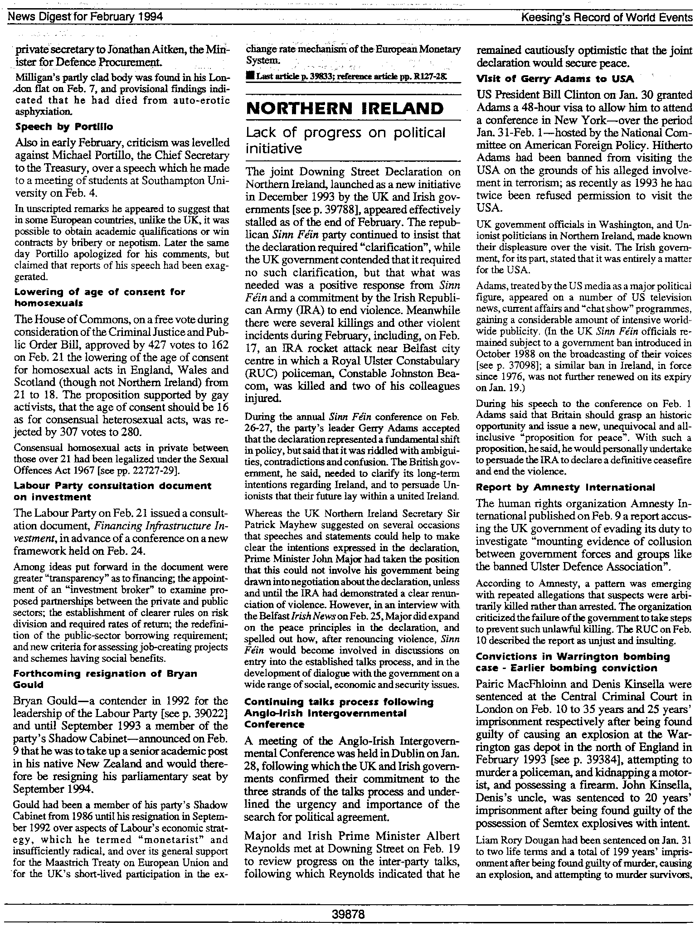

Figure 2. Sample news report containing a “competence” valence event (-2)

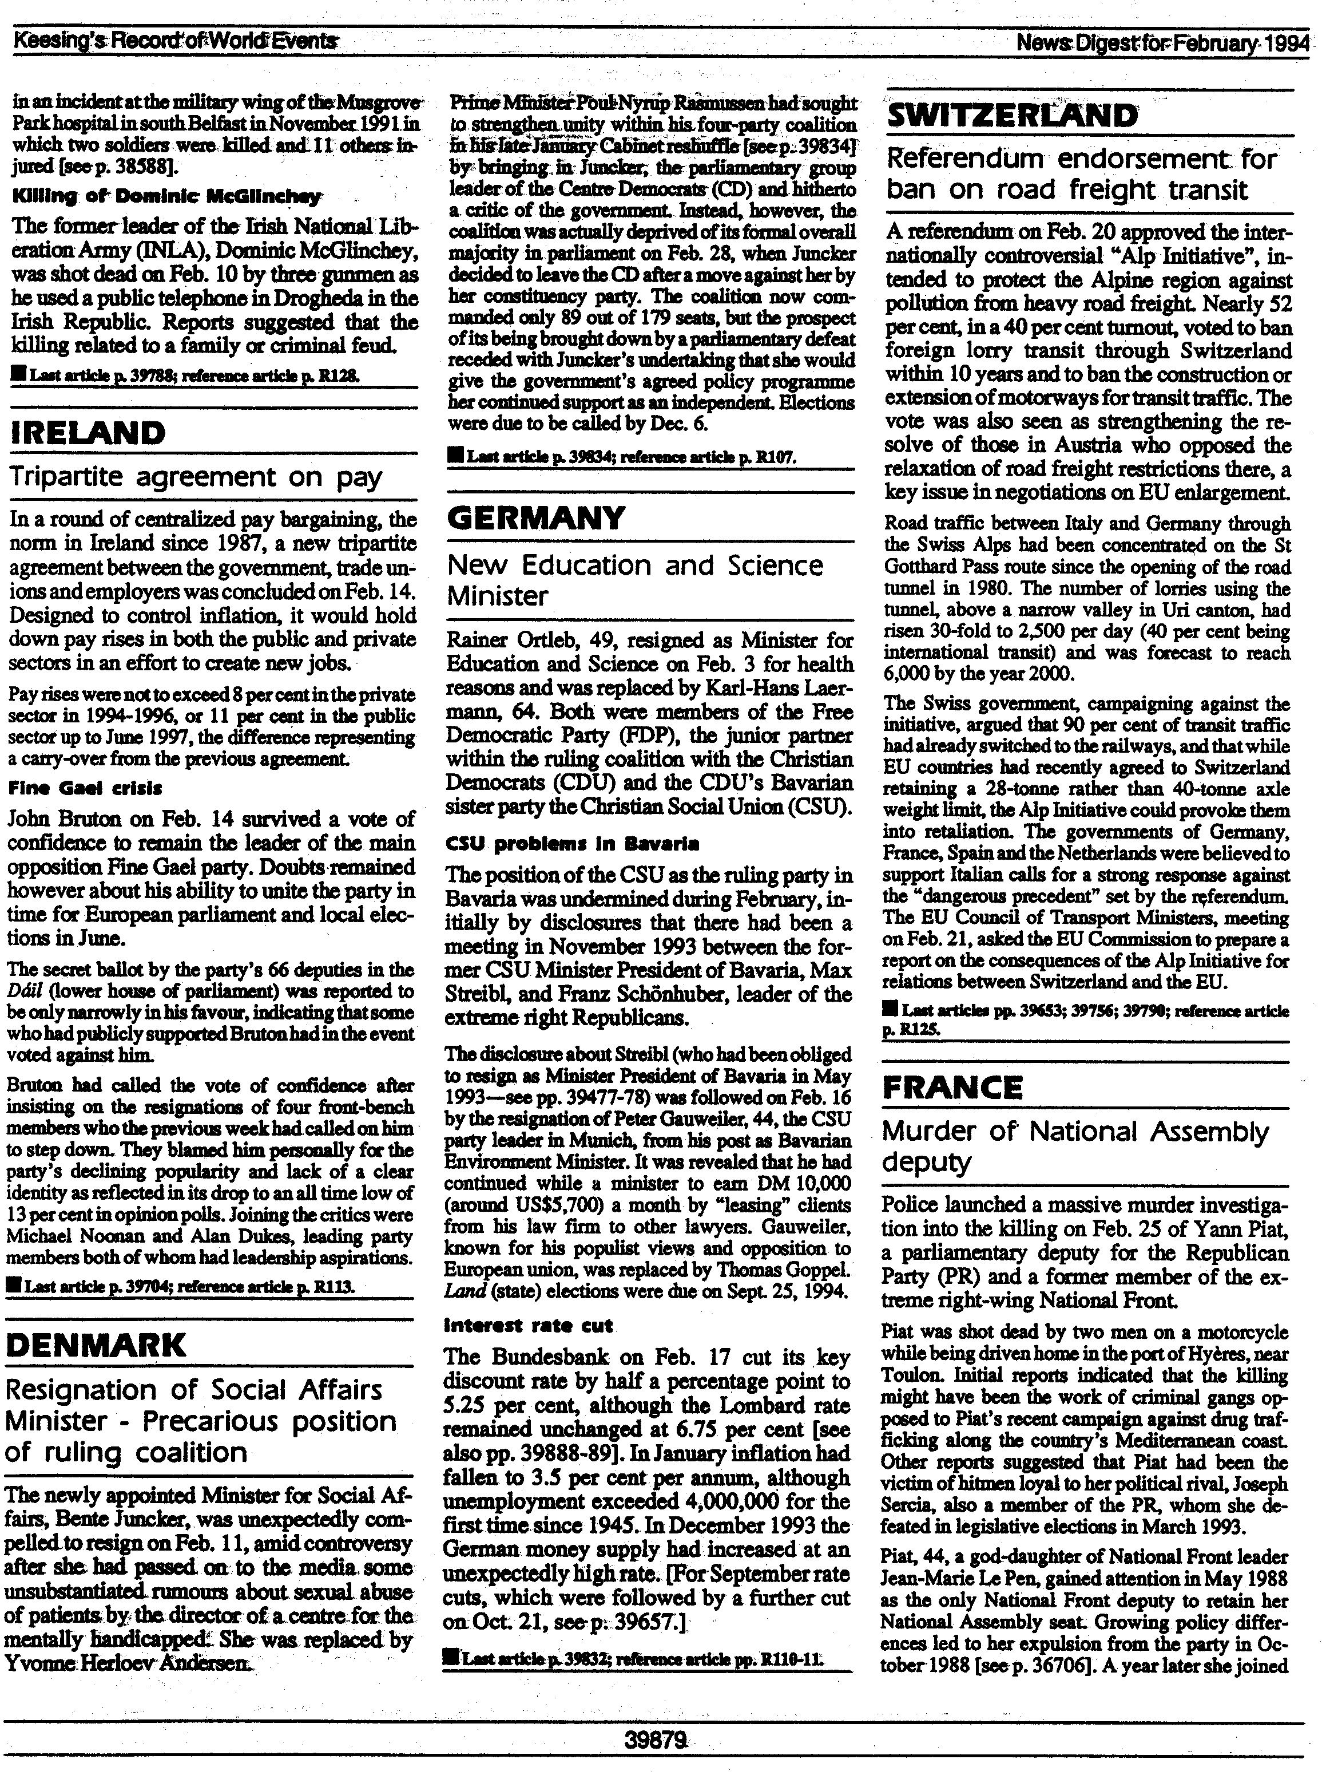

Figure 3. Sample news report containing a “unity” valence event (-1)

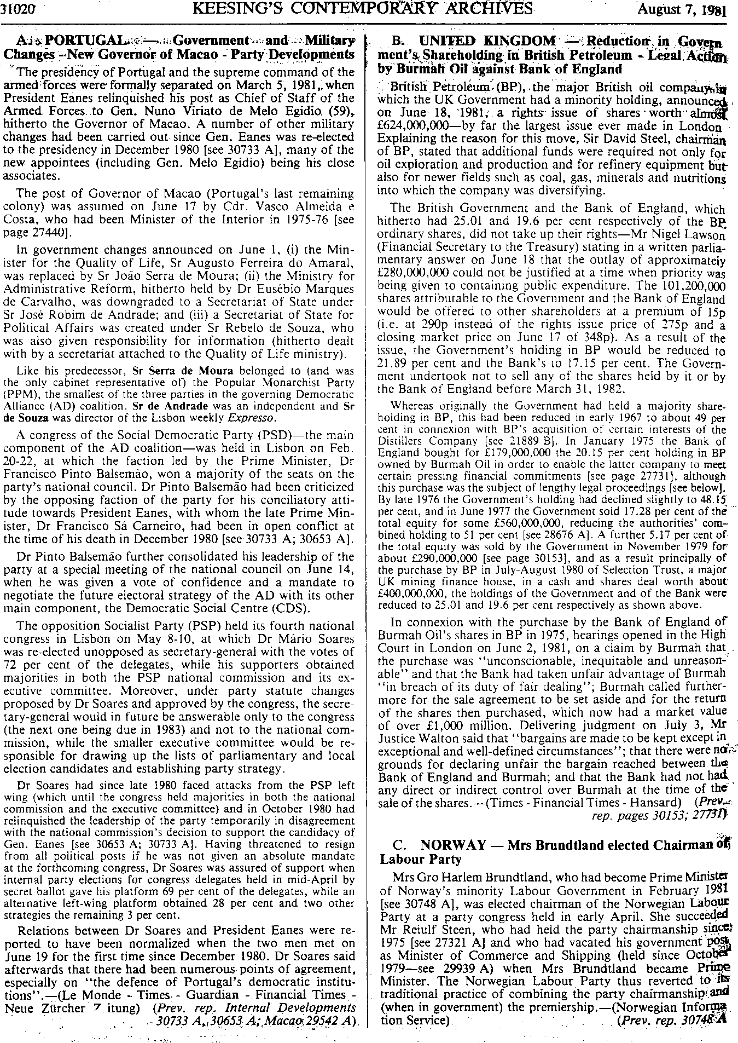
Figure 4. Sample news report containing a “unity” valence event (-2)

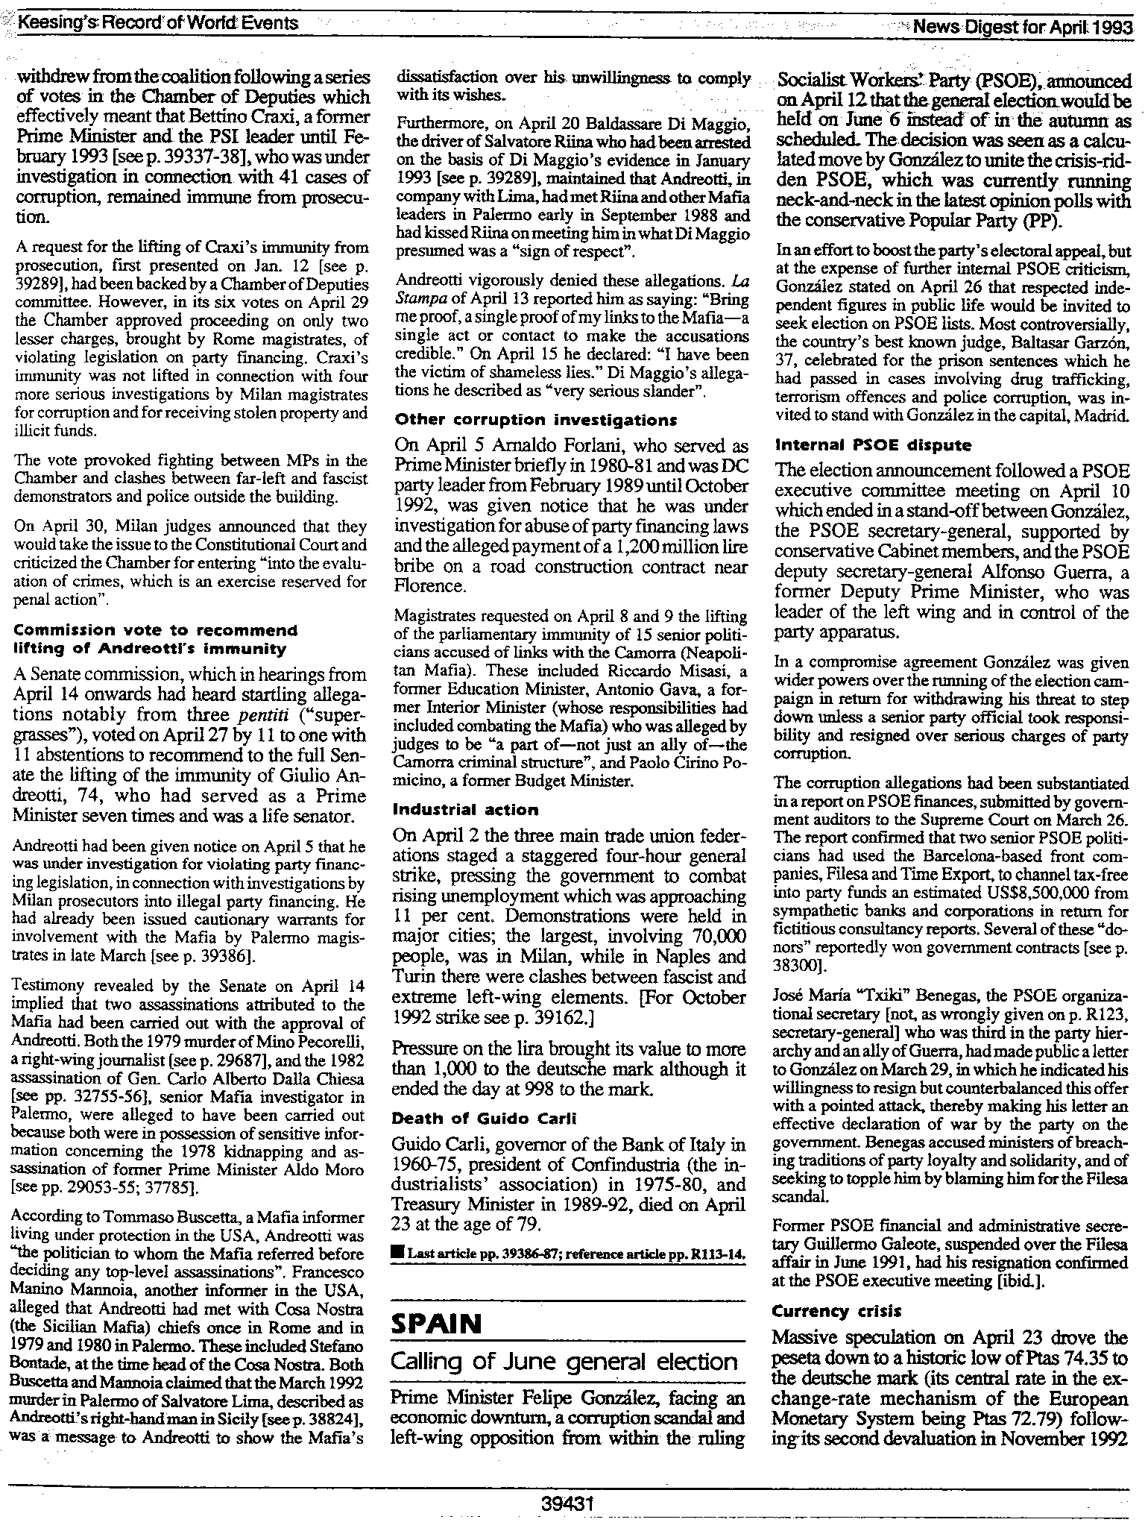
Figure 5. Sample news report containing an “integrity” valence event (-1)

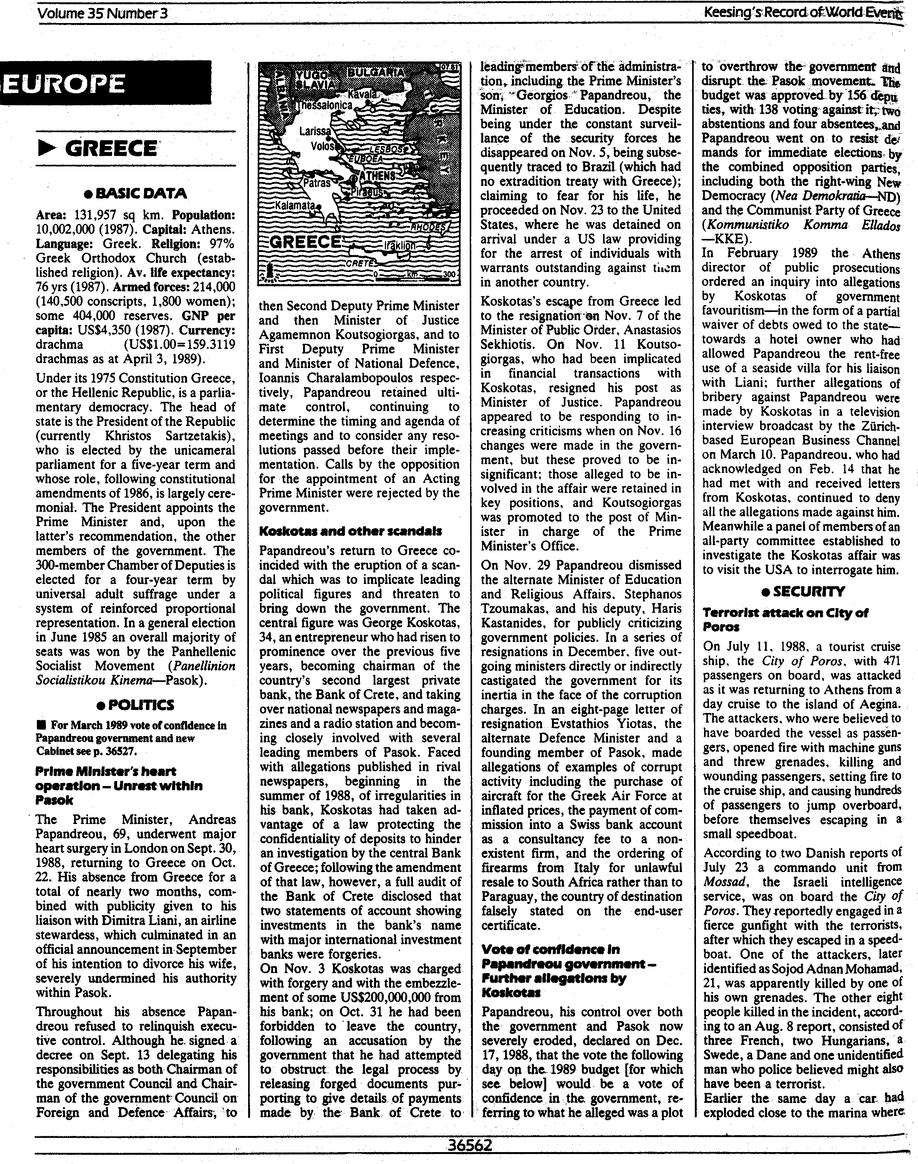
Figure 6. Sample news report containing an “integrity” valence event (-2)

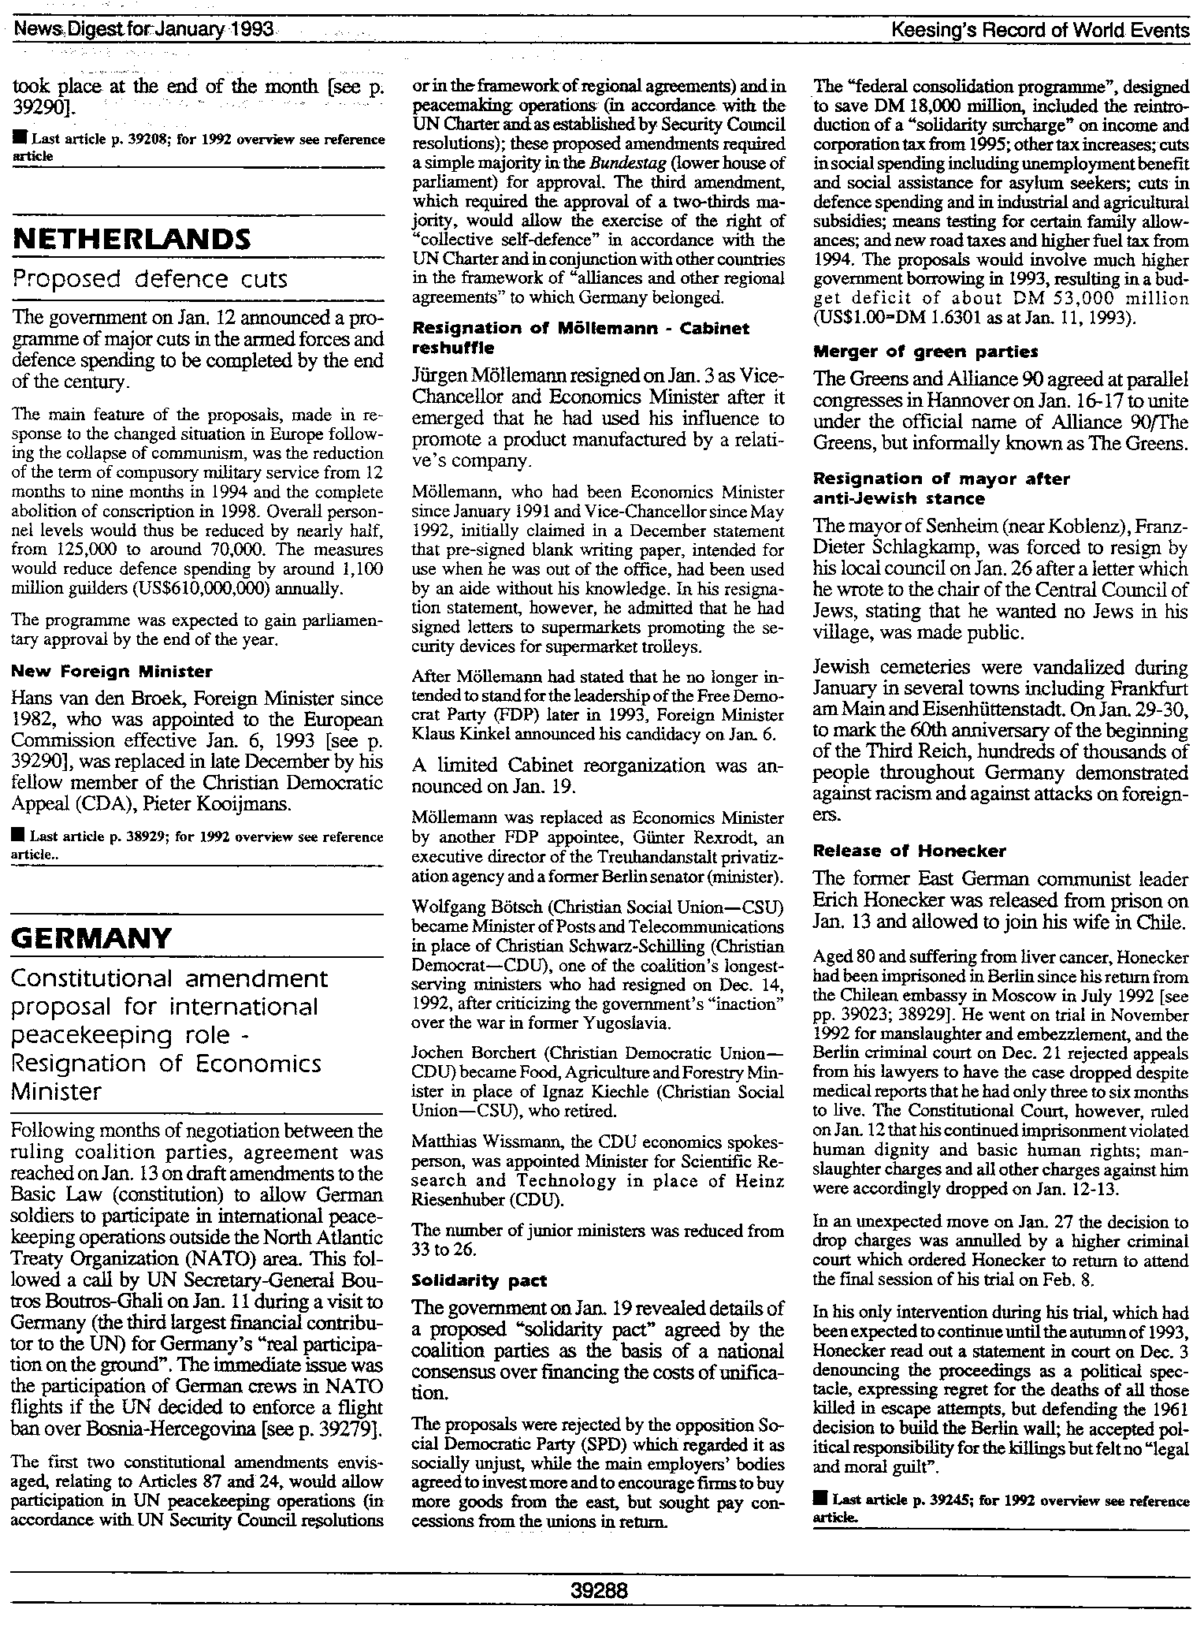

A number of other valence events were also identified during content analysis of these news reports. Under the entry, “Prime Minister’s heart operation” the PSOK was awarded a score of -2 in the “integrity” category due to the Prime Minister’s ‘liaison’ with an airline stewardess resulting in his divorce announcement, which strained party relationships. Under “Koskotas and other scandals” four other valence events affecting PSOK were also identified, all receiving scores of -2. These were the Minister of Public Order resigning (competence), the Minister of Justice resigning (integrity), two officials from the Ministry of Education resigning (unity), and a number of outgoing ministers criticising the government (unity).
The report shown in Figure 6 also includes two other valence events that were identified through content analysis. The first, mentioned under the “Resignation of Möllemann” entry, involved the resignation of Wolfgang Botsch (CDU) from his cabinet position following his criticism of the government’s inaction over the war in the former Yugoslavia. Because this event involved a minister criticising a government of which he was a member, the event was awarded a score of -2 under the “unity” category. The entry also describes the resignation of a CDU mayor due to his insensitive and ill-thought regarding the presence of Jews in his town. This event was deemed relatively serious due to the fact that the mayor was forced to resign over his remarks, but since the position he held was mayor of a town, following the guidelines the event was awarded a score of only -1.

