**Who looks up to the Leviathan? Ideology, political trust and support for restrictive state interventions in times of crisis**

**APPENDIX**

**Appendix A**

***Figure 1A***

Checking for balance in the frequencies of attributes by experimental trait.

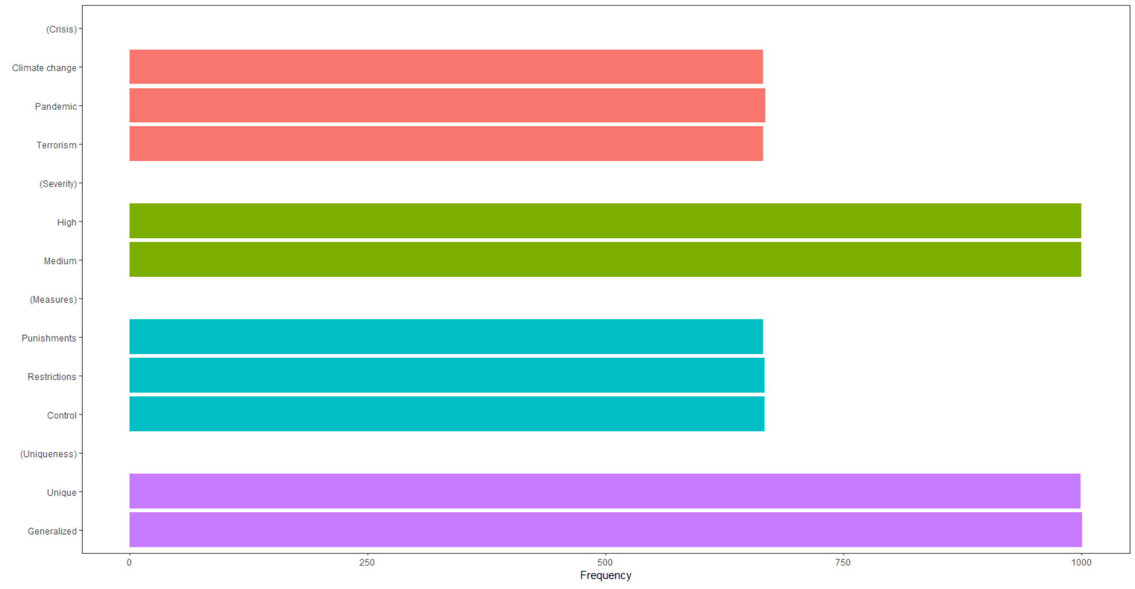

***Figure 2A***

Comparing levels of the three ideological categories across attributes and experimental traits (entire sample). Confidence intervals for each feature set around the grand mean. The results indicate that imbalance is not a problem.

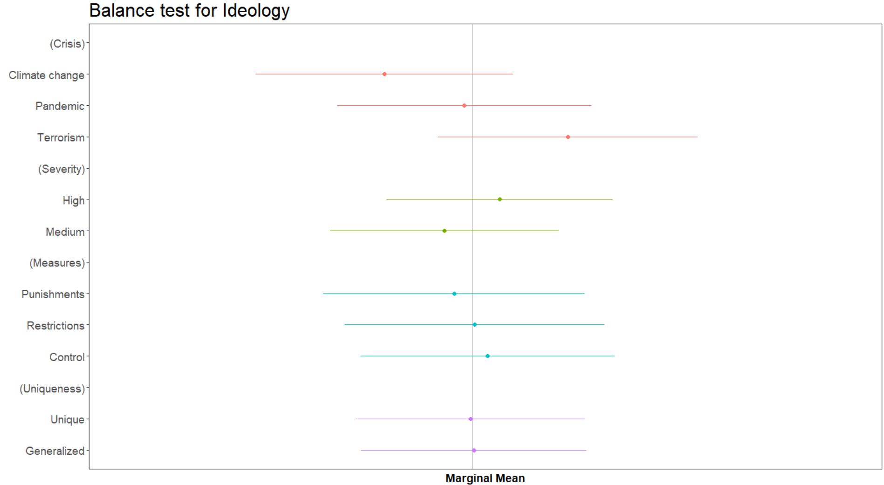

***Figure 3A***

Comparing levels of political trust across attributes and experimental traits (entire sample). Confidence intervals for each feature set around the grand mean. The results indicate that imbalance is not a problem.

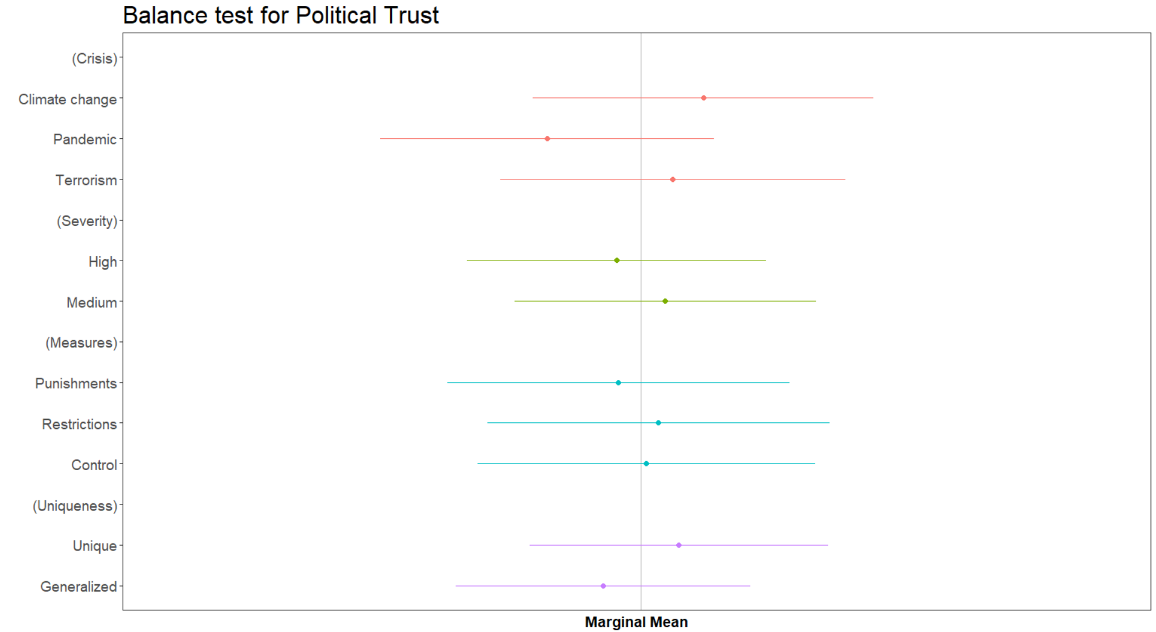

***Figure 4A***

Comparing levels of political trust across attributes and experimental traits (Ideological Right sub-sample). Confidence intervals for each feature set around the grand mean. The results indicate that imbalance is not a problem.

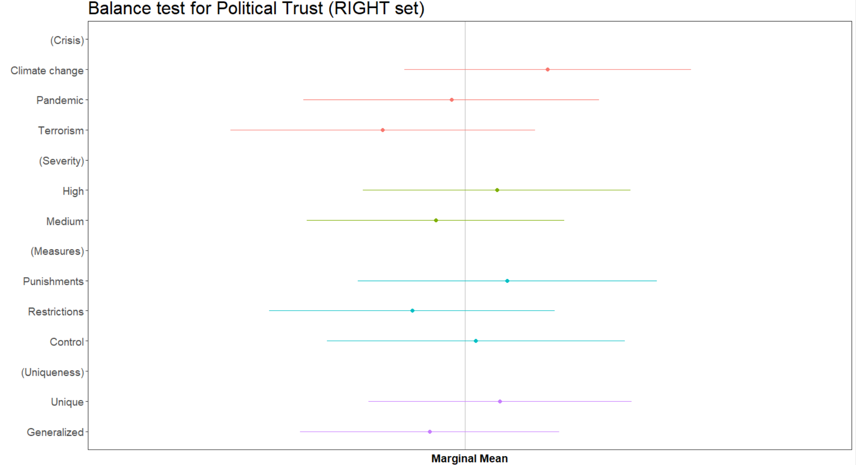

***Figure 5A***

Comparing levels of political trust across attributes and experimental traits (Ideological No-Right sub-sample). Confidence intervals for each feature set around the grand mean. The results indicate that imbalance is not a problem.

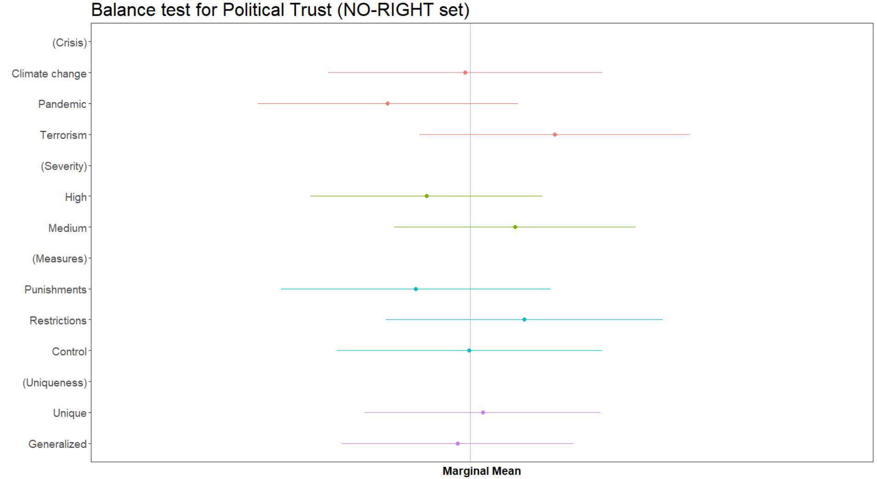

**Appendix B – Robustness checks**

In this Appendix B we replicate our main findings under different scenarios.

First, we replicate Figure 2 and 4 using a different operationalization for the *ideological variable*.

In Figure 1B and 2B we recode the 3-ideological categories differently, i.e., 0-3: left (we have 30.3% of respondents falling in this set); 4-6: centre (42.2%); 7-10: right (27.5%).

In Figure 3B and 4B we recode the 3-ideological categories as the following: 0-2: left (we have 19.7%); 3-7: centre (61.2%); 8-10: right (19.1%).

Finally, in Figure 5B we employ 5-ideological categories rather than 3: Left=0/2 (19.7%); Centre-Left=3/4 (18.5%); Centre=5 (25.4%); Centre-Right=6/7 (17.3%); Right=8/10 (19.1%). Considering as separated all the 11 categories of our ideological scale (between 0 and 10) is on the other side practically infeasible given that we are running a conjoint analysis and the risk of having at least some bins of data – needed to allow the comparison across individual characteristics and vignette’s attributes – with no observations is not to underestimate.

Then, we replicate Figure 3 and 4 using a different operationalization for the *political trust variable*.

In Figure 6B and 7B, we rescale the trust in the Italian Parliament variable to 1 for any value higher than its mean value in our database (i.e., 4.3) and 0 otherwise. In this case 54.5% of respondents get a value of 1.

In Figure 8B and 9B, we rescale the trust in the Italian Parliament variable to 1 for any value higher than its third quartile in our database (i.e., 6) and 0 otherwise. In this case 19% of respondents get a value of 1.

Finally, in Figure 10B and 11B, we employ 3 instead of 2 categories to compute our political trust variable: low trust (0 to 4; 45.5% of the respondents), intermediate trust (5 and 6; 35.5% % of the respondents), high trust (7 to 10; 19% of the respondents).

As can be seen, all our main results as reported in the Manuscript remains qualitatively robust to the different operationalization of our main variables.

**Figure 1B**. Replicating Figure 2 reported in the manuscript with a different rescaling of the ideological variable (right: 7/10)

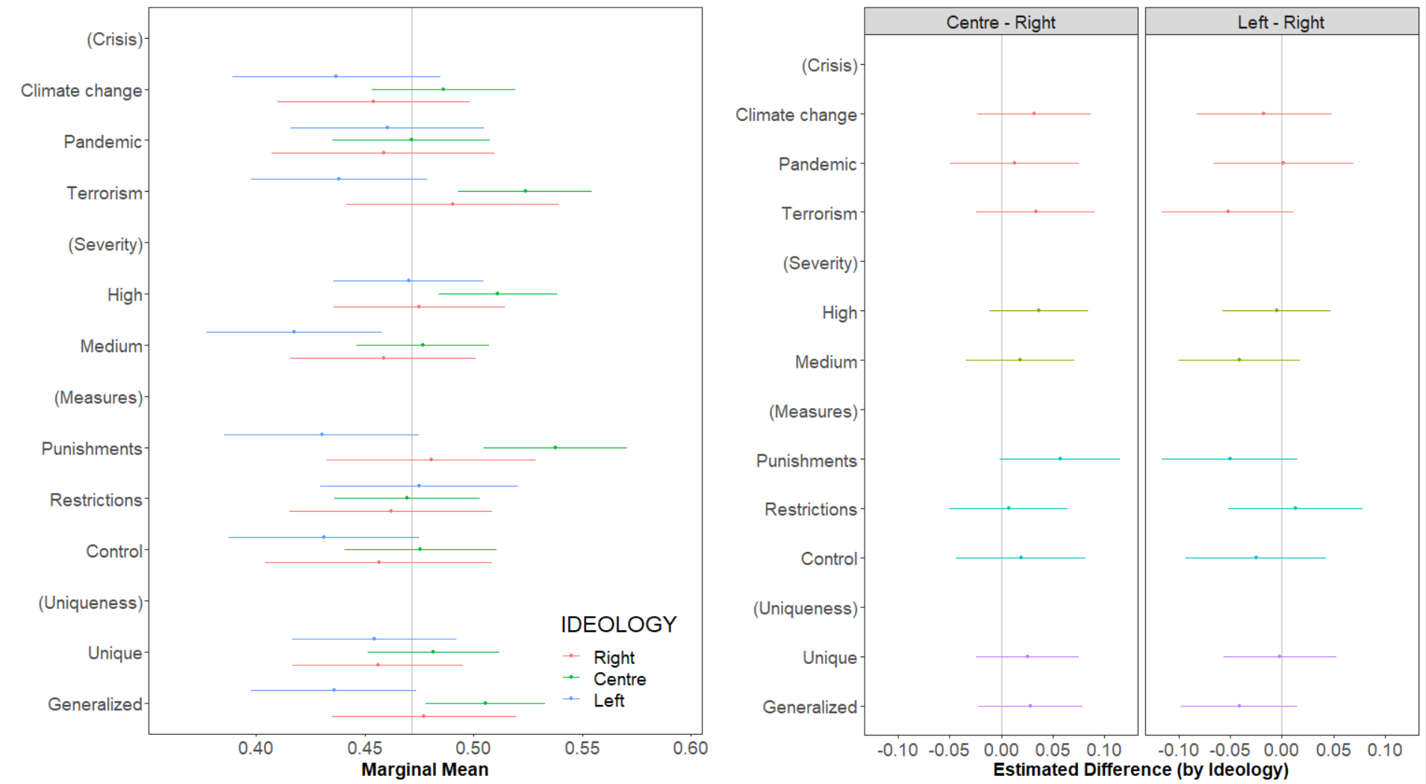

**Figure 2B**. Replicating Figure 4 reported in the manuscript with a different rescaling of the ideological variable (right: 7/10)

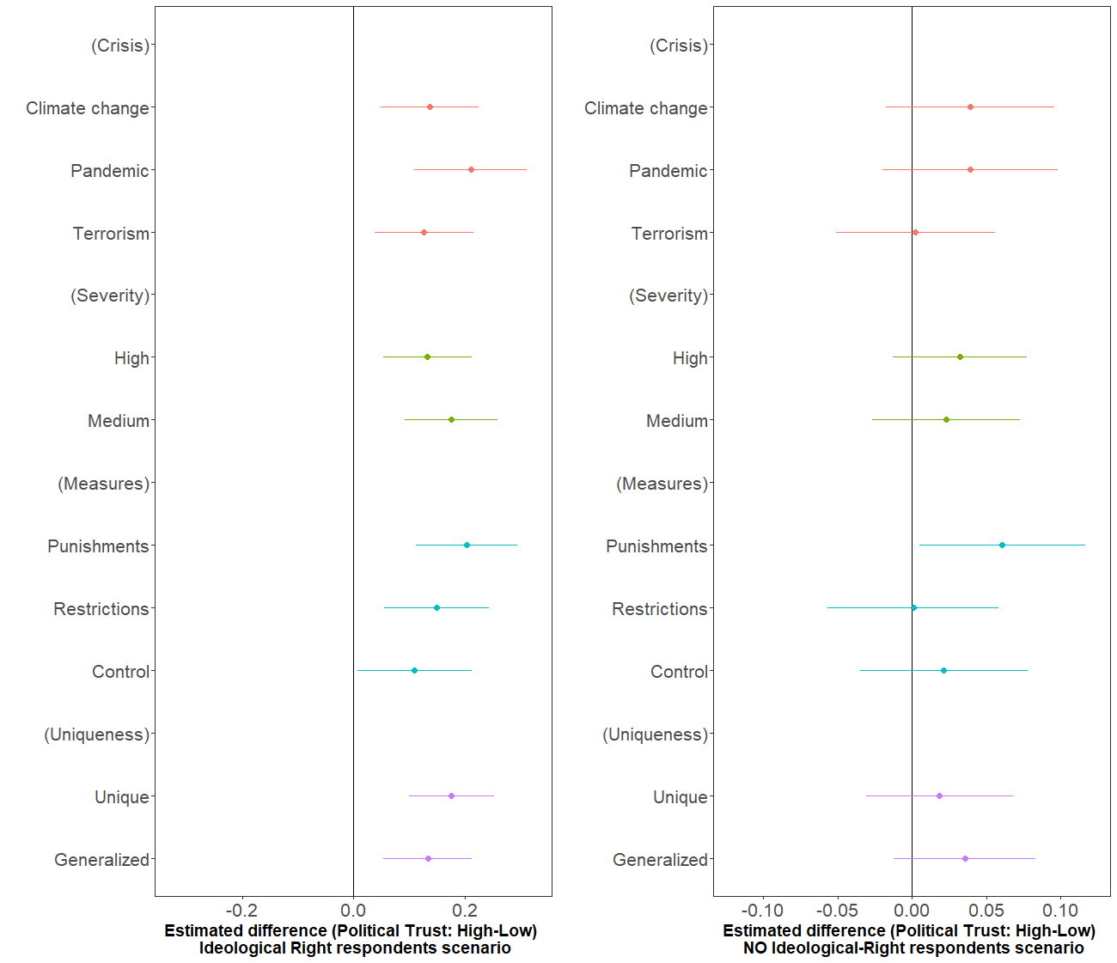

**Figure 3B**. Replicating Figure 2 reported in the manuscript with a different rescaling of the ideological variable (right: 8/10)

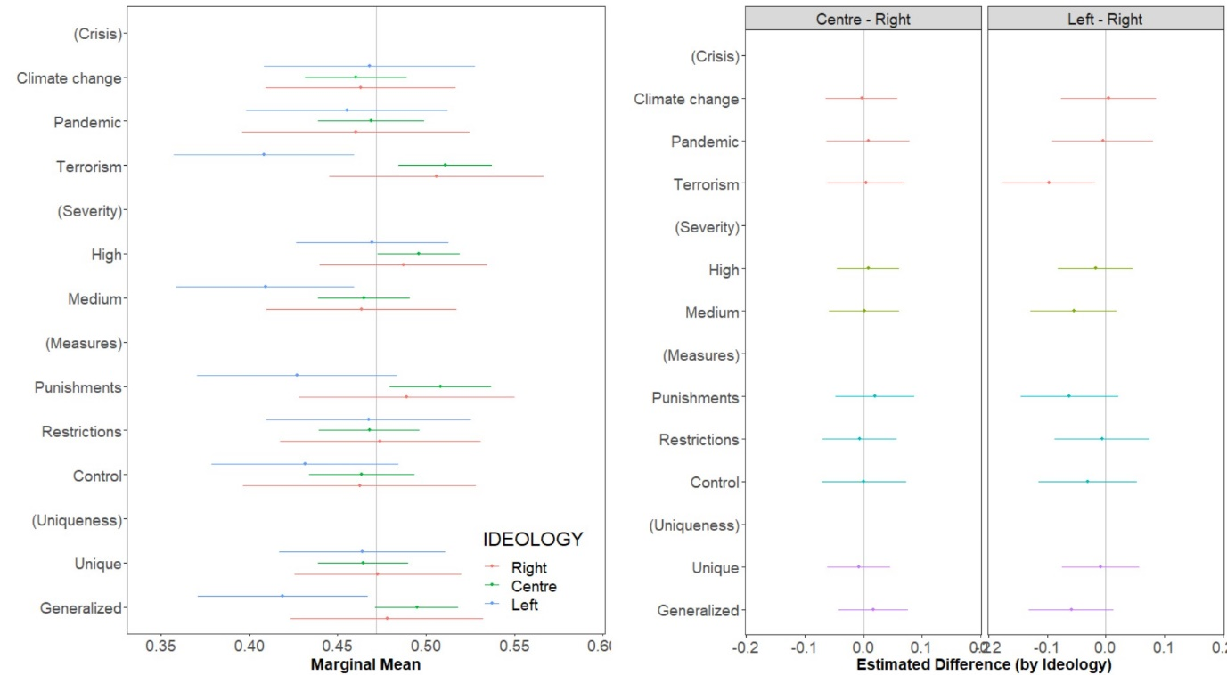

**Figure 4B**. Replicating Figure 4 reported in the manuscript with a different rescaling of the ideological variable (right: 8/10)

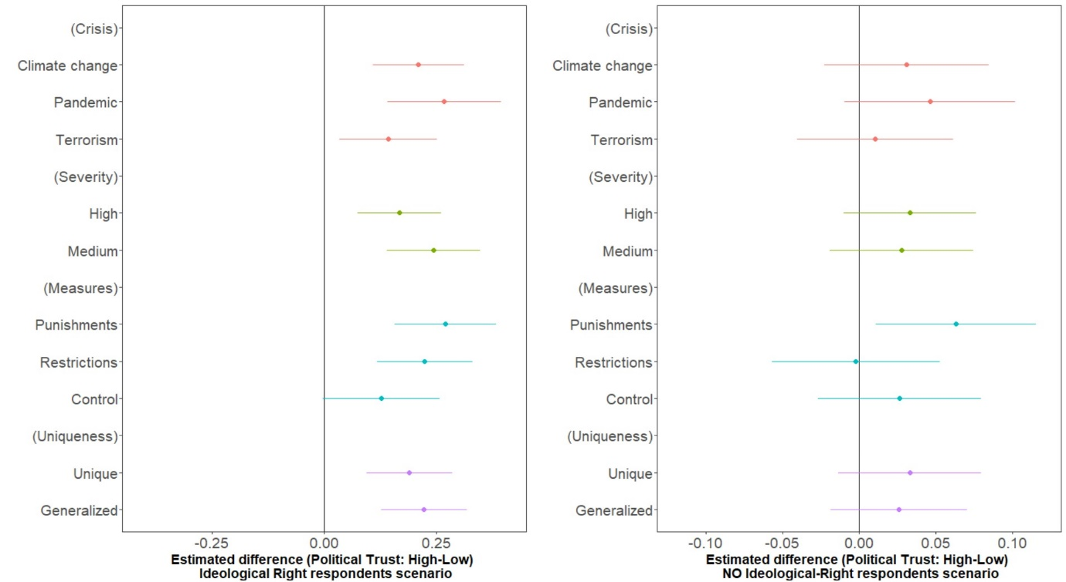

**Figure 5B**. Replicating Figure 2 reported in the manuscript with a different rescaling of the ideological variable (5 categories)

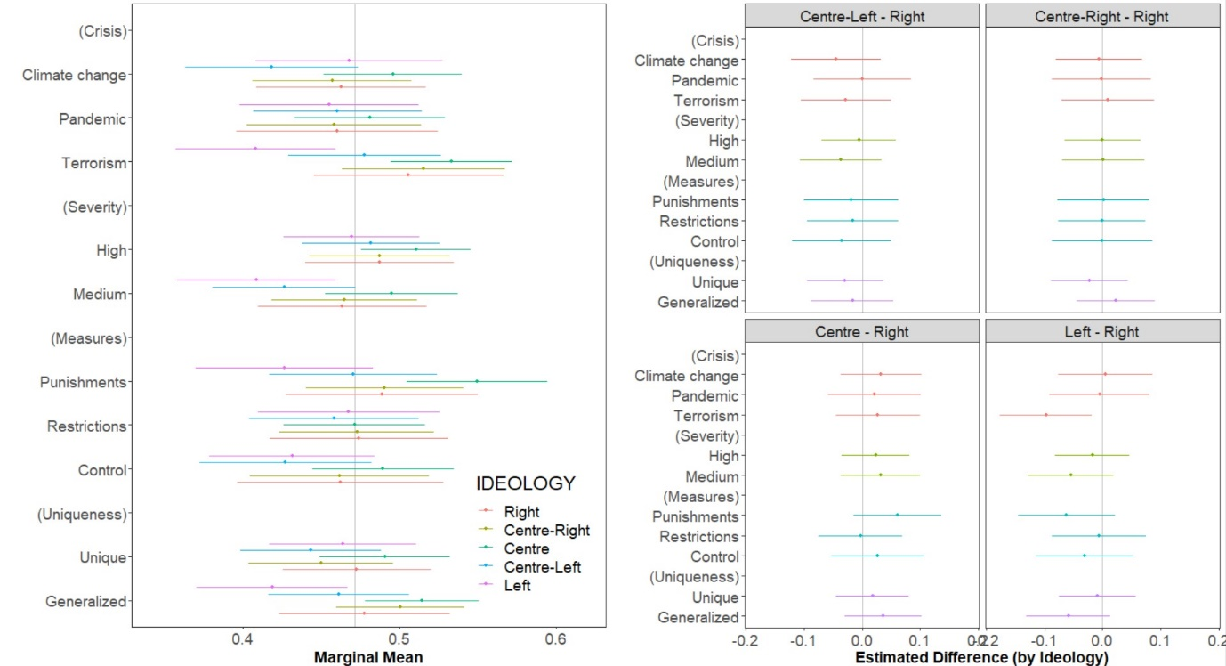

**Figure 6B**. Replicating Figure 3 reported in the manuscript with a different rescaling of the political trust variable (trust larger than 4)

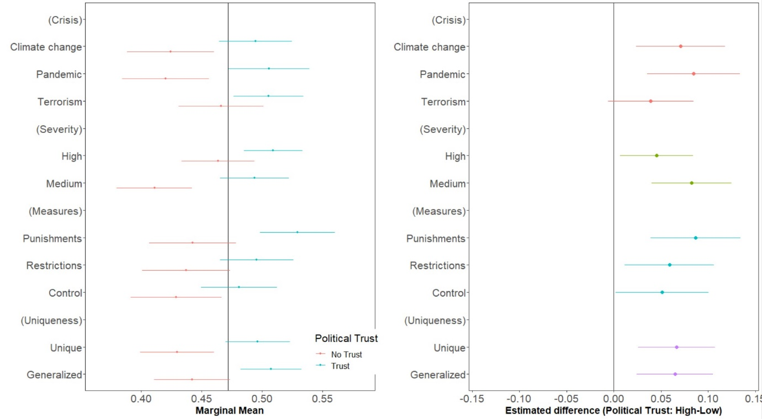

**Figure 7B**. Replicating Figure 4 reported in the manuscript with a different rescaling of the political trust variable (trust larger than 4)

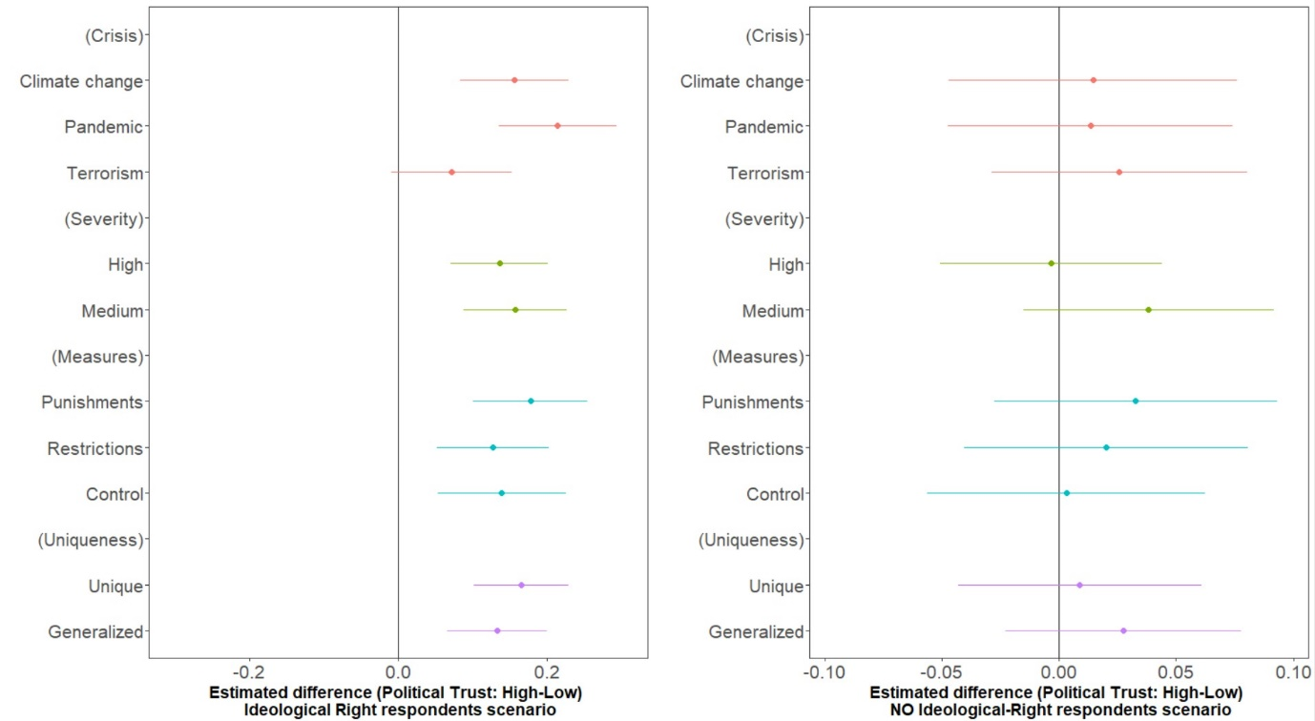

**Figure 8B**. Replicating Figure 3 reported in the manuscript with a different rescaling of the political trust variable (trust larger than 6)

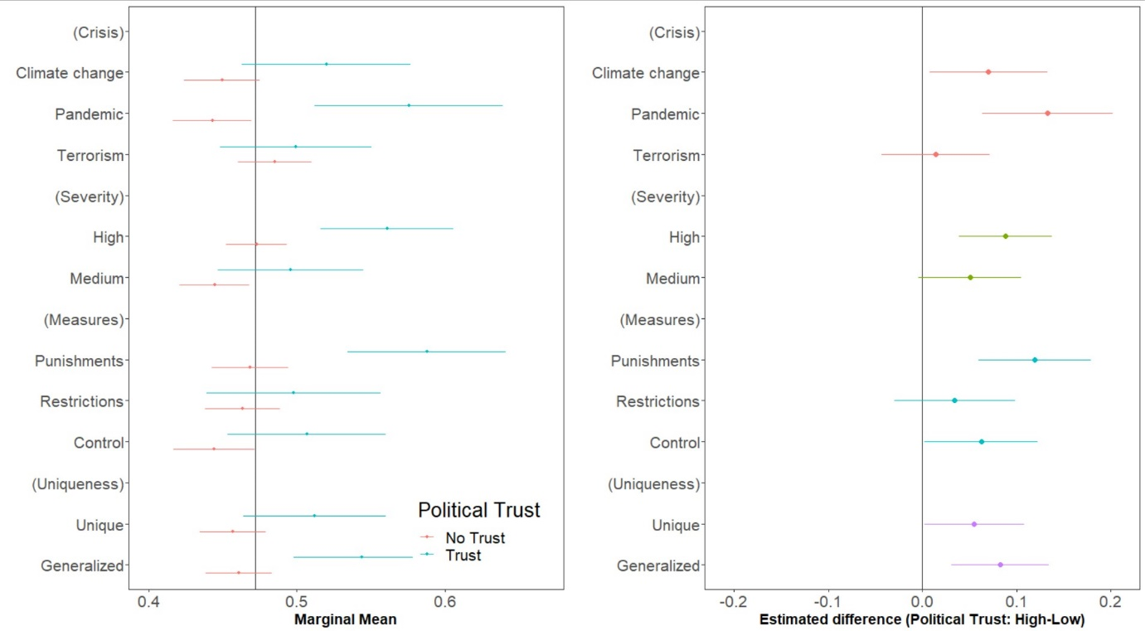

**Figure 9B**. Replicating Figure 4 reported in the manuscript with a different rescaling of the political trust variable (trust larger than 6)

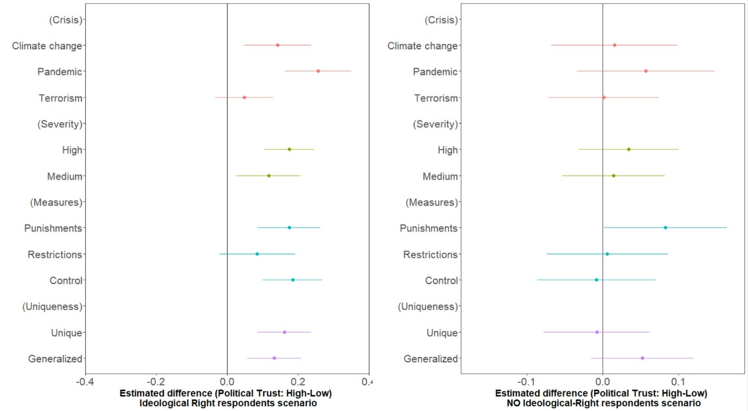

**Figure 10B**. Replicating Figure 3 reported in the manuscript with a different rescaling of the political trust variable (low/intermediate/high trust)

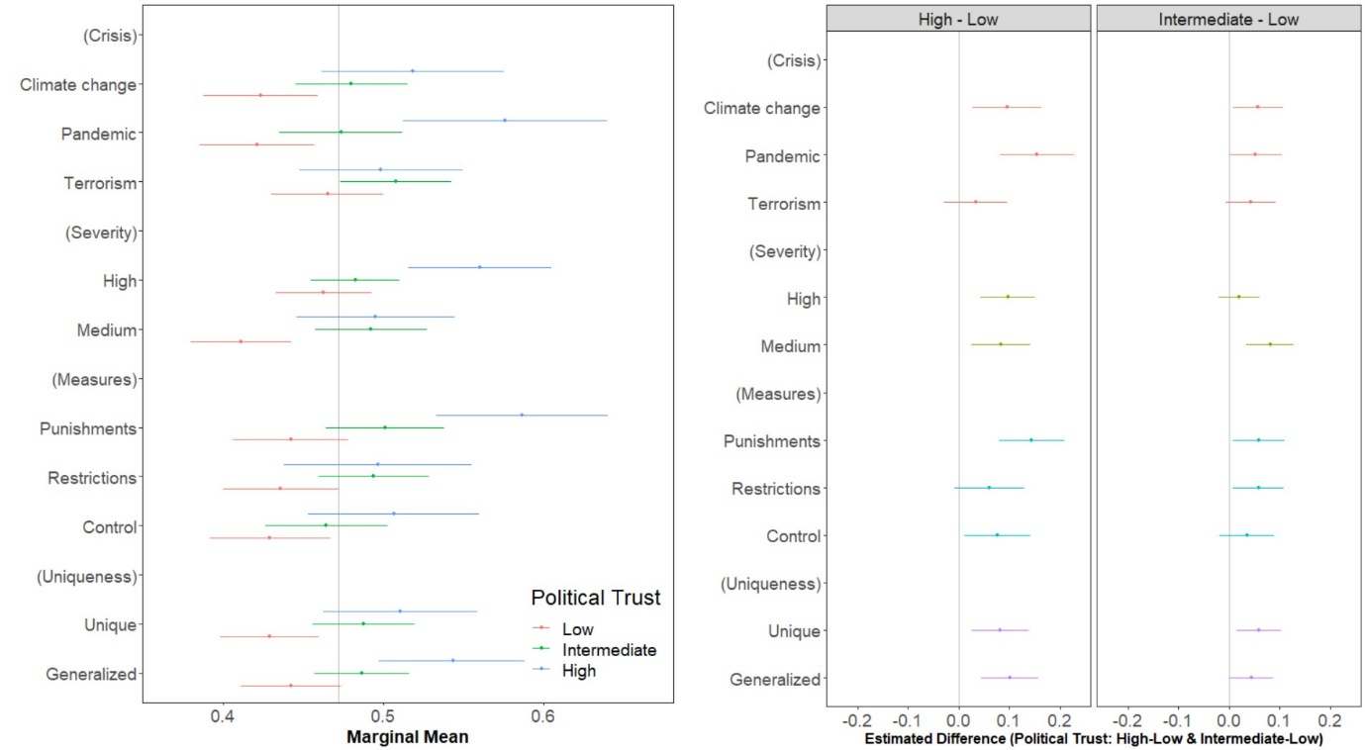

**Figure 11B**. Replicating Figure 4 reported in the manuscript with a different rescaling of the political trust variable (low/intermediate/high trust)

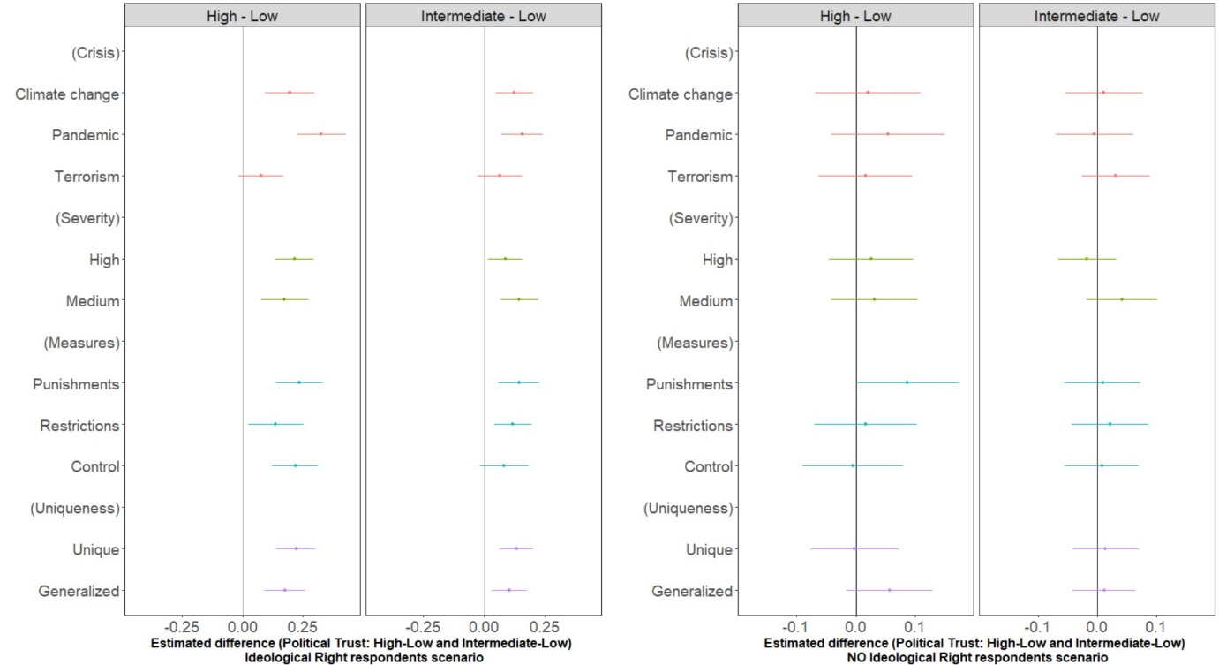

**Appendix C**

**Table 1C**. Socio-demographic features of the sample: Descriptive statistics

|  |  |  |
| --- | --- | --- |
| ***Attribute*** | ***Mean*** | ***Standard deviation*** |
| Gender (0=female; 1=male) | .487 | .499 |
| Age (in years) | 47.0 | 14.88 |
| Education (a dummy variable, equals to 1 if the respondent has at least a college degree and 0 otherwise) | .374 | .483 |
| Left-right ideological position (0 to 10 scale) | 4.936 | 2.685 |
| Trust in political institutions (0 to 10 scale) | 4.355 | 2.458 |