SUPPLEMENTARY MATERIAL
Twin research and Human Genetics

A Genome-Wide Association Study of Monozygotic Twin-Pairs Suggests a Locus Related to Variability of Serum High-Density Lipoprotein Cholesterol
Ida Surakka, John B Whitfield, Markus Perola, Peter M Visscher, Grant W Montgomery, Mario Falchi, Gonneke Willemsen, Eco JC de Geus, Patrik KE Magnusson, Kaare Christensen, Thorkild IA Sørensen, Kirsi Pietiläinen, Taina Rantanen, Kaisa Silander, Elisabeth Widen, Juha Muilu, Iffat Rahman, Ulrika Liljedahl, Ann-Christine Syvänen, Aarno Palotie, Jaakko Kaprio, Kirsten O Kyvik, Nancy L Pedersen, Dorret I Boomsma, Tim Spector, Nicholas G Martin, Samuli Ripatti, Leena Peltonen, on behalf of the GenomEUtwin Project

Supplementary Table S1.
Summary statistics of the absolute intra pair differences and means in the twin cohorts
 | Australia | UK | Sweden | Finland | Denmark | Netherlands
 | mean (sd)  N | mean (sd)  N | mean (sd)  N | mean (sd)  N | mean (sd)  N | mean (sd)  N
Age | 47.37 (12.64)  421 | 51.75 (11.39)  422 | 71.84 (5.84)  292 | 60.70 (15.44)  135 | 43.91 (19.08)  167 | 33.60 (12.17)  275
Differences
HDL | 0.25 (0.21)  393 | 0.24 (0.21)  418 | 0.26 (0.22)  286 | 0.23 (0.18)  133 | 0.27 (0.23)  136 | 0.24 (0.20)  268
LDL | 0.63 (0.56)  381 | 0.55 (0.51)  417 | 0.79 (0.77)  283 | 0.71 (0.69)  133 | 0.47 (0.43)  135 | 0.49 (0.41)  266
TC | 0.67 (0.61)  413 | 0.65 (0.61)  418 | 0.92 (0.86)  291 | 0.72 (0.65)  134 | 0.59 (0.48)  159 | 0.57 (0.46)  270
TG | 0.38 (0.32)  418 | 0.33 (0.29)  419 | 0.35 (0.27)  288 | 0.38 (0.26)  38 | 0.26 (0.21)  138 | 0.315 (0.249)  273
APOA1 | 0.13 (0.11)  413 | NA | 0.11 (0.09)  291 | 0.15 (0.12)  9 | 0.16 (0.15)  137 | 0.10 (0.08)  24
APOA2 | 0.14 (0.11)  408 | NA | NA | 0.17 (0.13)  9 | NA | 0.10 (0.09)  24
APOB | 0.16 (0.13)  412 | NA | 0.18 (0.16)  289 | 0.18 (0.22)  9 | 0.25 (0.24)  138 | 0.14 (0.16)  24
APOE | 0.26 (0.22)  397 | NA | NA | NA | 0.36 (0.32)  119 | 0.15 (0.12)  24
Means
HDL | 1.56 (0.34)  416 | 1.51 (0.37)  420 | 1.53 (0.37)  292 | 1.59 (0.40)  134 | 1.63 (0.37)  139 | 1.53 (0.33)  274
LDL | 3.42 (0.90)  411 | 3.32 (0.89)  419 | 3.85 (0.80)  291 | 3.45 (0.85)  135 | 3.14 (0.89)  137 | 2.81 (0.79)  274
TC | 5.67 (0.97)  420 | 5.28 (1.05)  421 | 6.02 (0.87)  292 | 5.36 (0.78)  135 | 5.40 (1.09)  166 | 4.88 (0.89)  274
TG | 0.30 (0.47)  420 | -0.22 (0.48)  421 | 0.23 (0.37)  291 | 0.03 (0.41)  39 | 0.08 (0.32)  139 | 0.001 (0.35)  274
APOA1 | 0.40 (0.17)  420 | na | 0.49 (0.16) 292 | 0.41 (0.16)  9 | 0.25 (0.30)  138 | 0.62 (0.22)  24
APOA2 | -1.02 (0.15)  420 | na | na | -1.12 (0.14)  9 | na | -0.51 (0.12)  24
APOB | -0.09 (0.25)  420 | na | 0.05 (0.19)  292 | -0.39 (0.21)  9 | -0.46 (0.37)  139 | 0.08 (0.32)  24
APOE | -3.30 (0.33)  416 | na | na | na | -2.53 (0.35)  133 | -3.17 (0.55)  24
Note: Summary statistics of the absolute intra pair differences and means for high density lipoprotein cholesterol (HDL), low density lipoprotein cholesterol (LDL), total cholesterol (TC), logarithmized triglyceride (TG), logarithmized apolipoproteins A1 (APOA1), A2 (APOA2), B (APOB) and E (APOE). sd: standard deviation; N: number of individuals. na: not available.

QQ-PLOTS OF APOLIPOPROTEIN LEVEL ASSOCIATION ANALYSES
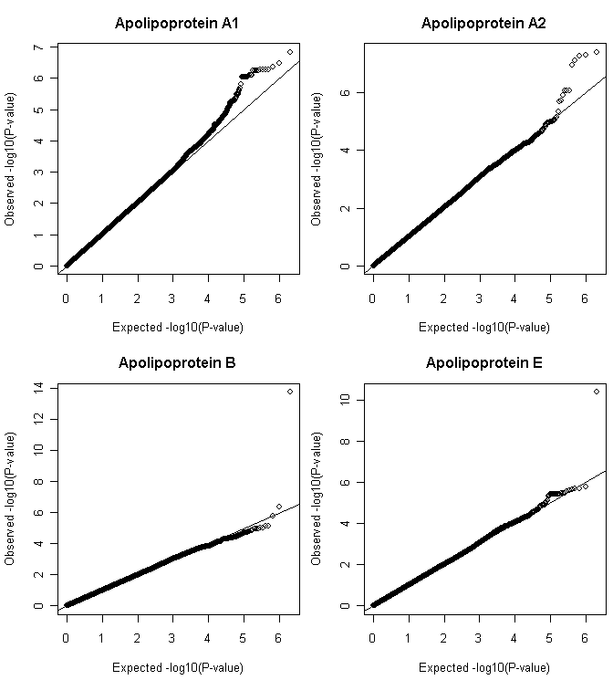
Supplementary Figure S1. Quantile-quantile plot of all four apolipoprotein level association analyses. Deviation from expected could be seen in the analyses of all four traits.

