Supplementary Figure 1

Genetic Influences on Hallux Valgus in Koreans: The Healthy Twin Study
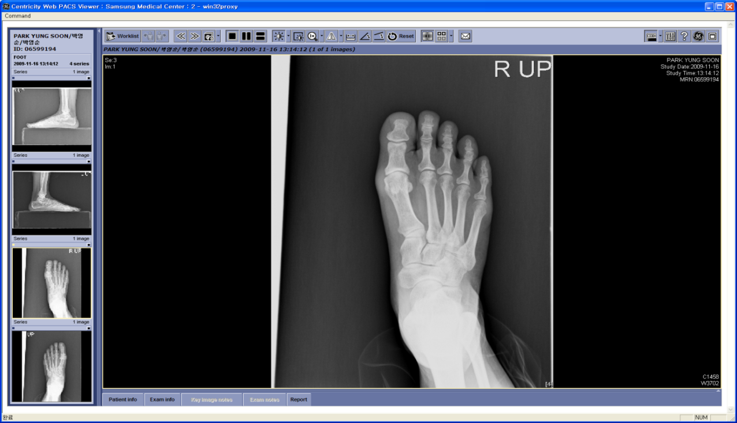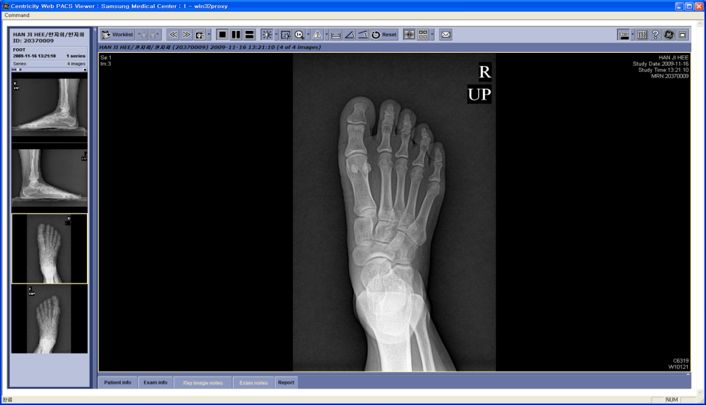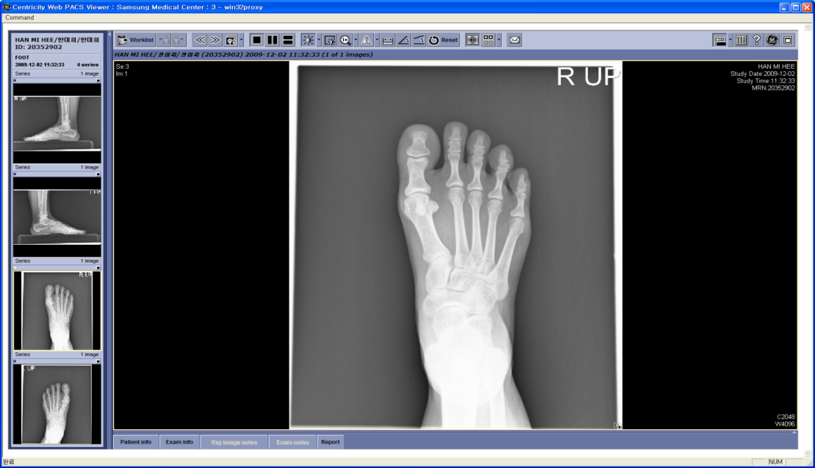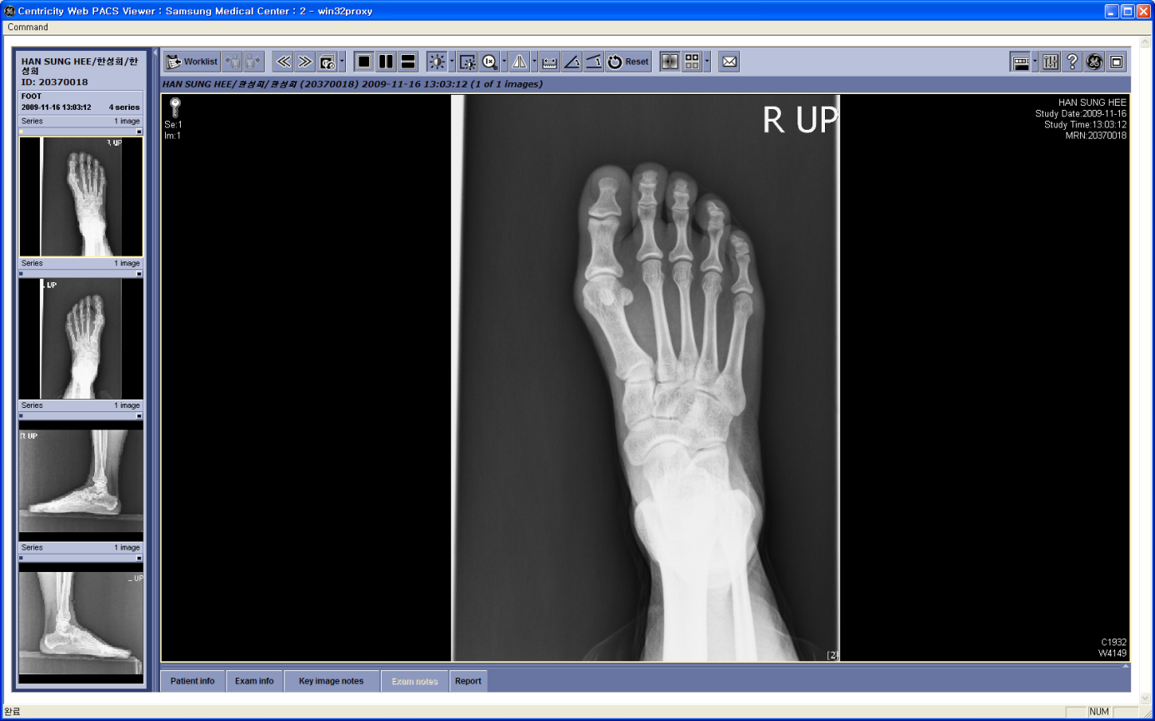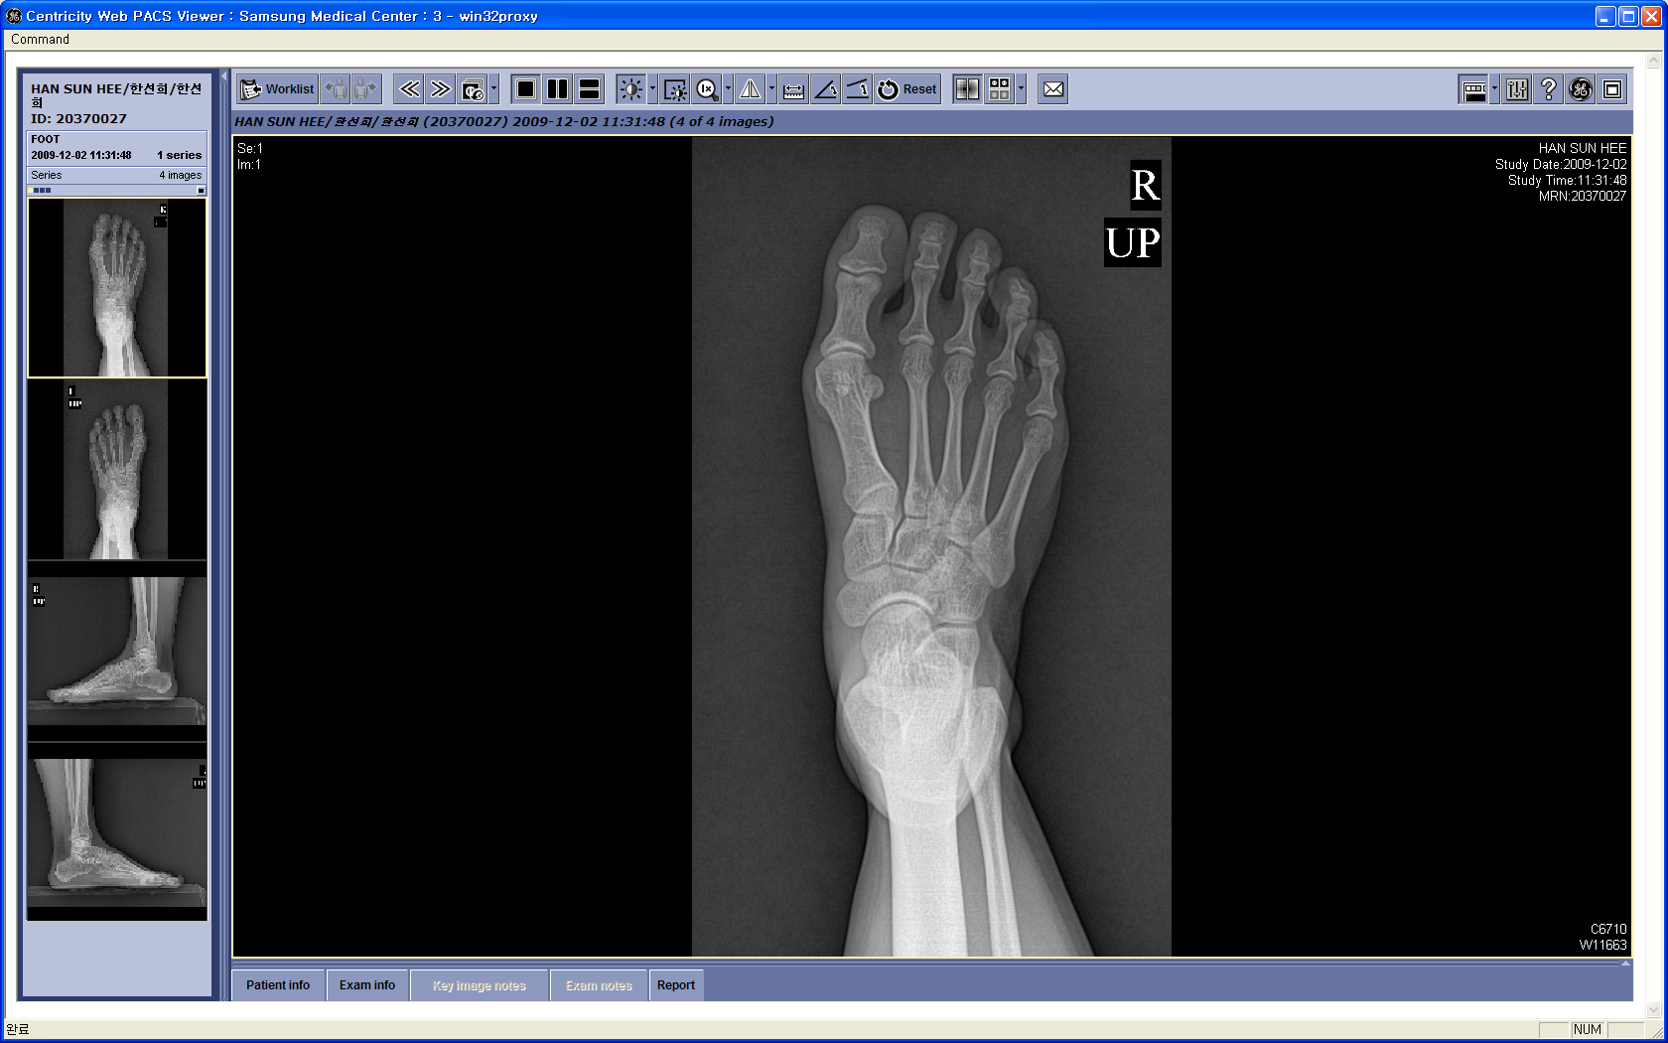
_{Mother}
_{Singleton sister 1}
_{Singleton sister 2}
_{MZ twin 1}
_{MZ twin 2}
Chang-Hyung Lee, Sooji Lee, HyoJeong Kang, Da-Eun Jung, Yun-Mi Song, Kayoung Lee, Kyungtai Lee,
JiHye Hwang, and Joohon Sung
Supplementary Figure 1. AP radiographs of a typical family consisting of one monozygotic twin (MZ) pair concordant for hallux valgus and their family members. Note that sister 1 also shows hallux valgus deformity and the mother has borderline hallux valgus angle widening.

