Twin Research and Human Genetics

Intensity-specific differential leukocyte DNA methylation in physical (in)activity: an exploratory approach

M. Caspers, S. Blocquiaux, R. Charlier, S. Knaeps, J. Lefevre, K. De Bock, M. Thomis

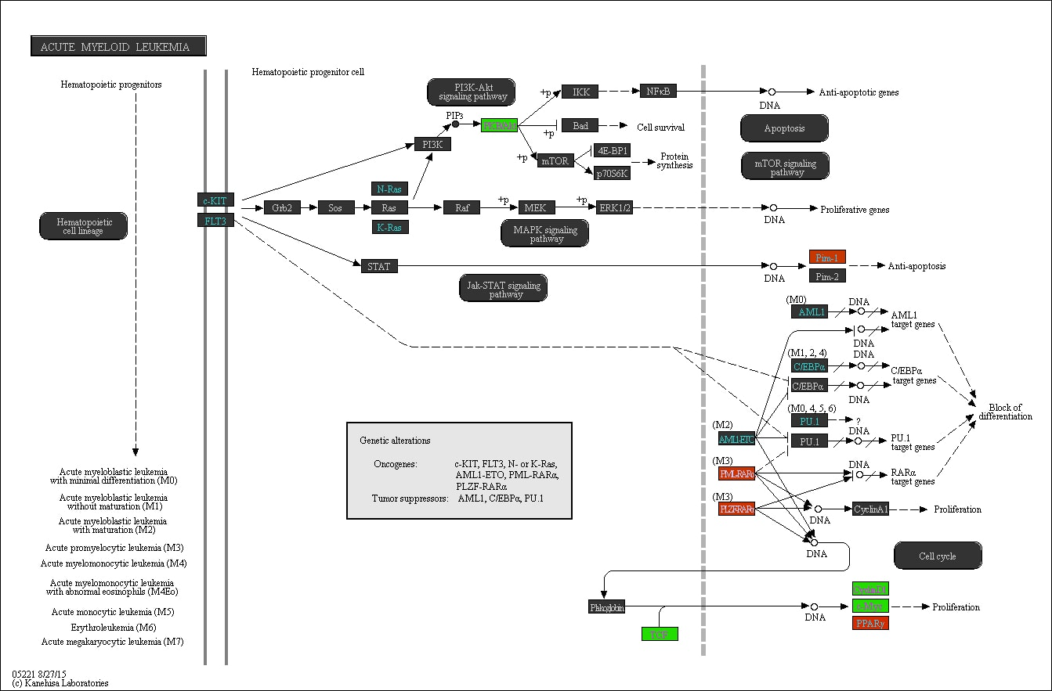
Supplementary Figure S1. The ‘Acute myeloid leukemia’ pathway in relation to SB. Promoter methylation of genes in red is positively associated with time spent on SB, whereas promoter methylation of genes in green is negatively associated with time spent on SB.
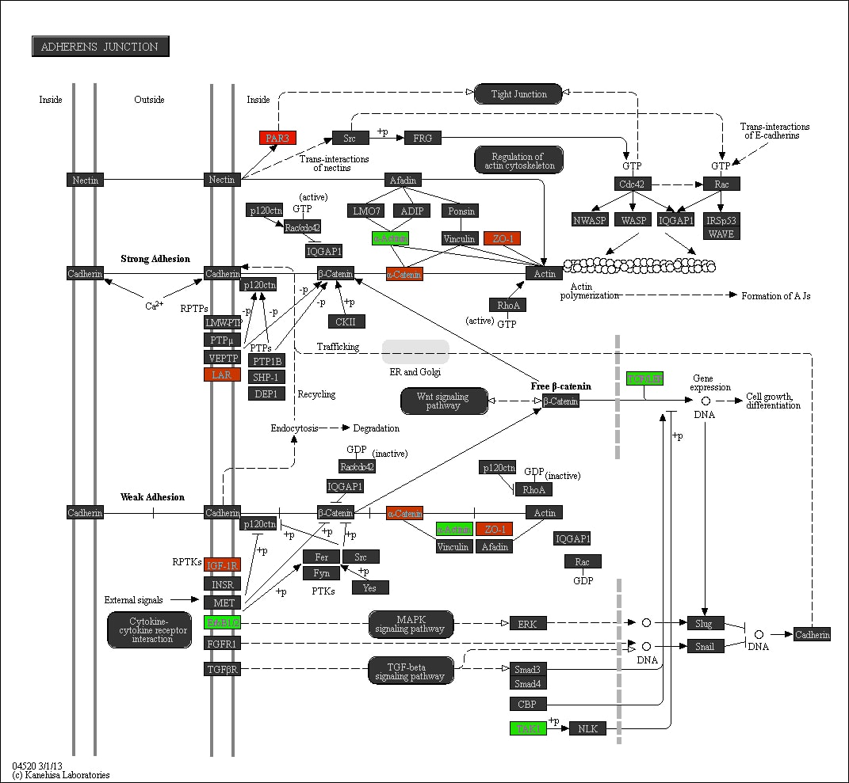
Supplementary Figure S2. The ‘Adherens junction’ pathway in relation to SB. Promoter methylation of genes in red is positively associated with time spent on SB, whereas promoter methylation of genes in green is negatively associated with time spent on SB.
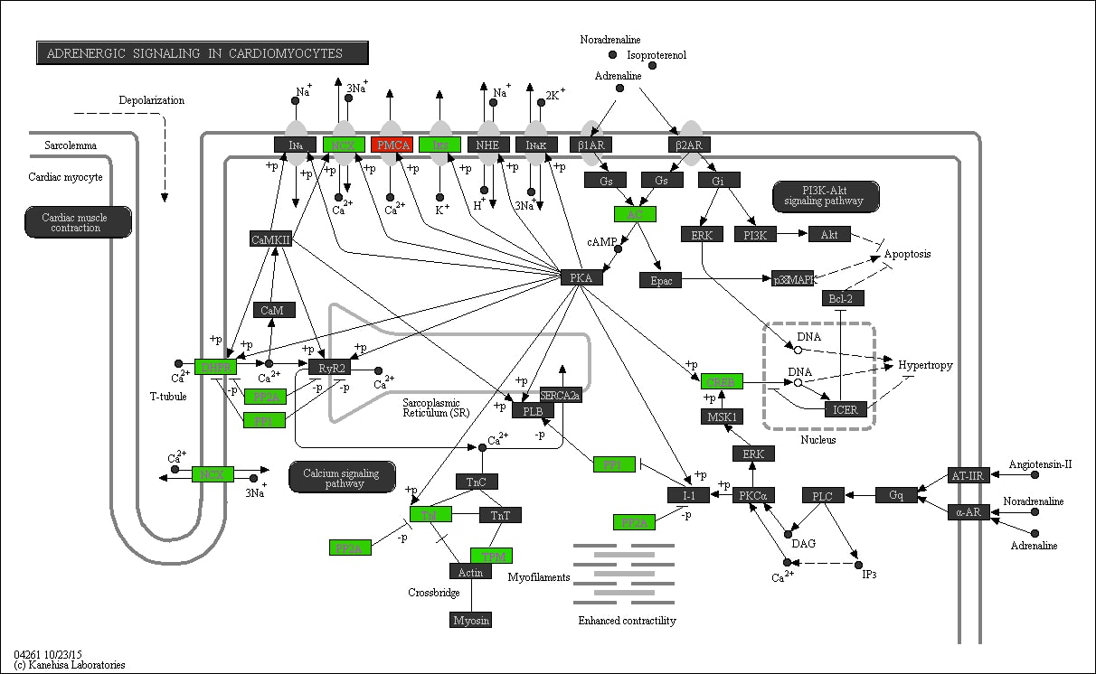
Supplementary Figure S3. The ‘Adrenergic signaling in cardiomyocytes’ pathway in relation to MVPA. Promoter methylation of genes in red is positively associated with time spent on MVPA, whereas promoter methylation of genes in green is negatively associated with time spent on MVPA.

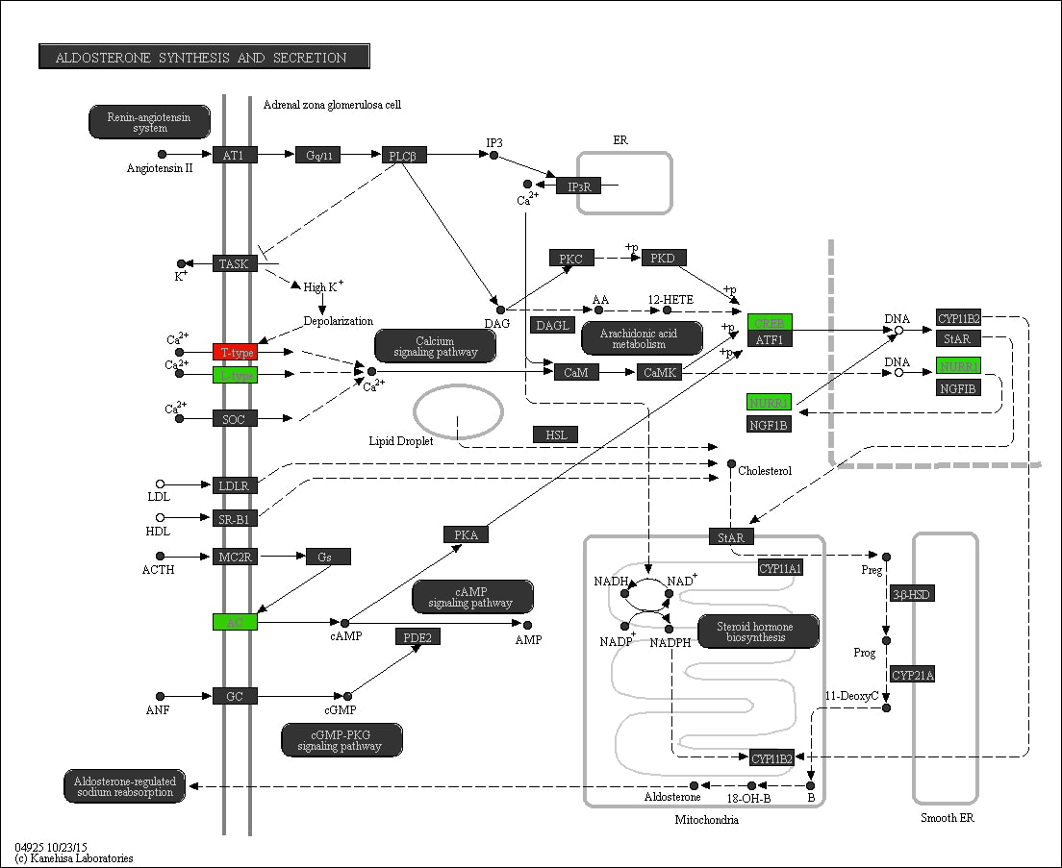

Supplementary Figure S4. The ‘Aldosterone synthesis and secretion’ pathway in relation to MVPA. Promoter methylation of genes in red is positively associated with time spent on MVPA, whereas promoter methylation of genes in green is negatively associated with time spent on MVPA.
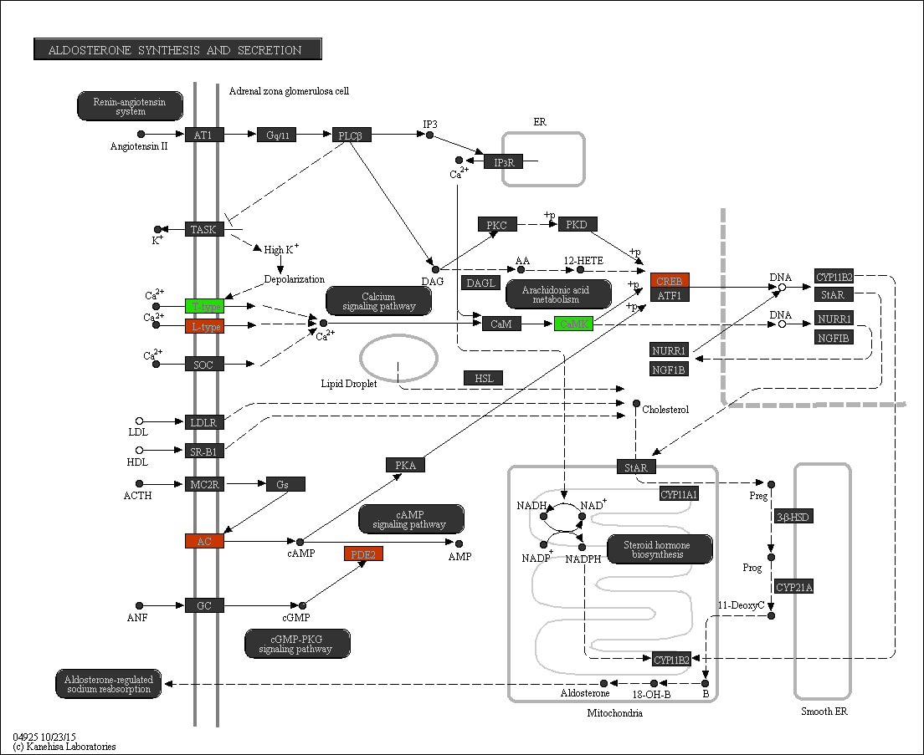

Supplementary Figure S5. The ‘Aldosterone synthesis and secretion’ pathway in relation to SB. Promoter methylation of genes in red is positively associated with time spent on SB, whereas promoter methylation of genes in green is negatively associated with time spent on SB.

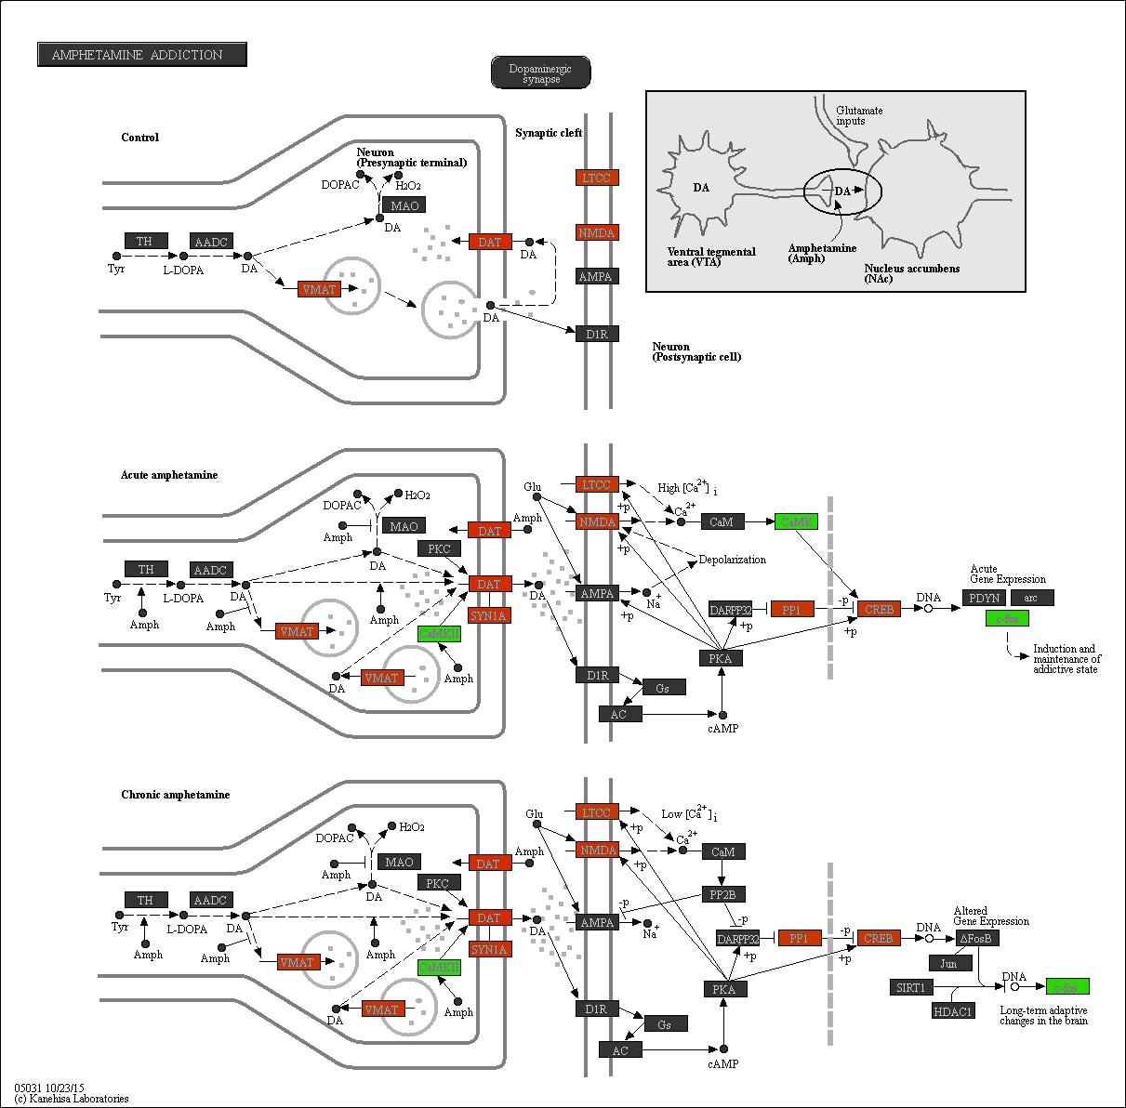

Supplementary Figure S6. The ‘Amphetamine addiction’ pathway in relation to SB. Promoter methylation of genes in red is positively associated with time spent on SB, whereas promoter methylation of genes in green is negatively associated with time spent on SB.

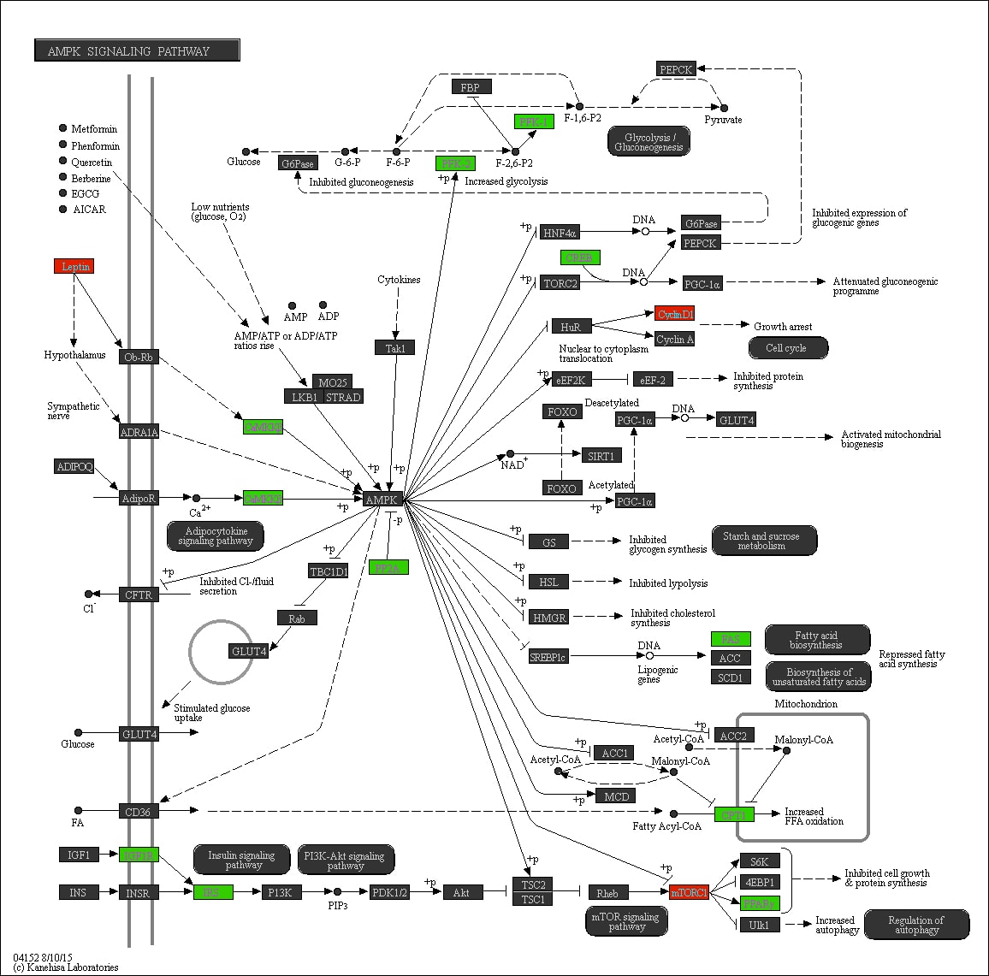

Supplementary Figure S7. The ‘AMPK signaling’ pathway in relation to MVPA. Promoter methylation of genes in red is positively associated with time spent on MVPA, whereas promoter methylation of genes in green is negatively associated with time spent on MVPA.

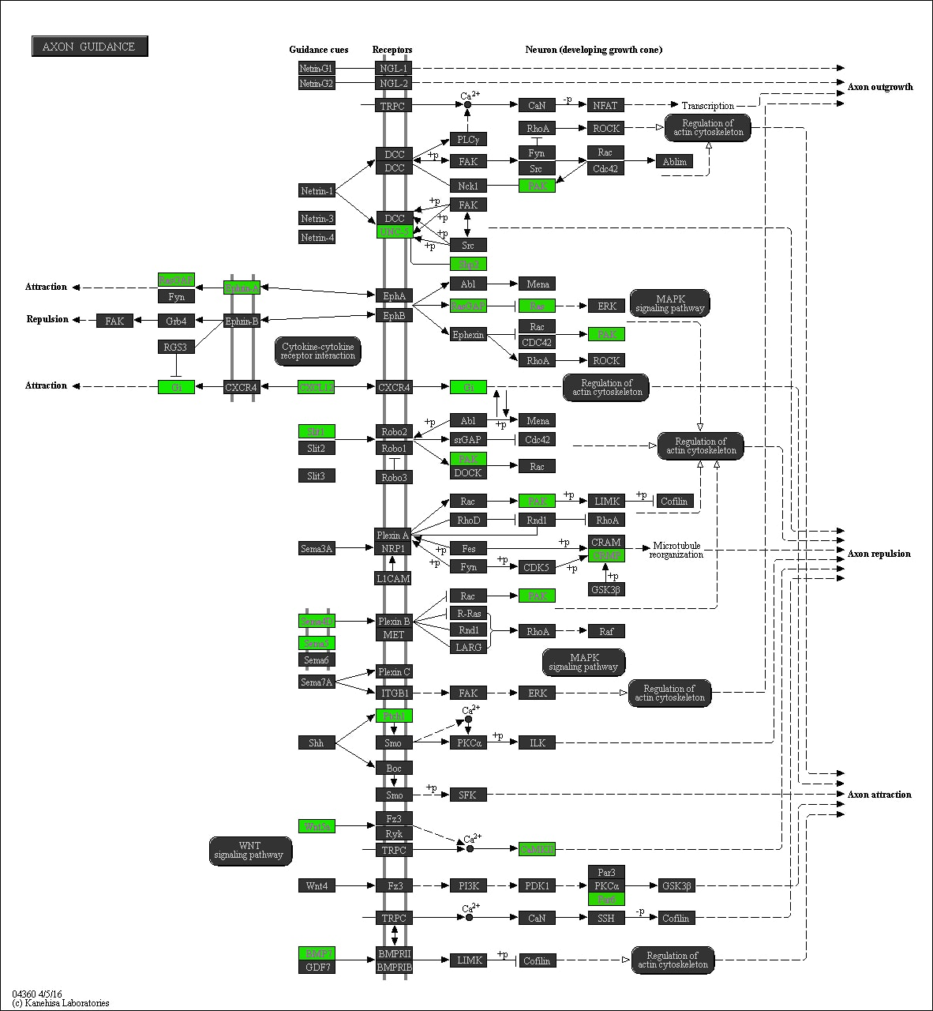

Supplementary Figure S8. The ‘Axon guidance’ pathway in relation to LPA. Promoter methylation of genes in red is positively associated with time spent on LPA, whereas promoter methylation of genes in green is negatively associated with time spent on LPA.

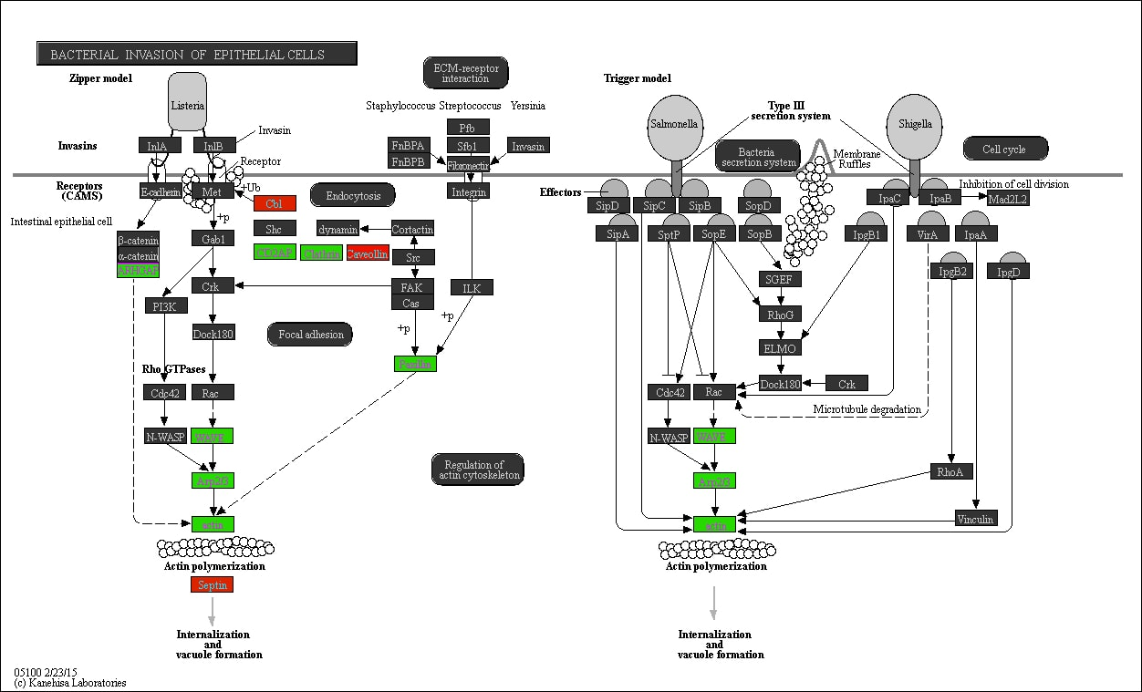

Supplementary Figure S9. The ‘Bacterial invasion of epithelial cells’ pathway in relation to LPA. Promoter methylation of genes in red is positively associated with time spent on LPA, whereas promoter methylation of genes in green is negatively associated with time spent on LPA.

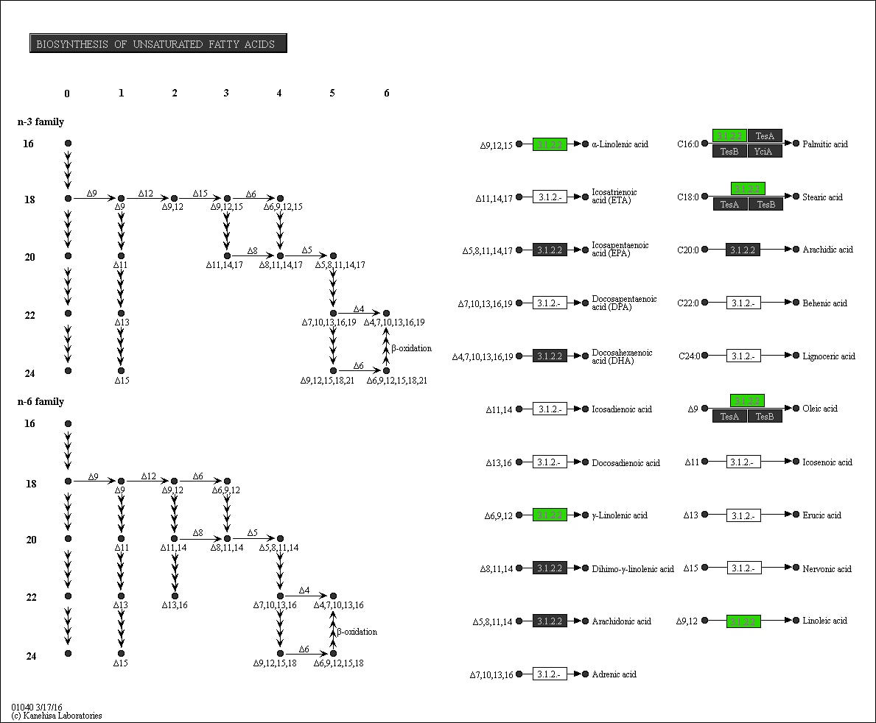

Supplementary Figure S10. The ‘Biosynthesis of unsaturated fatty acids’ pathway in relation to MVPA. Promoter methylation of genes in red is positively associated with time spent on MVPA, whereas promoter methylation of genes in green is negatively associated with time spent on MVPA.
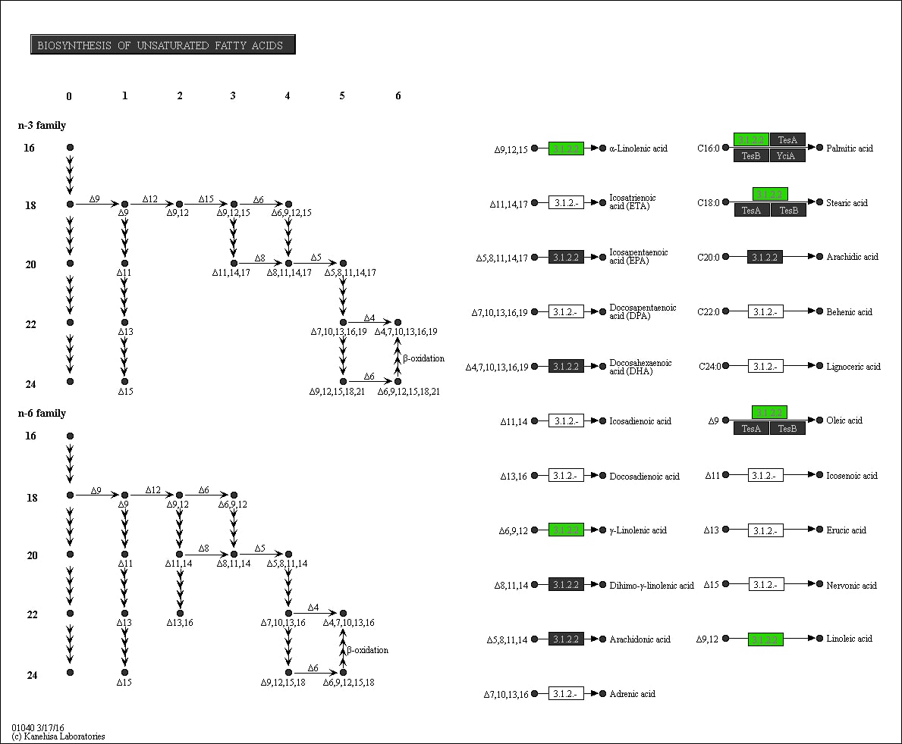

Supplementary Figure S11. The ‘Biosynthesis of unsaturated fatty acids’ pathway in relation to SB. Promoter methylation of genes in red is positively associated with time spent on SB, whereas promoter methylation of genes in green is negatively associated with time spent on SB.
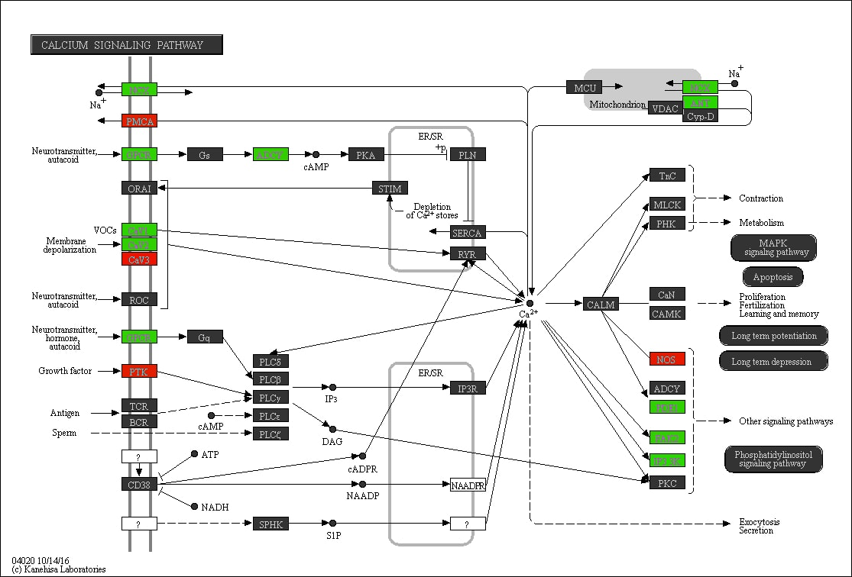

Supplementary Figure S12. The ‘Calcium signaling’ pathway in relation to MVPA. Promoter methylation of genes in red is positively associated with time spent on MVPA, whereas promoter methylation of genes in green is negatively associated with time spent on MVPA.

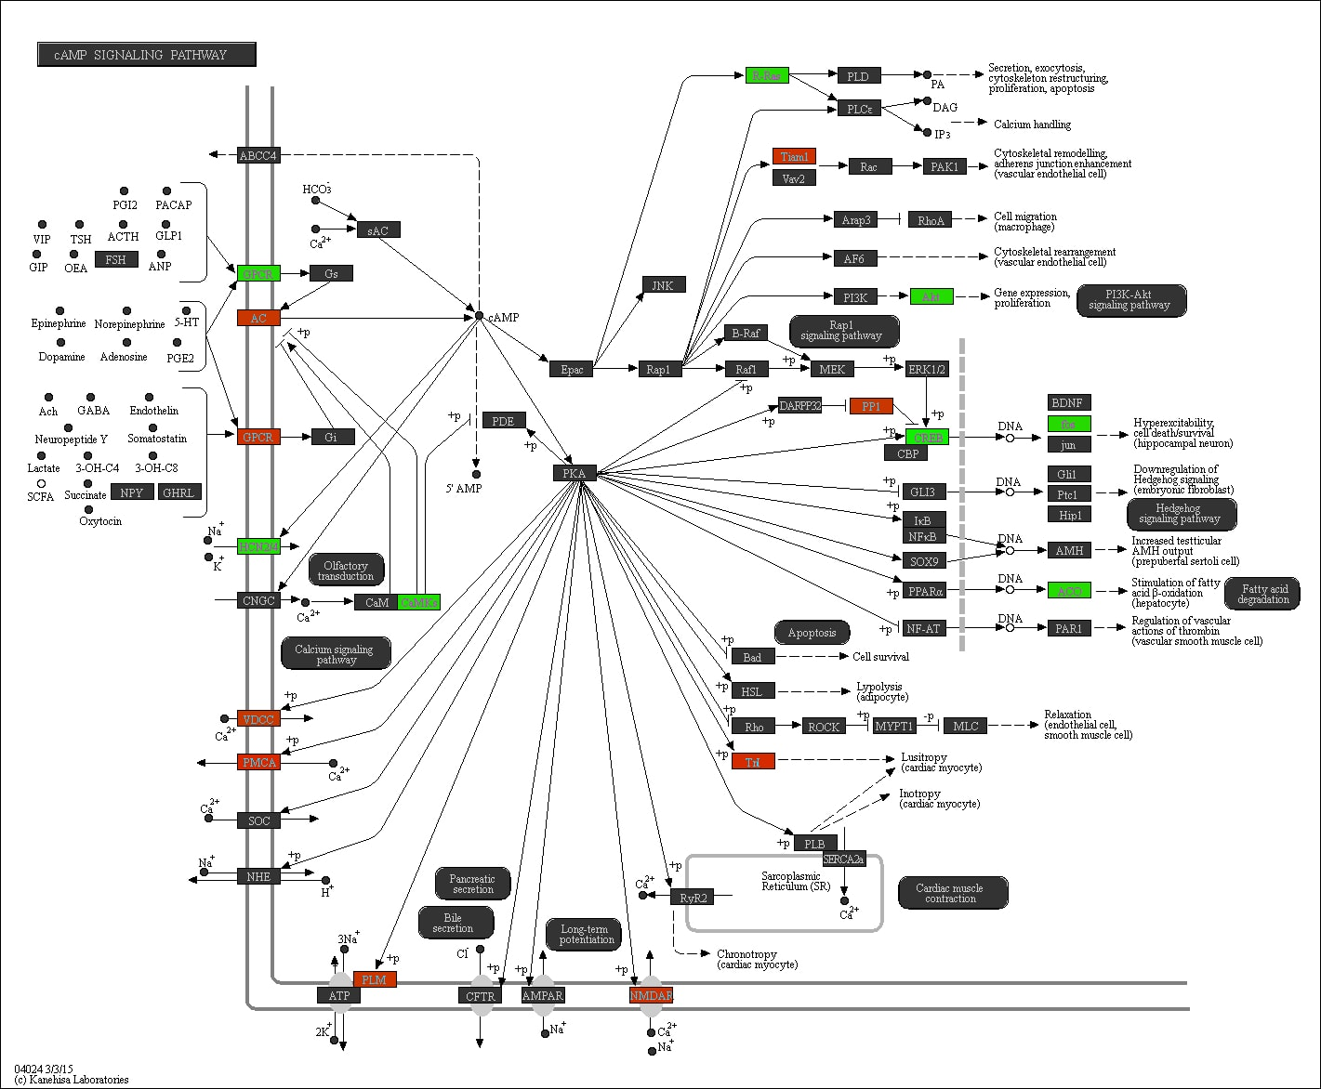

Supplementary Figure S13. The ‘cAMP signaling’ pathway in relation to SB. Promoter methylation of genes in red is positively associated with time spent on SB, whereas promoter methylation of genes in green is negatively associated with time spent on SB.

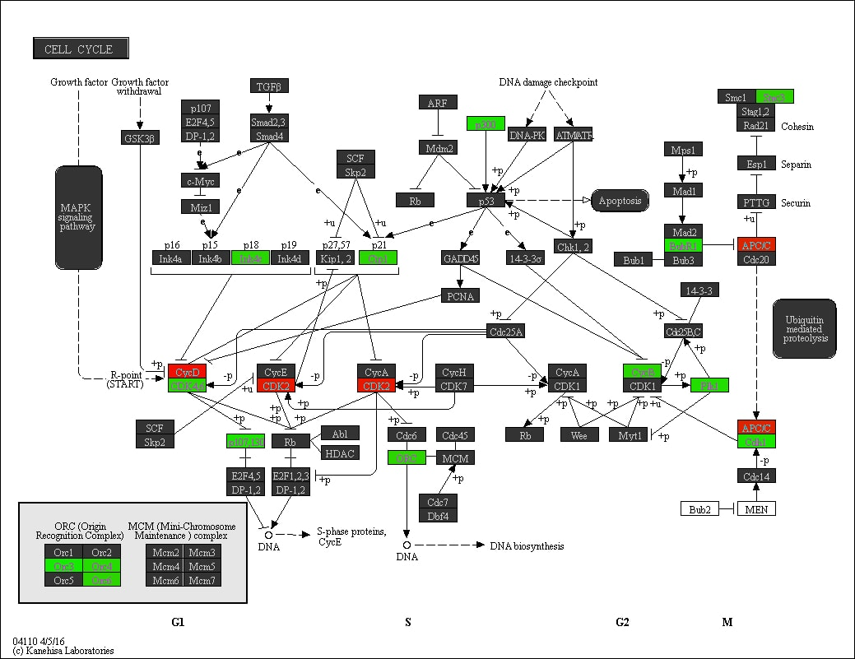

Supplementary Figure S14. The ‘Cell cycle’ pathway in relation to LPA. Promoter methylation of genes in red is positively associated with time spent on LPA, whereas promoter methylation of genes in green is negatively associated with time spent on LPA.

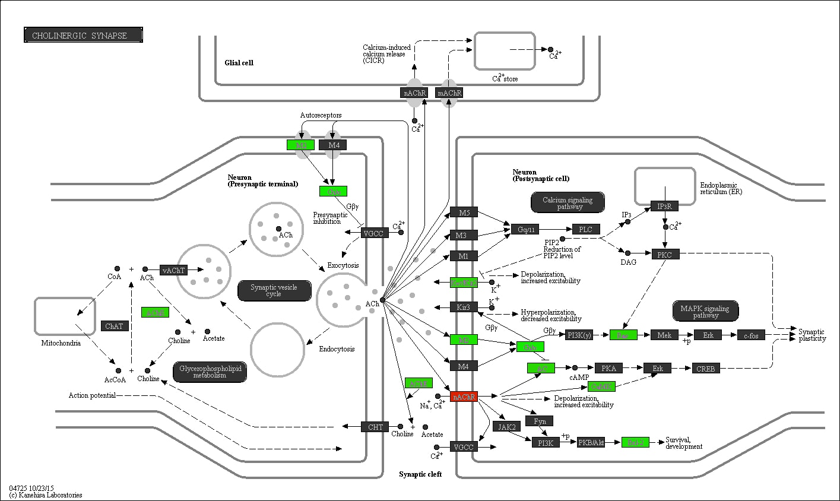

Supplementary Figure S15. The ‘Cholinergic synapse’ pathway in relation to LPA. Promoter methylation of genes in red is positively associated with time spent on LPA, whereas promoter methylation of genes in green is negatively associated with time spent on LPA.
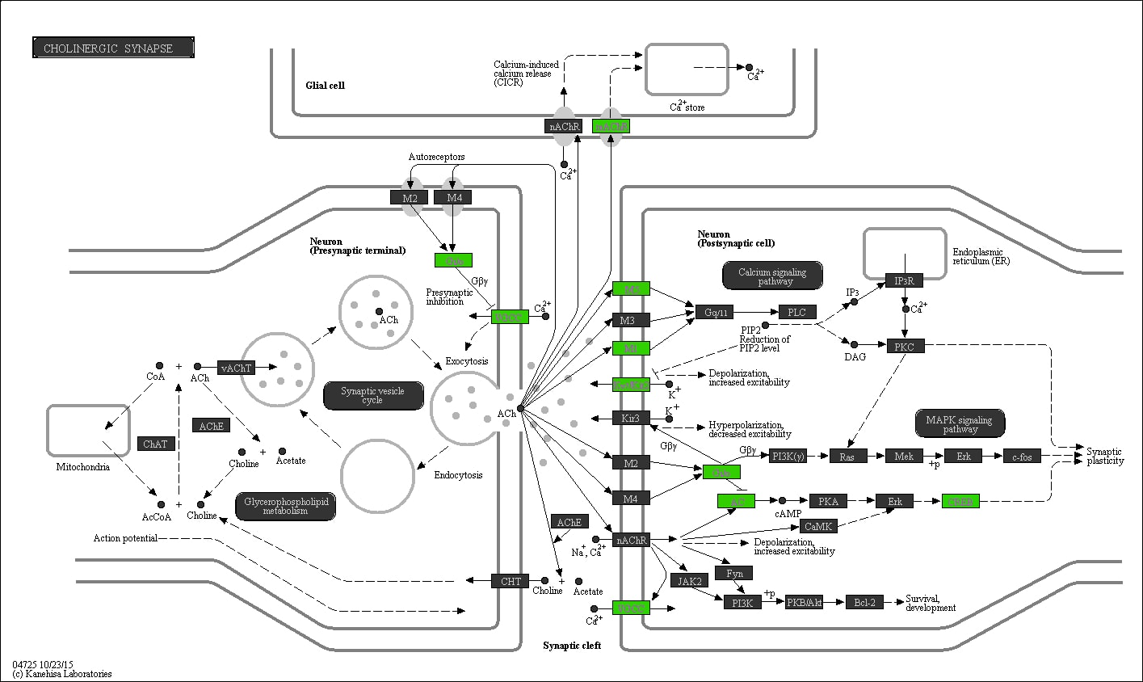

Supplementary Figure S16. The ‘Cholinergic synapse’ pathway in relation to MVPA. Promoter methylation of genes in red is positively associated with time spent on MVPA, whereas promoter methylation of genes in green is negatively associated with time spent on MVPA.
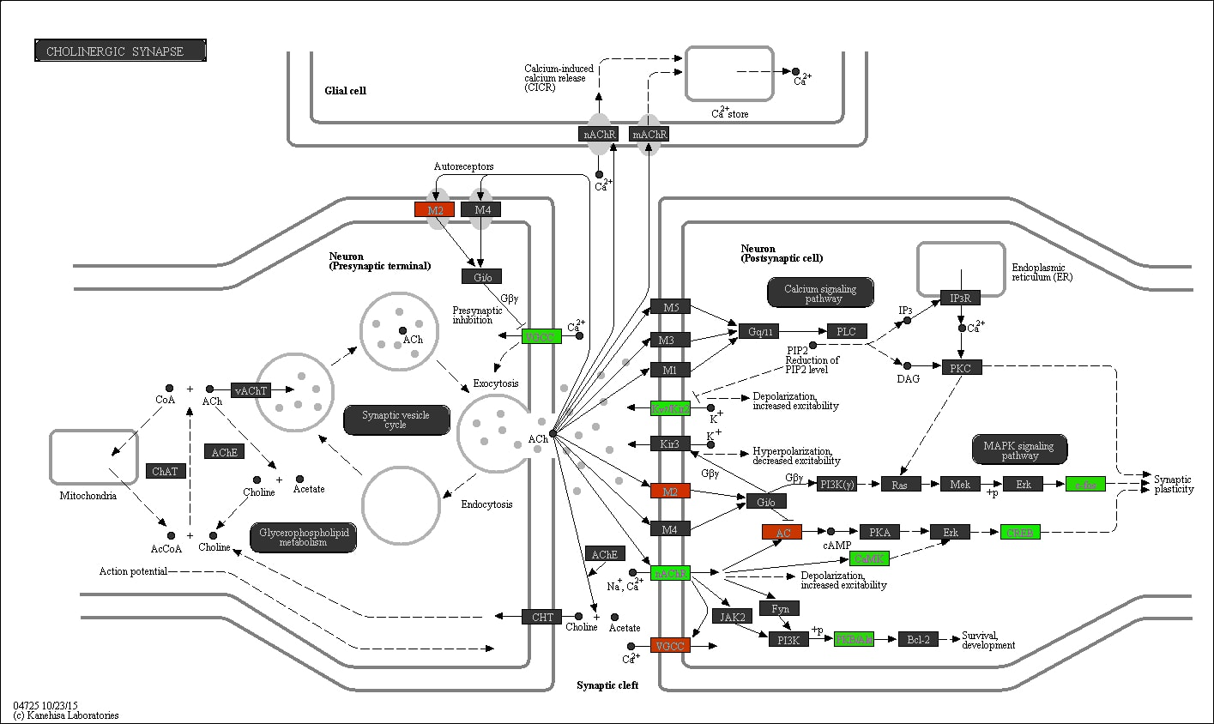

Supplementary Figure S17. The ‘Cholinergic synapse’ pathway in relation to SB. Promoter methylation of genes in red is positively associated with time spent on SB, whereas promoter methylation of genes in green is negatively associated with time spent on SB.
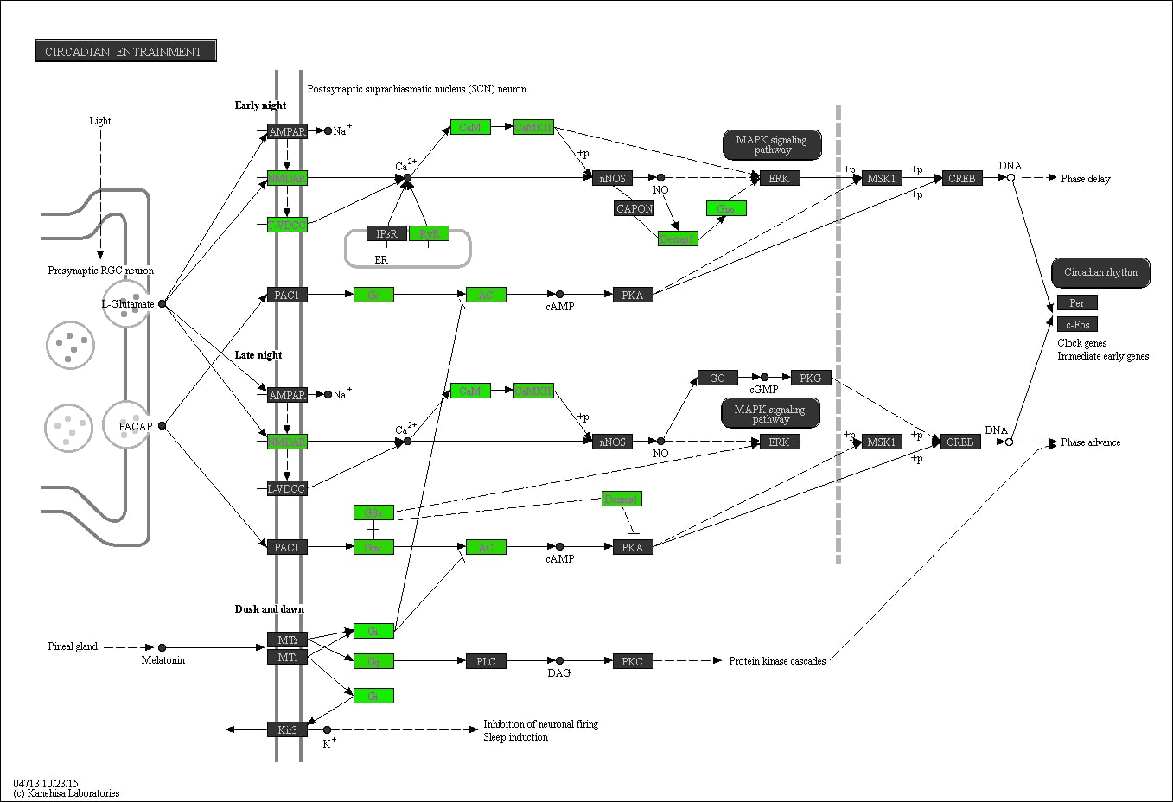

Supplementary Figure S18. The ‘Circadian entrainment’ pathway in relation to LPA. Promoter methylation of genes in red is positively associated with time spent on LPA, whereas promoter methylation of genes in green is negatively associated with time spent on LPA.

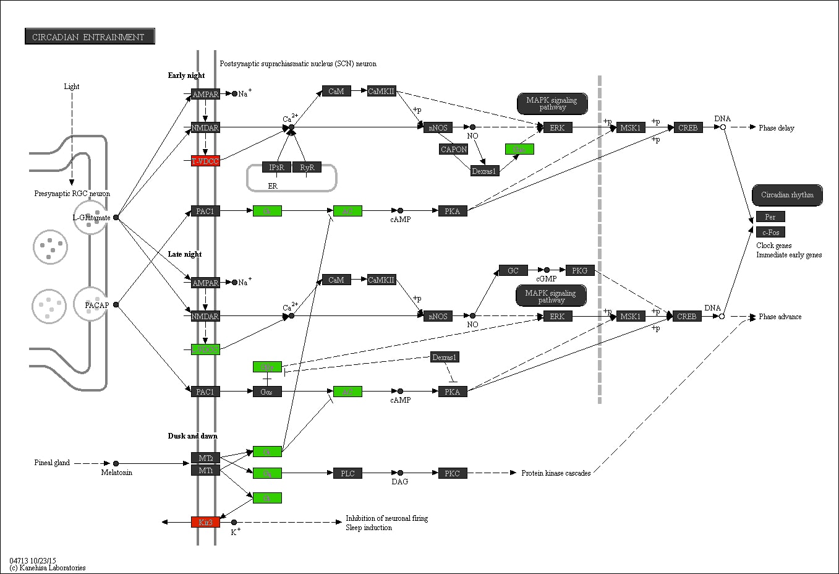

Supplementary Figure S19. The ‘Circadian entrainment’ pathway in relation to MVPA. Promoter methylation of genes in red is positively associated with time spent on MVPA, whereas promoter methylation of genes in green is negatively associated with time spent on MVPA.

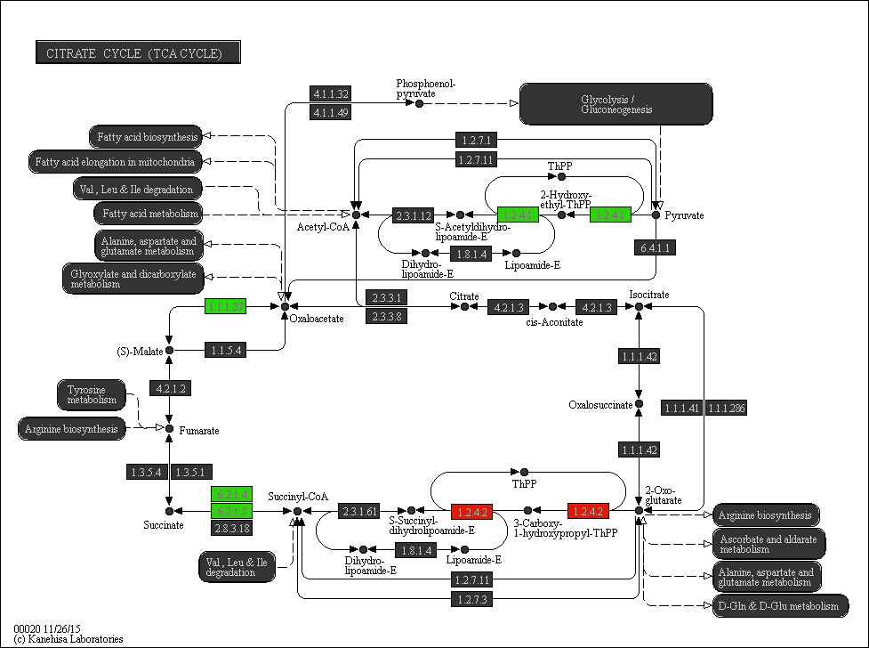

Supplementary Figure S20. The ‘Citrate cycle (TCA cycle)’ pathway in relation to LPA. Promoter methylation of genes in red is positively associated with time spent on LPA, whereas promoter methylation of genes in green is negatively associated with time spent on LPA.
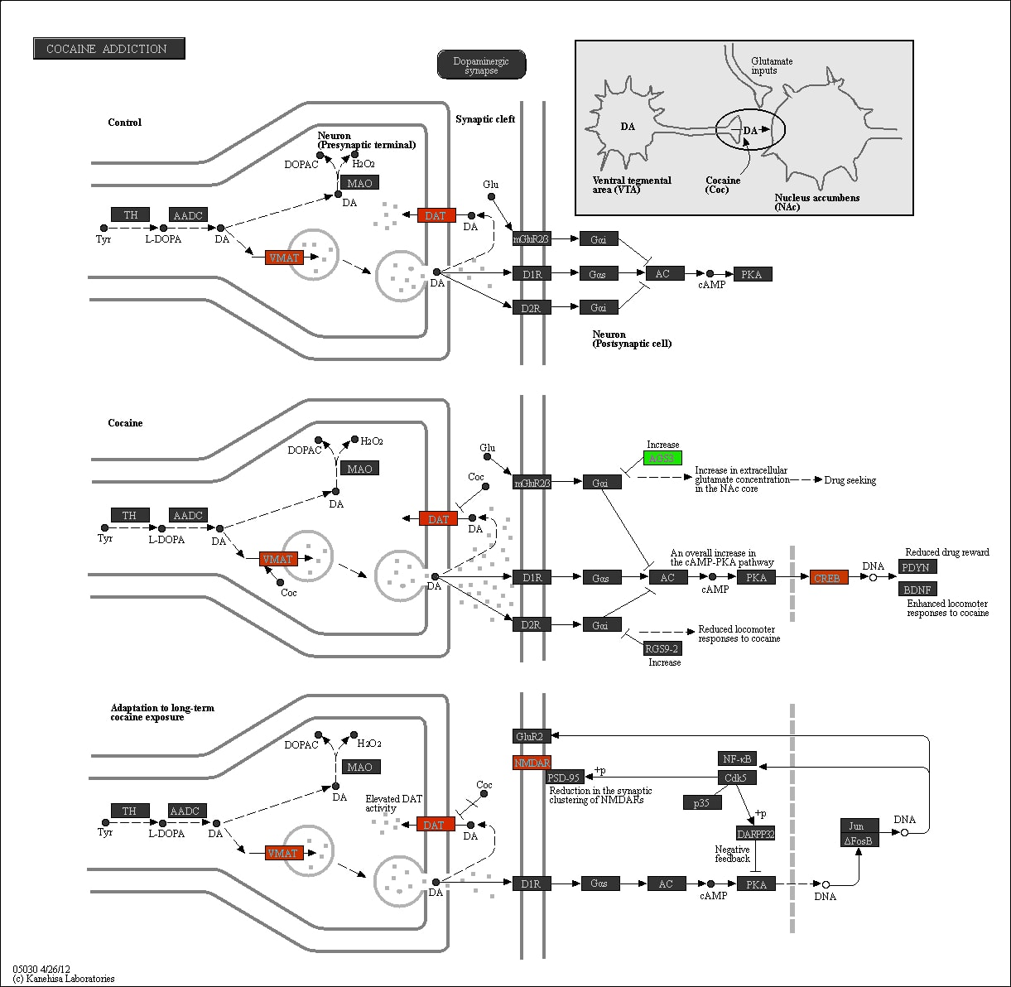

Supplementary Figure S21. The ‘Cocaine addiction’ pathway in relation to SB. Promoter methylation of genes in red is positively associated with time spent on SB, whereas promoter methylation of genes in green is negatively associated with time spent on SB.
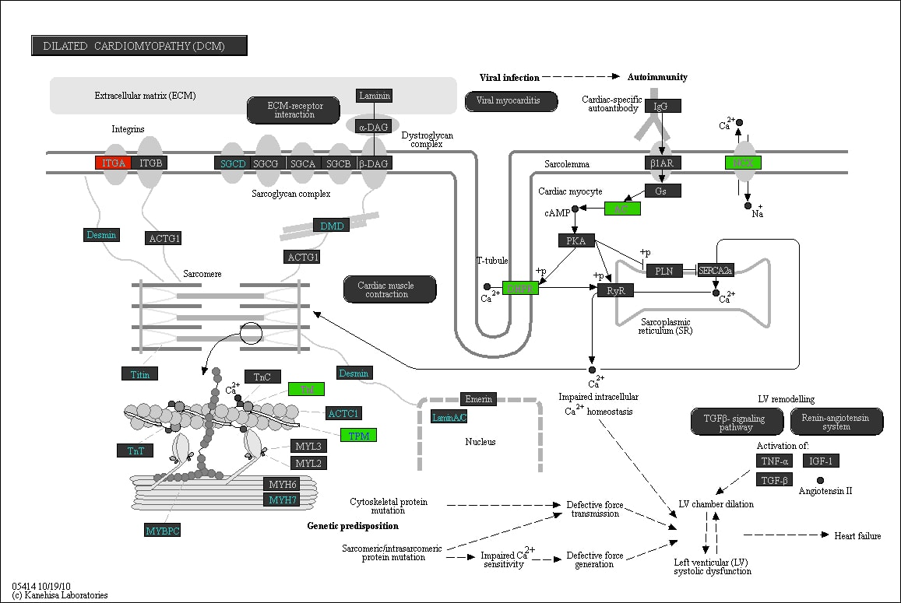

Supplementary Figure S22. The ‘Dilated cardiomyopathy (DCM)’ pathway in relation to MVPA. Promoter methylation of genes in red is positively associated with time spent on MVPA, whereas promoter methylation of genes in green is negatively associated with time spent on MVPA.
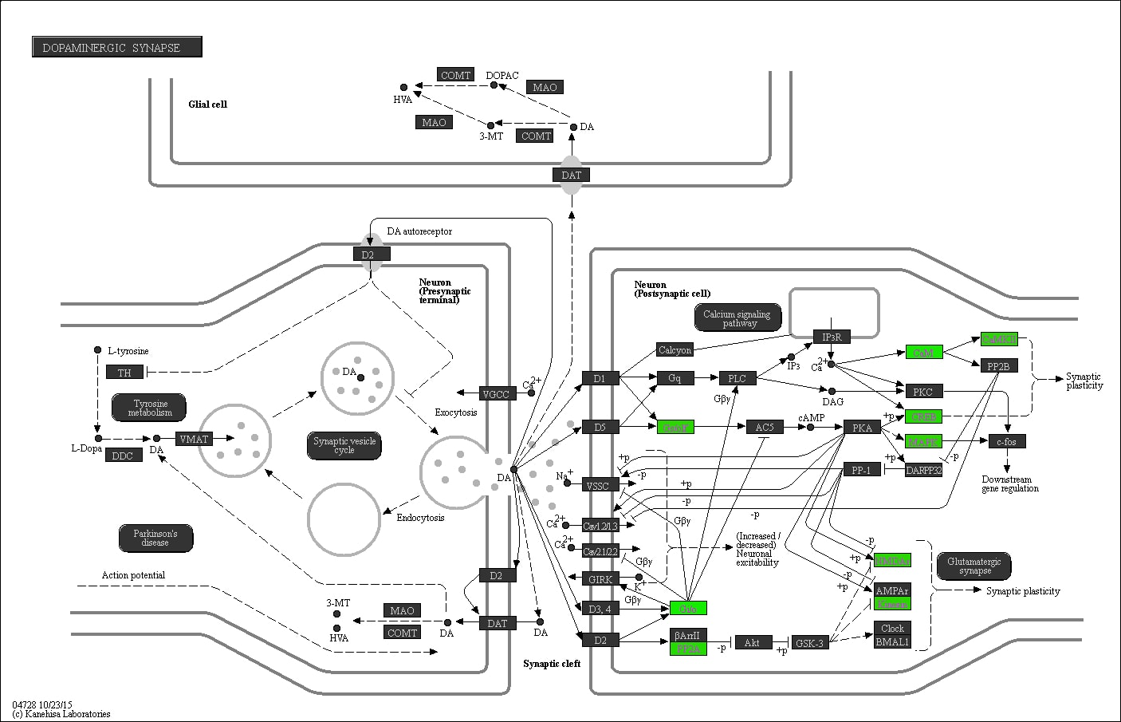

Supplementary Figure S23. The ‘Dopaminergic synapse’ pathway in relation to LPA. Promoter methylation of genes in red is positively associated with time spent on LPA, whereas promoter methylation of genes in green is negatively associated with time spent on LPA.
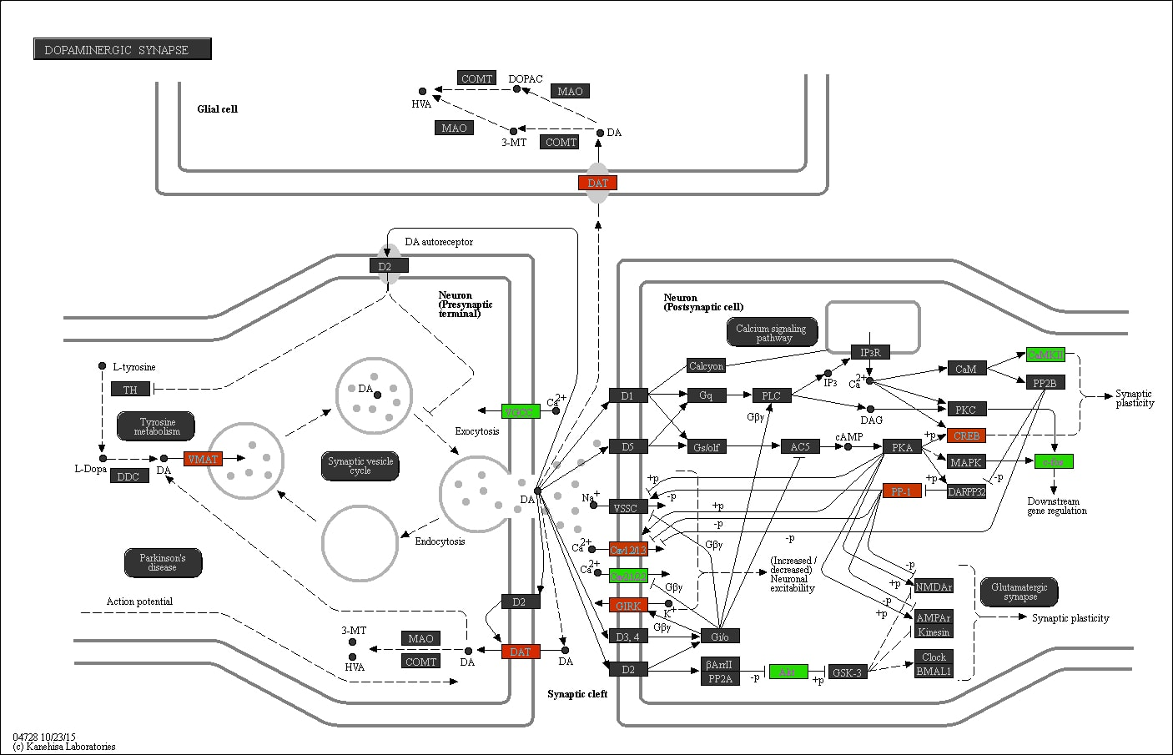

Supplementary Figure S24. The ‘Dopaminergic synapse’ pathway in relation to SB. Promoter methylation of genes in red is positively associated with time spent on SB, whereas promoter methylation of genes in green is negatively associated with time spent on SB.
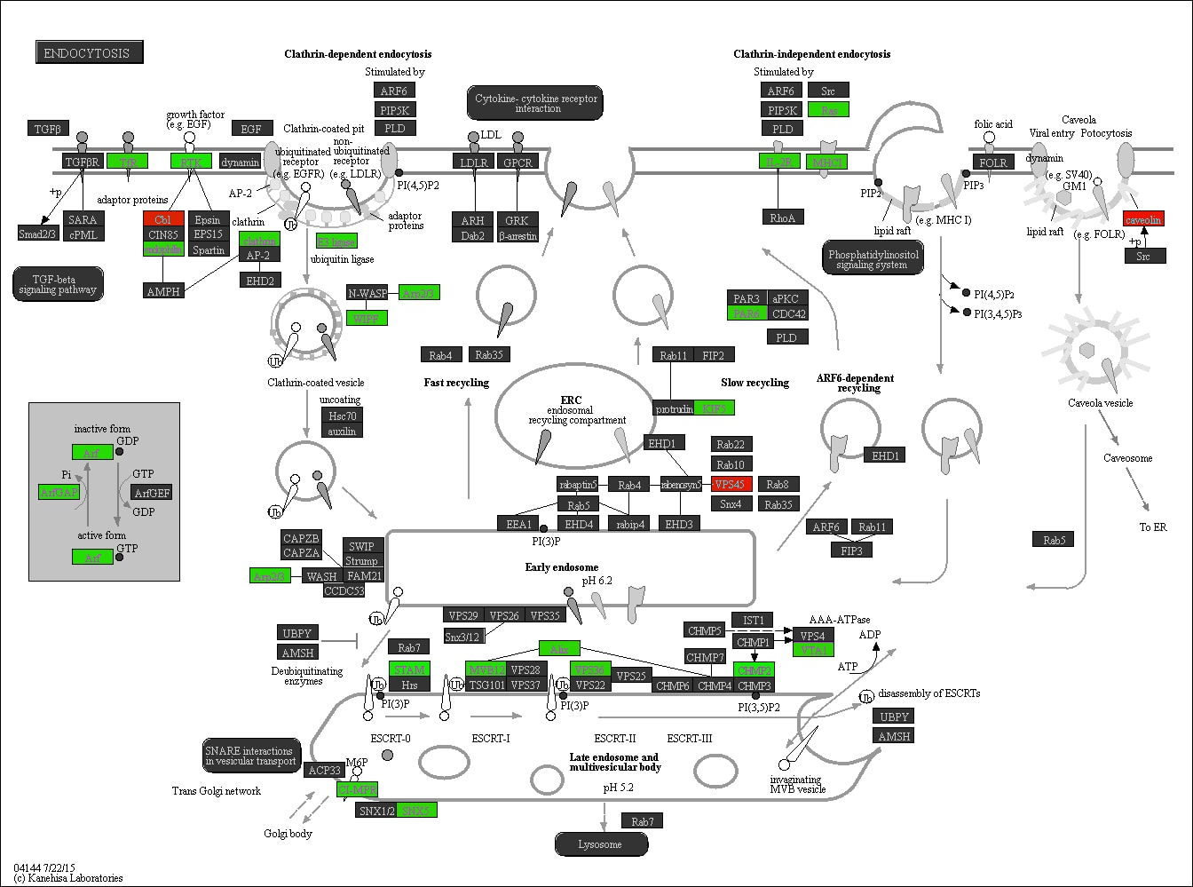

Supplementary Figure S25. The ‘Endocytosis’ pathway in relation to LPA. Promoter methylation of genes in red is positively associated with time spent on LPA, whereas promoter methylation of genes in green is negatively associated with time spent on LPA.

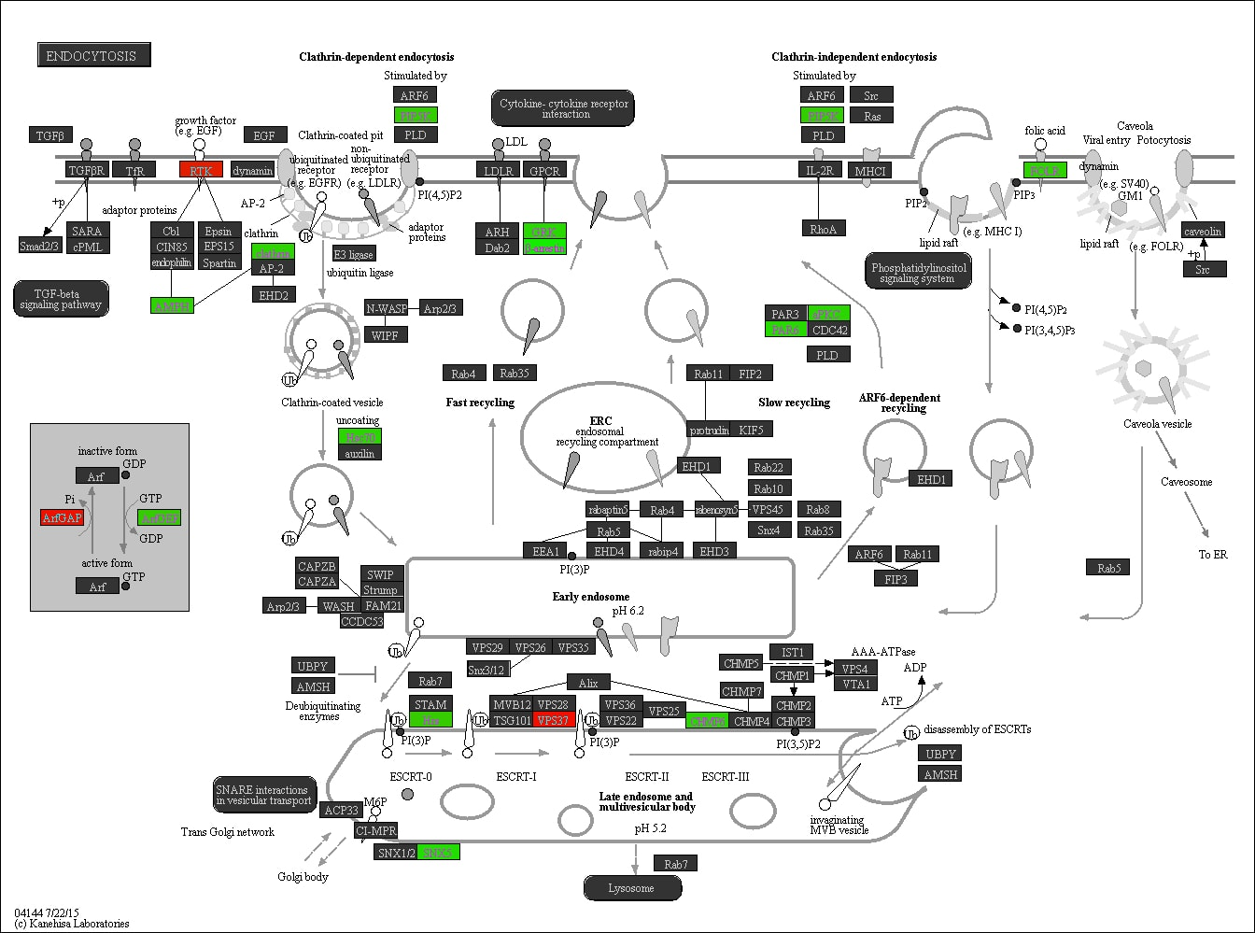

Supplementary Figure S26. The ‘Endocytosis’ pathway in relation to MVPA. Promoter methylation of genes in red is positively associated with time spent on MVPA, whereas promoter methylation of genes in green is negatively associated with time spent on MVPA.

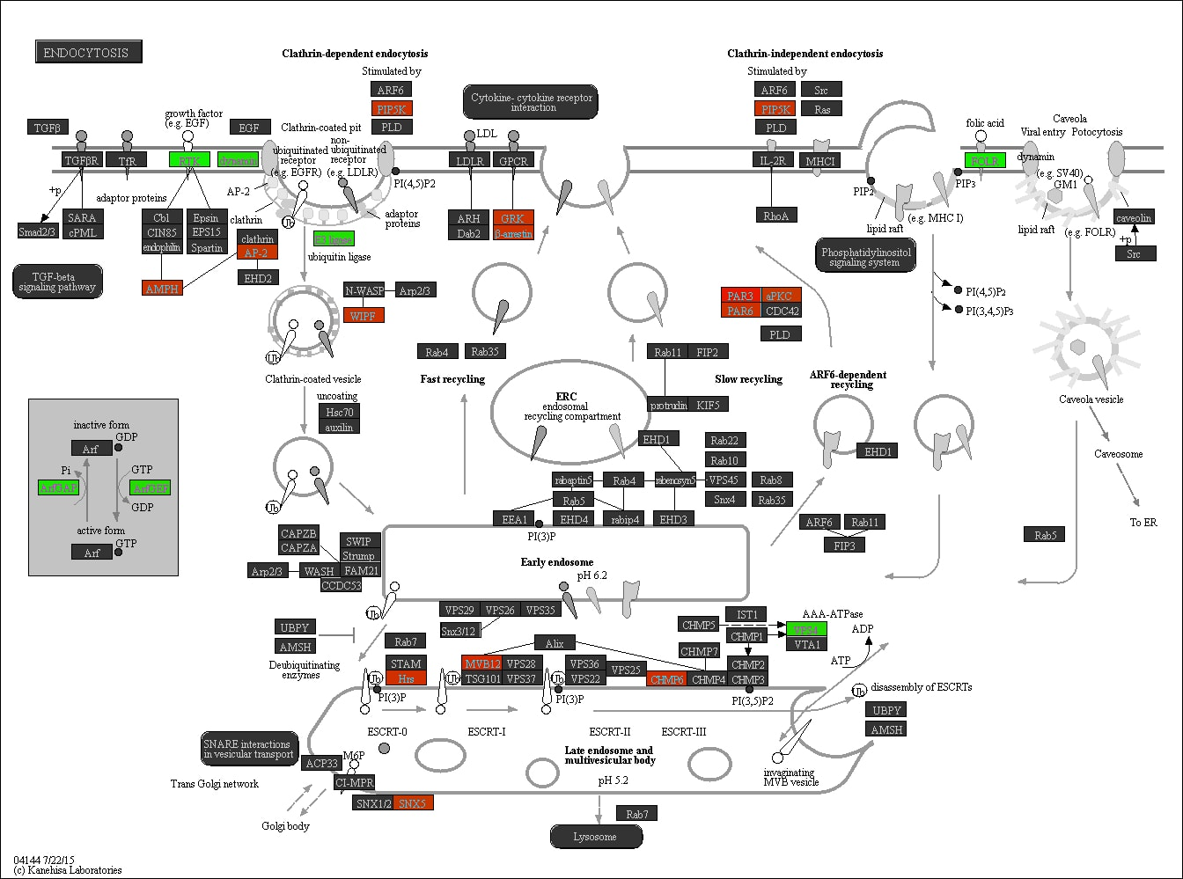

Supplementary Figure S27. The ‘Endocytosis’ pathway in relation to SB. Promoter methylation of genes in red is positively associated with time spent on SB, whereas promoter methylation of genes in green is negatively associated with time spent on SB.

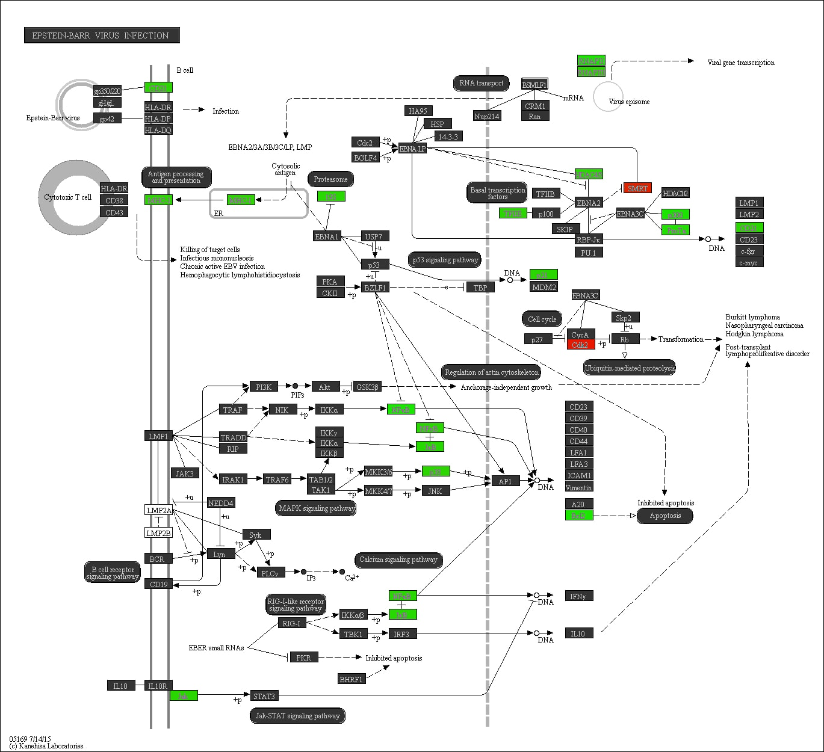

Supplementary Figure S28. The ‘Epstein-Barr virus infection’ pathway in relation to LPA. Promoter methylation of genes in red is positively associated with time spent on LPA, whereas promoter methylation of genes in green is negatively associated with time spent on LPA.

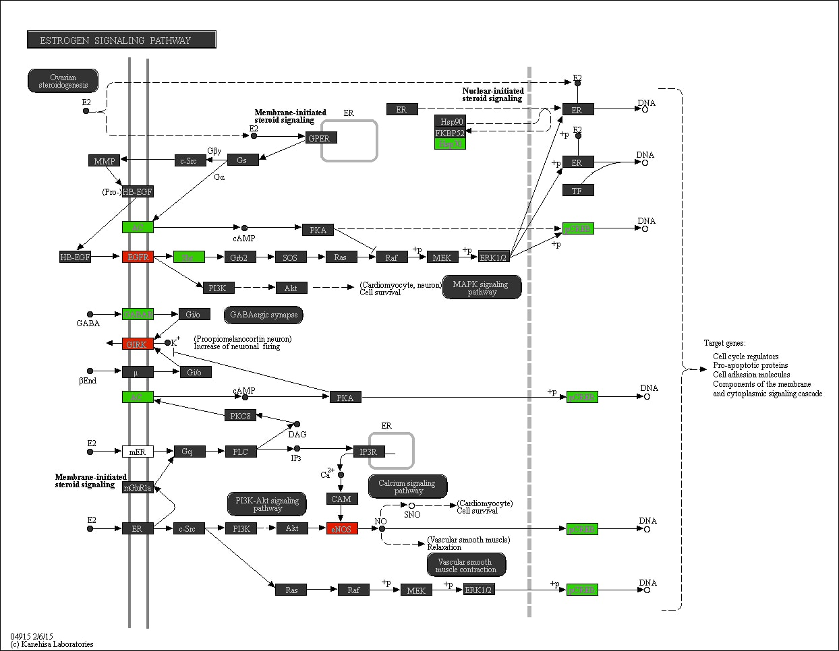

Supplementary Figure S29. The ‘Estrogen signaling’ pathway in relation to MVPA. Promoter methylation of genes in red is positively associated with time spent on MVPA, whereas promoter methylation of genes in green is negatively associated with time spent on MVPA.
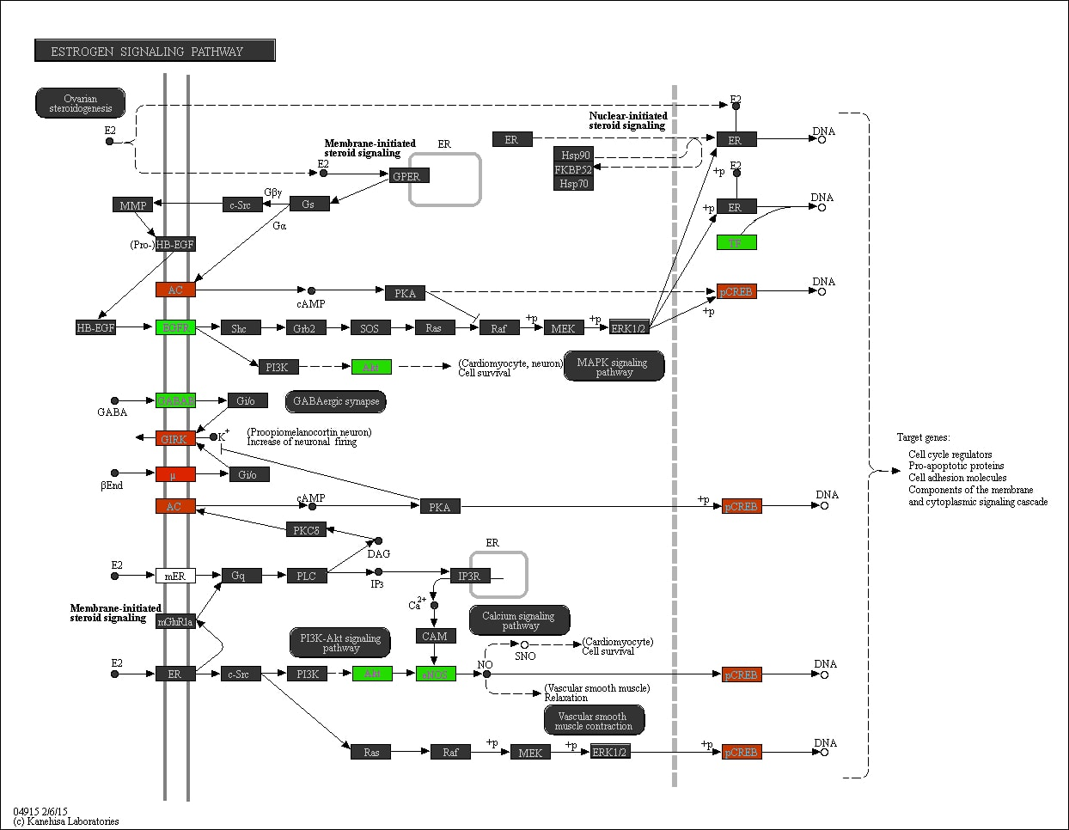

Supplementary Figure S30. The ‘Estrogen signaling’ pathway in relation to SB. Promoter methylation of genes in red is positively associated with time spent on SB, whereas promoter methylation of genes in green is negatively associated with time spent on SB.
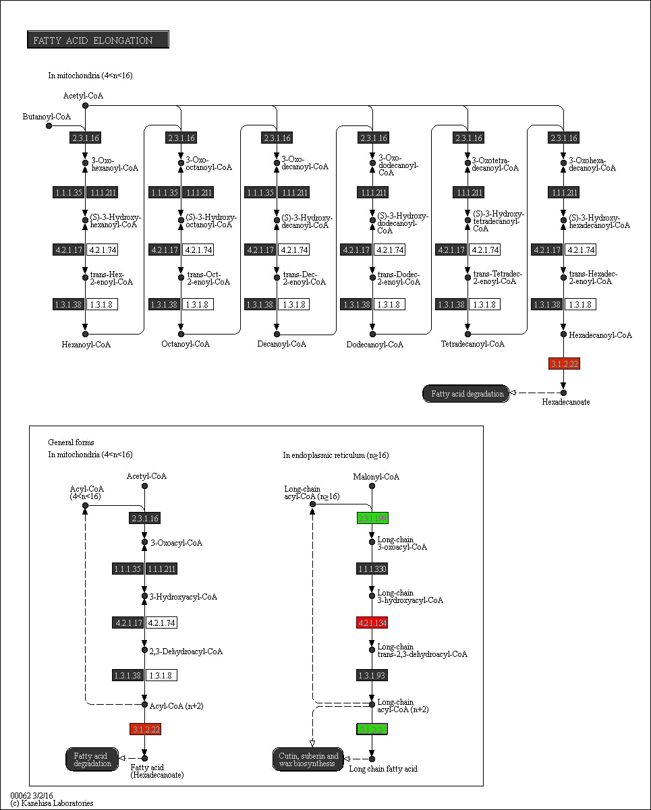

Supplementary Figure S31. The ‘Fatty acid elongation’ pathway in relation to SB. Promoter methylation of genes in red is positively associated with time spent on SB, whereas promoter methylation of genes in green is negatively associated with time spent on SB.
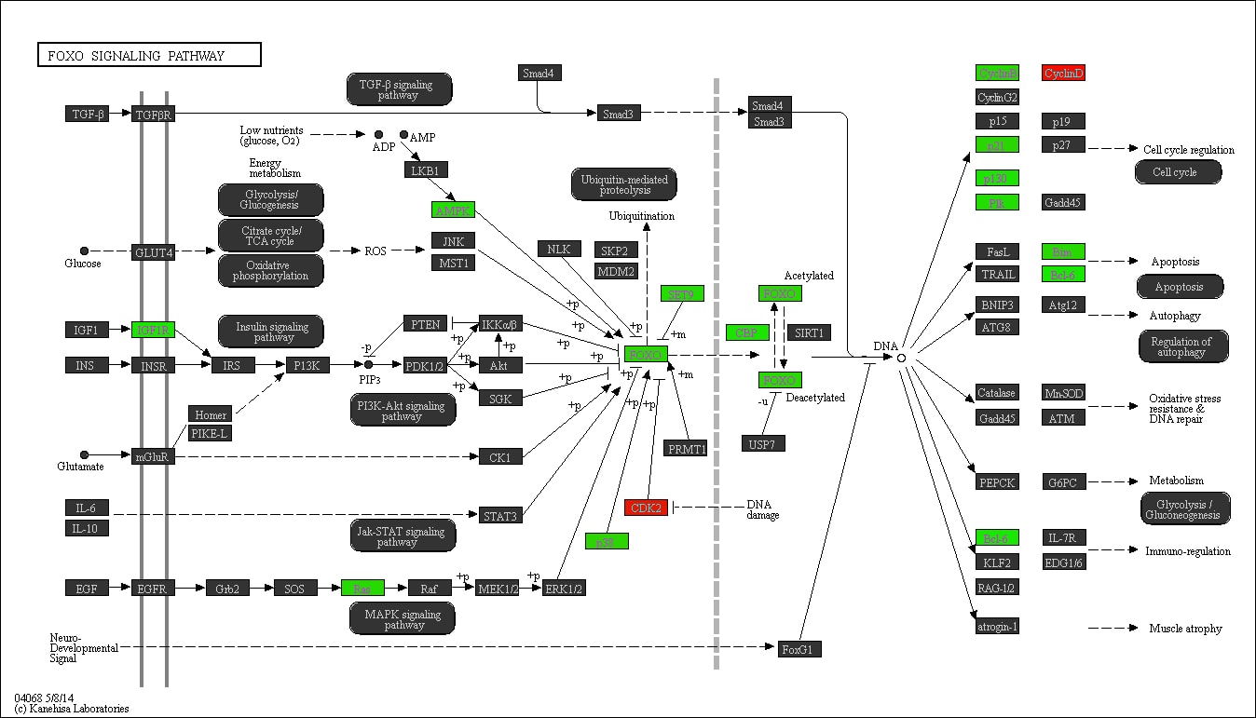

Supplementary Figure S32. The ‘FOXO signaling’ pathway in relation to LPA. Promoter methylation of genes in red is positively associated with time spent on LPA, whereas promoter methylation of genes in green is negatively associated with time spent on LPA.
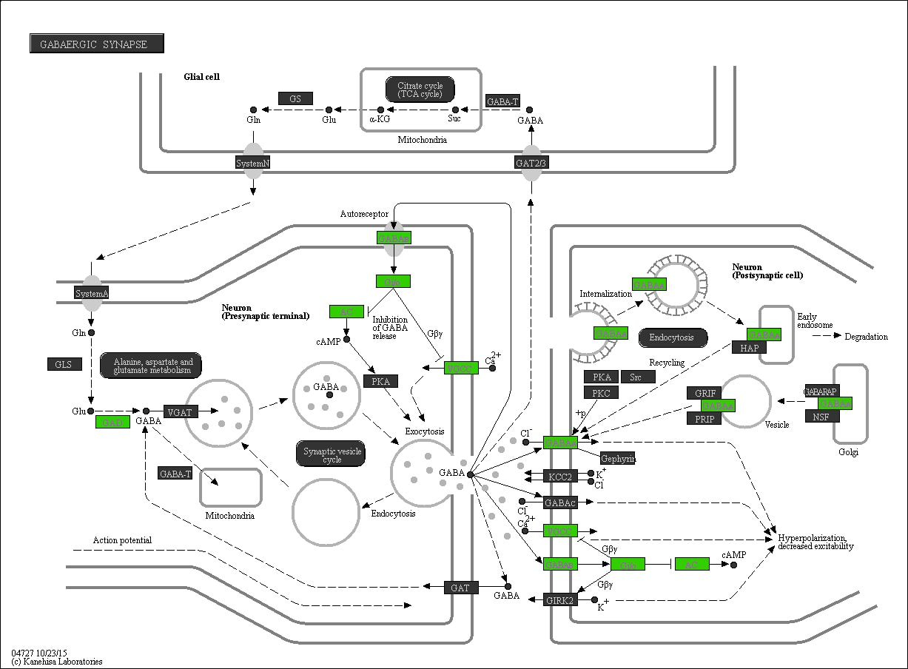

Supplementary Figure S33. The ‘GABAergic synapse’ pathway in relation to MVPA. Promoter methylation of genes in red is positively associated with time spent on MVPA, whereas promoter methylation of genes in green is negatively associated with time spent on MVPA.
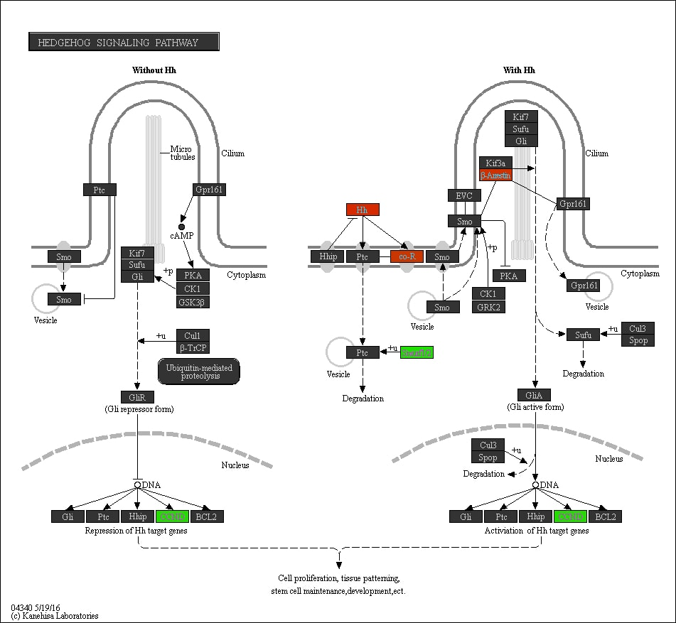

Supplementary Figure S34. The ‘Hedgehog signaling’ pathway in relation to SB. Promoter methylation of genes in red is positively associated with time spent on SB, whereas promoter methylation of genes in green is negatively associated with time spent on SB.

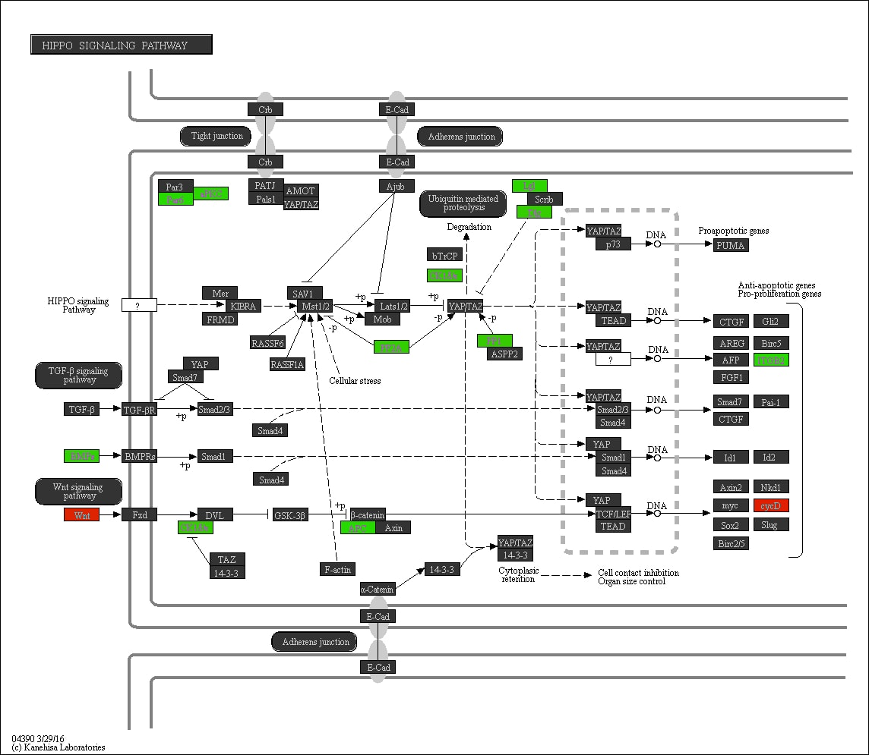

Supplementary Figure S35. The ‘Hippo signaling’ pathway in relation to MVPA. Promoter methylation of genes in red is positively associated with time spent on MVPA, whereas promoter methylation of genes in green is negatively associated with time spent on MVPA.
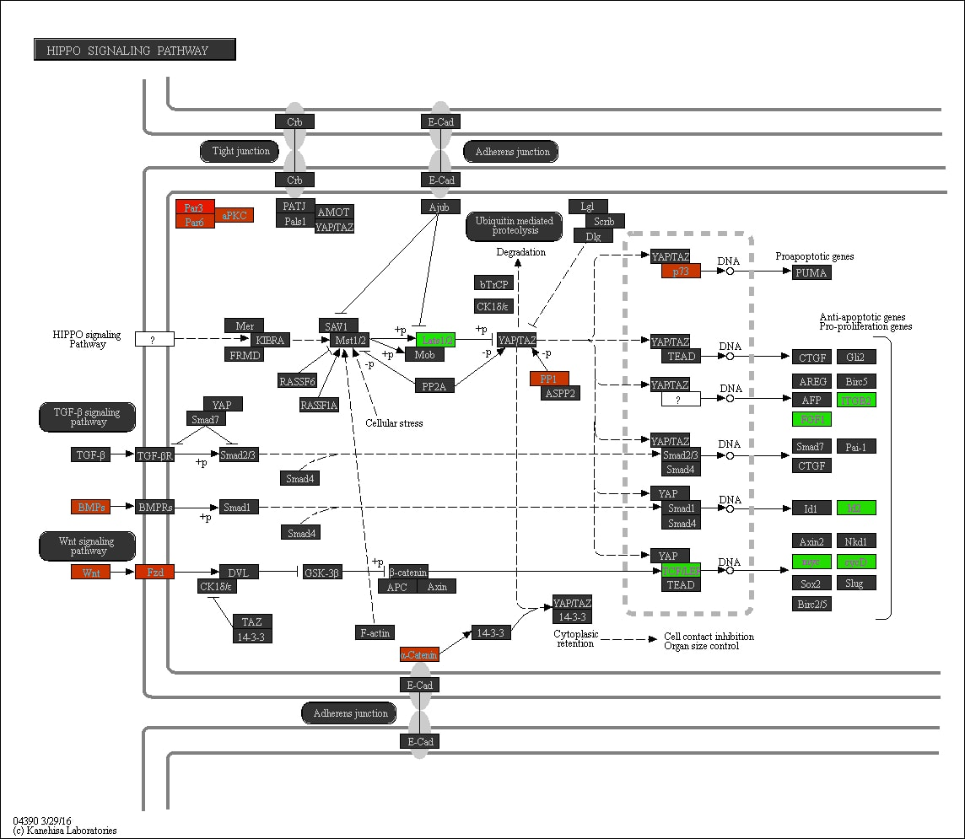

Supplementary Figure S36. The ‘Hippo signaling’ pathway in relation to SB. Promoter methylation of genes in red is positively associated with time spent on SB, whereas promoter methylation of genes in green is negatively associated with time spent on SB.
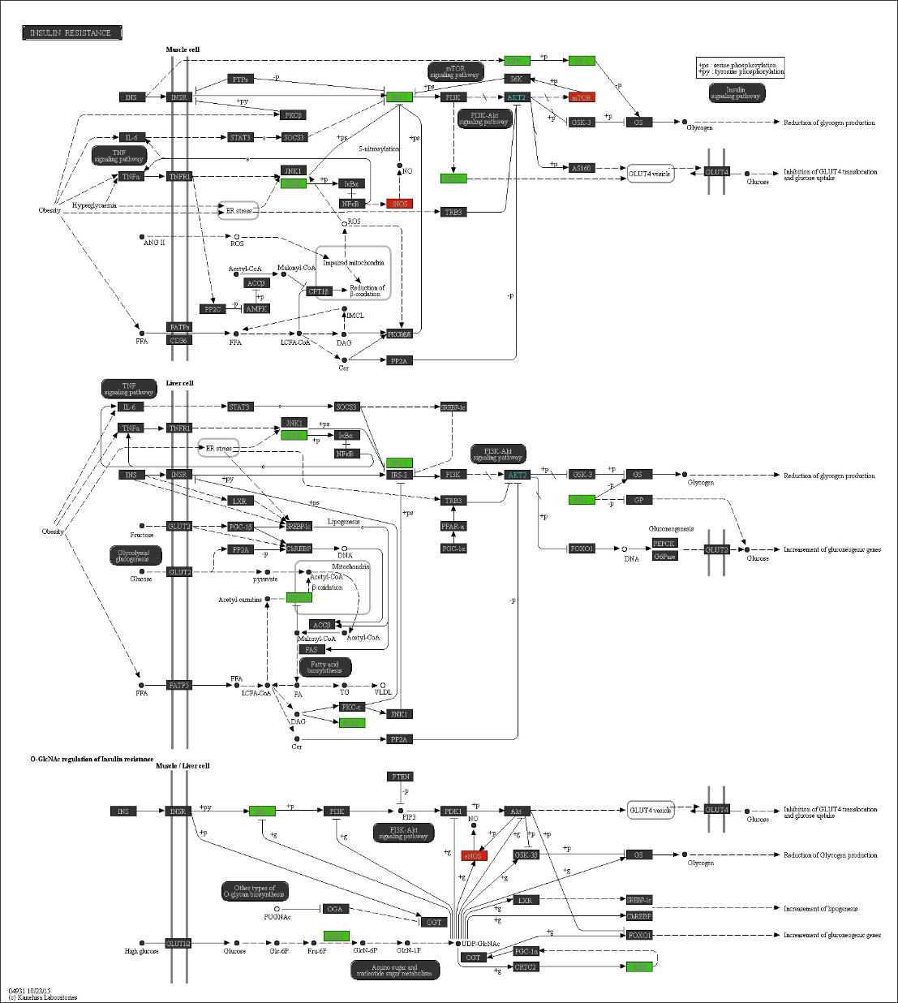

Supplementary Figure S37. The ‘Insuline resistance’ pathway in relation to MVPA. Promoter methylation of genes in red is positively associated with time spent on MVPA, whereas promoter methylation of genes in green is negatively associated with time spent on MVPA.
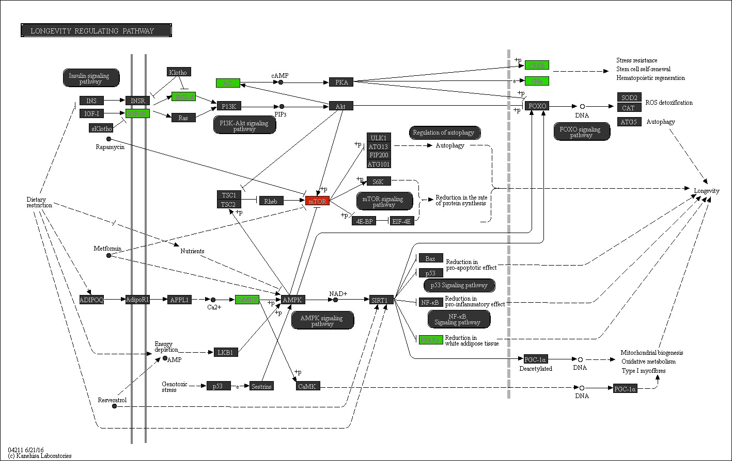

Supplementary Figure S38. The ‘Longevity regulating’ pathway in relation to MVPA. Promoter methylation of genes in red is positively associated with time spent on MVPA, whereas promoter methylation of genes in green is negatively associated with time spent on MVPA.
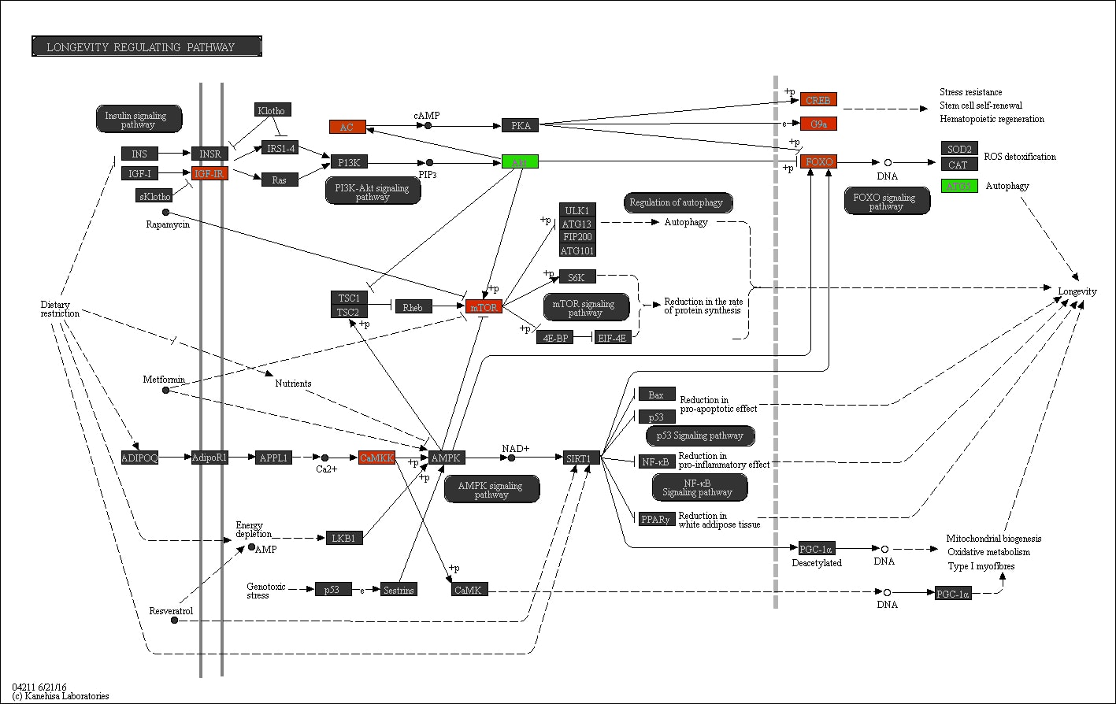

Supplementary Figure S39. The ‘Longevity regulating’ pathway in relation to SB. Promoter methylation of genes in red is positively associated with time spent on SB, whereas promoter methylation of genes in green is negatively associated with time spent on SB.
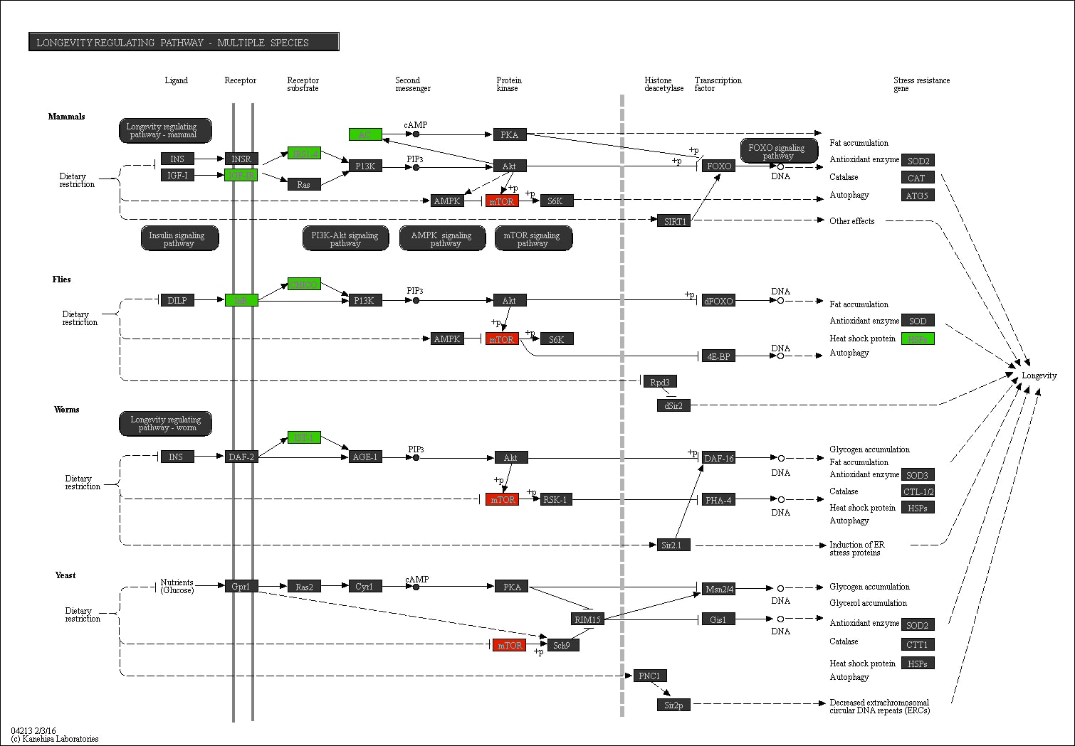

Supplementary Figure S40. The ‘Longevity regulating - multiple species’ pathway in relation to MVPA. Promoter methylation of genes in red is positively associated with time spent on MVPA, whereas promoter methylation of genes in green is negatively associated with time spent on MVPA.

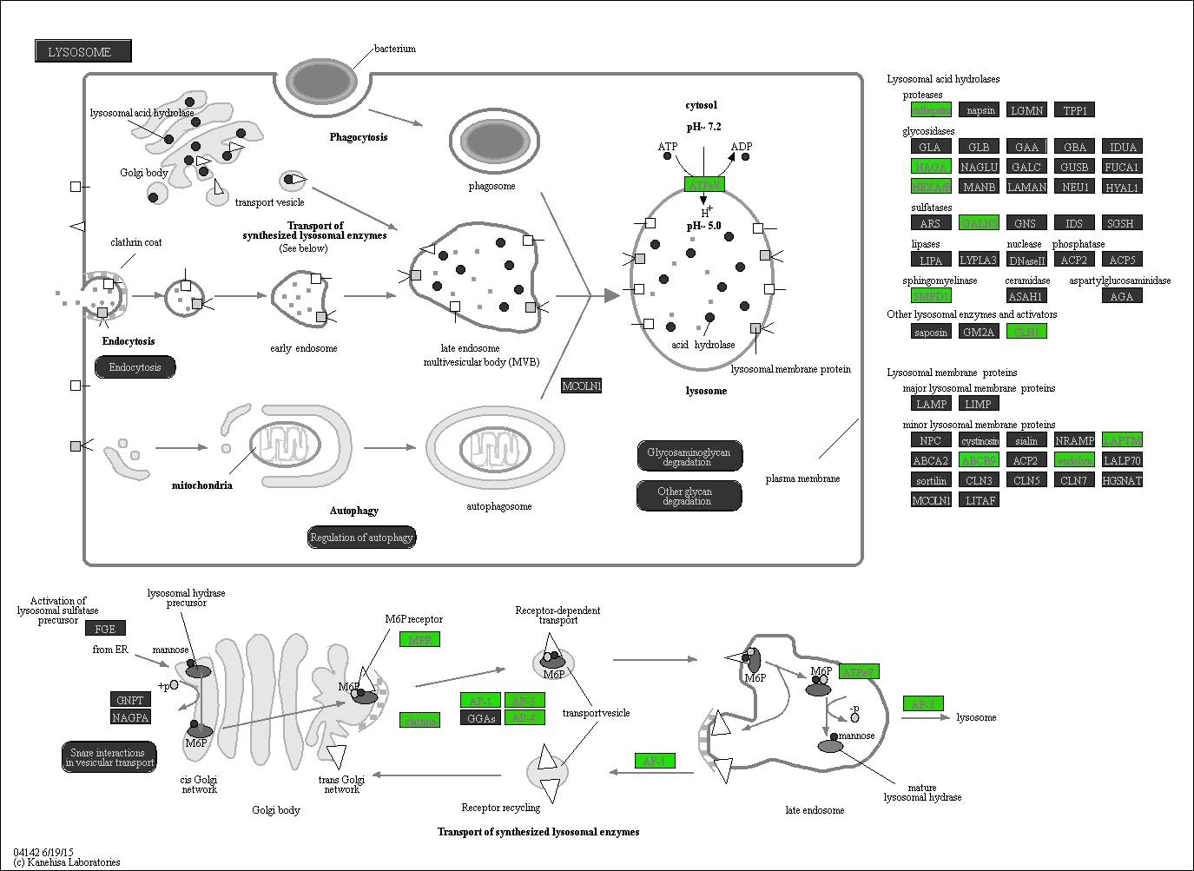

Supplementary Figure S41. The ‘Lysosome’ pathway in relation to LPA. Promoter methylation of genes in red is positively associated with time spent on LPA, whereas promoter methylation of genes in green is negatively associated with time spent on LPA.

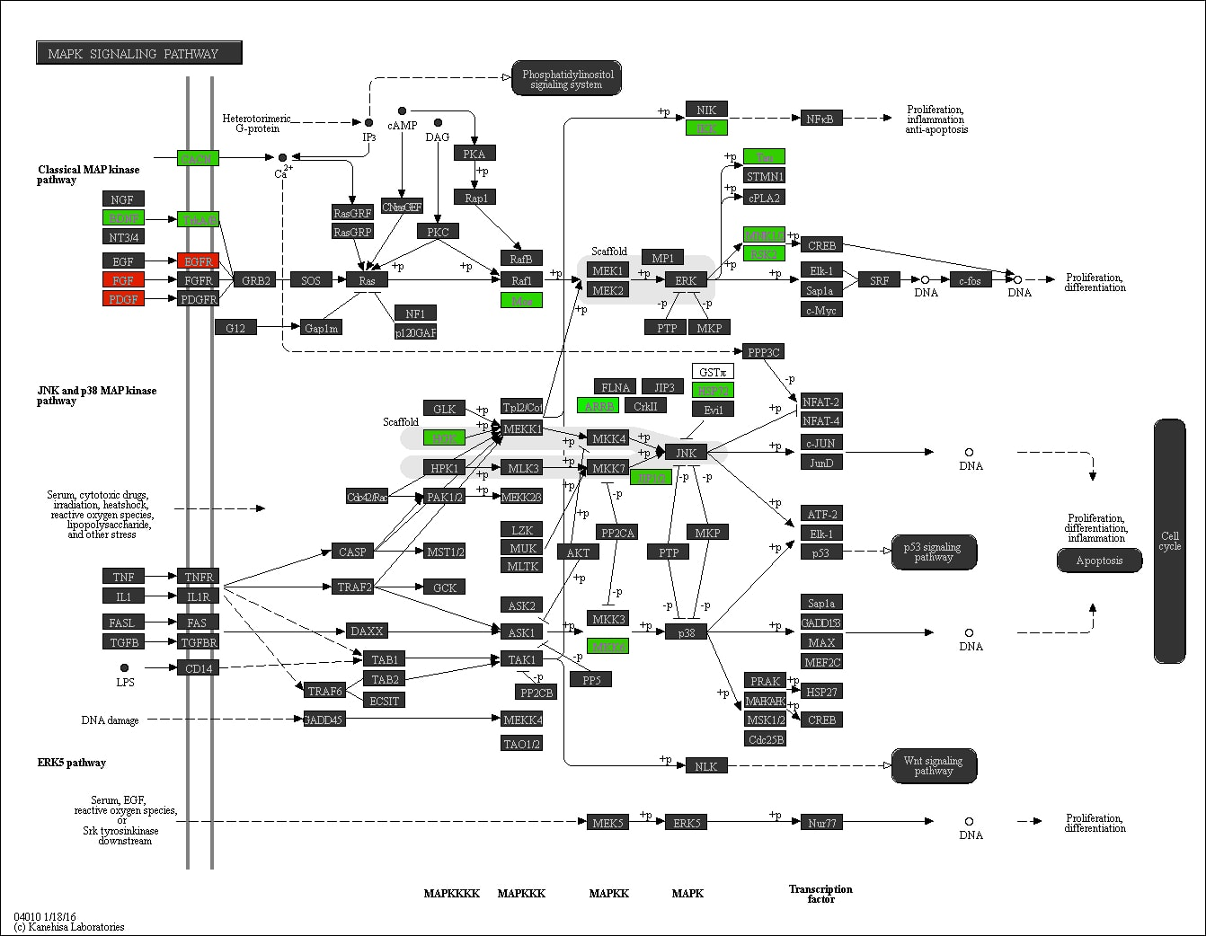

Supplementary Figure S42. The ‘MAPK signaling’ pathway in relation to MVPA. Promoter methylation of genes in red is positively associated with time spent on MVPA, whereas promoter methylation of genes in green is negatively associated with time spent on MVPA.

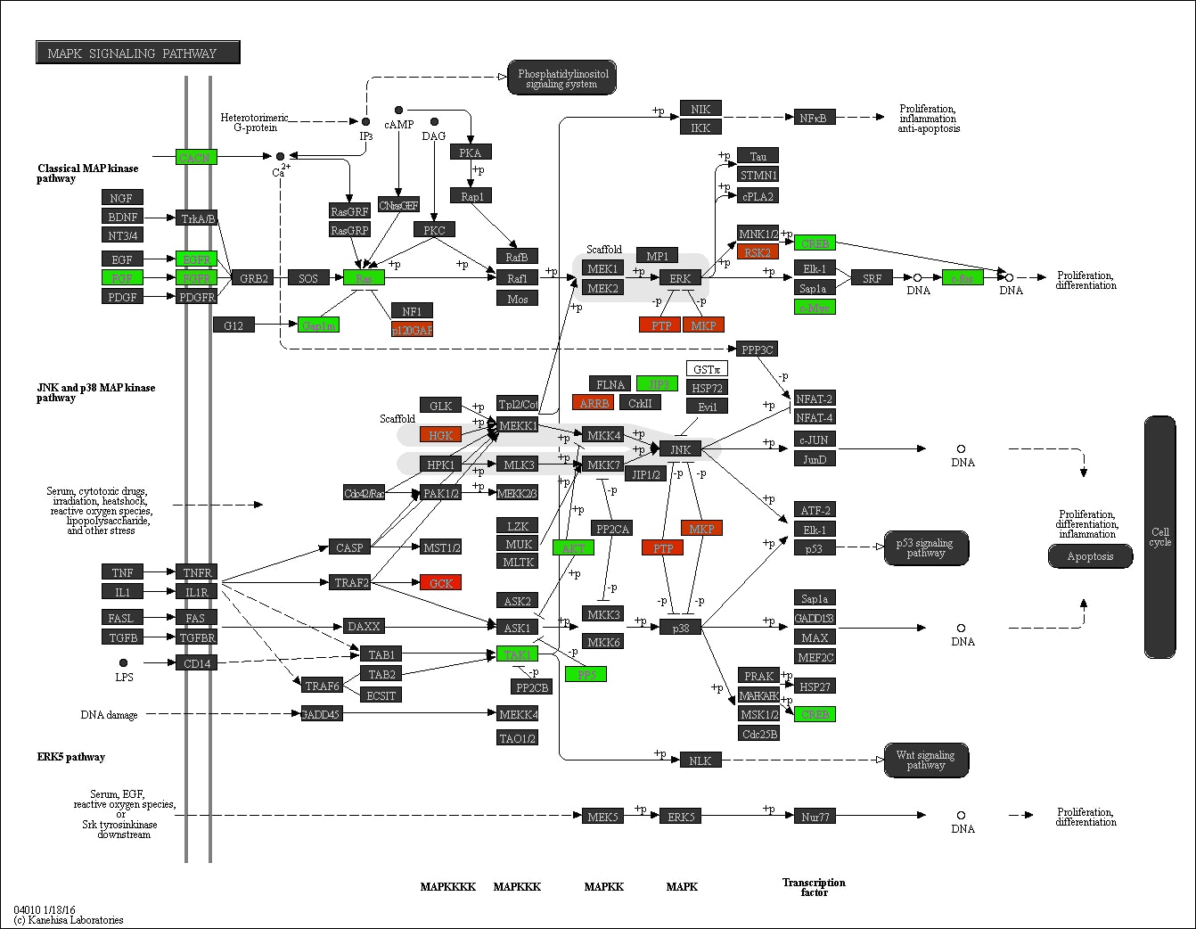

Supplementary Figure S43. The ‘MAPK signaling’ pathway in relation to SB. Promoter methylation of genes in red is positively associated with time spent on SB, whereas promoter methylation of genes in green is negatively associated with time spent on SB.

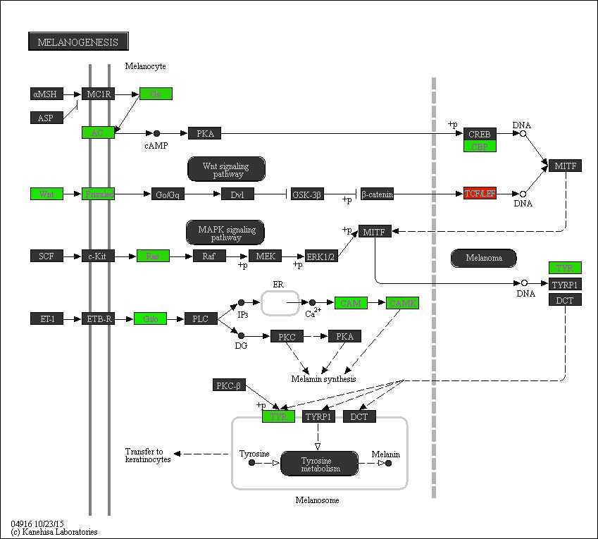

Supplementary Figure S44. The ‘Melanogenesis’ pathway in relation to LPA. Promoter methylation of genes in red is positively associated with time spent on LPA, whereas promoter methylation of genes in green is negatively associated with time spent on LPA.
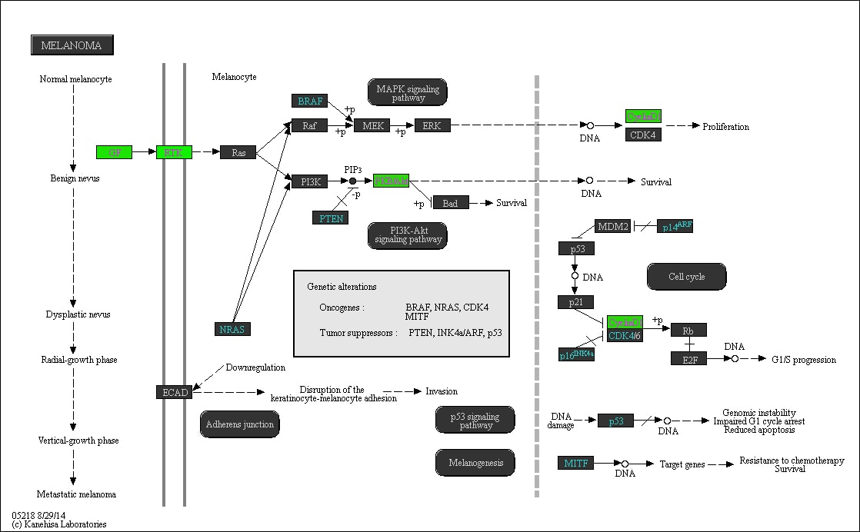

Supplementary Figure S45. The ‘Melanoma’ pathway in relation to SB. Promoter methylation of genes in red is positively associated with time spent on SB, whereas promoter methylation of genes in green is negatively associated with time spent on SB.

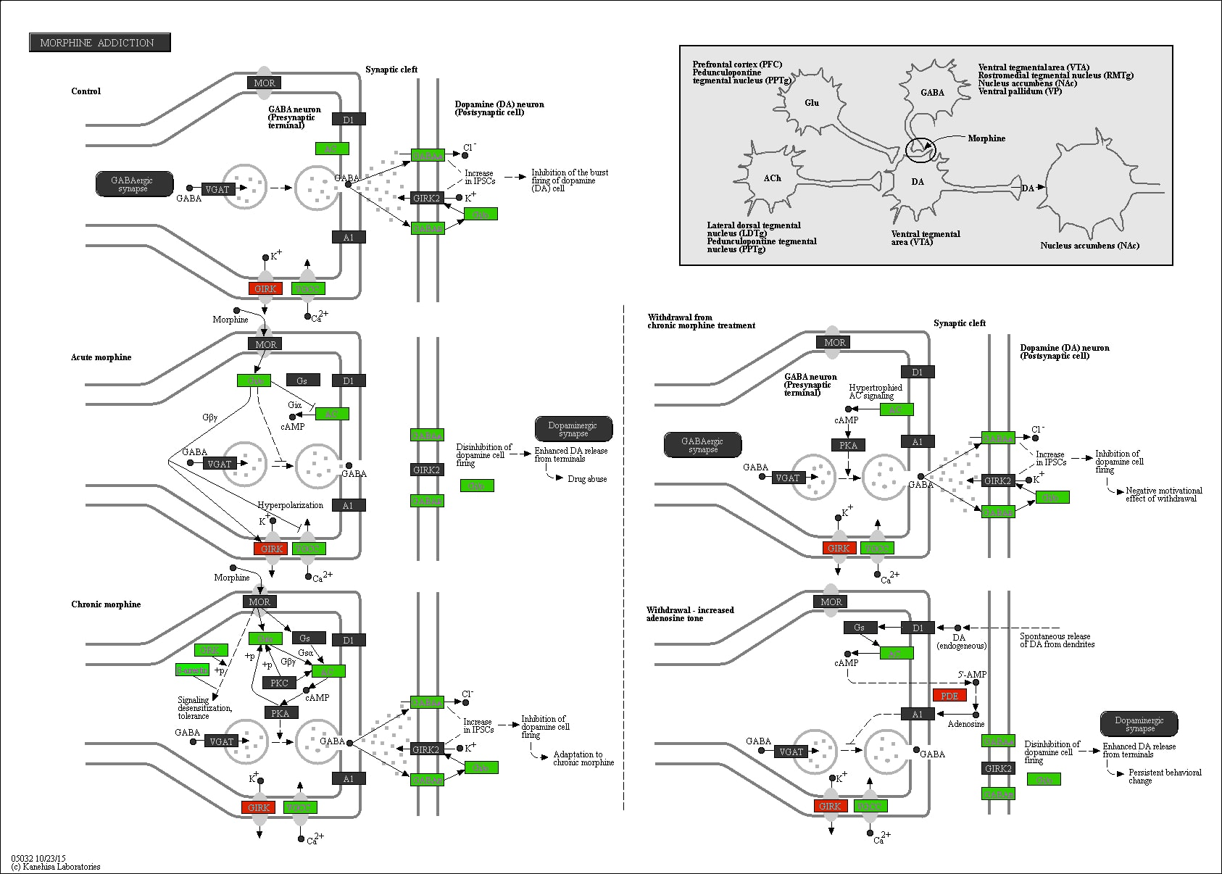

Supplementary Figure S46. The ‘Morphine addiction’ pathway in relation to MVPA. Promoter methylation of genes in red is positively associated with time spent on MVPA, whereas promoter methylation of genes in green is negatively associated with time spent on MVPA.
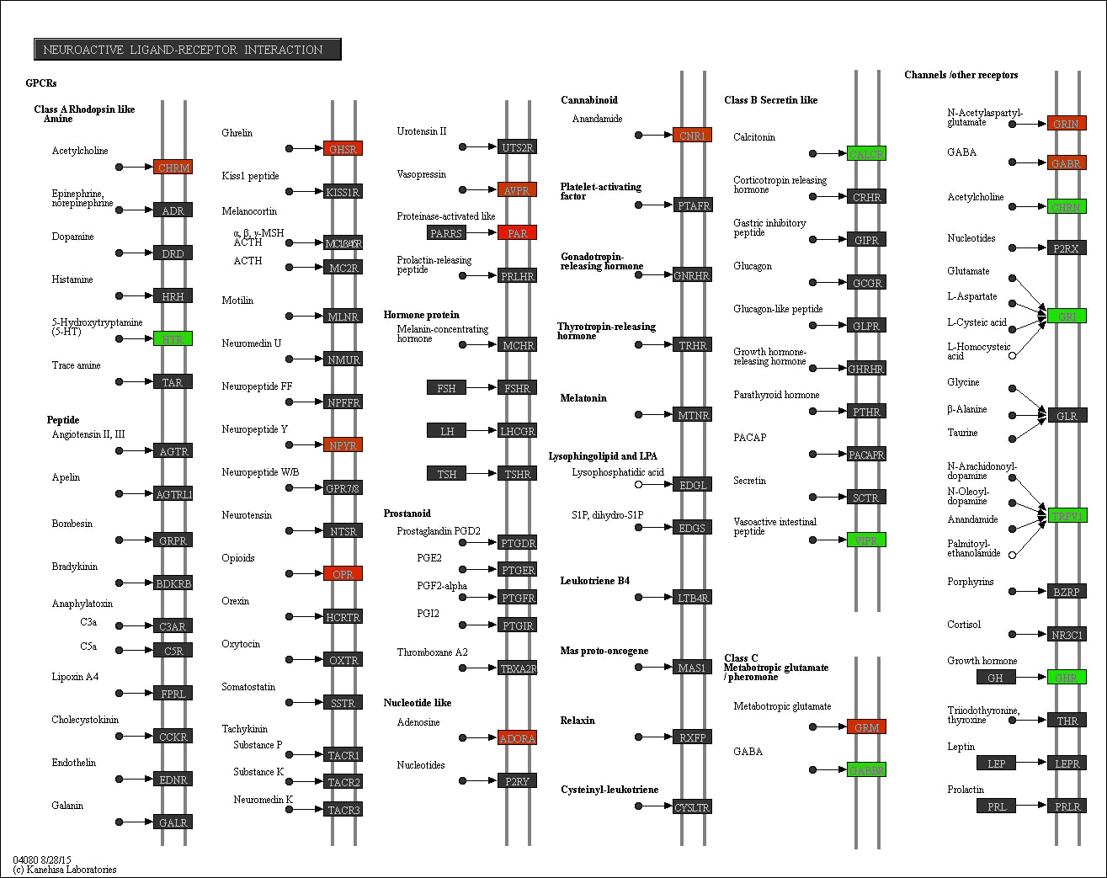

Supplementary Figure S47. The ‘Neuroactive ligand-receptor interaction’ pathway in relation to SB. Promoter methylation of genes in red is positively associated with time spent on SB, whereas promoter methylation of genes in green is negatively associated with time spent on SB.

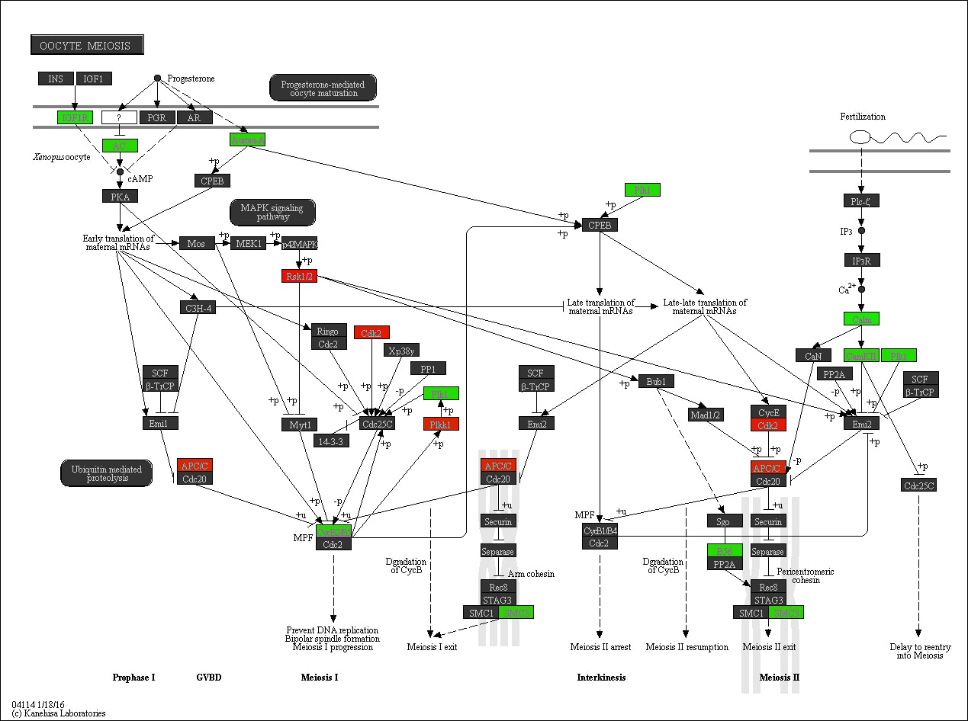

Supplementary Figure S48. The ‘Oocyte meiosis’ pathway in relation to LPA. Promoter methylation of genes in red is positively associated with time spent on LPA, whereas promoter methylation of genes in green is negatively associated with time spent on LPA.

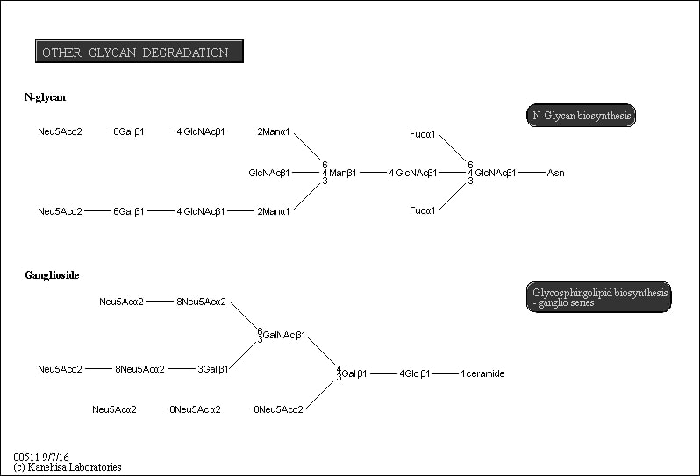

Supplementary Figure S49. The ‘Other glycan degradation’ pathway in relation to MVPA. Promoter methylation of genes in red is positively associated with time spent on MVPA, whereas promoter methylation of genes in green is negatively associated with time spent on MVPA.
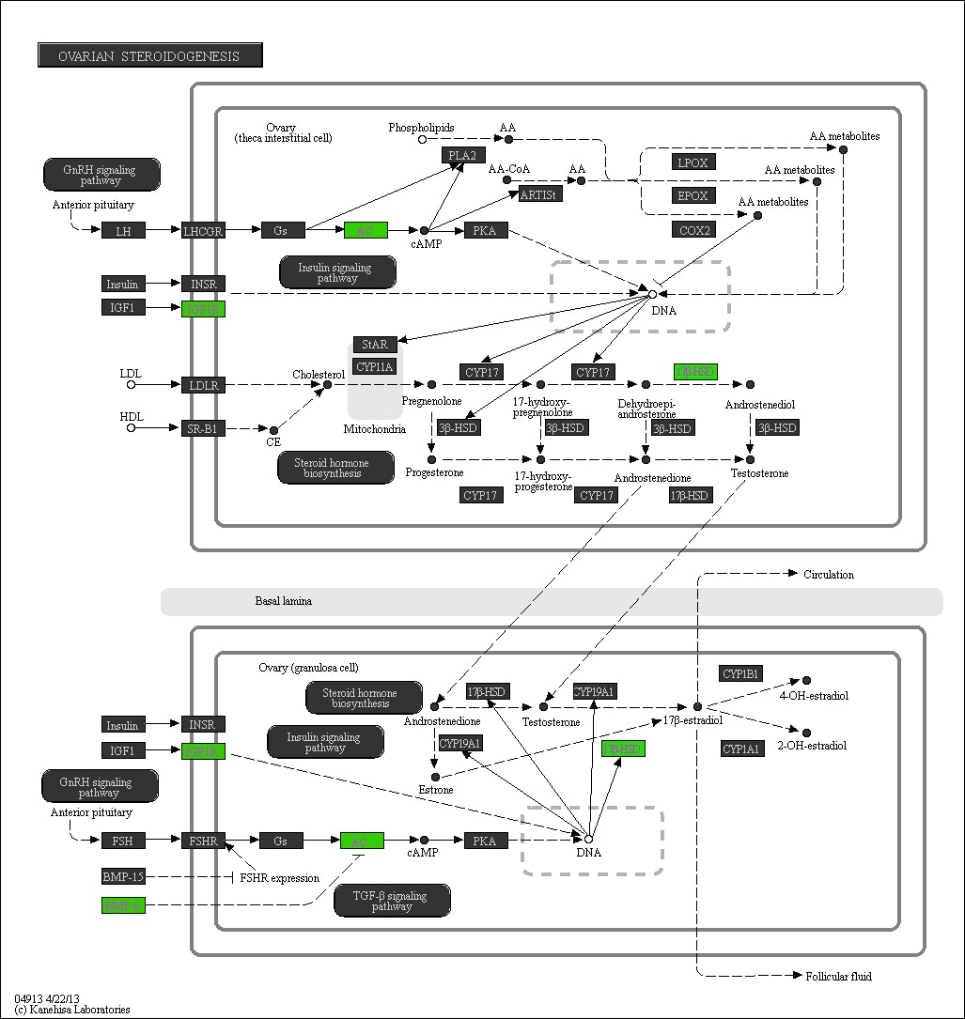

Supplementary Figure S50. The ‘Ovarian steroidogenesis’ pathway in relation to MVPA. Promoter methylation of genes in red is positively associated with time spent on MVPA, whereas promoter methylation of genes in green is negatively associated with time spent on MVPA.
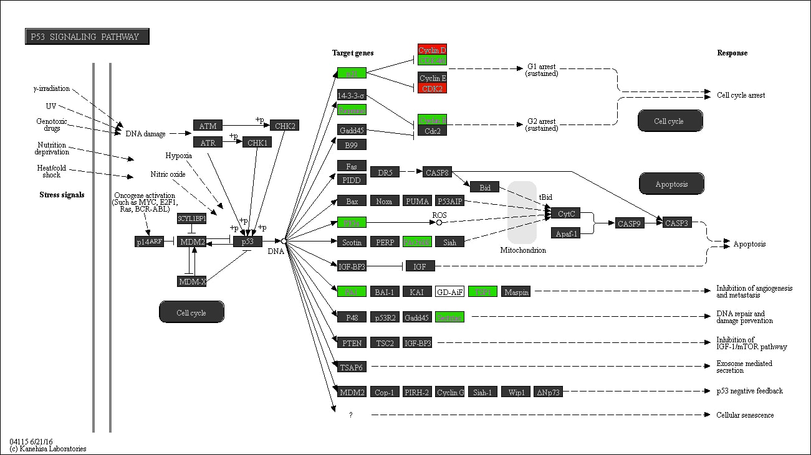

Supplementary Figure S51. The ‘p53 signaling’ pathway in relation to LPA. Promoter methylation of genes in red is positively associated with time spent on LPA, whereas promoter methylation of genes in green is negatively associated with time spent on LPA.

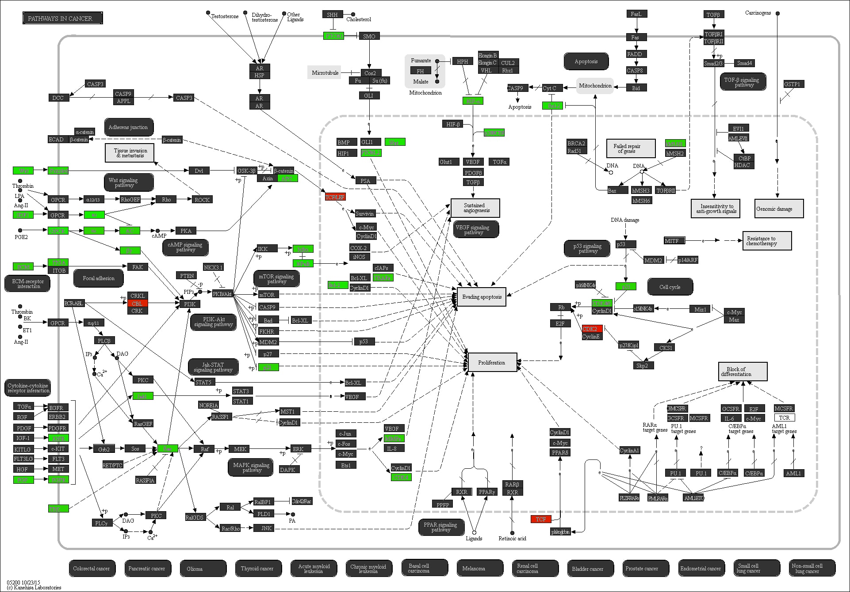

Supplementary Figure S52. The ‘Pathways in cancer’ in relation to LPA. Promoter methylation of genes in red is positively associated with time spent on LPA, whereas promoter methylation of genes in green is negatively associated with time spent on LPA.
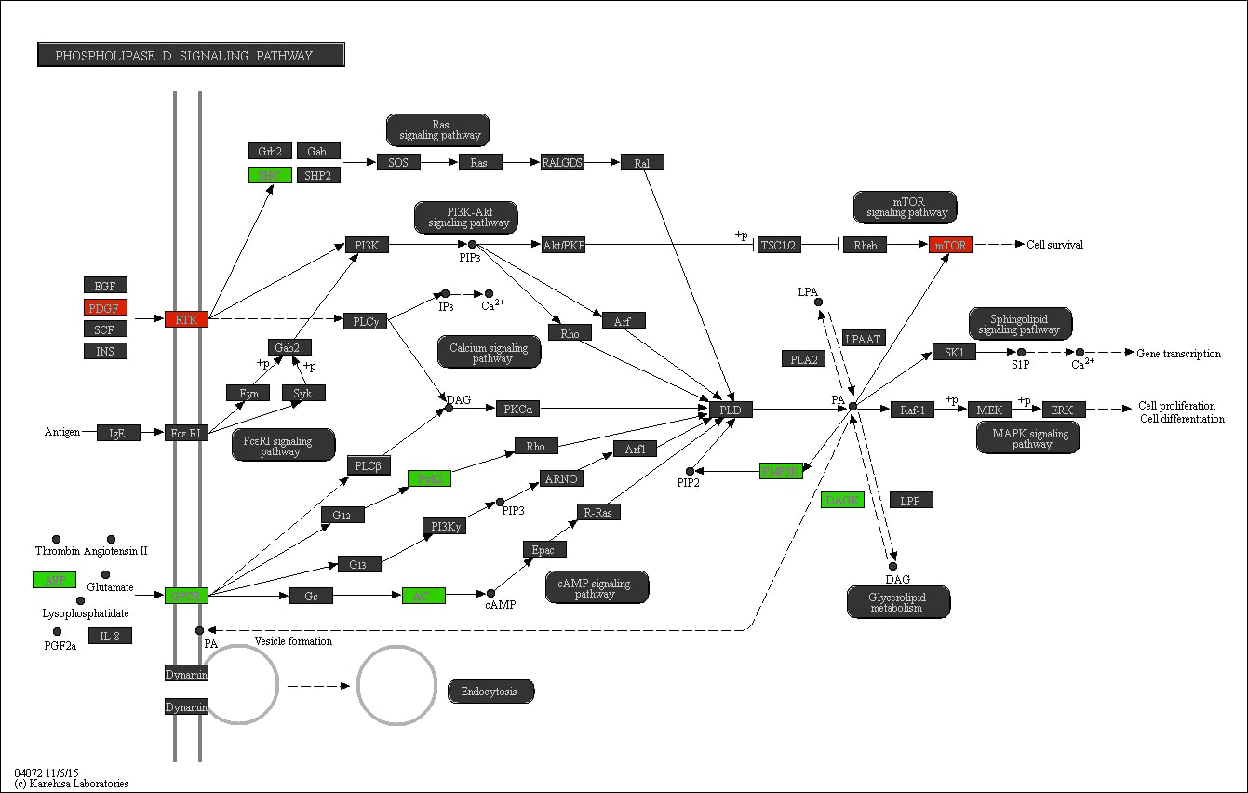

Supplementary Figure S53. The ‘Phospholipase D signaling’ pathway in relation to MVPA. Promoter methylation of genes in red is positively associated with time spent on MVPA, whereas promoter methylation of genes in green is negatively associated with time spent on MVPA.

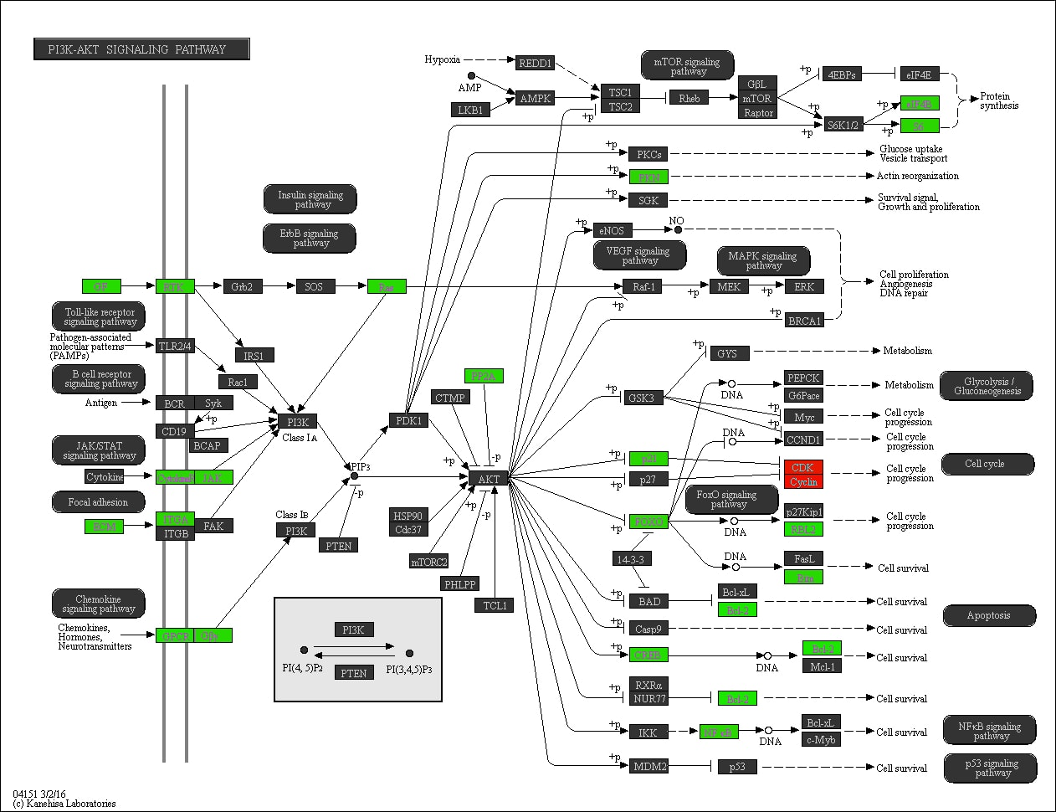

Supplementary Figure S54. The ‘PI3K-Akt signaling’ pathway in relation to LPA. Promoter methylation of genes in red is positively associated with time spent on LPA, whereas promoter methylation of genes in green is negatively associated with time spent on LPA.
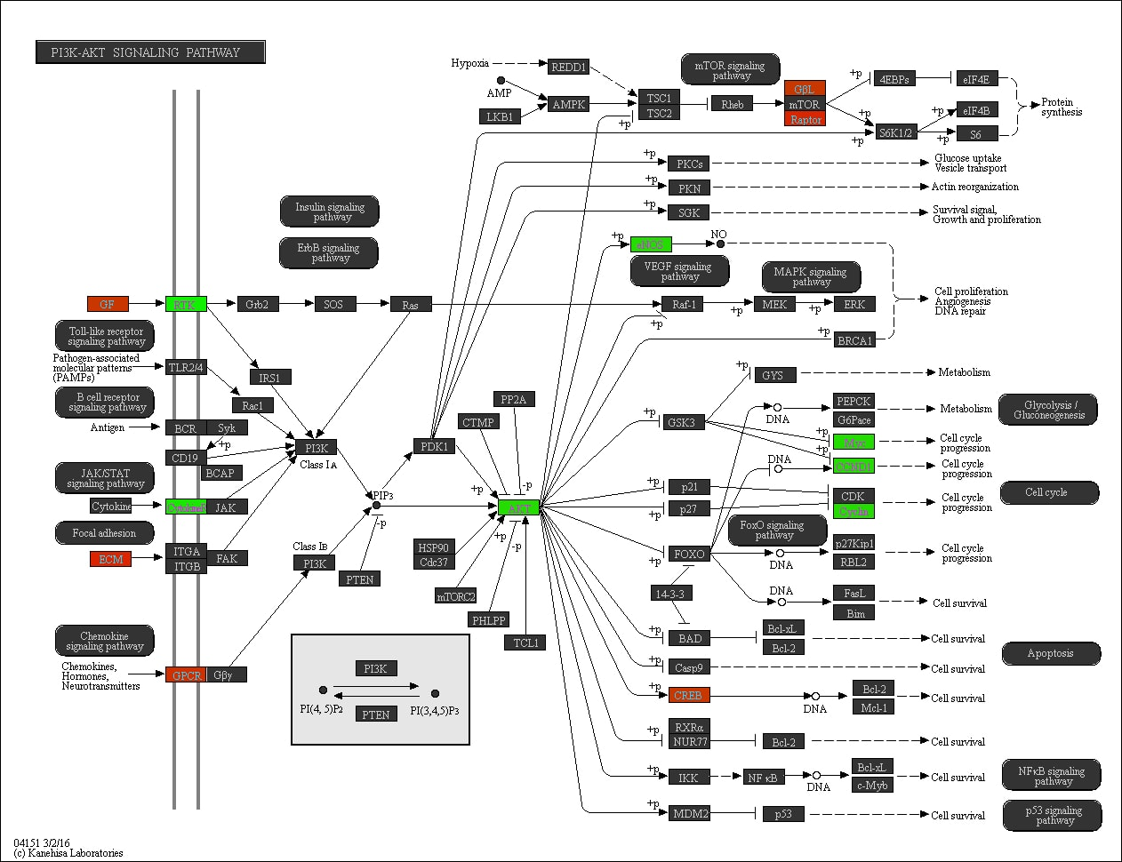

Supplementary Figure S55. The ‘PI3K-Akt signaling’ pathway in relation to SB. Promoter methylation of genes in red is positively associated with time spent on SB, whereas promoter methylation of genes in green is negatively associated with time spent on SB.
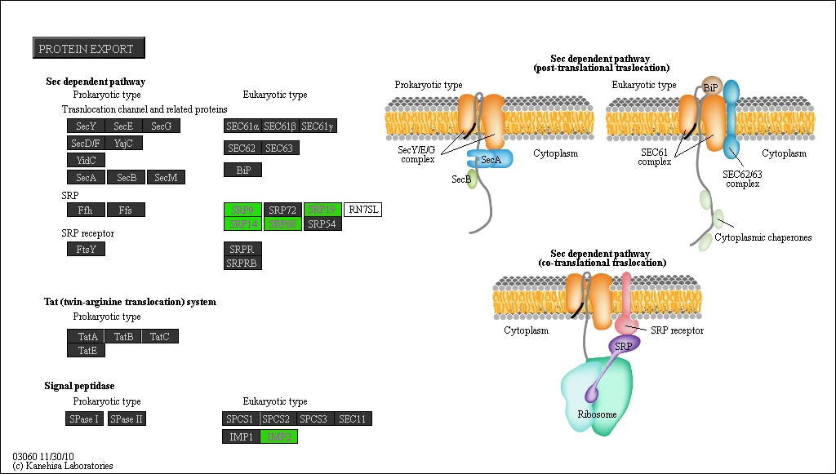

Supplementary Figure S56. The ‘Protein export’ pathway in relation to LPA. Promoter methylation of genes in red is positively associated with time spent on LPA, whereas promoter methylation of genes in green is negatively associated with time spent on LPA.

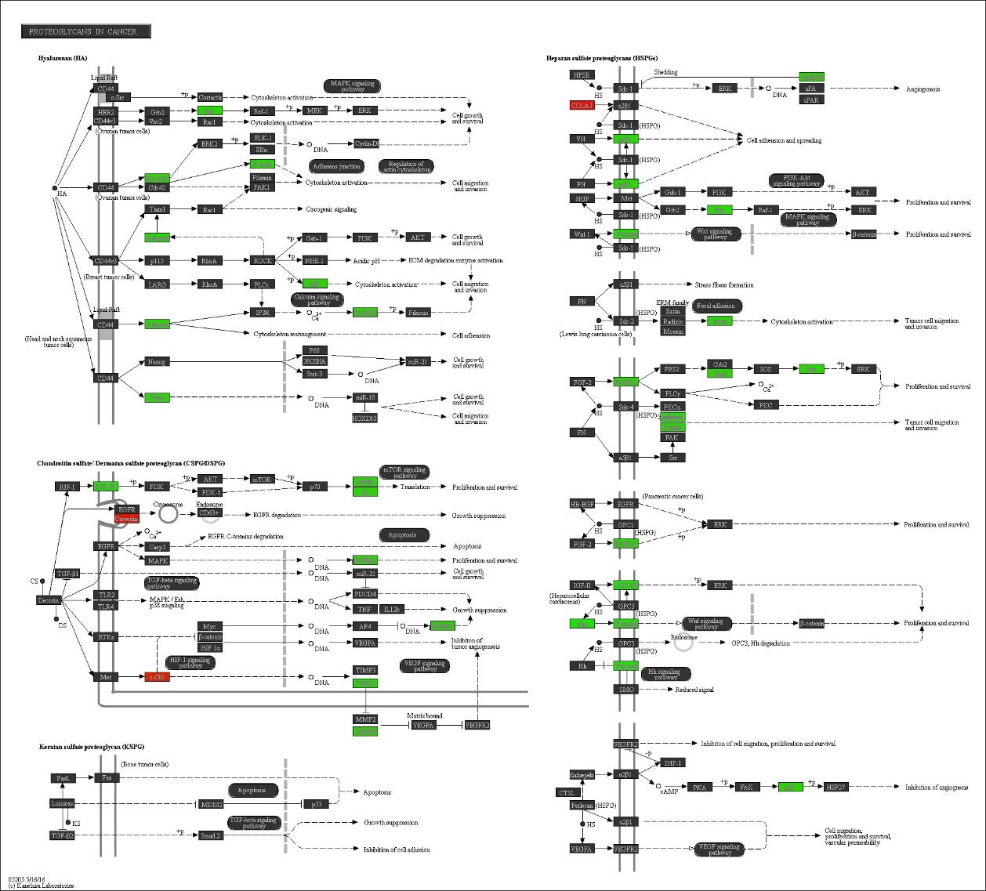

Supplementary Figure S57. The ‘Proteoglycans in cancer’ pathway in relation to LPA. Promoter methylation of genes in red is positively associated with time spent on LPA, whereas promoter methylation of genes in green is negatively associated with time spent on LPA.

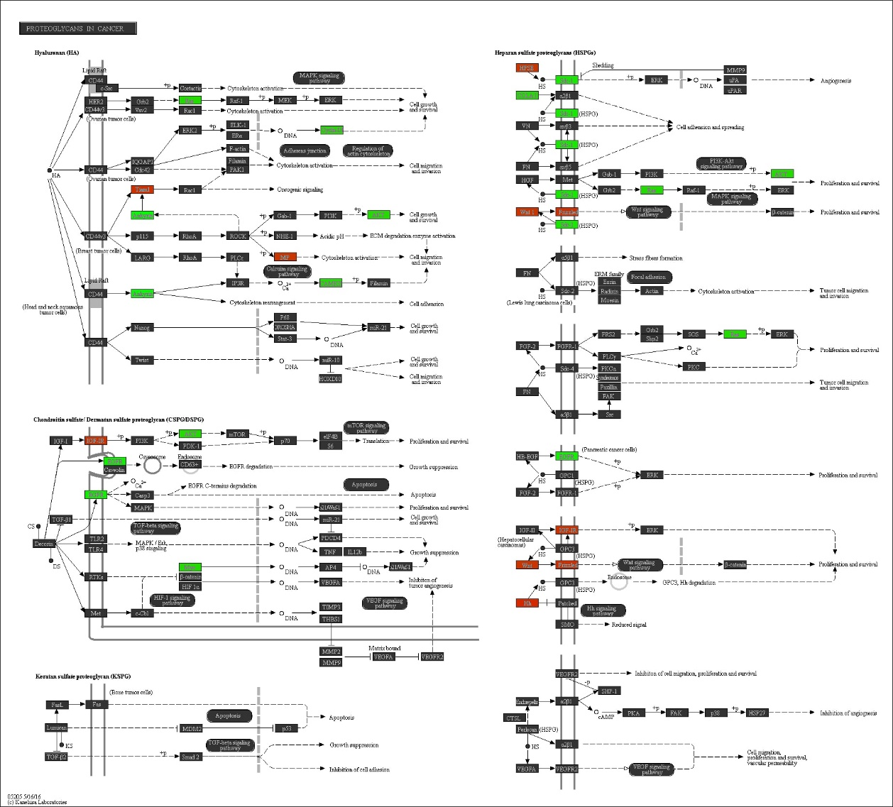

Supplementary Figure S58. The ‘Proteoglycans in cancer’ pathway in relation to SB. Promoter methylation of genes in red is positively associated with time spent on SB, whereas promoter methylation of genes in green is negatively associated with time spent on SB.

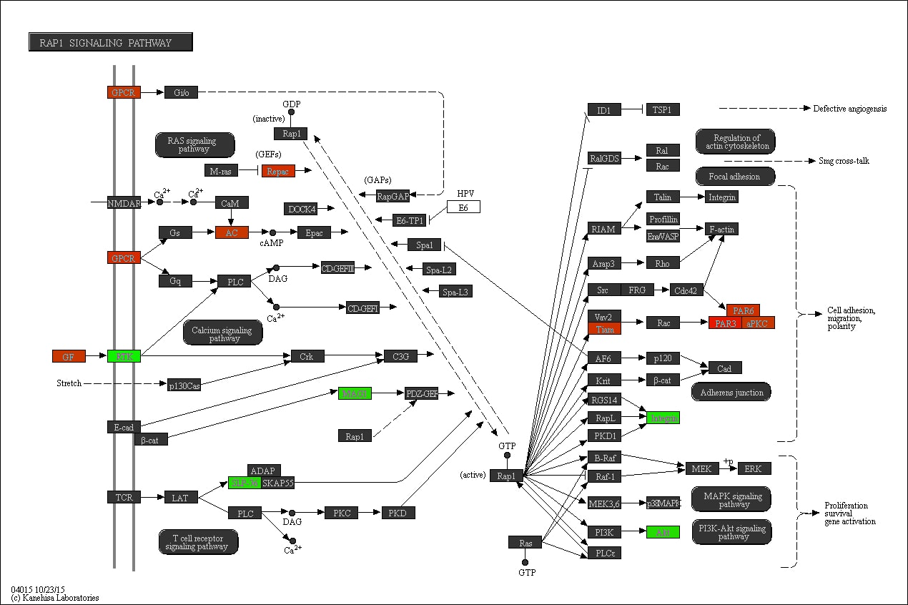

Supplementary Figure S59. The ‘Rap1 signaling’ pathway in relation to SB. Promoter methylation of genes in red is positively associated with time spent on SB, whereas promoter methylation of genes in green is negatively associated with time spent on SB.
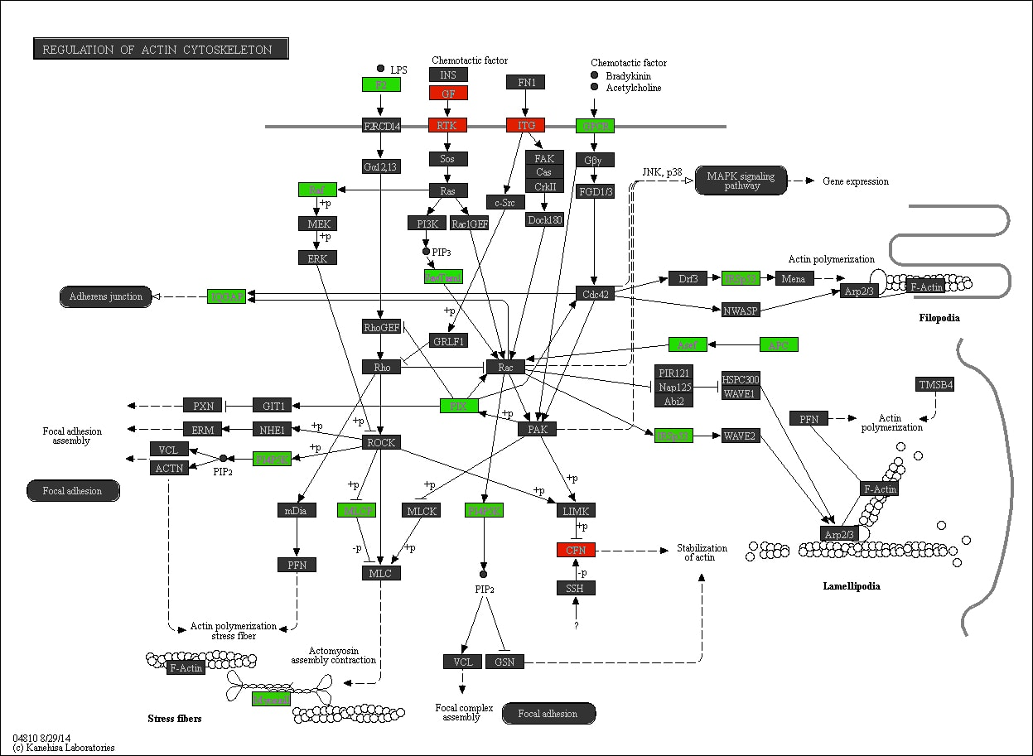

Supplementary Figure S60. The ‘Regulation of actin cytoskeleton’ pathway in relation to MVPA. Promoter methylation of genes in red is positively associated with time spent on MVPA, whereas promoter methylation of genes in green is negatively associated with time spent on MVPA.
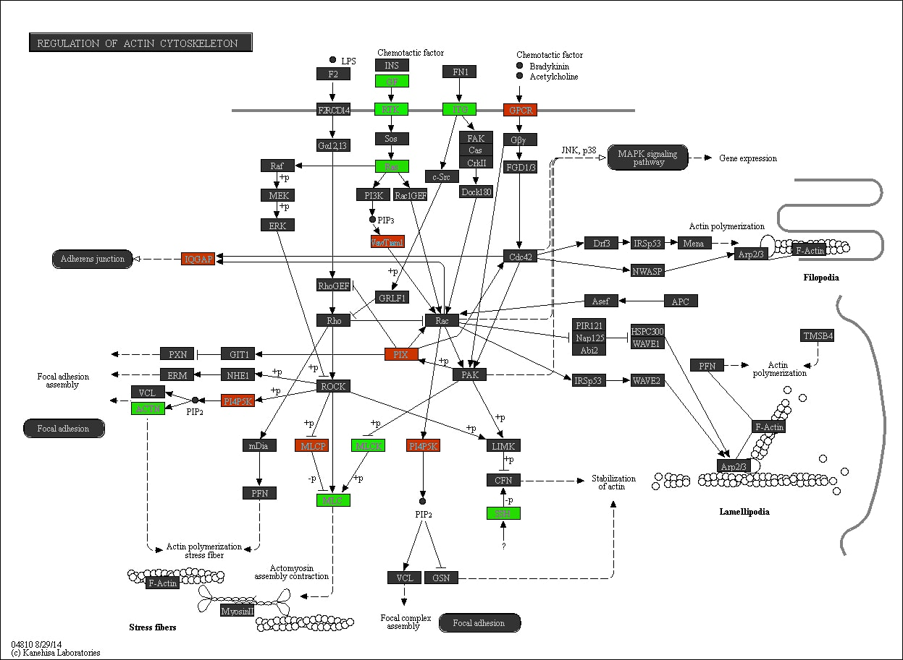

Supplementary Figure S61. The ‘Regulation of actin cytoskeleton’ pathway in relation to SB. Promoter methylation of genes in red is positively associated with time spent on SB, whereas promoter methylation of genes in green is negatively associated with time spent on SB.
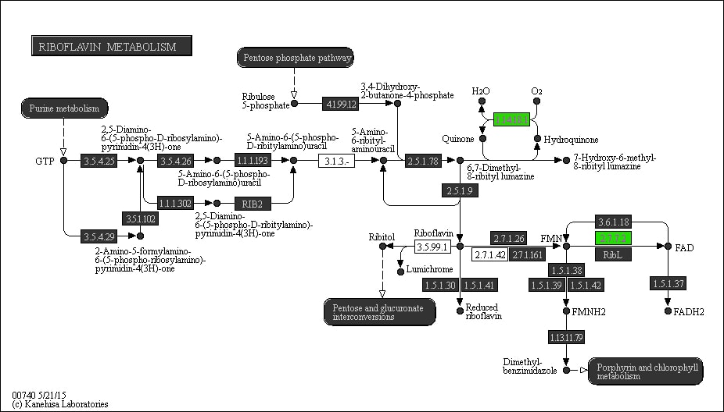

Supplementary Figure S62. The ‘Riboflavin metabolism’ pathway in relation to LPA. Promoter methylation of genes in red is positively associated with time spent on LPA, whereas promoter methylation of genes in green is negatively associated with time spent on LPA.

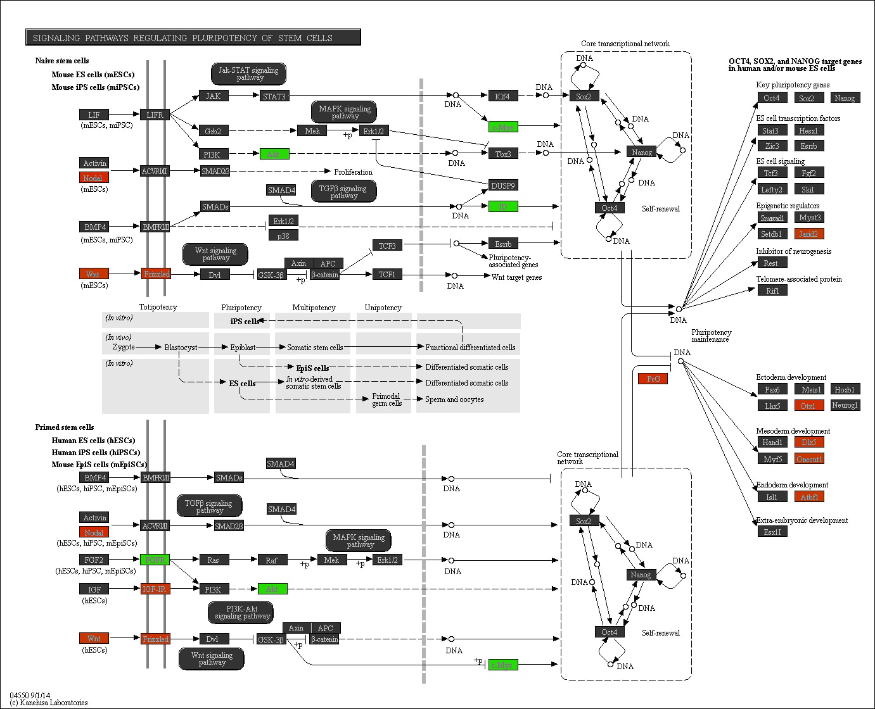

Supplementary Figure S63. The ‘Signaling pathways regulating pluripotency of stem cells’ in relation to SB. Promoter methylation of genes in red is positively associated with time spent on SB, whereas promoter methylation of genes in green is negatively associated with time spent on SB.

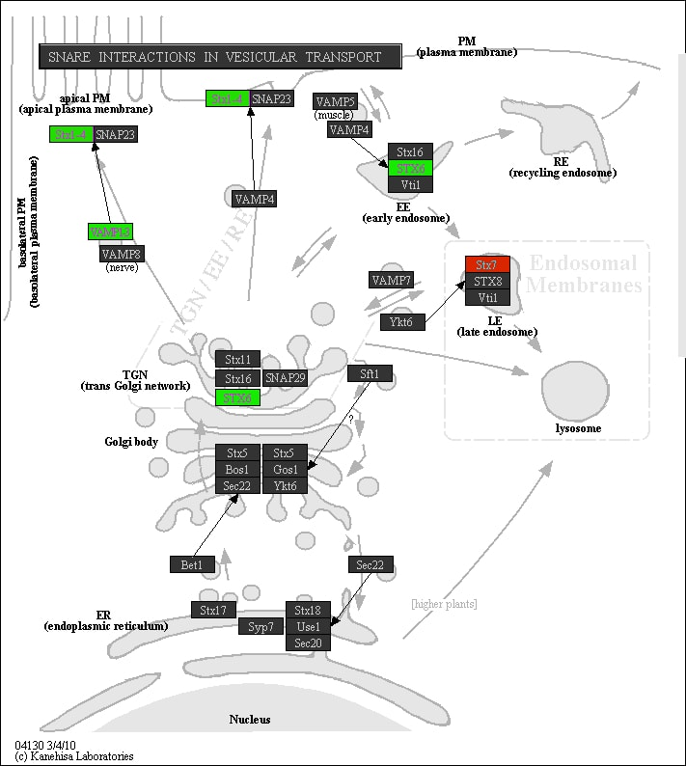

Supplementary Figure S64. The ‘SNARE interactions in vesicular transport’ pathway in relation to SB. Promoter methylation of genes in red is positively associated with time spent on SB, whereas promoter methylation of genes in green is negatively associated with time spent on SB.

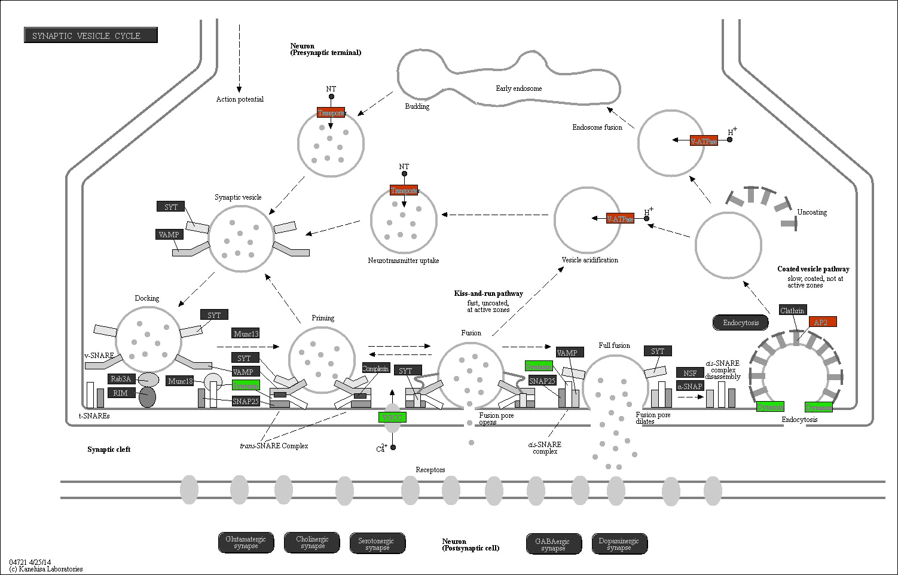

Supplementary Figure S65. The ‘Synaptic vesicle cycle’ pathway in relation to SB. Promoter methylation of genes in red is positively associated with time spent on SB, whereas promoter methylation of genes in green is negatively associated with time spent on SB.

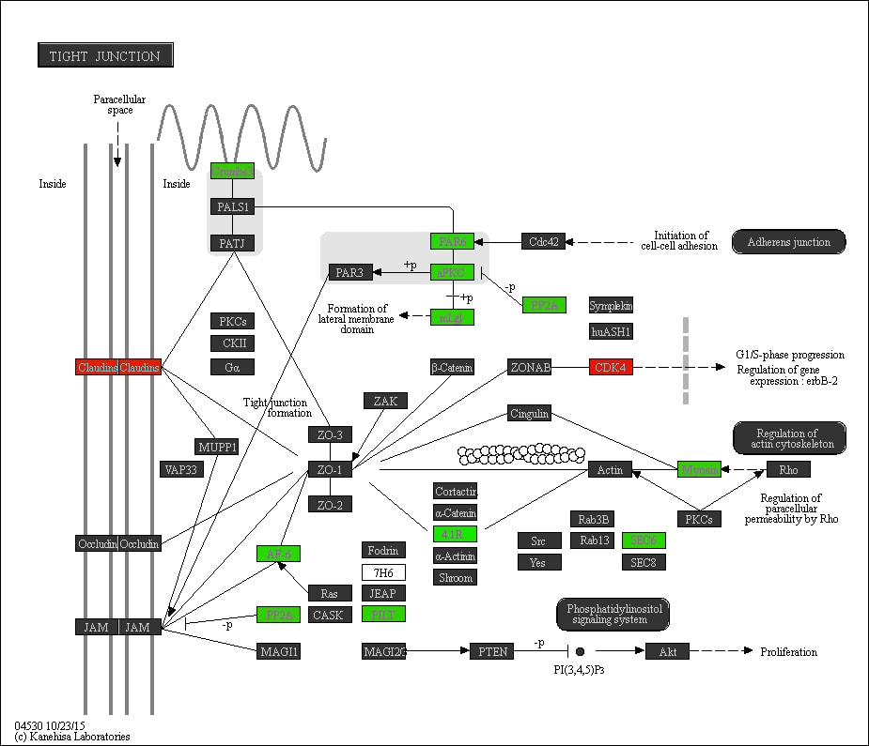

Supplementary Figure S66. The ‘Tight junction’ pathway in relation to MVPA. Promoter methylation of genes in red is positively associated with time spent on MVPA, whereas promoter methylation of genes in green is negatively associated with time spent on MVPA.

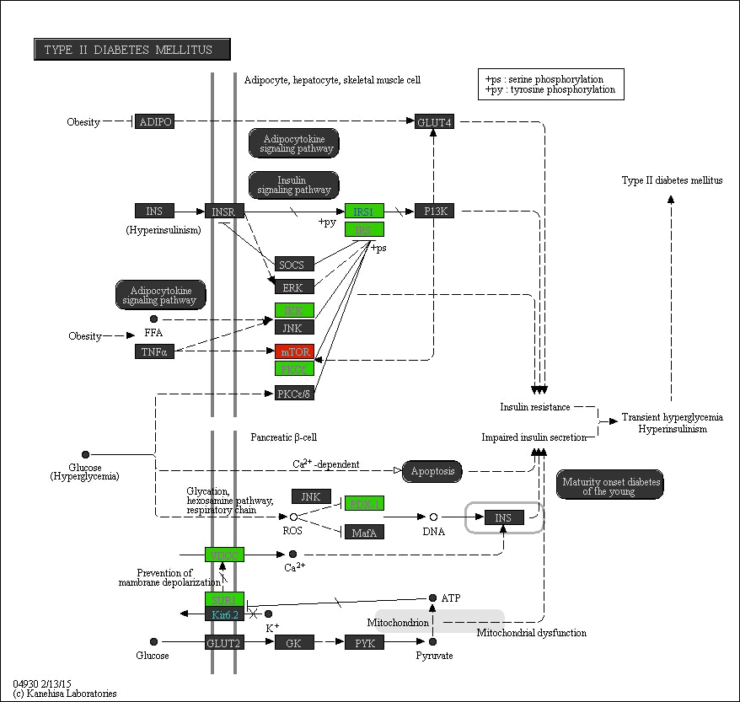

Supplementary Figure S67. The ‘Type II diabetes mellitus’ pathway in relation to MVPA. Promoter methylation of genes in red is positively associated with time spent on MVPA, whereas promoter methylation of genes in green is negatively associated with time spent on MVPA.
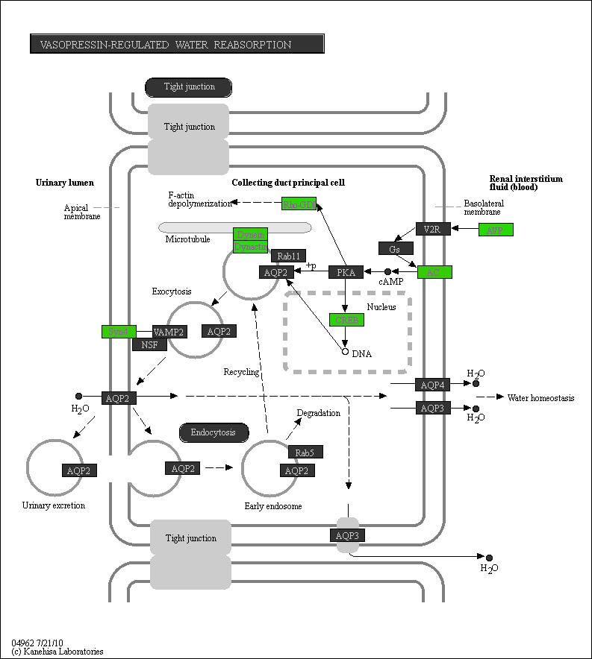

Supplementary Figure S68. The ‘Vasopressin-regulated water reabsorption’ pathway in relation to MVPA. Promoter methylation of genes in red is positively associated with time spent on MVPA, whereas promoter methylation of genes in green is negatively associated with time spent on MVPA.

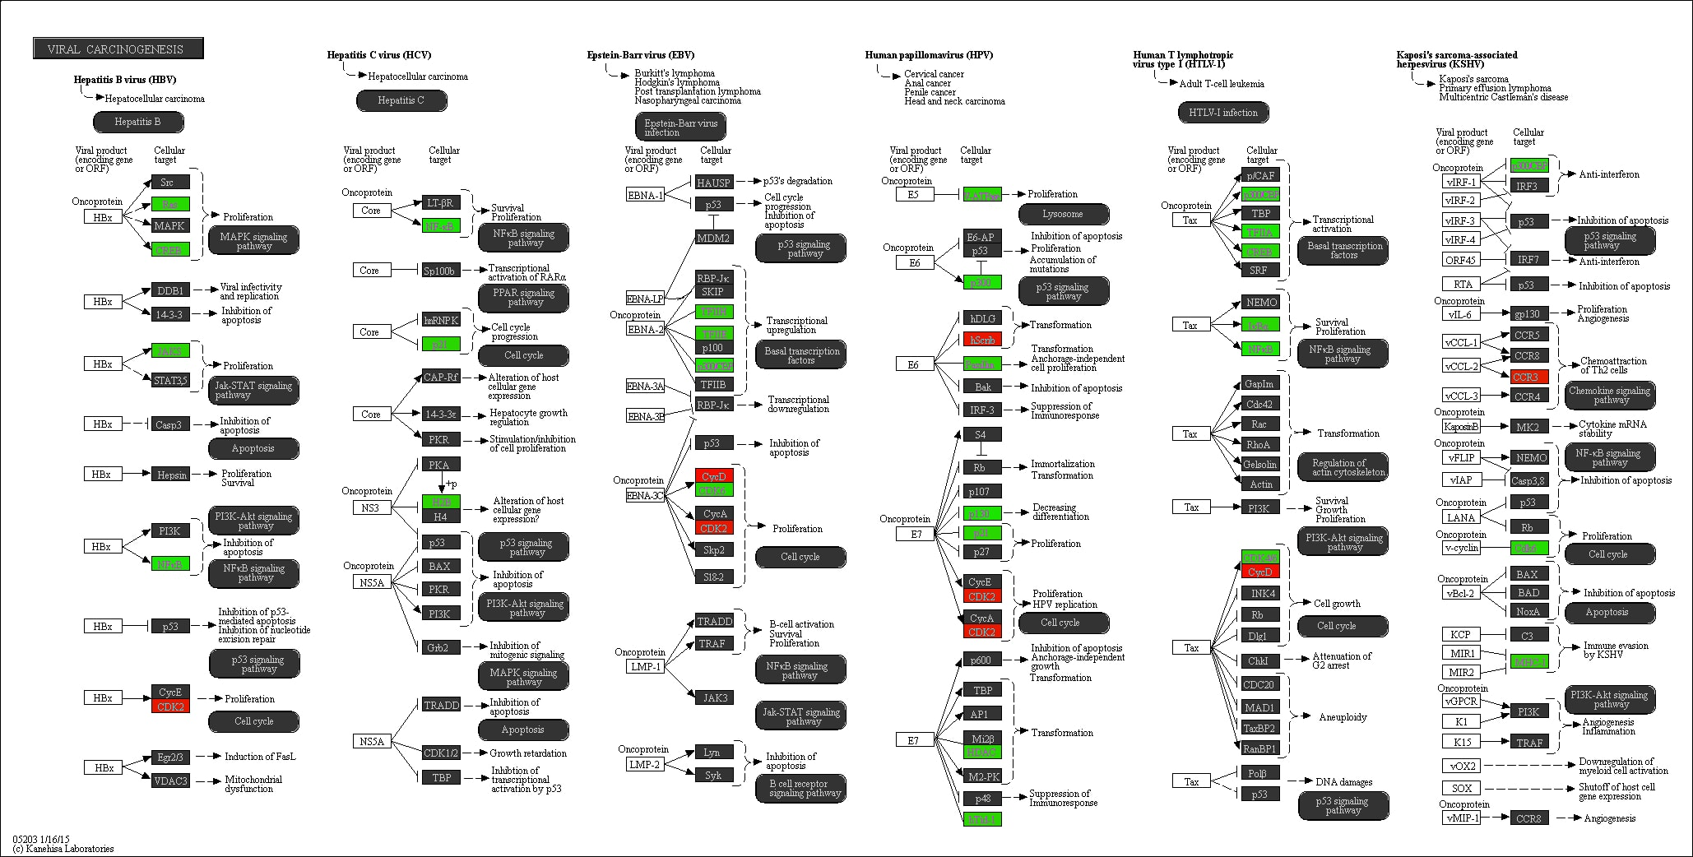

Supplementary Figure S69. The ‘Viral carcinogenesis’ pathway in relation to LPA. Promoter methylation of genes in red is positively associated with time spent on LPA, whereas promoter methylation of genes in green is negatively associated with time spent on LPA.

